

LECTURE NOTES

ON

SURVEY-I

Compiled by

Mrs. NIRALI DAS
Sr. Lecturer, Department of Civil Engineering
GANDHI ACADEMY OF TECHNOLOGY AND ENGINEERING

CONTENTS

S.No | ChapterName | PageNo
1 | IntroductionToSurveying,LinearMeasurements | 3-17
2 | ChainingandChain Surveying | 17-38
3 | AngularMeasurementandCompasSurveying | 38-69
4 | MapReadingCadastralMaps&Nomenclature | 69-71
5 | PlaneTable Surveying | 72-83
6 | LevellingandContouring | 83-124
7 | TheodoliteSurveyingandTraversing | 125-162
8 | ComputationofArea&Volume | 162-184

Chapter-1

INTRODUCTION

SURVEYING-
Surveyingisthe artof determiningthe relativepositionof differentobjectsonthe surface of theearthby means of measurements of distances, directions and elevations and then, preparing a map to any suitable scale.
TECHNICALTERMS:
    - Plan: A plan is a geographical representation of the features on the earth surface or below the earth surface as projected on horizontal plane. This may not necessarily show its geographical position on the globe. On a plan horizontal distances and directions are shown.
    - Map: The representation of earth surface on a small scale is called a map. The map must show its geographical position on the globe.
    - Topographical map: The maps which are on sufficiently large scale to enable the individual features shownonthemaptobeidentifiedonthegroundbytheirshapesandpositions arecalledtopographical map.
    - Geographical map: The maps which are on such a small scale that the features shown on the map are suitablygeneralizedandthemapgivesapictureofthecountryasawholeandnotastrictrepresentation of its individual features, are called geographical maps.

AIMANDOBJECTIVESOFSURVEYING-
Theaimofsurveyingistoprepareamaptoshowtherelativepositions,horizontaldistances,andelevationof the objects on the surface of the earth. The map is drawn to some suitable scale. It shows the natural features of a country, such as towns , villages , roads , railways , river etc. The objectives of surveying can be stated as follows.
    - Collect andrecorddataontherelativepositionsofpointson thesurfaceoftheearth.
    - Computeareasandvolumesusingthisdata,requiredforvariouspurposes.
    - Preparetheplans andmapsrequiredforvariousactivities.
    - Layout,usingsurveydata,thevariousengineeringworksincorrectpositions.
    - Checktheaccuracyoflaid out lines,builtofstructure.

CLASIFICATIONOFSURVAYING-
    - PRIMARY CLASSIFICATION

Surveyingisprimarily classifiedas:
      - Planesurveying
      - Geodeticsurveying

- PLANE SURVEYING:
In plane surveying the curvature of the earth is not taken into consideration. This is because surveying is carried out over a small area so the surface of the earth is consider as plane .Plane surveying is done on an area of less than 250 km².
- GEODETICSURVEYING:
Ingeodeticsurveyingthecurvatureoftheearthistakenintoconsideration.Itisextendedover a large area. It is carried out over an area exceeding 250 km².
    - SECONDARYCLASSIFICATION
      - Chainsurveying
      - Compass surveying
      - Planetablesurveying (iv)Thedolite surveying
(v)Tachometric surveying
GENERALPRINCIPLEOFSURVEYING-
Thetwobasicprinciples ofsurveyingneedtobefollowedforaccurately locatingpointsonearth.
- Toworkfromthewholeto part:
The main principle of surveying is to work from whole to part whether it is plane or geodetic surveying. Toachievethisinactualpractice,asufficientnumberofprimarycontrolpointsareestablishedwithhigher precisioninandaroundtheareatobedetailsurveyed.Minorcontrolpointsinbetweentheprimarycontrol points are then established with less precise method. Further details are surveyed with the help of these minor controlpointsby adopting anyofthesurveymethods. Themainideaofworking from wholeto part is to prevent accumulation of errors and localize minor errors within the frame work of control points. On the other hand if survey is carried out from part to whole, the errors would expand to greater magnitudes and the scale of the survey will be distorted beyond control.
Ingeneralpracticetheareaisdividedintoanumberoflargetrianglesandthepositionsoftheirverticesare surveyed with greater accuracy, using sophisticated instruments. These triangles are further divided into smaller triangles and their vertices surveyed with less accuracy.
- Tolocateanew stationbyat leasttwomeasurements fromfixedreferencepoints/control points.

The reference points / control points are selected in the area and distance between them, is measured accurately.Theline isthenplottedto aconvenientscaleon a drawingsheet. Incase,thecontrol pointsare co-ordinated, their locations may be plotted with the system of coordinates (Cartesian or spherical). The location of the required point may then be plotted by making two measurements from the given control points as explained below.

LetPandQbetwogivencontrolpoints.AnyotherpointRcanbelocatedwithreferencetothesepoints, by any of the following methods.
P
P P P R

R R R

Q
Q Q Q
  - (b) (c) (d)
Fig.1
- Bymeasuring distances PRand QR:- Thedistances PR and QR maybemeasured and thelocation of R may be plotted by drawing arcs to the same scale to which line PQ has been drawn as shown in Fig 1 (a).

- By dropping a perpendicular from R on PQ:- A perpendicular RT may be dropped on the line PQ. Distances PT, TQ and RT are measured and the location of R may be plotted by drawing the perpendicular RT to the same scale to which line PQ has been drawn (Fig. 1 (b)).
Theabovetwoprinciplesaregenerally usedin“Chainsurveying”.

- BymeasuringthedistanceQRand anglePQR:-ThedistanceQRand theanglePQRequaltoαare measuredandlocationofRmaybeplottedeitherbymeansofaprotractorortrigonometrically(Fig 1 (c)),
Thisprincipleisusedin“Theodolite traversing”.

- BymeasuringtheinterioranglesofthetrianglePQR:-TheinterioranglesP,QandRofthetriangle PQRaremeasuredwith anangle measuringinstrumentsuch astheodolites.Thelengthof sidesPR and QR are calculated by solving the triangle PQRand coordinates of R are calculated in the same termsasthoseofPandQ.Evenwithoutcalculatingtheco-ordinates,orsidesthelocationofR can be obtained by plotting the angles PQR and QPR (Fig 1(d).
Thisprincipleis usedinthemethodof‘Triangulation’.

Linearmeasurements

INTRODUCTION
Therearetwomainmethodsofdeterminingthedistancesbetweenpointsonthesurfaceof earth:
    - DirectMeasurement:Inthismethod,distancesareactuallymeasuredontheearthsurfacebymeansof
chains,tapesetc.
    - ComputativeMeasurement:Inthismethoddistancesaredeterminedbycalculationasintachometryand triangulation.

INSTRUMENTSFORMEASURINGDISTANCES
    - Tapes
    - SteelBands
    - Chains
    - Arrows
    - Pegs
    - RangingRods

    - RangingPoles (viii)Offset Rods

(ix)PlumbBobs

TAPES:Dependinguponthematerialtapesareclassified as
    - Cloth or linen tape
    - Metallictape
    - Steeltape
    - Invar tape
- Cloth or linen tape: Linen tapes are closely woven linen and varnished to resist moisture. They are generally10metresto30metresinlengthand12mmto15mminwidth.Clothtapesaregenerallyused for measuring offset measurements onlydue to following reasons :
  - Itiseasilyaffectedbymoistureandshrunk.
  - Itslengthgetsalteredbystretching.
  - Itislikely totwist andtangle.
  - Itisnotstrongasachainorsteel tape.
  - Itislight andflexibleanditdoesnotremainstraight instrongwind.
  - Duetocontinuoususe,itsfiguresgetin-distinct.
- Metallic Tape: A linen tape reinforced with brass or copper wires to prevent stretching or twisting of fibers is called a metallic tape. As the wires are interwoven and the tape is varnished, these wires are notvisibletonakedeyes.Thesetapesareavailableindifferentlengthsbuttapesof20mand30mlengths areverycommon.Thesearesuppliedinleathercasewithwindingmachine.Eachmetreisdividedinto decimeters and each decimeter is sub-divided into centimeters.
- Steel Tape:Steel tapes are available with different accuracy of graduation. Steel tapes are available indifferentlengthsbut10m,20m,30mand50mtapesarewidelyusedinsurveymeasurements.At the end of the tape a brass ring is provided. The length of metal ring is included in the length of tape. A steel tape of lowest degree of accuracy is generally superior to a metallic or cloth tape for linear measurements.
- Invar Tape: Invar tapes are made of an alloy of nickel (36%) and steel (64%) having very low co- efficientofthermalexpansion(0.000000122per 1ºC).Theseare6mmwideand areavailableinlength of 30m, 50m and 100m. These tapes are used for high degree of precision required for base measurements.

Chains:Thedifferent typesofchainsareused insurveyingand aregivenbelow.

- Gunter’schain: Itis66ft.longanddividedinto100links.Eachlinkmeasures0.66ft.
- Engineer’s chain:Itis100ft.longanddividedinto100links.Eachlinkmeasures1ft.

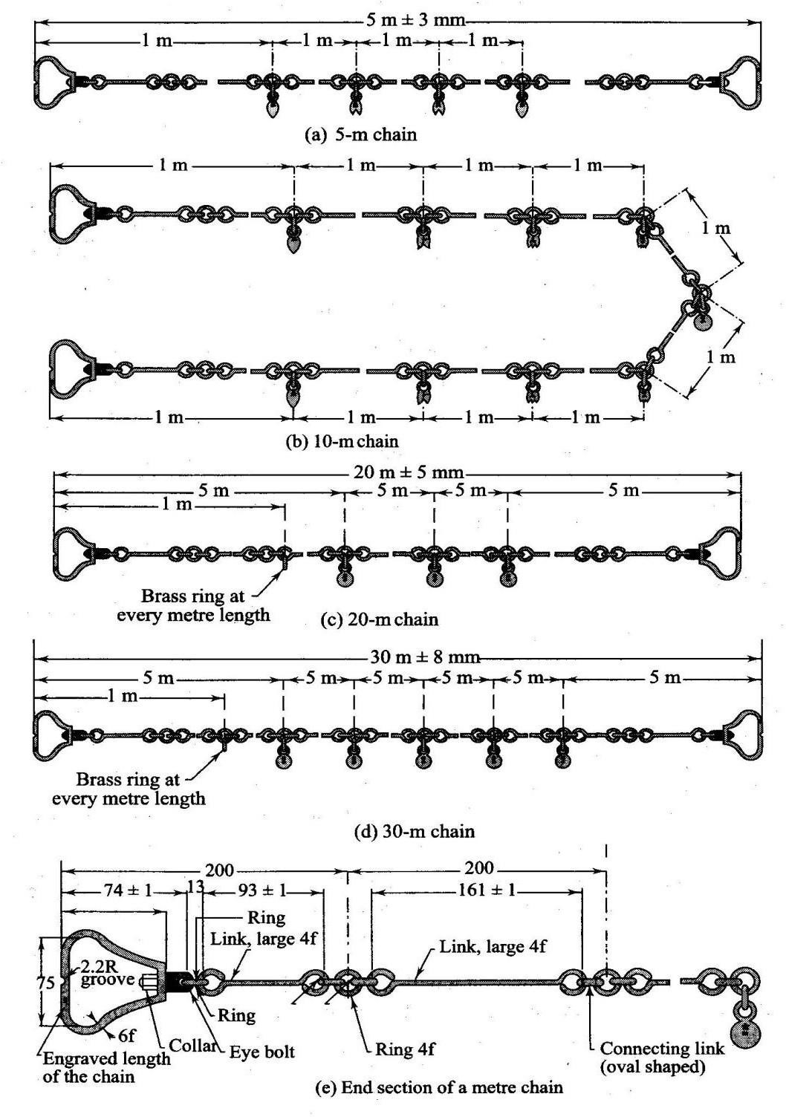

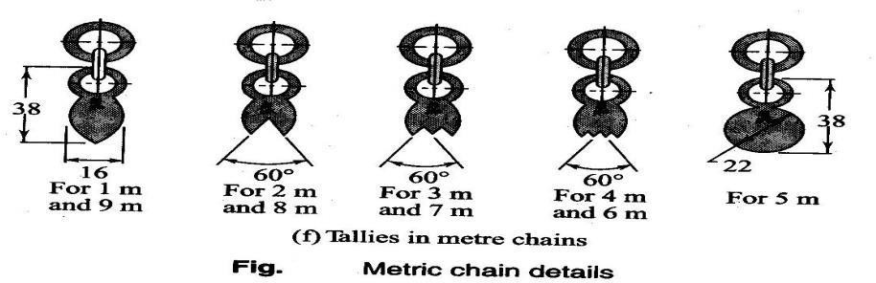
Fig.2.1
- Metric Chain:A metric chain is prepared with 100 or 150 pieces/ links of galvanized mild steel wireofdiameter4mm.Theendsofthepiecesarebenttoformloopsandconnectedtogetherbymeansofthree oval shaped rings which gives flexibility to the chain. Two brass handles are provided at the two ends of the chain with swivel joints so that chain can be turned round without twisting. The outside of the handle is the zero point or the end point of the chain. Thelength of the chain is measured from the outside of one handle to theoutsideoftheother. Thelength ofalinkisthedistancebetween thecentres ofthetwo consecutivemiddle rings as shown in the Fig. 2.1. The end links include the length of handle. Tallies are provided for marking 5m, 10m, etc are marked with letter “m” to distinguish the metric chain from non-metric chain. The length of chain whether 20m 0r 30m is indicated on the handle for easy identification.

SuitabilityofChains: Thechains aresuitableforthefollowing cases.
    - Itissuitableforordinaryorpreliminaryworksasitslengthaltersduetocontinuous use.
    - Itslengthgetsshorteneddueto bendingoflinksandgets lengthenedbyflattening oftherings.
    - Beingheavier,achain getssaggedconsiderably whensuspendedatthe ends.
    - Itcanbeeasilyrepairedinthefield.
    - Measurement readingscanbetakenveryeasily.
    - Itisonly suitableforrough works.
MeritsofChains:
- Theycanbereadeasilyandquickly
- Theycanwithstandwearand tear
- Theycanbeeasilyrepaired orrectifiedinthefield.
DemeritsofChains:
- Theyareheavyand taketoomuch timetoopenorfold.
- Theybecome longerorshorterdueto continuoususe.
- Whenthemeasurementistakeninsuspensionthechainsagsexcessivelygivingincorrectmeasurements.

ARROWS: Arrow are made of tempered steel wire of diameter 4mm.One end of the arrow is bent into a ring of diameter50mmandtheotherendispointed.Itsoveralllengthis400mm.Arrowsareusedforcountingthenumber of chains while measuring a chain line. Generally 10 arrows accompany a chain.

RANGING RODS: Rods, which are used for ranging a line are known as ranging rod. Such rods are made of seasonedtimberorseasonedbamboo.SometimesGIpipesof25mm/30mmdiameterarealsousedasrangingrods. They are generally circular in section of diameter 25mm/30mm and length 2m / 3m.The rod is divided into equal parts of 20cm each and the divisions are painted black and white or red and white alternatively so that the rod is visible from a long distance. The lower end of the rod is pointed or provided with an iron shoe.

RANGING POLES: These are similar to ranging rods except that they are heavier in section of length 4m to 6m. They are used for ranging very long lines in undulating ground.

OFFSET RODS: These are similar to ranging rods and o 3m long. The top is provided with an open hook for pulling or pushing a chain through obstruction like bushes etc.It is used for aligning the offset line and measuring short offsets.

PLUMBBOB:Itisusedtotransfertheendpointsofthechainontogroundwhilemeasuringdistancesinhilly terrain. It is also used for testing verticality of ranging poles, ranging rods.
PEGS: Woodenpegsusually2.5cmsquareand 15cm deepareusedto markthepositionofsurvey stations.
ADJUSTMENTOFCHAIN: Chainsareadjustedin thefollowing ways-
  - Whenthechain istoolong,it isadjusted by
    - Closing up thejointsof the rings
    - Hammeringtheelongatedrings
    - Replacingsomeoldringsbynewrings
  - Whenthechain istooshort,it isadjusted by
    - Straighteningthebentlinks
    - Openingthejoints of therings
    - Replacingtheold ringsbysomelarger rings

ERRORSINLINEARMEASUREMENTS/ CHAINING
Errorsinchainingmaybecausedduetovariationintemperatureandpull,defectsininstrumentsetc.Theymay be classified into two catagories.

    - Compensatingerrors
    - Cumulativeerror
- COMPENSATING ERRORS: Errors, which may occur in both directions (that is both positive and negative) and which finally tend to compensate are known as compensating errors.
- CUMULATIVEERRORS:Errors,whichmayoccurinthesamedirectionandwhichfinallytendtoaccumulate are said to be cumulative. They seriously affect the accuracy of the work and are proportional to the length of the line (L).The errors may be positive or negative.
  - Positive Cumulative Error:The error, which make the measured length more than the actual is known as positive cumulative error.
Sources:(a)Thelengthofchain/ tapeisshorterthanitsstandard length dueto
    - Bendingof links
    - Removaloftoo many rings dueto adjustment of its length.
    - Knotsinconnectinglinks.
    - Thefieldtemperatureislowerthanthatatwhichthe tapewas calibrated.
    - Shrinkageoftapewhenmoist
    - Clogging ofrings with mud.
  - Theslopecorrectionisignoredwhilemeasuringalongslopping ground.
  - Thesagcorrection,if not appliedwhenchain/ tapeissuspendedatitsends.
  - Incorrectalignment.
  - Negative Cumulative Error: The error, which make the measured length less than the actual is known as negative cumulative error.
Sources:(a)Thelength ofchain/tapeislongerthanits standardlengthdueto
    - Flatteningofconnectingrings.
    - Openingofthering joints.
    - The field temperature is higher than that at which the tape was calibrated. MISTAKES: Errors occurring due to the carelessness of the chainman are called mistakes. Following are a fewcommon mistakes:
- Onceanarrowiswithdrawnfromthegroundduringchainingitmaynotbereplacedinproperposition,if required due to some reason.
- Afullchainlength may beomittedoradded. Thishappenwhenarrowsarelostorwrongly counted.
- Thenumbermay beread fromthe wrongdirection;forinstancea6maybereadasa9.

- Some number may be called wrongly. For example 50.2 may be called as fifty two without thedecimal point being mentioned.
PRECAUTIONSAGAINST ERRORSANDMISTAKES:
- Thepointwherethearrowis fixedon theground shouldbemarkedwithacross(×).
- Thezeroend ofthe chainortapeshould beproperlyheld.
- During chaining the number of arrowscarried by the follower and leader should always tally with the totalnumber of arrows taken.
- The chainman should call the measurement loudly and distinctly and the surveyor should repeat them while booking.
- Rangingshould bedoneaccurately.
- Nomeasurementshouldbetakenwiththechainin suspension.
ERRORSINMEASUREMENT DUETOINCORRECTCHAIN/TAPELENGTH:
Duetousageofchainoverroughground,itsovalshapedringsgetelongatedandthusthelengthofchaingets increased. On the other hand, sometimes some of the links get bent and consequently the length of the chain gets decreased. Thus, the lengths obtained by chaining with a faulty chain are either too long or too short than the length which would be obtained with a chain of standard length. If the chain is too long the measured distance will be less and if the chain is too short the measured distance will be more.
LetLbethetruelengthof chainandL’bethefaulty length of chain.

Then,the truelengthof a line =
L' measuredlength L

CORRECTIONSINLINEARMEASUREMENTS
×
    - Correctionforstandardlength
    - Correctionforalignment
    - Correctionforslope
    - Correctionfortension
    - Correctionfortemperature
    - Correctionforsag

- Correction for standardlength: Beforeusing atape, its actual length is ascertainedby comparing it with a standardtapeofknownlength.Thedesignatednominallengthofatapeisitsdesignatedlengthe.g.30mor 100m. The absolute length of a tape is its actual length under specified conditions.
Let L=measuredlengthofa line

Ca=correction forabsolutelength
l=nominal designatedlength oftape
C= correction beappliedthe tape
Then, C=L.C
a l

Thesignofthecorrection Cawill bethesameas thatofC.

- Correction for alignment: Generally a survey line is set out in a continuous straight line. Sometimes, it becomesnecessary,duetoobstructiontofollowabentlinewhichmaybecomposedoftwoormorestraight portions subtending an angle other than 180º as shown in Fig.2.2.

A B
ϴ1
ϴ2
α
C

Fig.2.3.Correction foralignment

Let AC=l1;CB=l2
AngleBAC = ϴ1; AngleBAC = ϴ2Length AB=l1cosϴ1+l2cos ϴ2
Therequiredcorrection =(l1+l2)-(l1cosϴ1+l2cosϴ2)

- Correction for slope: The distance measured along the slope between two stations is always greater than thehorizontaldistancebetweenthem.Thedifferenceinslopedistanceandhorizontaldistanceisknownas slope correction which is always substractive.
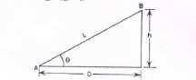
Fig.2.4SlopeCorrection

Let L=slopedistanceAB
D=horizontaldistanceAC
h=differenceinreducedlevelsofAandB
(L²−h²)
D=
SlopeCorrection =L– D=h2
2L

- Correctionforpull/tension(CP):
During measurement the applied pull may be either more or less than the pull at which the chain or tape was standardized. Dueto theelasticpropertyofmaterials thestrain will vary accordingto thevariation of applied pull and hence necessary correction should be applied. This correction is given by the expression
CP=((P-P0)xL)/(AxE)
where, P=PullortensionappliedduringmeasurementinNewtons A= Cross-sectional area of the tape in square cm.
L=Lengthofthemeasured line
P0=Standardpull
E=Modulus ofElasticityofthetape
Iftheappliedpull ismore,tensioncorrectionispositive,andifitisless,thecorrectionis negative.
- Temperaturecorrection (Ct):
This correction is necessary because the length of the tape or chain may be increased or decreasedduetoriseorfalloftemperatureduringmeasurement.Thecorrectionisgivenbytheexpression as mentioned below.
Ct=α(Tm-T0)L
where Ct =correction fortemperature
α=coefficientofthermalexpansion
Tm=temperature during measurement in degrees centigrade T0=temperatureatwhichthetapewasstandardizedindegreescentigrade L=length of tape
- Correction for sag (Cs)
Thiscorrectionisnecessarywhenthemeasurementistakenwiththetapeinsuspension.Itisgiven by the expression as mentioned below.

L⎛W⎞2
C_{s}= ⎜ ⎟
24⎝P⎠
whereW=totalwtofthetape;L=horizontaldistancebetweenthesupports P = pull applied during measurement

Problem1.Thelengthofasurveylinemeasuredwitha30mchainwasfoundtobe631.5m.Whenthechainwas compared with a standard chain, it was found to be 0.1m too long. Find the true length of the survey line.

Solution

Thetruelengthofaline= L’ = 30.1m. L = 30m
L'×

L

measuredlength

andmeasuredlength ofthesurvey line=631.5m
Thus,truelengthofthesurveyline=30.1×631.5=633.603m.
30

Problem 2. A 20m chain was found to be 4 cm too long after chaining 1400m. It was 8 cm too long at the end of day’sworkafterchainingatotaldistanceof2420m.Ifthechainwascorrectbeforecommencementofthework,find the true distance.

Solution
Thecorrectlengthoftheatcommencement=20m
Thelength ofthe chain after chaining1400m = 20.04 m.
Themean lengthofthechainwhilemeasuring= (20+20.04)/2=20.02m
Thetruedistanceforthewrongchainageof1400m=(20.02/20)x1400=1401.4m The remaining distance = 2420-1400 = 1020m
Themeanlengthofchainwhilemeasuringtheremainingdistance=(20.08+20.04)/2=20.06m The true length of remaining 1020m = (20.06/20)x 1020 =1023.06m
Hence,thetotaltruedistance= 1401.4 +1023. 06=2424.46 m Ans.

Problem No.3. A line was measured with a steel tape which was exactly 30 meters at 20℃ at a pull of 100N (or 10kgf), the measured length being 1650.00 meters. The temperature during measurement was 30° C and the pull applied was 150N (or 15kgf). Find the length of the line, if the cross-sectional area of the tape was0.025 sq.cm. The

co-efficient of expansion of the material of the tapeper 1 ºC =3.5x10−6and the modulus of elasticity of the material of the tape=2.1x105N/m𝑚2(2.1x106kg/c𝑚2).

Solution:
- Correctionoftemperaturepertapelength
=𝛼(𝑇𝑚−𝑇𝑜)𝐿
=0.0000035(30−20)30
=0.00105m (+ve)
- Correctionforpullpertapelength
=CP=((P-P0)xL)/(AxE)=((150-100)x30)/(2.5x2.1x10⁵)
=0.00286m(+ve)
Combinedcorrection=0.00105+0.00286=0.00391m True length of the tape = 30+0.0039=30.0039m
Truelength ofthe line =(30.0039x1650.00)/30
=1650.21m.

Chapter-2

Chainingandchainsurveying
Inadditiontochainortape,severalotherauxiliaryequipmentarerequiredinachainsurveyingThesearelistedin subsequent paragraphs.

Arrows
Arrows or chain pins, as these are called sometime, are made of stout steel wire 4 mm in diameter, 400 to 450 mmlong and black enameled. These are used to mark the end of each chain length as shown in Figure (a).

WoodenPegs
Thesearemadeofstouttimbergenerally25to30mmsquareorcircularsizeand150mmlongasshowninFigure(b). Wooden pegs are normally used to mark station position on ground on a quasi-permanent state. These are tapered at oneendsothattheycan bedriveninthegroundwithahammer.Thesearekeptatabout40mm(minimum)projecting above the ground.
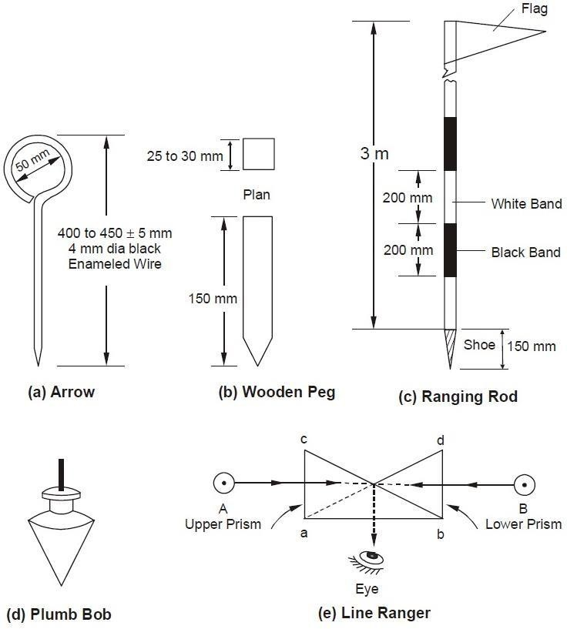

Ranging Rods
These are octagonal or circular in plan normally 25 to 30 mm diameter straight timber or tubular steel rods, 3 m in length and provided with an iron shoe at lower end as shown in Figure (c). These are painted in black and white alternatebandsandnormallyhaveaflagatthetopforeasyrecognitionandidentificationfromadistance.Iftheranging roads are graduated in meters and one tenth of a meter, they are called offset rods and are used for measurement of short offsets.

PlumbBob
It is usually heavy spherical or conical ball, as shown in Figure (d), of metal and is used to transfer points on ground bysuspendingitwiththehelpofastrongthread.Itisusedinmeasuringdistancesonslopinggroundbystepping.

Compass,Dumpylevelsand.Theodolitesarealsopositionedoverthestationpointaccuratelywith thehelpofplumb bobs.

LineRanger
A line ranger consists of either two plane mirrors or two right angled isosceles prisms placed one above the other as depictedin Figure(e).Thediagonalsofboththeprismsaresilveredsoastoreflecttheincidentrays. Linerangersare provided with a handle to hold the instrument. A line ranger can also be used to draw offset on a chain line.

Useofchain
Unfolding Of Chain: To open a chain the strap is unfastened and the two brass handles are held in the left hand and thebunchisthrownforwardwiththerighthand.Thenonchainmanstandsatthestartingstationbyholdingonehandle and another moves forward by holding the other handle until the chain is completely extended.
Folding of Chain : After the completion of the work the chain should be folded in to a bundle and fastened with a leather strap. To do this the handles of the chain should be brought together by pulling the chain at the middle. Commencingfromthemiddle,taketwopairsoflinkatatimewiththerighthandandplacethemobliquelyacrossthe otherin the left hand. When the chain is collected in a bundle, it is tied with a leather strap. This process is called the folding of chain.

Readingachain:
Asurveychainisgenerallycomposedof100or150linksformedbypiecesofgalvanisedmildsteel wireof4mm diameter. The ends of each link are looped and connected together by means of three circular or oval shaped wire ringstoprovideflexibilitytochain.Thelengthofeachlinkismeasuredasthedistancebetweenthecentresoftwo consecutive middle rings.
Theendsofchainareprovidedwithbrasshandleswithswiveljoints.Theendlinklengthincludesthelengthofhandle and is measured from the outside of the handle, which is considered as zero point or the chain end. Tallies, which are metallic tags of different patterns, are provided at suitably specified points in the chain to facilitate quick and easy reading. A semi-circular grove is provided in the centre on the outer periphery of handle of chain for fixing the mild steel arrow at the end of one chain length. The number of links in a chain could be 100 in a 20 m chain and 150 in a 30 m chain. The details of a metric chain are as shown in Figure

Testingofachain:
Duetocontinuoususe,achainmaybeelongatedorshortened.So,thechainshouldbetestedandadjustedaccordingly. If full adjustment is not possible, then the amount of shortening ( known as ‘too short’ ) and elongation ( known as ‘too long’ ) should be noted clearly for necessary correction applicable to the chain.
Fortestingthechain, atestgaugeisestablishedonalevelplatform withthehelp ofstandardsteel tape.Thesteel tape isstandardisedat20⁰Candunderatensionof8kg.Thetestgaugeconsistoftwopegshavingnailsatthetopandfixed onalevelplatformarequireddistanceapart(say20or30m).Theincorrectchainisfullystretchedbypullingitunder normal tension along the test gauge. If the length of the chain does not tally with standard length, then the attempt should be made to rectify the error. Finally the amount of elongation or shortening should be noted.

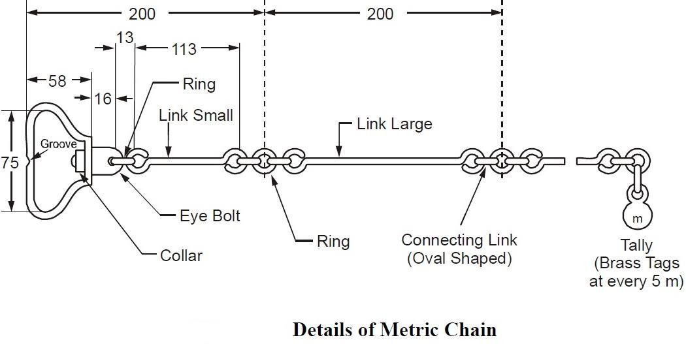
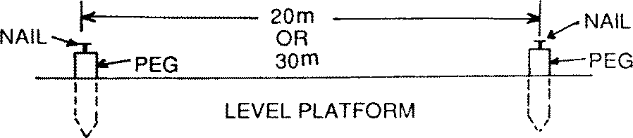
The allowableerror isabout2mmper 1mlength of thechain.The overalllengthof the chainshould be within the following permissible limit :
20 m chain : ± 5mm 30m chain : ± 8mm Adjustmentofachain:
Chains areadjustedinthefollowingways :
- Whenthechainistoo long,it isadjustedby :
  - Closingtheopened jointsof therings.
  - Reshapingtheelongatedrings.
  - Removingoneormorecircularrings.
  - Replacingtheworn-outrings.

- Whentheringistooshort, itisadjusted by:
  - Straighteningthebent links.
  - Flatteningthecircularrings.
  - Insertingthenewrings wherenecessary.
  - Replacingtheoldringsbysomelargerrings.

Ranging:
Theprocessofestablishingintermediatepointson astraightlinebetween twoend pointsis knownasranging.

Purposeofranging :
Thepurposeofrangingistomarkanumberofintermediatepointsonasurveylinejoiningtwostationsinthefieldso that the length between them may be measured correctly.
Ifthelineisshortoritsendstationisclearlyvisible,thechainmaybelaid intruealignment.Butifthelineislong or its end station is not visible due to undulation ground, it is required to mark a number of points with ranging rods.

CodeofSignalsforRanging

Sl.No. | Signalby the Surveyor | ActionbytheAssistant
1 | Rapidsweepwithrighthand | Moveconsiderably totheright
2 | Slowsweepwithrighthand | Moveslowly to theright
3 | Rightarmextended | Continueto move totheright
4 | Right armup andmovedto theright | Plumbthe rodtotheright
5 | Rapidsweepwithlefthand | Moveconsiderably totheleft
6 | Slowsweepwithleft hand | Moveslowlytotheleft
7 | Leftarm extended | Continueto moveto theleft
8 | Leftarmupandmovedtotheleft | Plumbtherod totheleft
9 | Bothhandsaboveheadand thenbrought down | Correct
10 | Botharmsextendedforwardhorizontallyandthe | Fixtherod
 | handsdepressed briskly
Directranging:
Whenintermediaterangingrodsarefixedalongthechainline,bydirectobservationfromeitherendstation,theprocess is known as “Direct Ranging”. Direct ranging is possible when the end stations are inter visible. The following procedure is adopted for direct ranging :
- Erectrangingrodsorpolesverticallybehind eachendoftheline.
- Standabout 2m behindtherangingrodatthebeginning ofthe line.
- Directthe assistantto hold aranging rodvertically at arm’s lengthat the point wheretheintermediatestation is to be established.
- Directtheassistanttomovetherodtotherightorleft,untiltherangingrodsappeartobeexactlyinastraight line.
- Stoopdownand check theposition ofthe rodby sighting overtheirlower ends in orderto avoid errorto non- vertically of the ranging rods.
- Afterascertainingthattherangingrods areinastraight line,signaltheassistanttofixtheranging rod.

Indirectranging:
Whentheendstationsarenotintervisibleduetotherebeinghighgroundbetweenthem,intermediaterangingrodsare fixed on the line in an indirect way. This method is known, as indirect ranging or reciprocal ranging. The following procedure is adopted for indirect ranging.
Suppose A and B are two end stations which are not intervisible due to high ground existing between them. Supposeitis requiredtofixintermediatepoints between A andB. Twochain mentakeup positionsatR1andS1with

ranging rods in their hands. The chainman at R1 stands with his face towards B so that he can see the ranging rods at S1 and B. Again the chainman at S1 stands with his face towards A so that he can see the ranging rods at R1 and A. Then the chainmen proceed to range the line by directing each other alternately. The chainman at R1 direct the chainman at S1 to come to position S2 so that R1 , S2 and B are in the same straight line. Again the chainman at S2directs the chainman at R1 to move the position at R2 so that S2 , R2 and A are in the same straight line. By directing each otheralternately in this manner,theychange theirpositions everytimeuntil theyfinally cometo thepositionsR and S,which are in the straight line AB. This means the points A, R, S and B are in the same straight line.

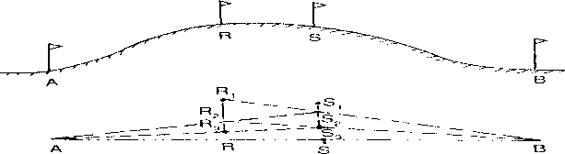

RoleofLeaderandFollower:
Thechainmanatforwardendofthechain,whodragthechainforward,isknownas leader. The duties of the leader are as follows:
- Todragthechain forwardwithsomearrowsandarangingrod.
- Tofixarrowsonthegroundattheendofeverychain.
- Toobeytheinstructionsofthefollower.

Thechainmanattherearendofthechain,whoholdsthezeroendofthechainatthe station, is known as the follower. The duties of the follower are :
- Todirecttheleaderatthetimeofranging.
- Tocarrytherearhandle ofthechain.
- Topickupthearrows insertedbytheleader.

ChainingonLevelGround:
Beforestartingthechainingoperationtworangingrodsshouldbefixedonthechainline,attheendstations.
Theotherranging rods,should be fixednear theend ofeachchain length,during the ranging operation.
To chain the line, the leader moves forward by dragging the chain and by taking with him a ranging rod and 10 arrows . The follower stands at the starting station by holding the other end of chain. When the chain is fully extended , the leader holds the ranging rod vertically at arm’s length. The follower directs the leader to move his rod totheleftorrightuntiltherangingrodisexactlyinline.Thenthefollowerholdsthezeroendofthechainbytouching

thestationpeg.Theleaderstretchesthe chain by movingitupand down withbothhands, and finallyplacesit onthe line. He then inserts an arrow on the ground at the end of the chain and marks with a cross ( X ).
Again,theleadermoves forwardbydraggingthe chainwithninearrowsandtherangingrod.Attheendofthe chain, he fixes another arrow as before. As the leader moves further, the follower picks up the arrows which were inserted by the leader. During chaining the surveyor or an assistant should conduct the ranging operation.
In this way, chaining is continued. When all the arrows have been inserted and the leader has none left with him, the follower hands them over to the leader; this should be noted by the surveyor. To measure the remaining fractionallength, theleadershoulddragthechain beyondthestationandthefollowershouldholdthezeroendofthe chain at the last arrow. Then the odd links should be counted.

ChainingonSloping Ground:
Chaining on the surface of a sloping ground gives the sloping distance. For plotting the surveys, horizontal distances are required. It is therefore, necessary either to reduce the sloping distance to horizontal equivalent or to measure the horizontal distances between the stations directly. The following are the different methods that are generally employed.
- DirectMethodorSteppingMethod
- IndirectMethod

DirectMethod:
Thismethodisappliedwhenslopeofthegroundisverysteep.Inthismethod,theslopinggroundisdividedin toanumberofhorizontal andverticalstrips,likesteps.So,thismethodisalsoknownassteppingmethod.Thelength of the horizontal portions are measured and added to get the total horizontal distance between the points. The steps may not be uniform, and would depend on the nature of the ground.
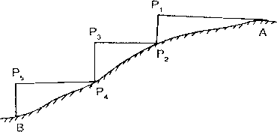

Procedure:
SupposethehorizontaldistancebetweenpointsAandBistobemeasured. The line AB is first ranged properly.
Then,thefollowerholdsthezeroend ofthetapeat A.
TheleaderselectsasuitablelengthAP1sothatP1isatchestheightandAP1 isjusthorizontal. The horizontal is maintained by eye estimation, by tri-square or by wooden set-square.

Thepoint P2is marked onthe ground byplumb-bob sothat P1isjustover P2.
ThehorizontallengthAP1isnotedthenthefollowermovestothepositionP2andholdsthezeroendofthetapeatthat point.
AgaintheleaderselectsasuitablelengthP2P3insuchawaythatP2P3ishorizontalandP3P4vertical. Then the horizontal lengths P2P3and P4P5are measured.
Sothetotalhorizontallength, AB=AP1+P2P3+P4P5

IndirectMethod:
When the slope of the ground surface is long and gentle, the stepping method is not suitable. In such a case, the horizontal distance may be obtained by the indirect methods. Those are of following types.
- Bymeasuringtheslopewith clinometers.
- Byapplyinghypotenusalallowance
- Byknowingthedifferenceoflevelbetweenthepoints.

Measuringslopewithaclinometer:
A clinometers is a graduated semicircular protractor. It consists of two pins P1 and P2 for sighting the object. A plum bob is suspended from point O with a thread. When the straight edge is just horizontal, the thread passes through 00. When the straight edge is tilted, the thread remains vertical, but passes through a graduation on the arc which shows the angle of slope.
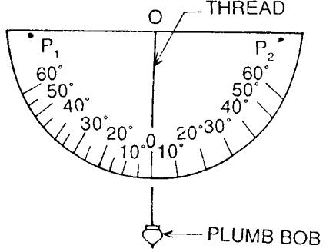

SupposeCandDaretwopointsonslopingground.Tworangingrodsarefixedatthesepoints.Thentwo otherpoints C1 and D1 are marked on the ranging rods so that CC1 = DD1
The clinometers is placed in such a way that its centre just touches the mark C1. The clinometers is then inclined gradually until the points P1, P2, and D1 are in the same straight line. At this position the thread of the clinometerswillshowananglewhichistheangleofslopeoftheground.Supposethisangleisα.Theslopingdistance CD is also measured.
Therequiredhorizontaldistance=CB=lcosα

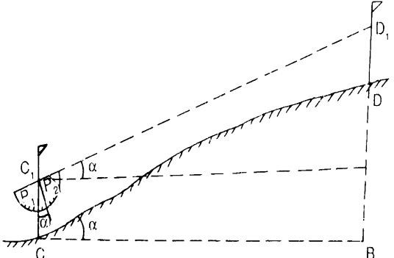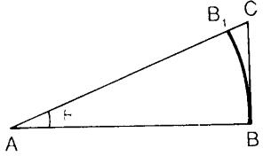

Applyinghypotenusal allowance
In this method , the slope of the ground is first out by using the clinometers. Hypotenusal allowance is thenmade for each tape length.
Let𝜃=angleofslopemeasuredbyclinometers AB = AB1 = 20m = 100 links
AC=ABsec𝜃=100sec𝜃
B1C=AC – AB1
=100 sec𝜃-100
=100(sec𝜃− 1)

Obstacle:
Achainlinemaybeinterruptedthefollowing situations:
- Whenchainingisfree,butvisionisobstructed.
- Whenchainingisobstructed,but visionisfree,and
- Whenchainingandvisionarebothobstructed

Chainingfreebutvision obstructed:
Such a problem arises when a rising ground or a jungle area interrupts the chain line. Here the end stations are not inter-visible.
Case–I
Theendstationsmaybevisiblefromsomeintermediatepointsontherisingground. Inthiscase,reciprocal ranging is resorted to, and the chaining is done by stepping method.
Case–II
Theendstations arenotvisiblefromintermediatepointswhenjunglearecomesacrossthechain line.

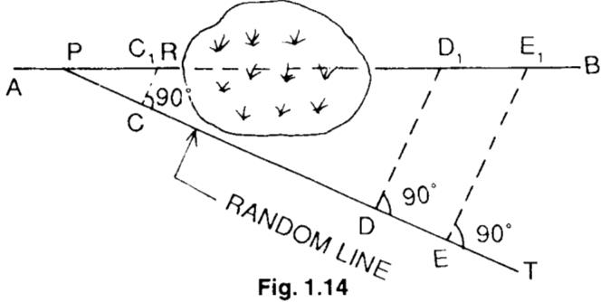

LetABlinebetheactualchainlinewhichcannotberangedandextendedbecauseofinterruptionbyajungle.Letline extended up to R. A point P is selected on the chain line and a random line PT is taken in a suitable direction. Points C,DandEareselectedontherandomlineandperpendicularsareprojectedfromthem.Theperpendicularat Cmeets the line at 𝒄𝟏
Theoretically,
𝐷𝐷1=𝐶𝐶1
𝑃𝐷 𝑃𝐶
𝐷𝐷1=𝐶𝐶1xPD (1)
𝑃𝐶

Againfromtriangle𝑃𝐸𝐸1and𝑃𝐶𝐶1
𝐸𝐸1=𝐶𝐶1
𝑃𝐸 𝑃𝐶
𝐸𝐸1=𝐶𝐶1xPE (2)
𝑃𝐶

Fromeq1and2,thelengths𝑫𝑫𝟏and𝑬𝑬𝟏arecalculated.ThedistanceismeasuredalongtheperpendicularsatDand
E.Points𝑫𝟏and𝑬𝟏shouldlieinthechainlineAB Distance 𝑷𝑬𝟏= √𝑷𝑬𝟐+ 𝑬𝑬𝟐
𝟏

Chainingobstructedbutvisionfree:
Such a problem arises when a pond or river comes across the chain line.The stations may be tackled in thefollowing ways.

Case–I
Whenapondinterrupts thechainline,it ispossibleto goaroundtheobstruction.

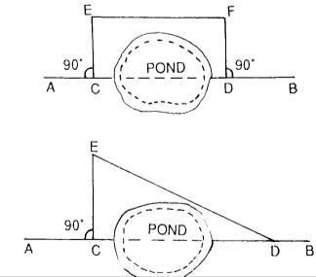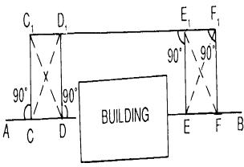

CD=EF

CD=√𝐸𝐷2+𝐶𝐸2

Chainingandvisionbothobstructed:
Suchaproblemariseswhenabuildingcomesacrossthechainline.Itissolvedinthefollowing manner.
Suppose AB is the chain line. Two points C and D are selected on it at one side of the building. Equal perpendicularsCC1andDD1areerected.ThelineC1D1isextendeduntilthebuildingiscrossed.Ontheextended line, two points E1and F1are selected. Then perpendiculars E1E and F1F are so erected that
E1E=F1F=D1D =C1C
Thus,thepointsC,D,EandFwilllieonthesamestraightlineAB Here, DE = D1E1
ThedistanceD1E1ismeasured,andisequaltotherequireddistanceDE.

Problem :
Achain lineABCcrossesariver,B andCbeing onthenear anddistantbanksrespectively.ThelineBM of length 75 m is set out at right angles to the chain line at B. If the bearings of BM and MC are 287⁰ 15’ and 62⁰ 15’ respectively, find the width of the river.

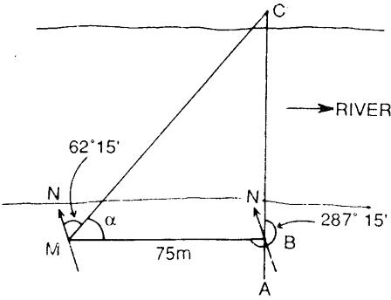
Solution :
<BMC =BBofBM– FBof MC
i.e.𝛼=(287015′−18000′)−62015′=4500′
FromtriangleMBC,=𝑡𝑎𝑛4500′
𝐵𝑀
𝐵𝐶=𝐵𝑀𝑡𝑎𝑛4500′=75𝑚

Sothewidthofriveris75 m.

Definition:
CHAINSURVEYING

Thechainsurveyingisone of themethodoflandsurveying.Itisthesystemof surface inwhichsides

ofdifferenttriangulararemeasureddirectlyinthefieldandnoangularmeasurementaretaken.

PrincipleofChain Surveying:
The principle of chain surveying is triangulation. This means that the area to be surveyed is divided in to a number of small triangles which should be well conditioned. In chain surveying the sides are directly measured by chain or tape.
Chainsurveyingisrecommendedwhen:
- Theground surfaceis moreorlessleveled.
- Asmallareaistobesurveyed.
- Asmall– scalemapistobepreparedand
- Theformationofwellconditionedtrianglesiseasy Chain surveying is unsuitable when:
  - Theareaiscrowded with manydetails.
  - Theareaconsistsoftoomany details.
  - Theareaisvery large.
  - Theformationofwell – conditionedtrianglesbecomesdifficultdueto obstacles.

WellConditioned Triangle:
- Atriangleissaidtobewell–conditionedwhennoangleislessthan300orgreaterthan1200.Anidealtriangle is considered to be best conditioned or ideal triangle.
- 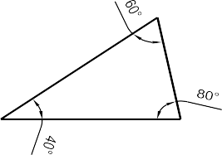Wellconditionedtrianglesarepreferred becausetheir apex pointsarevery sharpand can belocated bysingle ‘dot’.

Well-ConditionedTriangle

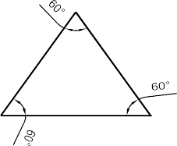

IdealTriangle

ILL–ConditionedTriangle:
  - Atrianglein whichanangleis less than300and greaterthan1200is saidto beill-conditioned triangle.
  - Illconditionedtrianglesarenotusedinchain surveying.
20
0
25
0
Ill-ConditionedTriangle

Accessoriesinchain survey
Thefollowingequipmentsarerequiredforconductingchainsurvey:

1.Metricchain (20 m) | =1 no
2.Arrows | =10 nos
3.Metallictape (15m) | =1 no
4.Ranging rods | =3 nos
5.Offsetrod | =1 no
6.Clinometer | =1 no
7.Plumbbob with thread | =1 no
8.Crossstafforoptical square | =1 no
9.Prismaticcompasswith stand | =1 no
10.Woodenpegs | =10 nos
11.Mallet | =1 no
12.Fieldbook | =1 no
13.Goodpencil | =1 no
14.Pen knife | =1 no
15.Eraser | =1 no

ReconnaissanceSurveyandIndexSketch:

During reconnaissance survey, the surveyor should walk over the area and note the various obstacles and whetherornottheselectedstationsareinter-visible.Themainstationshouldbesoselectedthattheyenclosethewhole area. The surveyor should be take care that the triangles formed are well-conditioned.
Theneathandsketchoftheareawhichispreparedduringreconnaissancesurveyisknownas“indexsketch” or “key plan”. The index sketch shows the skeleton of survey work.

SelectionofSurveyingStations:

Surveystationsarethepointsatthebeginningandtheendingofachainline.Thestationsareclassifiedunder 3 categories
i.e-(a) Main Station
- SubsidiaryStation
- TieStation
- Mainsurveystationattheendofchainlineshouldbeinter-visible.
- Surveylineshouldbeminimumas possible.
- Themainprincipleofsurveyingsuchasworkingfromwholetopartandfrom partto whole.
- Thestationsshouldbewell conditioned triangle.
- Everytriangleshouldbeprovidedwithacheckline.
- Tielineshould beprovided to avoid too longoffsets.
- Obstaclestorangingandchangingifanyshouldbeavoided.
Thelargersideofthetriangleshouldbeplacedparallel totheboundaries,roads,buildings, etc.tohaveshortoffsets.
- Chainlineshouldbelieoverleveled ground.
- Lineshouldbelaidononesideoftheroadto avoiddisturbanceofchainingby passingoftraffic.

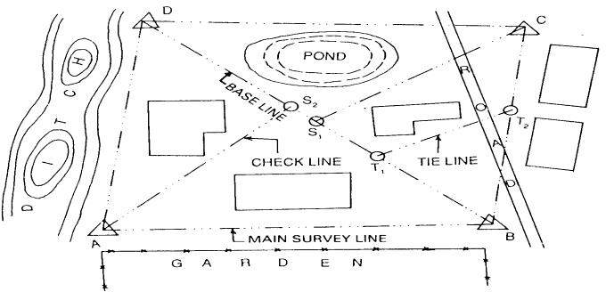

INDEXSKETCH

Baseline:

Thelineonwhichtheframeworkofthesurveyisbuiltisknownasthe“Baseline”.Itisthemost important line of the survey work. Generally, the longest of the main survey line is considered as base line.

Tie line:
Thetielineis alinewhichjoins subsidiarystations onthemain line.

Checkline:
Thelinejoining the apex point oftriangle to some fixed point on its base is knownas check line. It is taken to check the accuracy of the triangle.

Offset:
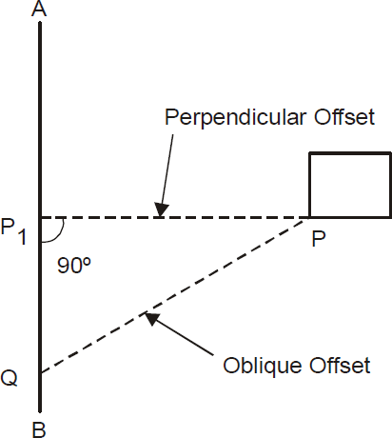
Thelateralmeasurementtakenfromanobjectto the chain line is
knownasoffset.Offsetsaretakentolocateobjectswith reference tothe chain line. They are two types:
  - PerpendicularOffset
  - ObliqueOffset

PerpendicularOffset:
Whenthelateralmeasurementforfixingthedetailpointsaremaidperpendiculartothechainline.The offsets are known as perpendicular offset.

ObliqueOffset:
When the lateral measurement for fixing the detail points are maid at any angle to the chain line. The offsets are known as oblique offset. It can be done by following two(2) process
i.e-
- Longoffset
- Shortoffset

Settingoffsetwithchainandtape(Manualmethods) 3-4-5 Offset
PerpendicularoffsetofchainlineatanypointAisobtainedusingthefollowingmathematicalexpression(3²
+4²=5²). Apoint Bislocatedonchain lineat adistanceof

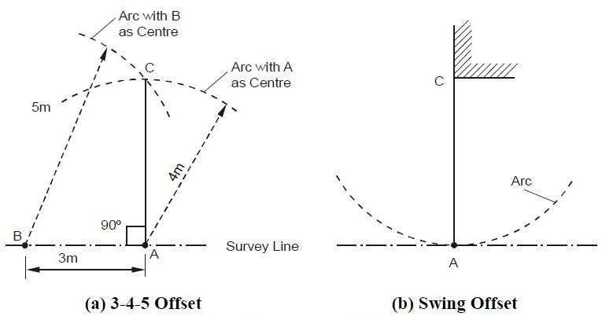
3mfromAsuchthatAB=3m.Next,anarcissetongroundwithcentreatAandradiusequalto4m.Another arc is laid with center at B and radius equal to 5 m intersecting the previous arc at C as shown in Figure (a). Line AC will then be perpendicular to line AB.

SwingOffset
The perpendicular distance of an important feature, e.g. building corner, from the chain line is measured using swing offset method. The zero end of tape is kept at point of interest (Figure (b)) and pointA (i.e. normal from Conchainline)islocatedbyswingingthetapewithCascenter.ThepointAischaracterizedbyapointatwhich the arc generated by swing is tangential to survey line and the distance of C from any point on chain line is minimum.
Itmaybenotedthatusuallyonlysmalloffsetscanbesetbymanual methods.

Optical Square:
- Itisamostsuitableinstrumentforsettingout alineat arightangletoanotherline.
- Itconsistsof a circularmetalbox about5c.m.in diameter and1.25c.m.indeep.Itconsistsof two inclined mirror at an angle of 450.
- Theupperglassisknownashorizontalglassandthelowerendglassisknownasindexglass. Principle:

Ifthetwomirror’sareinclinedwiththesurfaceatanangleof450.Theplaneissuccessfullyreflectedunder deviation of twice the angle.
Uses:
  - Itisused tofind outfootofperpendicularto thechain line.
  - Tosetoutaperpendiculartoachain line.

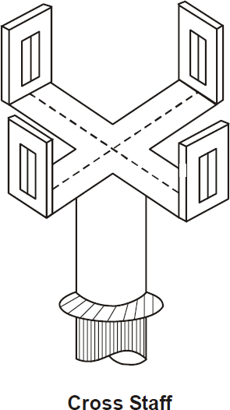
Crossstaff:
Thecross-staffconsistsoffourmetalarmswithverticalslits. Thetwopairsof
armsareatrightanglestoeachother.Theverticalslitsaremeantfor sighting the
rangingrods.Thecross-staffismountedonawoodenpoleoflength 1.5m.anddiameter
2.5c.m. Thepoleis fittedwith an iron shoe.

LimitingLengthofOffset:
The maximum length of the offset should not be more than the length of the tape used in the survey. Generally , the maximum length of offset is limited to 15 m. however, this length also depends upon the following factors:
- Thedesiredaccuracyofthemap
- Thescale ofthemap
- Themaximum allowance deflection oftheoffsetfromitstruedirection
- Thenatureofground

SourcesofErrors:
Errorsmayarisefromthreesources:

Instrumental
Error may arise due to imperfection or faulty adjustment of the instrument with which measurement is being taken. For example, a tape may be too long or an angle measuring instrument may be out of adjustment. Such errors are known as instrumental arrors.

Personal
Error may also arise due to want of perfection of human sight in observing and of touch in manipulating instruments.Forexample,anerrormaybethereintakingthelevelreading orreadinganangleonthecircleof a theodolite. Such errors are known as personal errors.

Natural
Error may also be due to variations in natural phenomena such as temperature, humidity, gravity, wind, refraction, and magnetic declination. If they arenot properly observed while taking measurements, the results

willbeincorrect.Forexampleatapemaybe20metresat20⁰Cbutitslengthwillchangeifthefieldtemperature is different.

Field Book:
- Thebookinwhichthechainortapemeasurementsareenteredorsketchedofdetailpointsarerecordediscalled field book.
- Itssizeis20c.m.X12c.m.
- Thechainline mayberepresentedabout 1.5c.m.to2.0c.m. apart rolleddown themiddleofeach page.
- Thechain lineis started fromthebottomofpageandworkup words.
- Itshouldbewell bounded andasizeofconvenientforthe pocket.
- Alldistancealongthechainlineareenteredeither to theleft ortotherightofthechain line.
- Thenewlineshouldbestartedfromanewfreshpageandnameoflineshouldbenotedatthefootandbooking proceeds from the bottom of the page to up wards.
- At the different feature within the offset are reached, surveyor draw them and enters the chain and length of each offset.
- Fieldbooksmay betwo types
  - SingleLine
  - DoubleLine

Single-LineField Book
Inthistypeoffieldbook,asingleredlineisdrawnthroughthemiddleofeachpage.Thislinerepresentsthechain line and the chainages are written on it. The offsets are recorded with sketches to the left or right of the chain line.

Double-LineFieldBook
In this type of field book, two red lines, 1.5 cm apart, are drawn through the middle of each page. This column represents the chain line, and the chainages arewritten in it. Theoffsets are recorded with sketches to the left or right of this column.

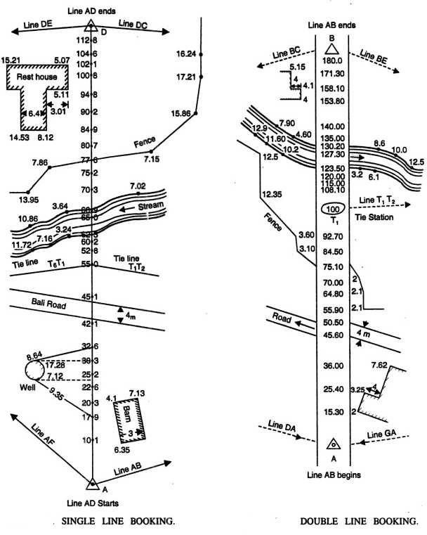

EQUIPMENTSOFPLOTTING:
Followingaretheequipmentsof plotting
- Drawingboard(normalsize–1000 mmX700 mm)
- Tee–Square
- Set–square (450𝑎𝑛𝑑600)
- Protractor
- CardboardScale
- Instrument box
- Drawingsheets

Procedureforplotting:
- Asuitablescaleischosensothattheareacanbeaccommodatedin thespaceavailable inthemap.
- Amargin ofabout 2cm.from theedgeofthesheet is drawnaroundthesheet.
- Thenorthlinemarked on theright-hand corner, and should perfectlybevertical. When it isnotconvenient to have a vertical north line, it may be inclined to accommodate the whole area within the map.

- The framework iscompleted with allsurvey lines,check lines and tie lines.If there is some plotting errorswhich exceeds the permissible limits, the incorrect lines should be resurveyed.
- Theplottingofoffsets shouldbecontinuedaccording tothesequencemaintainedinthefield book.
- Theconventional symbolsareusedin themap shouldbeshownon theright– hand side.
- Thescaleofthemapisdrawnbelow theheading orinsomesuitablespace.Theheading should be writtenon the top of the map.
- Unnecessarylines,objects,etc.shouldbeerased.
- Themapshouldnotcontainany dimensions.

Recommended scalesforsomeofthetypes ofmap couldbe
  - GeographicalMaps:1/25000to1/100000andevensmaller.Atlasmapsandwallmaps could even have smaller scales.
  - TopographicalMaps:1/25000to1/250000showingnaturalandman-madefeaturesand contours.
  - Cadastral or Land Revenue Maps : 1/500 to 1/5000, relatively larger scales showing holdingsofindividuals.Usedfortax/revenuecollectionandforplanningandmanagement.
  - BuildingSites,TownPlanningSchemesetc.:1/5000to1/10000,forbuildingsites larger scale, e.g. 1/1000 can be used.
  - Roads,RailwayLinesorCanalMaps:Longitudinalsectionscanbedrawntoahorizontalscaleof 1/1000to1/20000whileforverticalplotsthescalesare1/100to1/200.Forplottingcrosssections, both horizontal and vertical scales are 1/100 to 1/200.

Itcanbenotedthatonmanymapswithsmallerscales,manyimportantlandfeaturescannotbeplottedtoscale. However, these, being important details, cannot be ignored. Hence, these are represented on map sheet by suitable conventional symbols.

SomeoftheconventionalsymbolsapprovedbyBureauofIndianStandard(BIS)areasshowninFigure.

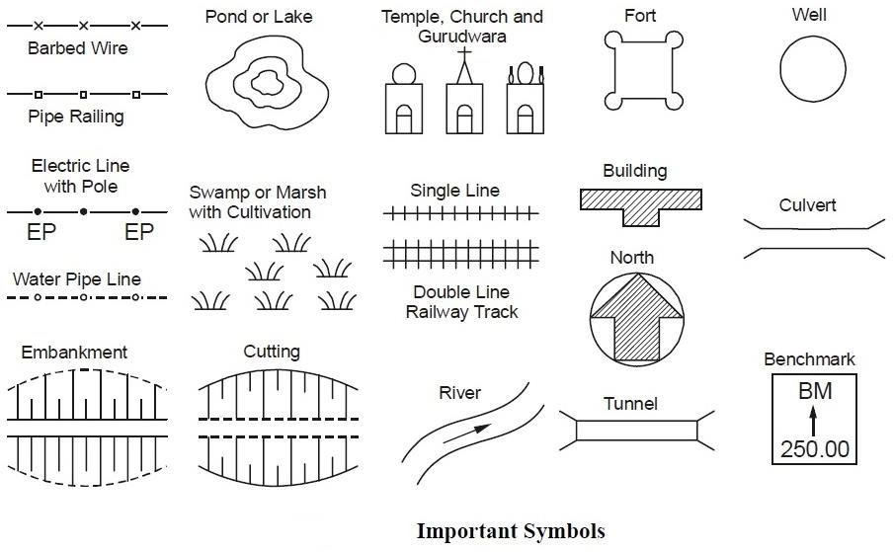
ERRORSINCHAINSURVEYING:
Errorsin chainingmaybecauseddueto variation intemperatureandpull,defects ininstruments, etc. They may be either;
    - Compensating Error
    - CumulativeError

CompensatingError:
Errors which may occur in the both directions (i.e. both positive and negative) and which finally tend to compensateareknownascompensatingerrors.Theyareproportionalto√𝐿 ,where√𝐿 -isthelengthoftheline.Such error may be caused by
- Incorrectholdingfthechain.
- Inaccuratemeasurement ofrightangleswithchain,tape.
- Horizontalityandverticalityofstepsnotbeingproperlymaintainedduringthestepping operations.
- Fractional partsofthechain ortapenot beinguniform throughout itslength

CumulativeError:
Errorswhichmayoccurinthesamedirectionand whichfinallytendto accumulative.Theyseriouslyaffect the accuracy of work, the length of the line (L).
Positive Error: when the measured length is greater than the actual length,(the chain length is too short), the error is said to be positive error. Such error occur due to:
  - Thelengthofchainortapebeing shorterthanthe standard length.
  - Slopecorrectionnotbeingapplied.

  - Correctionforsagnot beingmade.
  - Measurementbeingtakenwithfaultyalignment.
  - Measurementbeingtakeninhighwindswiththetapeinsuspension.
NegativeError:Whenthemeasuredlengthislessthantheactuallength,(thechainlengthistoolong),theerrorissaid to be negative . These errors occur when length of chain or tape is greater than the standard length due the following reasons :
- Theopening ofring joints.
- Theappliedpull being muchgreaterthanthe standard.
- Thetemperatureduringmeasurement beingmuch higherthanstandard.
- Wearingofconnecting rings.
- Elongationofthelinksdueto heavy pull.

PrecautionsagainstError:
Followingaretheprecautionsshouldbetakentoguardagainst errorsandmistakes.
- Thepoint wherethearrowis fixedon thegroundshouldbemarkedwitha cross (X).
- Thezeroendofthechainortapeshouldbeproperly held.
- The chain man should call the measurement loudly and distinctly and the surveyor should repeat them while booking.
- During chaining , the number of arrows carried by the follower and leader should always tally with the total numbers of arrows taken.
- Measurementsshouldnotbetakenwithtapein suspensioninhigh wind.
- Insteppingoperations,horizontalityandverticality shouldbeproperlymaintained.
- Rangingshould bedoneaccurately.
- Nomeasurementshouldbetakenwiththechainin suspension.
- Careshouldbetaken sothatthechainisproperlyextended.
Chapter-3

Angularmeasurementandcompasssurveying

Compass:
Thecompass works on the principle that a freely suspended magnetic needle takes the direction of the magnetic lines of force at a place. This provides us a reference direction with respect to which all angles can be measured.
Therearetwotypes ofcompasses
  - Theprismaticcompass
  - Thesurveyor’scompass.
Thesurveyor’scompass israrelyusedin comparisonpurposes. Theprincipleoftheoperation ofboth the compass is the same but they are made differently used in the field

Theprismaticcompass.

Itisthemostsuitabletypeofsurveyingcompasswhich consistsofacircularboxabout 100 mm in diameter.
Itcanbeusedasahandinstrumentoronatripod.
Itcanbeaccuratelycenteredovergroundstationmarks.
Themainpartsofaprismaticcompassisasfollows

MagneticNeedle:
Themagnetic needle is the most important of the measurement. The needle, generally of theboard form,issupportedonahard,steelpivotwithanagatetip.Whennotinuse,theneedlecanbelifted offthe pivot, by a lifting needle, actuated by the folding of the objective vane. This is done to on sure that the pivot tip is not subjected to undue wear. The magnetic needle should be perfectly symmetrical and balanced at its midpoint on the hard pointed pivot. It should be weighted with an adjustable weight to compensate for the dip angle. The needle should be sensitive and take up the north-south direction speedily. The needle should lie in the same horizontal plane as the pivot point, and a vertical plane should be made in such a way that the centre of gravity of the needle lies as much below the pivot point as possible.

Graduatedring:
An aluminum graduated ring 85 to 110 mm diameter is attached in the needle on its top a diametrical arm of the ring. Aluminum, being a non- magnetic substance, is used to ensure that the ring does not influence the behavior of the needle. The graduation of the ring is from 0 to 360°. 0°/360° is marked on the south end of theneedle and the graduation go in a clockwise direction., with 90°marked on thewest,180onthenorth,and270°ontheeastdirections.Thegraduations aremarkedtohalfdegrees,but it is possible to read the angle as per least count.. Thegraduations on thering areinverted as they areto be read by a prism.

Eyevaneprism:
The point on the prismatic compass from where the straighting is done is known as the eye vane, which is made up of a rectangular frame to the graduated ring when it is folded over the glass plate cover of thecompass. Theprism has convex surfaces, which magnify the graduations on thering. A metal cover is used to cover the reading face of the prism when it is not in use. The prism can be raised or lowered on themetalframeforadjustingtotheeyeoftheobserver.Darkglassesmay beprovidedontheframe,which can be brought in view while shiting bright objects to reduce glare.

Objectvane:
Diametrically opposite the eye vane the object vane, which is a metal frame hinged at the bottom for folding over the glass cover when it is not in use. A fine silk thread or hair is shifted on the frame vertically,whichcanbe usedtobisectaranging rodorthehairidfittedon theframevertically,whichcan be used to bisect a ranging rod or other objects. When the frame is folded over the glass cover, it pressing against a pin, which actuates the lifting lever of the needle and lifts the needle off the pivot. Also fitted belowthisframeontheboxisabrakepin,which,when,gentlypassed,stopstheoscillationoftheneedle

bypressingagainsthegraduatedaluminiumring.Theobjectvanemaybeprovidedwithmirrors,which can be moved over the frame for sighting objects at a height or far below.

CompassBox:
Theneedleandotherfittingsareenclosedina metalboxwithaglasscovertopreventdust.Thetwo
vanes are also attached to the box at diametrically opposite ends. The box is attached to a metal plate through a ball and socket arrangement for leaving the compass. While the compass may also be used by holding it in thehand,itispreferabletouseitwithatripod,forwhichthemetalplatehasascrewedendthatcanbeattached to a tripod. The compass box can be carried in a leather pouch when not in use.

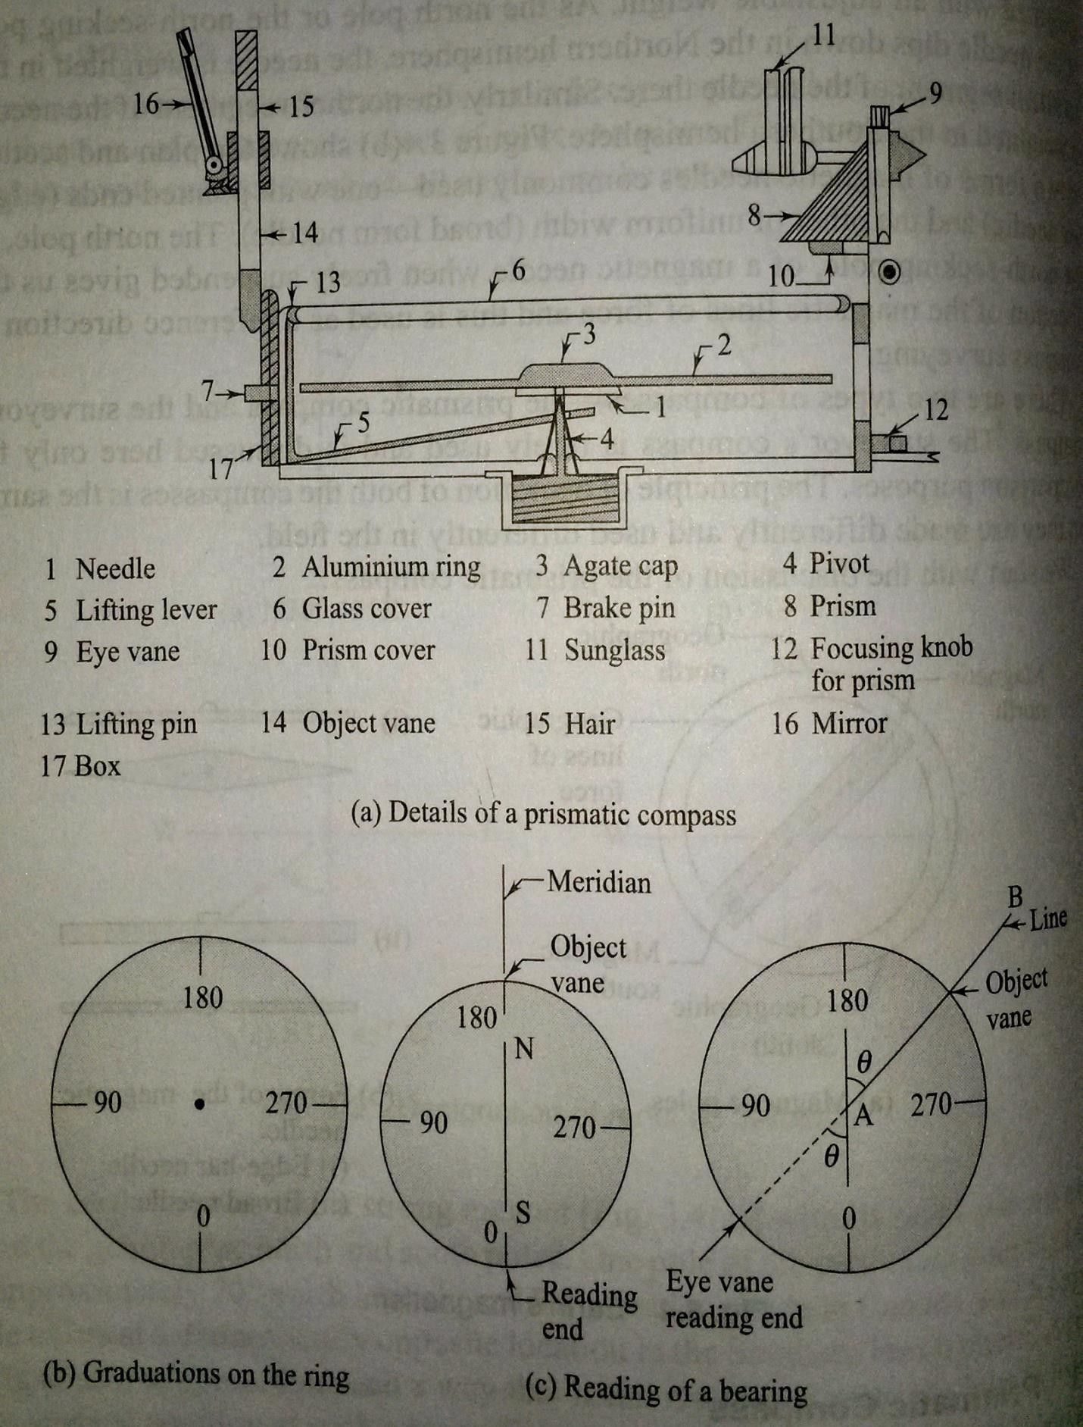

UseofPrismaticCompass:
Thefollowingsteps arerequired in usingprismaticcompass.
  - Settingupandcenteringscrewtheprismaticcompassontothetripodandplacethetripodoverthestation.itis centered over the tripod. Centering is done by adjusting the tripod legs.
  - Level the compass using the ball and socket arrangement. Levelling is done approximately so that the needle can move freely in a plane, after opening the objective and eye vanes.
  - Open the object vane and eye vane see that needle moves freely. Direct the object vane towards the ranging rod or any other objects at the next station. Sighting is done by bisecting the object with the cross hair on the object vane while looking through the eye vane. Theprism of the eye vane has to be adjusted for a clear view of the graduations by moving it up of down. It is clear that the graduated ring along with the attached needle always points to the north direction while the box is rotated with the vanes. The line of straight between the stations is throughthe eye vane and the cross hair of the object vane and should pass through the centreof the pivot.
  - Once the object has been clearly sighted, damp the oscillation of the needle with the breaking pin if required. Oncetheobject has been pin ifrequired. Oncethe needlecomes to rest, looking throughtheprism, recordthe reading at the point on the ring corresponding to the vertical hair seen directly through the slit in the prism holder.

Graduationonring:
It is clear from the graduations that the prismatic compass gives the WCBs of the lines. The reading taken through the prism has to be zero when the lines. The reading taken through the prism has to be zero when the line of sightispointingtothenorth.Thereadingendisthesouthendoftheneedle.Therefore,the zerograduationismarked at the south end .

Temporaryadjustments:
Ateverystationwhereprismaticcompassisplaced,Thefollowingadjustments,asdescribedabove,havetobe made:centeringleveling, and focusingthe prism. Theprismhastobe focusedonceif the samepersonhasto takethe prism.Theprismhastobefocusedonlyonceifthesamepersonhastotakethereadings.Centeringisdonebyadjusting onlythelegstobringthecompassexactlyoverthestation.Levelingisdonetoensurethatasthe compassisrotatedit moves very nearly in a horizontal plane and the needle moves freely.

Surveyor’sCompass

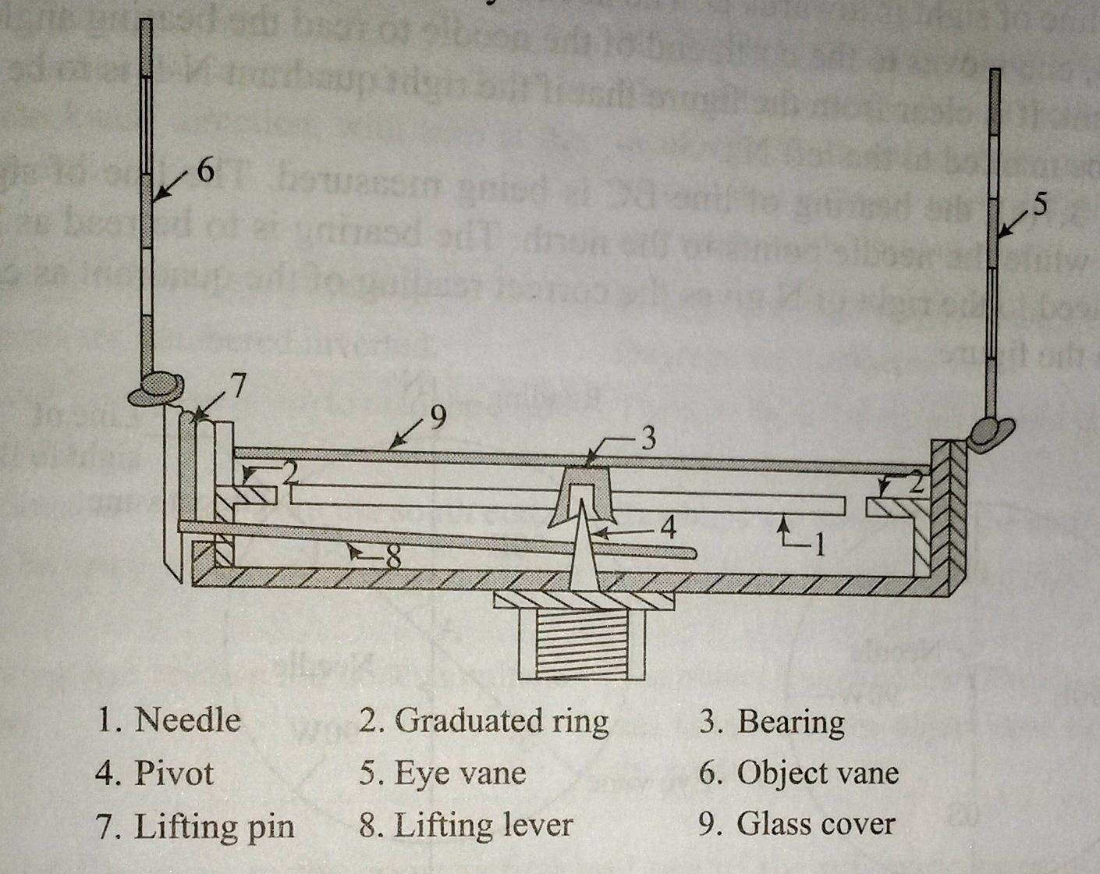

Thesurveyor’scompass isanoldtypeofinstrumentfindingrareusetoday. Abriefdescriptionofthe instrument is given below. The surveyor’s compass has the following components.
Magneticneedle:Theedgebarmagneticneedle restson apivot ofhardmetalandfloats freely.

Graduationring:
Thegraduatedringisnotattachedtotheneedlebuttothecoverboxofthecompassandinsideit.The graduations are in the quadrennial system. The letters N, W, S, and E are marked on the ring along with graduations from 0° to 90° in each quadrant. The graduations are marked to Half-degrees but can be read to one-fourth of a degree by judgement.The E and W half-degrees but can be read in the ring. The moves with the compass as the box is roated for sighting, the needle pointing to the north always.

Objectvaneand eyevane:

Theobjectvaneconsistsofafinethreadorhairfittedontoametalframeforsightingobjects.Theeye vane is a similar frame with a fine slit but has no prism to read the graduations.

Baseand tripod:
Thesurveyor’scompasscannotbeusedwithoutatripod.Abasewithaball andsocketarrangement and a screwing end for the tripod is used.
Anarrangementforliftingtheneedleoffthepivot isprovided.Thisisactuatedwhentheobjectvane is folded onto the cover glass.

Usingsurveyor’scompass:
Thefollowing steps arerequired.
- Attachthecompassbox tothetripod.Placethetripodoverthestationandcentreandleveltheinstrument.
- Rotatetheinstrumenttobringtheobjectvaneinlinewiththerangingrodattheadjacentstation.Looking through the eye vane, finely bisect the ranging rod.
- Note the reading, by going around to the objective vane side, at the north end of the needle by looking throughtheglass.Takethereading alongwiththequadrantbynothingdownthelettersoneithersideofthe reading.

Graduationon ring:
Fig explain the graduations on the ring. N and S are marked along the north-south direction. E and W are markedalongtheeast-westdirectionbuttheirpositionsareinterchanged,withEmarkedtotheleftofNandWtothe right of the N. This is done to ensure that the correct quadrant is noted when the reading is taken at the north end of the needle.
Fig , shows the bearing of line AB being measured. The compass is at A and the line of sight is towards B. The needle points to the north direction. After sighting B, one moves to the north end of the needle to read the bearing angleandthequadrant. It isclearfromthefigurethatiftherightquadrantN-Eistoread,Eshouldbemarkedtothe left N.
In figthebearingoflineBCisbeingmeasured. ThelineofsightisalongBCwhiletheneedlepointstothenorth. The Bearing is to read as N-W, and W placed to the right of N gives the correct reading quadrants as can be seen from the figure.

ComparisonBetweenPrismaticandSurveyor’sCompasses:

Theprismaticcompassandthesurveyor’s compassarebothbasedonthesameprincipleoforientationofamagnetic needle along the north-south direction. Both the instruments measure magnetic bearings.

Differencesbetweenthe prismaticcompassandsurveyor’scompass

Sl no |  | PrismaticCompass | Surveyor’sCompass
1 | Magnetic needle | Ithasabroadneedlebutdoes not act as anindex. | Ithasanedgebarneedleand act as anindex.
2 |  | Thegraduatedringisattached withtheneedle.Thisdoesnot  rotatealongwiththelineof sight. | Thegraduatedringisfixedto theboxandisindependentof needle.
3 |  | The graduations are in W.C.B systemhavingzeroatthesouth end.  Itrangesfrom0°to360°inthe clockwise direction.  Thegraduationsareengraved inverted. | The graduations are in Q.B.systemhaving North andsoutharemarkedwith0° where as east and west are marked with 90°.  Itrangesfrom0to90. East and west are also interchangeable.  Thegraduationsareengraved erect.
 |  | Theeyevanehasaprismtoread  thegraduatedring. | Theeyevanehas no prism  andisnotusedforreading.
 |  | Canbeusedinthehand-held position also | Hastobeusedwithatripod only.
 |  | Sightingandreadingare done  simultaneouslyfromone position of the observer. | Sightingandreadingcannot  donesimultaneouslyfromone position of the observer

Meridians:

Thefixeddirectiononthesurfaceoftheearthwithreferencetowhichbearingsofsurveylinesareexpressed is called as Meridians .

Bearing:
Thehorizontalanglebetweenthereferencemeridianandthesurveylinemeasuredinaclockwisedirectionis call bearing.
Therearefourdifferent typesofmeridianswhichcanbeusedasreference directions.

Truemeridian:
The true or geographic meridian at a point is the line of intersection of a plane passing through the north and south poles and the point with the surface of the earth. Since the earth is approximately a sphere, it is clear that the meridians through different points meet at the north and south poles. The true meridians through different points are not parallel. The true meridian at a place can be established through astronomical observations. The direction of the truemeridianremainconstant.Ifthemagneticbearingofthesunistakenatnoon,thelocationofthetruemeridianat the point can be found. The sun is taken at noon is on a plane passing through the north and south poles at a place.
Thetruebearingofsurveylineisthehorizontalanglethatlinemakeswiththetruemeridianpassingthroughoneof its ends.

Magneticmeridian:
Themagneticmeridianthroughapointonthegroundisthedirectiontaken byafreelysuspendedmagnetic needleplacedatthatpoint.Themagneticmeridiancanbeaffectedbyanyseriousmagneticinterference.Suchasan overhead electric cable or the presence of magnetic substance, such be explained later. The magnetic bearing of a survey line is the horizontal angle compass measures the magnetic bearing of a line.

GridMeridian :
State survey maps are based on one or more true meridians of places so that they placed centrally.The northsouthlinesofthegridareparalleltothelinerepresentingthecentral meridian.Thedirectionofthegridlines along the north-south directin is known as Grid Meridian. The bearing of survey lines referred to and reckoned from grid lines are called Grid Bearing.

Arbitrarymeridian:
Thearbitrarymeridian atapointisanywell-defineddirectionbetweenanytwopoints,suchasthespireofa church, a well-defined point on the ground, or a tower. Such meridians can be used for local surveys as they will

servethepurposeofareferencedirection,and therequired computationsarepossiblewithsuchdata.Thearbitrary bearingofalineisthehorizontalanglebetween thelinedirectionofthedirectionofthearbitrarymeridianthrough one end of the line.

Designation ofBearings:
Thebearing ofsurvey linesaredesignatedinthefollowing systems
- WholeCirclebearingsystem(W.C.B)
- Quadrentalbearingsystem(Q.B)

Wholecirclebearingsystem (WCB):
Inthissystemofbearingofalinemeasuredfromthetruenorthormagneticnorthinclockwise direction. The value of bearing may vary from 0 to 360.It is also known as Azimuthal System.

QuadrentalBearingsystem(WCB):
In this system of bearing of a line measured eastward or westward from the north or south which ever is nearer .In this system both North and South direction are used as referencemeridians.The bearings are measured either clockwise or anticlockwise depending upon the position of the survey line .It is also called Reduced Bearing.

Conversionofbearings:
IftheWCBsaregiven,convertthemtoquadrentalorreducesbearings.Similarly,QBscanalsobe converted to WCBs.

Wholecirclebearingto reduced bearing:
ToconvertWCB(measuredclockwisefromthenorthdirection)toRBs,the followingsimplerules are followed.
(a)IftheWCBislessthan90°,theRBisnumericallyequaltotheWCB.Thequadrant designationisN-E.
- IftheWCBis between90°and 180°,theRBis equalto 180°-WCB.ThequadrantdesignationisS-E.
- IftheWCBis between 180°and270°,theRB isequal toWCB _ 180°.Thequadrantdesignation isS-W.
- Ifthe WCBis between 270°and360°, theequalto360°_WCB. Thequadrant designationis N-W.
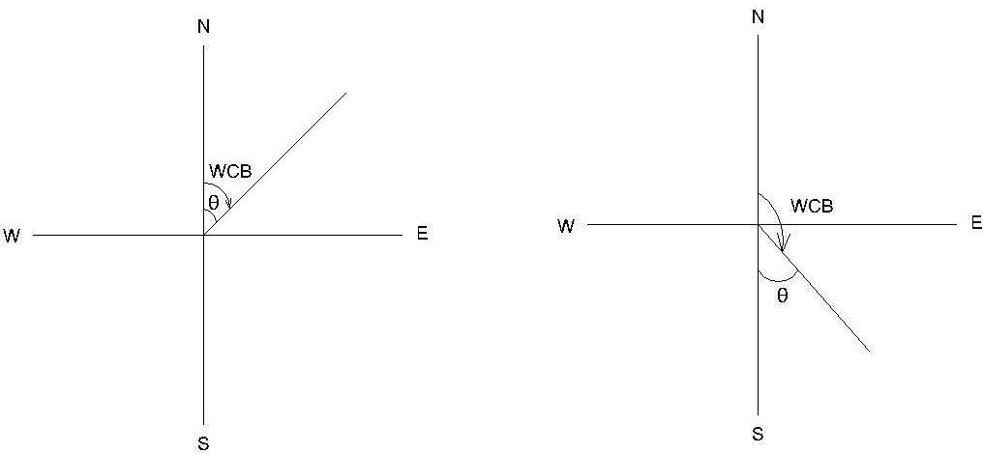

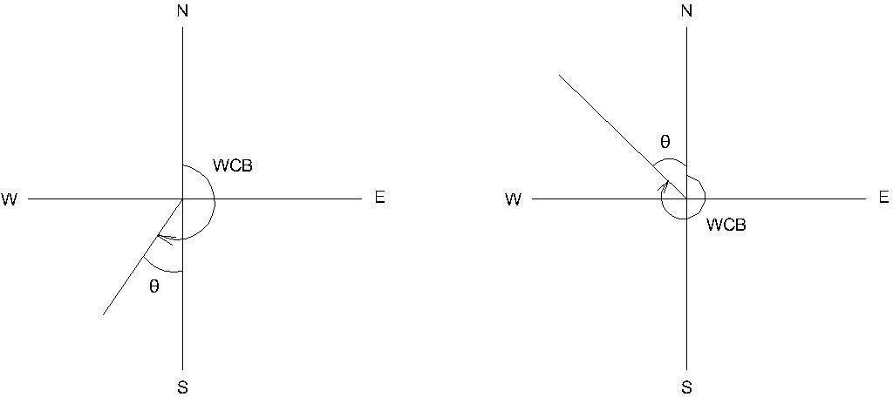

Quadrentalbearingtowholecircle bearing:
ToconvertgivenQBstoWCB,thefollowingsimplerulesaretobefollowed.
  - Ifthequadrantdesignationis N-E,theWCB isnumericallyequaltotheRB.
  - IfthequadrantdesignationisS-E,theWCBisequal to180°-QB.
  - Ifthequadrantdesignation isS-W,theWCB isequalto 180+QB.
  - Ifthequadrantdesignationis N-W,theWCBis equalto360°-QB.

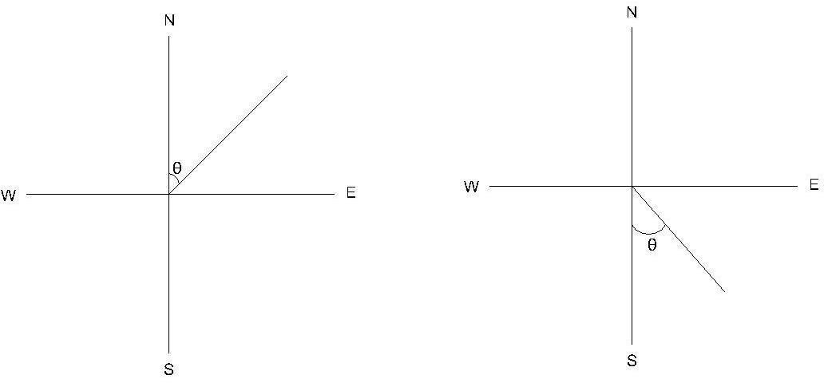

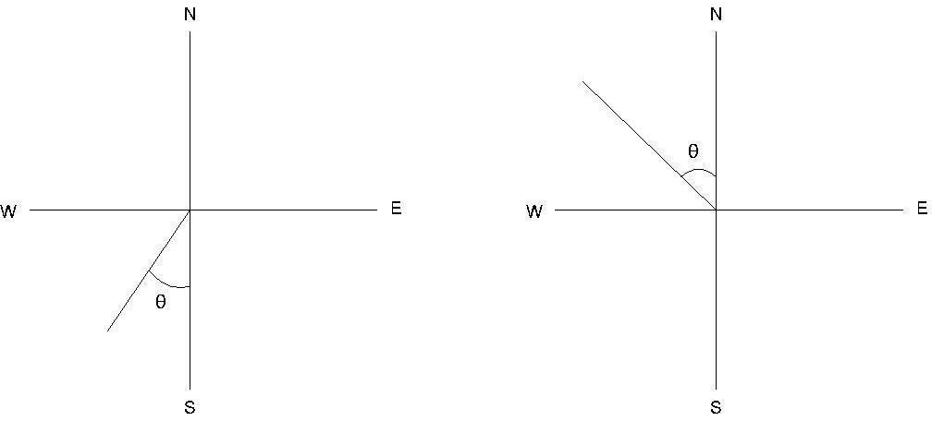

Example:ConvertthefollowingWCBs toRBsand RBstoWCBs.
    - 187°30',48°15', 295°0, 126° 30'
    - N30°30'W,S45°15'E,S38°15'W, N49°30'E.

Sol.:

a)
187°30'ThisliesintheS-Wquadrant.RB==187°30'-180°=S7°30'W 48°15'lies in the N-E quadrant. RB=N 48°15'E
295° 00' , this lies in the N-W quadrant. RB=360°-29°5= N65°00'W 126°30'thisliesintheS-Equadrant.RB=180°-126°30'=S53°30'E

b )
N30°30'W This lies in the N-W quadrant. WCB= 360°00'- 30°30'= 329°30' S45°15'E, This lies in the S-E quadrant. WCB= 180°00'- 45°15' = 134°45' S38°15'W,ThisliesintheS-Wquadrant.WCB=180°00'+S38°15'=218°15' N49°30'E. This lies in the N-E quadrant. WCB = 49°30'

Foreand Back Bearings:
ForeBearing :
Thebearingofalineinthedirectionofprogress ofthesurveyiscalledForeorforwardBearing(FB).

Back Bearings:

Thebearingofalinein theoppositedirectionofprogressofthesurveyis calledBackd Bearing(BB).
TherelationbetweentheFB&BBis

Back Bearing=ForeBearing± 180°
Use+sign ifFB isless than180°&Use-signifFB isgreaterthan 180°
Iftheforebearingisgiven,intheQuadrantalSystem,thebackbearingisequaltotheforebearingbutthe designating letters will be exactly opposite. N will be changed to S and vice versa and E will be changed to W and vice versa.

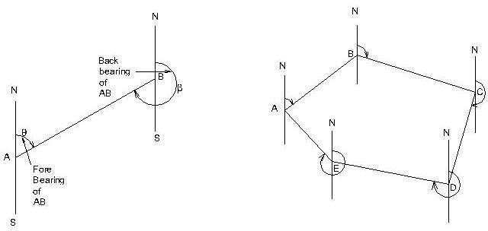

CalculationofIncludedAnglesfrom Bearings
Atthepoint wheretwosurveylinesmeet,two anglesareformed–anexteriorangleandaninteriorangle.
Theinteriorangleorincludedangleisgenerallythesmallerangle(<180°).thedifferenceofbearingoftwoadjacent lines is the included angle measured clockwise from the line whose bearing is less.

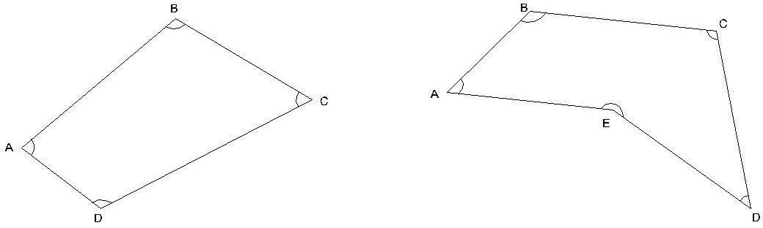

CalculationofBearingsfromIncludedAngles.
In order to calculate the bearing of the next line the following statement may be made. Addtheincludedanglemeasured clockwisetothebearingoftheprevious line.Ifthesumis:
Morethan180⁰,deduct180⁰ More than 540⁰,deduct 540⁰
Lessthan180⁰,add180⁰,toget thebearingofthenext line.

Note:
- Inaclosedtraverseruninanticlockwisedirection, theobservedincludedanglesareinterior angles.
- Inaclosedtraverseruninclockwisedirection,theobservedincludedanglesareexterior angles.

Example:Find theincludedangle betweenlinesABandAC,iftheirreducedbearing are
      - ABN40⁰10'E ACN89⁰45'E
      - ABN10⁰50'E ACS40⁰40'E
      - ABS35⁰45'W ACN45⁰20'E
      - ABN30⁰25'E ACN30⁰25'W
BearingsofAB=N40⁰ 10/E;BearingofAC=N89⁰ 45/E both lineslie in NE quadrant.
IncludedangleBAC=differenceinthebearings = 89⁰45/-40⁰10/=49⁰35/.Ans.
(ii)
BearingofAB=N10⁰50/E;BearingofAC=S40⁰40/E lineslie in adjacent quadrants.
IncludedangleBAC=180⁰–sumofthebearings=180⁰–(10⁰50/+40)^{/=}128⁰30/(iii)
BearingofAB=S35⁰45'W BearingofAC=N45⁰20/E
Thelinesliein opposite quadrants,
Includedangle CAB= 180⁰–(differencein bearings)=180⁰–(45⁰20/-35⁰45/)
=170⁰25/.

(iv)
Bearingof AB = N 30⁰ 25/ E BearingofAC=N30⁰25/W
Thelineslieinadjacentquadrants.
TheIncludedangleCAB =sumofthebearings=30⁰25/+30⁰25/=60⁰50/.

Example2
Thebearingsofthesides ofaclosedtransverseABCDEAareasfollow:
Side F.B. B.B.
AB 107⁰15/ 287⁰15/
BC 22⁰00/ 202⁰00/
CD 281⁰30/ 101⁰30/
DE 181⁰15/ 1⁰15/
EA 124⁰45/ 304⁰45/
Computetheinterioranglesofthetraverseandexercisenecessarychecks., Solution:
- TheincludedangleA=ThedifferenceinbearingsofABandAE. As the bearing of AB is less than of AB, add 360⁰.
IncludedangleA=107⁰15/+360⁰-304⁰45/=162⁰30/.
Theincluded angleatB=Thedifferencein bearings ofBC and BA
=22⁰00/+360⁰-287⁰15/
IncludedangleB=94⁰45/.
Theincluded angleatC=Thedifferencein bearingsofCDand CB
=281⁰30/-202⁰00/=79⁰30/
IncludedangleC=794⁰45/.
Theincluded angleatD=Thedifferencein bearings ofDEand DC
=181⁰15/-101⁰30/=79⁰45/
IncludedangleD=79⁰45/.
Theincluded angleatE=Thedifferencein bearings ofEAand ED
=124⁰45/-1⁰15/=123⁰30/
.IncludedangleE=123⁰30/.Ans. Check :
Sumof theincludedangles ofapentagon
= (2x5-4) = 6 right angles. And,sumoftheincludedanglesA+B+C+D+E
=162⁰30/ +94⁰45/+79⁰30/ + 79⁰45/+123⁰30/
=540⁰00/or6right angles Hence,O.K.

Example
AclosedcompasstraverseABCDwasconductedroundalakeandthefollowingbearingswereobtained. Determine which of the stations aresuffering from local attraction and give the values ofthe corrected bearings:

AB | 74⁰20/ | 256⁰0/
BC | 107⁰20/ | 286⁰20/
CD | 224⁰50/ | 44⁰50/
DA | 306⁰40/ | 126⁰00/
Solution:

OnexaminationtheforeandbackbearingsofCDdifferexactlyby180⁰.Hence,stationsCandDarefree from local attraction.Stations affected by local attraction are A and B.

Calculationofincludedangles:
InteriorangleatA=bearingofAD– bearingofAB
=126⁰00/-.74⁰20/=51⁰40/
ExteriorangleA=360⁰-51⁰40/=308/20/
InteriorangleatB=bearingofBA–bearingofBC 256⁰ 0/- 107⁰ 20/ = 148⁰ 40/
Exteriorangleat B=360⁰-148⁰40/ =211⁰20/

InteriorangleatC =bearingof CB–bearing ofCD
=286⁰20^{/-}224⁰50/ =61⁰30/
ExteriorangleatC=360⁰00^{/-}261⁰30/=298030/
Exteriorangle D =bearing ofDA– bearingofDC
=306⁰40/ -44⁰50/ =261⁰50/
Check:SumofexterioranglesofthequadrilateralABCD (2x4+4) = 12 right angles.O.K.
Totalsumofexteriorangles
=308⁰20/ +211⁰20/+298⁰30/ +261⁰50/
=180⁰=12 right angles.O.K.

Calculation ofbearing:
Bearing of CD 224⁰50/ (given) Add angle at D = + 261⁰50/
Sum=486⁰40/
Sumismorethan 180⁰,subtract =(-)180⁰00/
. Bearing of DA = 306⁰ 40/ Add angle at A =+308⁰20/
=615⁰00/
Sumismorethan 540⁰,subtract =(-)540⁰00/
. Bearing of AB =75⁰00/ Add traverse angle at B + 211⁰20/
Sum=286⁰20/
Sumismorethan 180⁰,subtract-180⁰00/
. BearingofBC =106⁰20/

AddtraverseangleatC +298⁰30/
Sum =404⁰50/
Sum ismorethan180⁰,subtract -180⁰00/
. BearingofCD=224⁰50/checked
Result:Correctedbearingsofthelinesare:
Side | FB | BB
AB | 75⁰00/ | 225⁰0/
BC | 106⁰20/ | 286⁰20/
CD | 224⁰50/ | 44⁰50/
DA | 106⁰40/ | 126⁰40/

Effectofearth’smagnetism:
Theearthbehaveslikea strongmagnetwithitspolesplacedawayfromthegeographicnorthandsouth poles.
One pole of the earth’s magnet is placed at approximately 70° north latitude and 96° west longitude in Canada and similar poleexists at a diametrically opposite location in theSouthern hemisphere. A magnetic needle supported in such a way that it can rotate in a vertical plane will take up a vertical position at such a place. Since one end of a magnetic needle points to the north direction and is designed as the north pole of the needle, it is clear that the imaginarymagnetinsidetheearthhasitssouthpolethere.Thisisbecauseunlikepolesattracteachother.Thenorth pole of a magnet is strictly the north-seeking pole.
Themagnetic lines or forces due to earth’[s magnetism generally go from near the South pole to North pole. Such lines of force are parallel to the surface (horizontally) only near the equator. At other places, as these lines to thepoles,theyaredirectionasthelinesofforces; itwilldip(fromthehorizontal)byasmallangle.Thisisknownas the dip angle. The dip angle increases as we go from the equator to the poles.

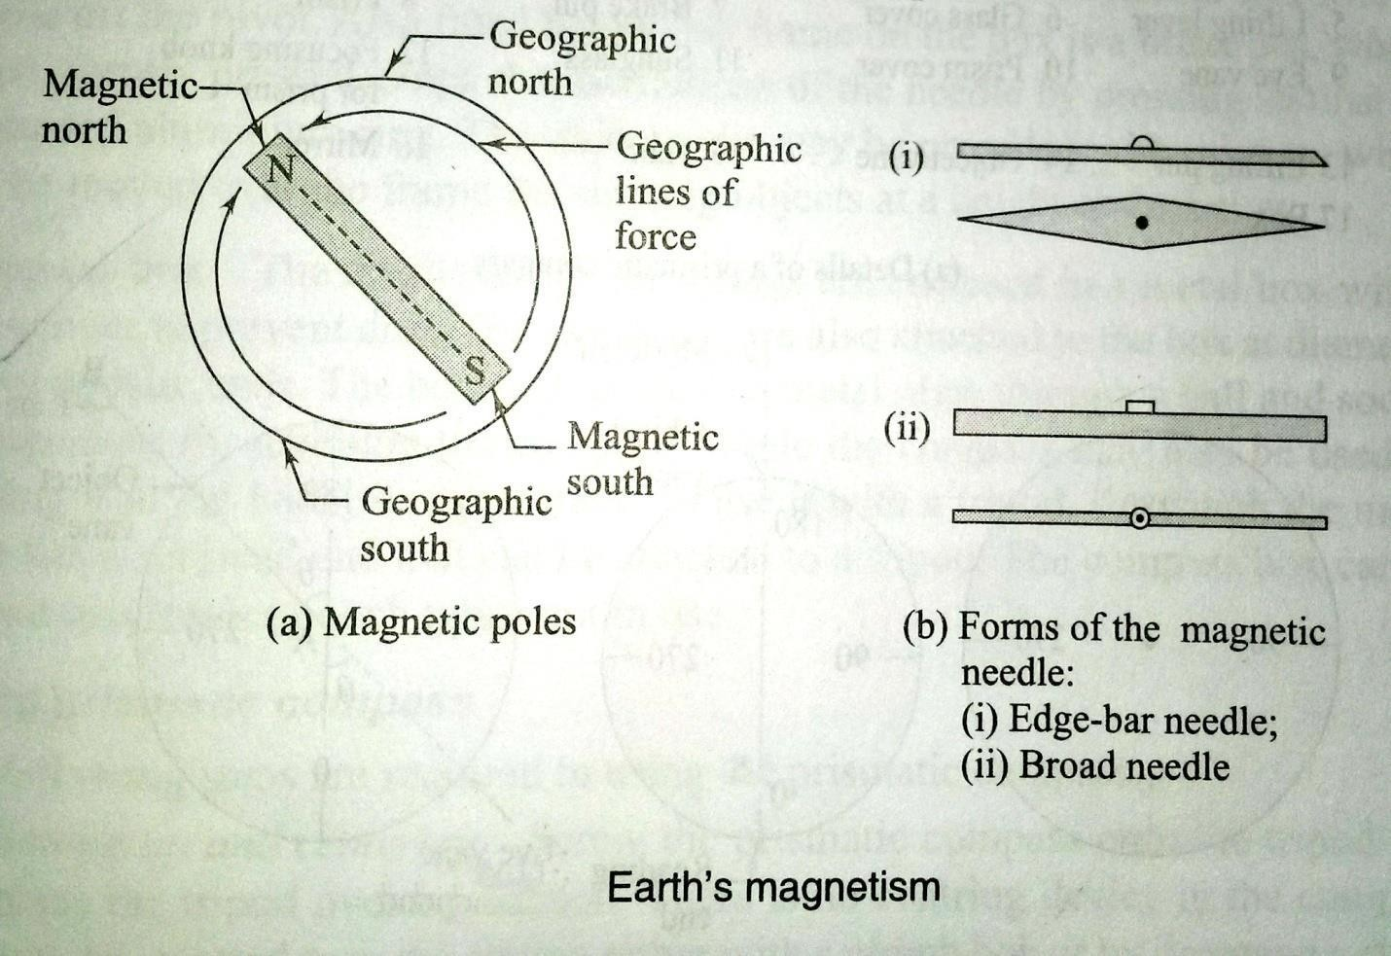

A magnet needle is generally made perfectly symmetrical and supported on a hard, pointed pivot. To make it take up a horizontal position, it is generally weighted with an adjustable weight. As the north pole or the north-seeking pole of the needle dips down in the Northern hemisphere, the needle is weighted in the southern segment of the needle there. Similarly, the northern segment of the needle is weighted in the Southern hemisphere. Shown in the planandsectionoftwofromofmagneticneedlescommonlyused-onewithpointedends(edge-barneedle)andother of uniform width (broad form needle). The north pole, or the north- seeking pole, of a magnetic needle when freely suspended gives us the direction of the magnetic lines of the forces and this is used as a reference in compass surveying.

MagneticDeclination:
- Thehorizontalanglebetweentruenorthandmagneticnorthataplaceatthetimeofobservation,is called magnetic declination.

- Theangleofconvergencebetweenthetruenorthandmagneticnorthat anyplacedoesnotremain constant.
- Itdependsuponthedirectionofthemagneticmeridianatthetimeofobservation.
- Ifthemagneticmeridianisoneasternsideoftruemeridian,theangleofdeclinationissaidtobe eastern declination of positive declination.
- Ontheotherhandifthemagneticmeridianison westernside,thedeclinationissaidtobewestern declination or negative declination is zero.
- Theimaginarylinesjoiningtheplacesofequaldeclinationeitherpositiveornegative,onthesurfaceof the earth, are called “Isogonic lines”.
- Theisogonicslineshavingzerodeclinationareknownas‘Agoniclines’.

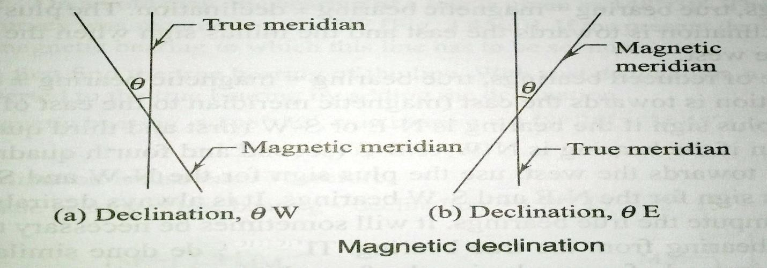

Marinersgenerallycallmagneticdeclinationas‘variation’.

DeterminationofMagneticDeclination:
    - Truemeridians at anumberofplaces in the area, aredetermined by makingastronomical observations (specially to stars).
    - Compassobservationsaremadebysighting thetruemeridians attheplaces
    - Theangleofinclinationbetweentruemeridianandmagneticmeridiangivenbyacompassreading, is the desired magnetic declination at the place.
    - Magneticdeclination=Truebearing–Magneticbearing”.*

Calculation ofTrueBearing.

TrueBearing=Magneticbearing+magneticdeclination, use + ve sign if declination is east
and–vesign,ifit iswest.

CalculationofMagneticBearing.
Magneticbearing =TrueBearing +magneticdeclination,
use–vesignforeasterndeclinationand+vesign forwesterndeclination.

VariationofDeclination
Declination at my place does not remain constant but keeps on changing from time to time. These variations may be classified under four heads viz.
- Seculavariation 2.Annualvariation
3.Diurnalvariation 4.Irregularvariation
- Secular Variation.: The earth magnetic poles are continually changing their positions relatively to the geographical poles. Earth Magnetic meridian also changes and affects the declination of places. Secularvariation is a slow continuous changeand declination ofplaces. Alters in amoreand less regularmannerfromyearto year.Dueto its magnitude, secular variation is the most important for land surveyors. It appears to be of periodic character and follows a sine curve. The swing of declination at a place over a period of centuries, may be compared to a simple harmonic motion. A secular change from year to year is also not uniform for any given place. It is also different for different places. To convert magnetic bearings into true bearings, an accurate amount of declination is essentially required. As such it is very important for a surveyor to know the exact amount of declination. When observations for the declination are made in different years of a century, it is revealed that magnetic meridian moves from one side of true meridian to the other. The change produced annually by secular variation at different places amounts from 0.02 minute to 12 minute. The variation at depends upon the geographical position of different place. The annual secular change is greatestnear the middle point of a complete cycle and least at it extreme limits.

- Annual Variation.: Change in declination at a place over a period of one year, is known as annual variation. Fromtheobservationsmadeatdifferentplacesoveraperiodof12months, itisfoundthatannualvariationisabout1 minute to 2 minutes, depending upon their geographical positions.

- DiurnalVariation.Thedepartureofdeclinationfromitsmeanvalueduringaperiodof24hoursatanyplaceis called diurnal variation. The diurnal variation depends upon the following factors:
  - Thegeographicalpositionoftheplace. Itisgreatestfortheplacesinhigherlatitudesandlessernearthe equator.
  - Seasonoftheyear.Itiscomparatively moreinsummerthaninwinteratthesameplace.
  - Thetime.Itismoreindayandlessat night.
  - Theyearofthecycle.Itisdifferentfordifferentyearsinthecompletecycleofsecularvariation.
(4) Irregular Variation. Abrupt change of declinations at places due to magnetic storms, earthquakes and other solarinfluences,arecalledirregularvariations.Thesedisturbancesmayoccuratanytimeatanyplaceandcannotbe predicted. The displacement of a needle may vary in extent from 1⁰ to 2⁰.

Example.Thetrueand magneticbearingsofalineare78⁰45and75⁰30/respectively.Calculatethemagnetic declination at the place.

Solution.
Magneticdeclination=Truebearing-Magneticbearing
=78⁰45/-75⁰30/
=3⁰15/
Asthesign is+ve, declination iseast oftruemeridian.
.Magneticdeclination=3⁰15/East.

6.5Errorincompasssurveying:
Thefollowingerrorsarecommoninsurveyingwithcompass.

Instrumentalerrors:
Itiscausedbythedefectivepartsoftheinstrument.Theseare

- Theneedlemaynotbestraight,giving wrong readings.
- Thepivotpointmayhavebecomeblunt andthe needlemay notmovefreely.
- Thelineofsightmaynot passthrough thecentreofthegraduatedring.
- Theringmaynotmoveinahorizontalplaneduetothedipoftheneedleasaresultofthewrong adjustment of the balancing weight.
- Thecrosshair in the objectivevane4maynot bestraight ormayhavebecome loose.

Personalerrors:
- Readingthegraduationsinthewrongdirectionorreadingthequadrantswrongly. (b)Improper centering of the compassover the station.
(c)Notlevelingthecompassproperly.
(d)Notbisectingthesignalatastationproperly.

Othererrors:
- Variationindeclinationduringtheday,whenthesurveyiscarriedoutover alongdurationduringthe day
- Localattractionduetotheproximityofexternalmagneticinfluencesatoneormorestations
- Othervariationsduetomagneticstorms, cloudcover,etc,whichaffectthemagneticneedle.
.

PRECAUTIONSTOBETAKENINCOMPASSSURVEY
Theinstrumentalandobservationalerrorsduringacompasssurveymaybeminimizedbytakingthe following precautions:
  - Setupandlevelthecompasscarefully.
  - Stopthevibrations oftheneedlebygentlypressing thebrake-pinsothatitmaycometorest soon.
  - Alwayslookalong theneedleand notacrossit,toavoid parallax.
  - Whentheinstrumentisnotinuse,itsmagneticneedleshouldbekeptoffthepivot.Ifitisnotdone,thepivot is subjected to unnecessary wear which may cause sluggishness of the magnetic needle.
  - Beforetakingareading,thecompassboxshouldbegentlytappedtoensurethatthemagneticneedleis freely swinging and has not come to rest due to friction of the pivot.
  - Stationsshouldbeselectedsuchthat theseareaway fromthesourcesoflocalattraction.
  - Surveyorshouldnevercarry ironarticles,suchasabunchofkeyswhich maycauselocal attraction.

  - Fore and back bearings of each line should be taken to guard against the local attraction. If the compass is not be set at the end of a line, the bearings may be taken from any intermediate point along that line.
  - Twosetsofreadingsshouldbetakenateachstationforimportantdetailsbydisplacingthemagneticneedle after taking one reading.
  - Avoidtakingareading inwrongdirectionviz. 25⁰to20⁰instead20⁰to25⁰and so.
  - If the glass cover has been dusted with a handkerchief, the glass gets charged with electrostatic current and the needle adheres to the glass cover .This may be obviated by applying a moist finger to the glass.
  - Objectvaneand eyevanemust bestraightened beforemaking observations.

MAINTENANCEOFPRISMATICCOMPAS:
The Prismatic compass is a fine instrument that is easy to set up and use. It is ideally suited for rough, speedy survey work. Thefollowing points areimportant formaintaining thecompass in good condition. Thecompass comes in a leather cover. The compass should be kept in its cover when not in use.
- The compass should be tested frequently, before using it for surveying. Check regularly to see whether the magnetic needle is freely moving or sluggish.
- Set up the compass at a point and take the bearing of a line connecting to a well-defined object. Rotate the compass and immediately bring it back to the same point, bisect and take the reading. The reading should be the same. If not, the needle is not moving properly due to a blunt pivot.
- Checkwhethertheneedle(orthegraduatedring)movesin ahorizontal plane
- Keeptheinstrumentfree ofdustandcleantheglasscoverwithafinecloth.

.

COMPASSSURVEYING
6.1Principleoftraversing
A series of connected straight line each joining two points on the ground is called a traverse. End pointsareknownastraversestationsandstraightlinesbetweentwoconsecutivestationsarecalledtraverse legs.
Traversemaybeeither aclosedtraverseoran open traverse.

ClosedTraverse:
Atraversewhicheitheroriginatefromastationand closesonsamestationorrunsbetweentwostationwhose co ordinates are known in terms of a common system of co ordinates is known as closed traverse. In closed traverse accuracy of linear as well as angular measurements may be known.

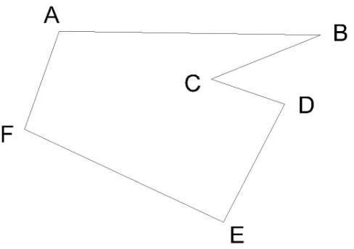

ClosedTraverse

OpenTraverse:
A traverse which neither returnsto its starting station nor ends on another known station is known as opentraverse .In open traverse accuracy of linear as well as angular measurement may not be checked.
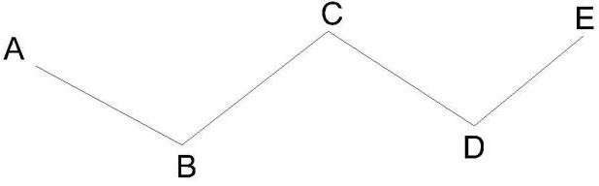
OpenTraverse

DifferencebetweenChainsurveyAndCompassSurvey
Chainsurveyispreferredtoiftheareatobesurveyedissmallinextentandhigheraccuracyisaimedatwhere as if the area is comparatively large with undulation and less accuracy is required, compass surveyis adopted.

LocalAttraction:
Northendofafreelysuspendedmagneticneedlealwayspointstothemagneticnorth,ifnotinfluencedby any other external forces except the earth’s magnetic field.
Themagneticneedlegetsdeflectedfromitsnormalposition,ifplacednearmagneticrocks,ironorescables etc. sucha disturbing force is known as local attraction.

Detectionoflocalattraction:
Thepresenceoflocalattractionatanystationmaybedetectedbyobservingtheforeandbackbearingsofthe line. If the difference between fore and back bearing is 180⁰,both end stations are free from local attraction. If not, the discrepancy may be due to:
(1)Anerror inobservationofeitherforeorbackbearingsorboth.
    - Presenceoflocalattractionateitherstation.

    - Presenceoflocalattraction atboththe stations.
Thecorrection tootherstations may bemadeaccording to thefollowing methods.
- Bycalculatingtheincludedanglesattheaffected stations
- By calculating the local attraction of each station and then applying the required corrections starting from the unaffected bearing.

Methodofeliminationoflocalattraction byinclosed:
  - Computetheincludedanglesateachstationfromtheobservedbearing,incaseofaclosed traverse.
  - Startingfromtheunaffectedlinerundownthecorrectbearingofthesuccessivesides.

Methodofeliminationoflocalattraction byapplying correctionstobearingin closed :
Followingstepsarefollowed
- Calculatethemagnitudeanddirectionoftheerror duetolocalattractionateachaffectedstation
- Rundownbearingstartingfromthebearingunaffectedbylocalattraction.

MethodsofPlottingofTraverse:
Before plotting of traverse survey it should be checked whether the observed bearing are correct. If not the required correction to each bearing may be made so that the traverse will perfect in the geometrical figure based on field data.
Thetraversemay beplotted by oneof the method
- By Parallel Meridians; Afterdeciding the layout of the traverse a line representing the magnetic meridian through thelocationofthestation isdrawnonthepaper.ThebearingofthelineABisplottedwiththeordinaryprotractorand its length duly reduced to scale, is marked off to get the location of station A is drawn . The bearing of BC is plotted andlengthBCisplottedtoscale.Theprocessiscontinuedtilllaststationisplotted.Inaclosetraverselastlineshould beendonthestartingstationA.Incaseofaclosedcircuitoratanyotherknownstationincaseoflinearclosedtraverse. If dose not the distance between two locations of the same station is termed as closing error.

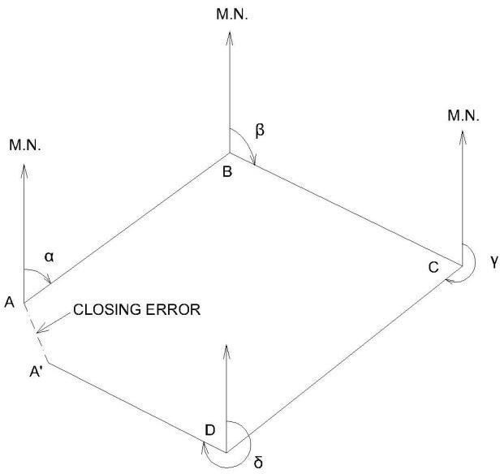

ByIncludedAngles;
AfterdecidingthelocationofthestationAonthepaperdrawalinetorepresentthemagneticmeridianpassing through A . Plot themagnetic bearing of the chain line AB and plot AB duly reduced to scale. Now plot the included angleABCby aprotractorandplotthe locationofstationC.Theprocessiscontinuedtillallthestationareplotted. It maybenotedthatforaclosedtraverseiflinearmeasurementbetweenstationsarecorrectandplottingiserrorlessthe closingstationwillcoincidewiththestationA.Ifnotthedistancebetweentwolocationofthestartingstationisknown as closing error.

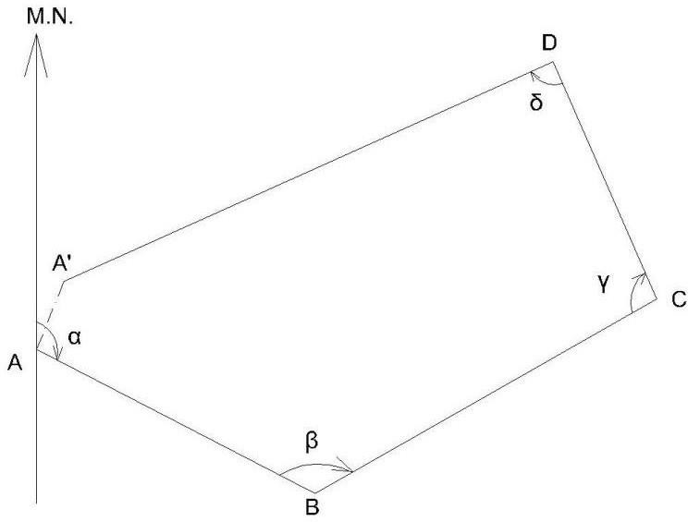

PlottingBy tangents.
Defectionanglesofthechainlinesareplottedbygeaometryconstriuctionwiththehelpoftheirnatural tangents. The traverse may be plotted as followed.
From the location of the starting station A draw a line passing through A to represent its magnetic meridian .To draw the bearing of traverse leg AB cut a length of10 cm on themagnetic meridians ofstationAatB1.AtB1erectaperpendicularB1B2onthepropersideofthemeridian.TakeB1B2 equalto10 x tangent of the reduced bearing i,e angle of deflection of the line AB in centimeter.
JoinAB2andproduceittogetthedirectionoftraverselineABplotlengthofABonthelineAB2toadesired scale.

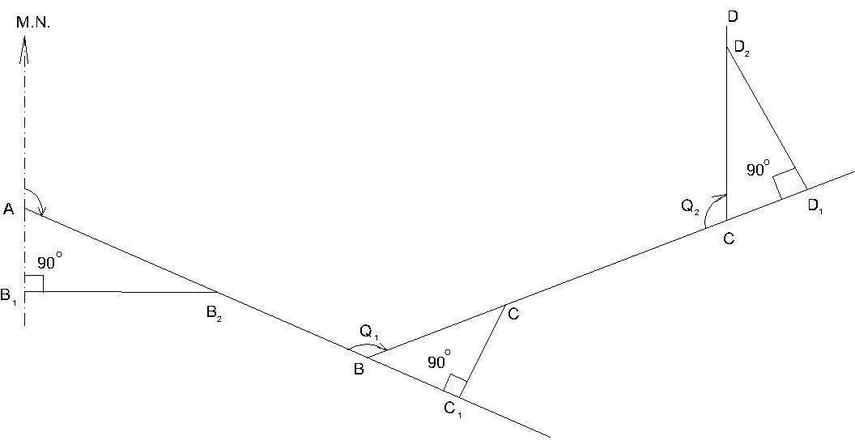

TheDeflectionanglesofthesuccessive chainlinesforthepurposeofplottingareobtained bythefollowing
formulae.
- Iftheincludedanglebetweenadjacentlinesisbetween0°and 90°,deflectionangleisequalto the
includedangle.
- Iftheincludedangleisbetween90°and180°,subtractthegivenincludedanglefrom 180° to get the deflection angle.
- Iftheincludedangleisbetween180°and270°,subtract180°fromthegivenincluded angle.
- Iftheincludedangleisbetween270°and360°,subtractthegivenincludedanglefrom 360° to get the deflection angle.
Continuetheprocess tillallthetraverselegsareplotted.

AdjustmentofClosingError:

When a closed traverse is plotted from the field measurements, the end station of a traverse generally does not coincide exactly with its starting station. This discrepancy is due to the errors in the field observations i.e. magneticbearingsandlineardistances.Suchanerrorofthetraverseisknownasclosingerrororerrorofclosure.

Whentheangularandlinearmeasurementsareofequalprecision,graphical adjustmentofthetraversemaybe made. This method is based on the Bowditch’s rule. Corrections are applied to lengths as well as to bearings of the lines in proportion to their lengths. Graphical method is also sometimes known as proportionate method of adjustment.

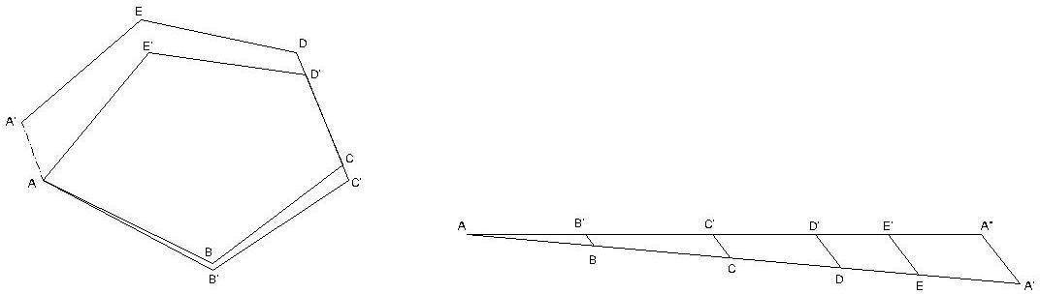

Method.Theadjustment ofacompass traversegraphically,may bemadeasfollow:

Let ABCDEA’ be a closed traverse as plotted from the observed magnetic bearings and linear measurements of the traverse legs. A is thestarting station and A’ is the location of the station A as plotted. Hence, A’A is the closing error.

Adjustment.Followingproceduremaybeadopt.

- 1Drawastraight lineAA’equal totheperimeterofthetraversetoanysuitable scale.
- SetoffthedistancesAB,BC,CD,DE,and EA’equal tothelengthsofthesidesofthetraverse.
- DrawA’A”parallel andequaltotheclosingerrorA’A.
- DrawparallellinesthroughpointsB,C,D,andEtomeetAA”atB’,C’D’andE’.
- DrawparallellinesthroughtheplottedstationsB,C,D,EandplottheerrorsequaltoBB’,CC’,DD’inthe direction of A’A’.
- JointhepointsAB’C’D’E’Atogettheadjustedtraverse.

Errorinchainandcompasssurveying:

ErrorsinChaining:-

- Incorrectlengthofchain
- Incorrectranging
- LooseChain
- Temperaturechange
- Variationinpull
- Errorsinslopemeasurement
- Incorrectmarking
- Personalmistake

Thefollowingerrorsarecommoninsurveyingwithcompass.

Instrumentalerrors:
Itiscausedbythedefectivepartsof theinstrument.Theseare
- Theneedlemaynot bestraight, givingwrong readings.
- Thepivotpoint mayhavebecomeblunt and the needlemay not movefreely.
- Thelineofsightmaynot passthrough thecentreofthegraduatedring.
- Theringmaynotmoveinahorizontalplaneduetothedipoftheneedleasaresultofthewrong adjustment of the balancing weight.
- Thecrosshair intheobjectivevane4 maynot bestraight ormay havebecome loose.

Personalerrors:
- Readingthegraduationsinthewrongdirectionorreadingthequadrantswrongly. (b)Improper centering of the compassover the station.
(c)Notlevelingthecompassproperly.
(d)Notbisectingthesignalatastationproperly.

Othererrors:
- Variationindeclinationduringtheday,whenthesurveyis carriedoutover alongdurationduringtheday
- Localattractionduetotheproximityofexternalmagneticinfluencesatone ormorestations

- Othervariationsduetomagneticstorms, cloudcover,etc,whichaffect themagneticneedle.

PRECAUTIONSTOBETAKENINCOMPASSSURVEY
Theinstrumentalandobservationalerrorsduringacompasssurvey,maybeminimizedbytakingthe following precautions:
  - Setupandlevelthecompasscarefully.
  - Stopthevibrations oftheneedlebygentlypressing thebrake-pinsothatitmaycometorest soon.
  - Alwayslookalong theneedleand notacrossit,toavoid parallax.
  - Whentheinstrumentisnotinuse,itsmagneticneedleshouldbekeptoffthepivot.Ifitisnotdone,thepivot is subjected to unnecessary wear which may cause sluggishness of the magnetic needle.
  - Before taking a reading,the compass box should be gently tapped to ensure that the magnetic needle isfreely swinging and has not come to rest due to friction of the pivot.
  - Stationsshouldbeselectedsuchthat theseareaway fromthesourcesoflocalattraction.
  - Surveyorshouldnevercarry ironarticles,suchasabunchofkeyswhich maycauselocal attraction.
  - Fore and back bearings of each line should be taken to guard against the local attraction .If the compass is not be set at the end of a line, the bearings may be taken from any intermediate point along that line.
  - Twosetsofreadingsshouldbetakenateachstationforimportantdetailsbydisplacingthemagneticneedle after taking one reading.
  - Avoidtakingareading inwrongdirectionviz. 25⁰to20⁰instead20⁰to25⁰and so.
  - Iftheglasscoverhasbeendustedwithahandkerchief,theglassgetschargedwithelectrostaticcurrentand the needle adheres to the glass cover .This may be obviated by applying a moist finger to the glass.
  - Objectvaneand eyevanemustbestraightened beforemaking observations.

MapReading CadastralMapsandNomenclature
Whatisa map?
Amapisrepresentationofselectednaturalandmanmadefeaturesofthewholeor part of the earth's surface on a flat sheet of paper on a definite scale and in their correct relative geographic positions and elevations.
Whatisconventionalsign?
Conventionalsignsaresymbolsusedtorepresentcertainartificialornatural features/ objects on the map. They are seldom drawn to scale.
Whatisscale?
Byscaleitmeanstheproportionwhichthedistancebetweentwopointsonthemap bears to the distance between the same two points on the ground.
Defineimportanttechnicaltermsusedinmapreading?
- Bearing-TheangleformedbyalinejoiningtwopointsandtheNorth and South line. Bearings are always measured clockwise.
- BenchMark-Apermanentmarkusuallycutintoawallrecordingexact

heightforfuturereference,markedBMwiththeheightonOrdnanceSurvey Maps.
- Contours -Alinedrawnonthemapjoiningupallpointsofequalheight above
sealevel.
- Gradient-Theslopeofahillexpressedasa fraction.
- GridLines-LinesrunningparalleltoandatrightanglestoaNorthandSouth line through approximately the centre of the area covered by the grid system.
- GridNorth-Exceptthroughtheorigin,gridlinesdonotlietrueNorthand South or East and West, Grid North is the direction of the North South grid lines on a map.
- Magnetic-ThedifferencebetweentrueNorth&MagneticVariationNorth.
- Setting -PlacingamapsothatNorthonthemappointstowardtheNorth so that the objects on the map are placed in relationship to the same objects on the ground.
- Trig Point - A point fixed during the triangulation at the beginning of a survey,markedonOrdanceSurveyMapsbyasmalltrianglewiththeheight.
- TrueNorth-ThedirectionoftheNorthPolefromthepoint. Define important Topographical terms used in map reading?
- Basin- Anareaoffairlylevelgroundsurroundedbyhillsortheareadrained by a river and its distributaries.
- ColorSaddle -Anarrow ridgeofhigh landjoininguptohigerhills.
- Crest-Thehighestpartofahillormountainrange.Itisthat lineonarange of hills or mountains from which the ground slopes down in opposite directions.
2
- DeadGround-Groundwhichbyreasonofundulationsorhillsisnotvisible to the observer.
- Defile-Anyfeaturewhethernaturalorartificialwhich couldcauseabodyof troops to contract its front. An example of a natural defile is mountain pass while a bridge is an example of an artificial defile.
- Escarpment-Thesteephillsideformedbyasuddendropinthegeneral ground level usually from a plateau.
- Knoll-Asmallisolatedhill.
- Plateau-Atableland,anelevatedregionofconsiderableextentgenerally fairly level.
- Ridge- Thelinealongahillorrangeofhillsormountainsfromwhichwater flows in opposite directions, a divide, sometimes and the crest of a line of
hillsasitappearsalongthehorizon.
- Watershed-Thelineseparatingthewaterflowingintotwodifferentriver

systems,theedgeofariverbasin. Define grid line?
Amapiscoveredwithanetworkof purplelines,somerunningNorthandSouthand other West and East. These form a series of small squares all over the map. These lines are known as 'Grid Lines'.
Whatarethebasicrulesforgivinggrid reference?
- Areferencemustalwayscontainanevennumberoffigures.Inthenormal method, it will contain six figures.
- AlwayscountalongtheEASTINGlinesfirstfromWESTtoEASTandthen from
SOUTHtoNORTH,alongNORTHINGS.
- Forthesixfiguresreference,thethirdandthesixthfigurerepresentthe divisions of 1000 yards square to the nearest 10th part, so they have to be estimated and for these figures slight latitude is allowed.
- Ifageneralgridreferenceistobegivenorthereisonlyonesuchobjectin one
squaree.g.bridge,temple,road,junction,thenafourfiguregridreference would suffice.
WhatarevarioustypesofNorth?
- TrueNorth-ThedirectionofNorthpolefromthe observer.
- MagneticNorth-Itisthepointtowhichanaccuratecompassneedlepoints, when freely suspended.
- GridNorth-ItisthedirectiontowhichtheNorthSouthgridlinesonamap point.
Definevarioustypesof bearings?
- Bearing-Theclockwiseangleformedbyastraightlinejoiningtwopoints and direction of NORTH, is called the bearing between the two points. A bearing is always measured clockwise.
3
- GridBearing.MeasuredonthemapfromtheGridNorthbythehelpofa protractor.
- MagneticBearing.MeasuredfromMagneticNorthbythecompass.
- TrueBearing.CalculatedbyfindingouttherelationoftrueNORTHandGrid Cadastral map:
Cadastral maps are generally regarded as anessential part of the land management infrastructure in mostcountries yet there is often misunderstanding about their characteristicsandrole.Duetothevastrangeofdifferentcadastralsystemsandresulting cadastral maps, it is very difficult to describe a"typical" cadastralmap.It is the authors' view that it is also very

PlaneTable Survey
Definition:-
Aplanetableisadeviceusedinsurveyingandrelateddisciplinestoprovideasolidandlevelsurfaceon which to make field drawings, charts and maps. The early use of the name plain table reflected its simplicity and plainness rather than its flatness.

Objectives:-

  - Itissuitableforlocationofdetailsaswell ascontouringforlargescalemaps directlyinthefield.
  - Assurveyingandplottingaredonesimultaneouslyinthefield,chancesofgettingomissionofany detailget less.
  - Theplottingdetailscanimmediatelygetcomparedwiththeactualobjectspresentinthefield.Thuserrorsas well as accuracy of the plot can be ascertained as the work progresses in the field.
  - Contoursandspecificfeaturescanberepresentedandcheckedconvenientlyasthewholeareaisinviewat the time of plotting.
  - Onlyrelevantdetailsarelocatedbecausethemapisdrawnasthesurveyprogresses.Irrelevantdetailsget omitted in the field itself.
  - Theplanetablesurveyisgenerally morerapid andlesscostlythanmostothertypesof survey.
  - Astheinstrumentsusedaresimple,notmuchskillforoperationofinstrumentsisrequired.Thismethodof survey requires no field book.

Disadvantage:-

  - Theplanetablesurvey isnot possiblein unfavorableclimatessuchasrain,fog etc.
  - Thismethodofsurvey isnotvery accurateandthusunsuitableforlargescaleorprecise work.
  - Asnofieldbookismaintained,plottingatdifferentscalerequirefullexercise.
  - Themethodrequireslargeamount oftimeto bespent inthe field.
  - Qualityofthefinalmapdependslargelyonthedrafting capabilityofthesurveyor.
  - Thismethodiseffectiveinrelativelyopencountry wherestationscanbesighted easily

Principle:-

TheprincipleofplanetablesurveyisParallelism ,Itmeansthattheraydrawnfromstationtoobjectsonthe paper are parallel to the lines from the station to the objects on the ground.

Accessoriesofplanetable:-

- Planetable

- Alidade

- TheSpirit level

- Thecompass

- TheU–Forkor plumbingFork withplum bob

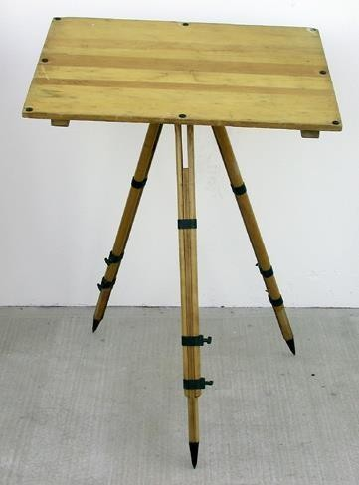
- The PlaneTable:-
  - Theplanetableisadrwingboardofsize750mmX600mm made of well seasoned wood like Teak, pine,etc.
  - Thetopsurfaceofthe tableiswelllevelled .
  - Thebottomsurfaceconsistsofathreadedcircularplatefor fixing the table with the tripod stand by a wing nut.
  - Theplanetableis meantfor fixing theadrawing sheetoverit.
  - Thepositionoftheobjectsarelocatedonthissheetbydrawing raysand plotting to any suitable scale.

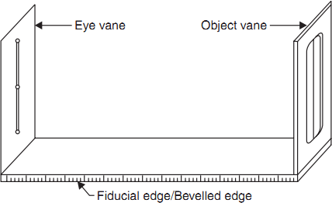
- Alidade:-
Therearetwotypesofalidade–Plainandtelescopic aldade.
- Plainalidade:-theplainalidadeconsistsofametalor wooden ruler of length about 50cm. one of its edge is
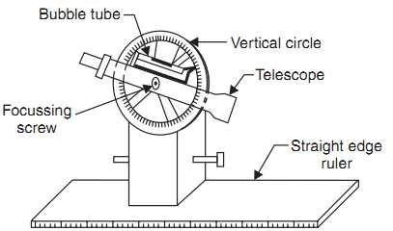
beveled,andisknownasfiducialedge.It consistsoftwovanesatbothendswhicharehingedwiththeruler.Oneis known as object vane and the other is known as sight vane.

- Telescopic alidade:-The telescopic alidade consists of a telescope meant for inclined sight or sightingdistantobjectsclearly.Thealidadehasno vanesattheends,butisprovidedwiththefiducial edge

Thefunctionofthe alidadeisto sightobjects.Therays shouldbedrawnalongthefiducial edge.

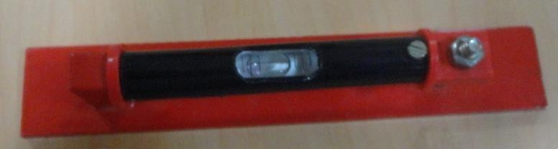
- The Spirit level:-It is a smaller metal tubecontainingasmallbubbleofspirit.The bubble is visible on the top along a graduated glass tube. The spirit level is meant for leveling the plane table.

- Thecompass:-Therearetwokindsof compass
  - Thetroughcompass
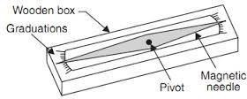
  - Thecircularbox compass.
- The trough compass:- It is rectangular box made of non magnetic metal containing a magnetic needle pivoted at the centre.Thiscompassconsistsof‘0’markatboththeendsto locate N-S direction.
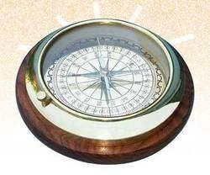
- The Circular box compass:- It carries a pivoted magnetic needle at the centre.Thecircularboxisfittedonsquarebaseplate.Sometimestwobubble tubes are fixed at the right angles to each other on the base plate. The compass is meant for making the north direction of the map.

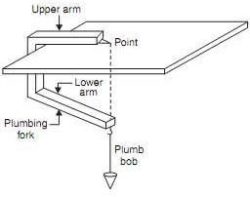
- TheU– Forkorplumbing Fork
withplumbob:- TheU-fork isametal stripbent in the
shapeofa‘U’ (Hair pin)havingequalarm lengths. Thetop
armispointed and thebottomarmcarriesa hookfor
suspendingaplumb bob .
This ismeant for centeringthetableovera station.

Procedureofsetting upplanetableovera station
Thefollowingfivestepsshould befollowedwhilesettingup aplanetableoverastation:-

- Fixingthetableonthetripodstand:-Thetripodstandisplacedovertherequiredstationwithitslegwellapart. Then the table is fixed on it by a wing nut at the bottom.
- LevellingtheTable:-TheTableislevelledbyplacingthespiritlevelatadifferentcornersandvariousposition of the table. The bubble is brought to the centre of its run at every position of the table by adjusting he legs.
- Centringthetable:-At firsttheDrawingsheetisfixedonthetable.Asuitablepointisselectedonthesheetto represent the station “A” on the ground.
Apinisthenplacedon thisselected point.
TheupperendoftheU-Forkismadeincontactwiththestationpinandtheplumbbobissuspendedfromthehookat the lower end is brought over the station “A” by turning the table clock wise or anti clock wise or slightly adjusting the table or legs.
ThisoperationiscalledCenteringandthetableisclamped.Careshouldbetakenthatthisoperationshouldbe done without disturbing the Leveling
- MarkingtheNorthline:-Thetroughcompassisplacedontherighthandtopcornerofthedrawingsheetwithits north end approximately towards the north. Then the compass is turned clock wise or anti clock wise so that the needle exactly coincides with the 0-0 mark . Now a line representing the north line is drawn through the edge of the compass. It should be ensured table is not turned.
- Orientation:-Whentheplanetableissurveyistobeconductedbyconnectingseveralstation,theorientation must be performed at successivestation . it may be done by twomethods
  - Backsightingmethod b.magneticneedlemethod.
a.Backsighting Method:-
Thismethodisaccurateandisalwayspreferred.Thefollowingsteps arefollowedduringtheback
sightingmethod .
- SupposeAandBaretwo station.TheplanetablesetupoverA.Thetableisleveledbythespirit level and centered by the U- Fork so that the point a is just over station A. The north line is marked at the right hand top corner of the sheet by the compass.
- With the help of the alidade touching the point a The ranging rod at B is bisected and ray is drawn.thedistanceABismeasuredandplottedtoanysuitablescale.Sothepointbisrepresents station B
- ThetableisshiftedandsetupoverB. ItisleveledandcenteredsothatbisjustoverB.Nowthe alidade is placed along the line ba, and the ranging rod at A is bisected by turning the table clockwise or anticlockwise. At this time the centering may be disturbed and should be adjusted immediately if required .When the centering, leveling and bisection of ranging rod at A are perfect, then the orientation is said to be perfect.

  - MagneticneedleMethod:-Thismethodissuitablewhenthelocalattractionis notsuspected.Thefollowingsteps are followed during the magnetic needle method.
    - i. Suppose A and B are two station . The plane table set up over A. The table is leveled by the spiritlevelandcentered bytheU-ForksothatthepointaisjustoverstationA.Thenorthlineis marked at the right hand top corner of the sheet by the compass in such a way that the neddle coincides with 0-0 mark . after this a line representing the north line is drawn through the edge of the compass box. Then the table is clamped.
    - With the help of the alidade touching the point a The ranging rod at B is bisected and ray is drawn.thedistanceABismeasuredandplottedtoanysuitablescale.Sothepointbisrepresents station B
    - The table is shifted and set up over B. It is leveled and centered so that b is just over B. The table isleveled.Nowthecompassisjustexactlyoverthenorthlinedrawnpreviously.Thetableisthen turnedclockwiseoranticlockwiseuntiltheneedlecoincides with0-0markofthecompass.While turning the table it should be kept in mind that the centering and leveling is not disturbed. In case it is disturbed it should be adjusted immediately.
    - Whenthecenteringandlevelingareperfectandtheneedleisexactlyat 0-0mark,theorientation is said to be perfect.
MethodsOfPlaneTable.:-
Therearefourmethodsofplanetable.Theyare Radiation
Intersection Traversing Resection

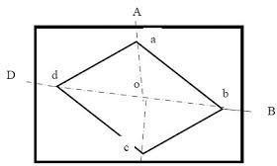
Radiation:-
Thismethodissuitableforlocatingtheobjectsfroma single station.
In this method rays are drawn from the station to the objects and the distances from the station to the object aremeasuredandplottedtoanysuitablescalealongthe respective rays.
Procedure:-
- SupposeOisastationontheground fromwheretheobjectsA,B,C,&D are visible.

- TheplanetablesetupoveratP.Adrawingsheetisfixedonthetable,whichisthenleveledand centered . A point o is selected on the sheet to represent the point o.
- TheNorthlineismarkedontherighthandtopcornerofthedrawingsheetwiththetrough compass .
- Withthealidadetouchingthepointo,RangingrodatA,B,C,&Darebisectedandtheraysare drawn.
- ThedistancesOA,OB,PC,&ODaremeasuredandplottedtoanysuitablescaletoobtainthe points a,b,c, & d representing A, B, C,& D on the paper.

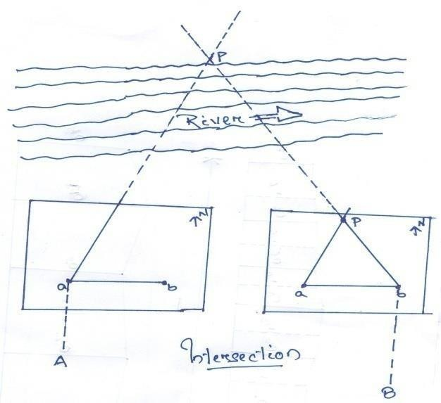
Intersection:-
Thismethodissuitableforlocatinginaccessiblepointsbythe intersectionof the ray drawn from two station instrument station.
Procedure:-
- Suppose A & Bare two station and P is an object on the far bank of the river . It is requiredto fix thepositionofPonthesheetbytheintersectionof the rays drawn From A and B.
- The table is set up at A. it is leveled and centered sothatapointaonthesheetisjustoverthestation
A. The North line is marked on the right hand top cornerofthedrawingsheetwiththetroughcompass.
- WiththealidadetouchingthepointatheobjectPandtherangingrodatBarebisectedandrays are drawn trough the fiducial edge of the alidade.
- ThedistanceABismeasuredandplottedto anysuitablescaletoobtain thepointb.
- The table is shifted and centered over B and leveled properly. Now the alidade is placed along the linebaand orientation is doneby back sighting.. Whilebacksighting it should bekept in mind that thecenteringandlevelingisnotdisturbed.Incaseitisdisturbeditshouldbeadjustedimmediately.
- Withthealidadetouchingb,theobjectPisbisectedandrayisdrawn.Supposethisrayintersects the previous ray at a point p. This point p is the plotted position of P.

Traversing:-
Thismethodissuitableforconnectingthetraversestation
Procedure:-
- SupposetheP,Q,R,&Sarethetraversestations.

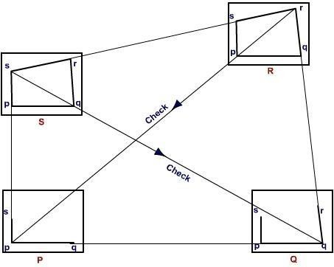
- Thetableis set up at the station P. Asuitablepoint is selectedon thedrawing sheet let it be p. such that the whole area may plotted on the drawing sheet..the table well leveled, centered and the north line is marked on
righthandtop corner of the sheet.
- Withthealidade
touchingthepoint p the ranging rod at Q is bisected and the ray is drawn . The distance PQ is measured and plotted to any suitable scale to obtain the point q
- The table is shifted and set up overthestationQ.
Itisthenwell
leveled,centered ,andorientedbybacksightingandclamped.
- WiththealidadetouchingthepointqtherangingrodatRisbisectedand therayisdrawn.The distance QR is measured and plotted to any suitable scale to obtain the point r
- ThetableisshiftedandsetupoverthestationR.Itisthenwellleveled,centered,andorientedby back sighting and clamped .
- WiththealidadetouchingthepointrtherangingrodatSisbisectedand therayisdrawn.The distance RS is measured and plotted to any suitable scale to obtain the point s
- Thetableisshifted andsetupoverthestationS.Itisthenwellleveled,centered,andorientedby back sighting and clamped.
- Withthealidadetouching thepoint s therangingrodatPis bisectedandtherayis drawn.
- Attheendthefinishingpointmaynotcoincidewiththestartingpointandtheremaybeclosing error. This error is adjusted graphicallyby Bowditch’s rule.
- Aftermakingthecorrectionforclosingerrorthetableisagainsetupoverat A.After(wellleveled, centered , and oriented by back sighting the surrounding are located by radiation).
- Thetableisthenshiftedandsetupatallstationofthetraverseandproperadjustmentsthedetails are located by the radiation and intersection methods.

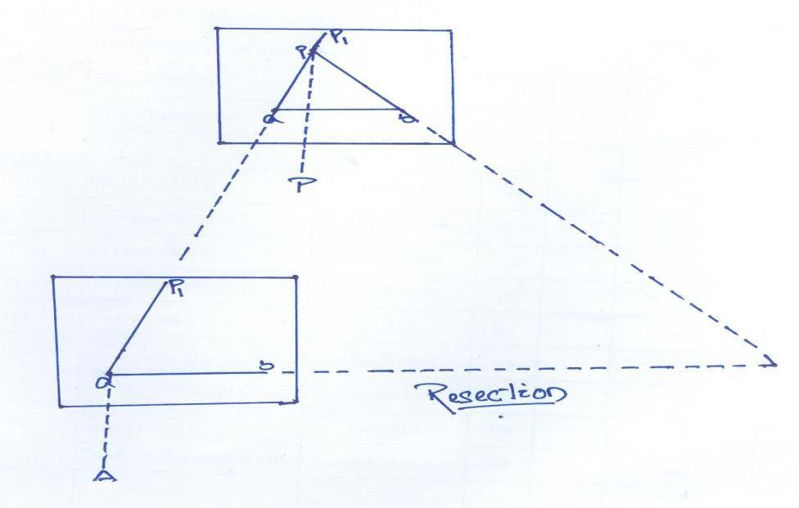
Resectionmethod:-
Thismethodissuitableforestablishingnew stations at aplacein orderto locatemissing details.

Procedure
  - Suppose it is required to establish a station at position on P. Let us select two points A and B on the ground .The distance AB is measuredandplottedtoanysuitable scale. This line AB is known as the “base line”.
  - ThetableissetupatA.Itisleveled;centeredandorientedbybisectingtherangingrodatB.the table is then clamped.
  - Withthealidadetouchingpointa,therangingrodatPisbisectedandaray isdrawn.Then apointP1is marked on this ray by estimating with the eye.
  - ThetableisshiftedandcenteredinsuchawaythatP1isjustoverP.Itisthenorientedbyback sighting the ranging rod at a.
  - Withthealidadetouchingpointb,therangingrodatBisbisectedandaray isdrawn.Supposethisray intersects the previous ray at a point P. This point represents the position of the station P on the sheet. Then the actual position of the station P is marked on the ground by U-fork and plumb bob.
Resection methodbasedon(1)thetwo-pointproblem,and(2)thethree-point problem.

- Twopoint problem:-
Inproblem,twowelldefinedpointswhosepositionhavealreadybeenplottedontheplanandselected.thenby perfectly bisecting these points a new station is established at the required position.

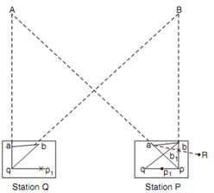
Procedure:-
  - Suppose A and B are two well defined points whoseposition are plotted onmapasaandb.itisrequiredtolocate a new station at P by perfectly bisecting A and B
  - AnauxiliarystationQisselected at a suitable position on the ground.The table is set up at Q and it is leveled; centeredandorientedbyaneyeestimate. It is then clamped.
  - Withthealidadetouchingaandb thepointsAandBarebisectedand aray is drawnsuppose these raymeet at q
  - with the alidade centered on q the ranging rod at A is bisected and a ray is drawn.Thenbyeyeestimationapointp1is marked on this ray.
  - The table is then shifted and centered on P with p1 just over P. It is then leveled and oriented by the backlighting.Withthealidadetouchingthepoint athepointAisbisectedandtherayisdrawn.Supposethisray intersects at pq1at the point q1as assumed previously.
  - Withthealidadecenteredonp1 thepointBisbisectedandarayisdrawn.Suppose thisrayintersecttherayqb at a point b1. The triangle abb1is known as triangle of error and is to be eliminated.
  - Thealidadeplacedalong thelineab1andarangingrodRisfixedatsomedistancefromthetable.Thenthe alidade placed along the line ab and the table is turned to bisect R. at this position the table is said to be perfectly oriented.
(h)Finally,withthealidadecenteredonp andq,thepointspandQarebisectedand raysaredrawn.Supposethese rays intersect at a point a. This would represent the exact position of the required station A. Then the station A is marked on the ground.

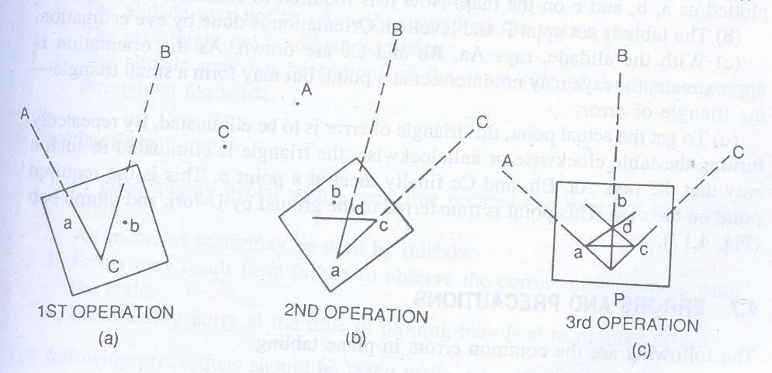
- The Three-point problem:- inthisproblem,threewelldefined
pointsareselectedwhosepositionshave already been plotted on the map. Then, by perfectly bisecting these three well- defined points, a new station is established at the required position.
Noauxiliarystationisrequiredinorder to solve this problem. The table is directlyplacedattherequiredposition.
Theproblem may besolved by three
methods(a)thegraphicalorBessel’smethod,(b)themechanical method,and (c)thetrialanderror method.
- TheGraphicalmethod
  - SupposeA,BandCarethreewell-definedpoints whichhavebeenplottedasa,b andc. Nowitis required to locate a station at P.
  - ThetableisplacedattherequiredstationPandleveled.Thealidadeisplacedalongthelinecaandthe point A is bisected and ray drawn.
  - Againthealidadeisplacedalongthelineacandthe pointcisbisectedand thetableisclamped. Withthe alidadetouching a, thepoint b is bisectedand a ray is drawn.Supposethis ray intersects theprevious ray at a point d .
ThealidadeisplacedalongdbandthepointBisbisected.Atthis positionthetableissaidtobaperfectlyoriented. Now the rays Aa, Bb and Cc are drawn. These three rays must meet at a point p which is the required point on the map. This point is transferred to the ground by U-fork and plumb bob.

Errorsand Precautions:-
- InstrumentalErrors
  - Thesurfaceoftablemaynot beperfectly level.
  - Thefiducialedgethealidademight not bestraight.
  - Thevanes maynot bevertical.
  - Thehorsehair maybelooseand inclined.
  - Thetablemay belooselyjoined with the tripod stand.
  - Theneedleofthethroughcompassmaynotbeperfectlybalanced. Alsoitmaynotbeableto move freely due to sluggishness of the pivot point.

- PersonalErrors
  - Thelevelingofthetablemay not beperfectly.
  - Thetablemay notbecentred properly.
  - Theorientation of the tablemay notbeproper.
  - Thetablemight notbeperfectly clamped.
  - Theobjects maynotbebisectedperfectly.
  - Thealidademaynotbecorrectlycentred on thestation point.
  - Theraysmight notbedrawnaccurately.
  - Thealidademaynot becentred onthe samesideofthestationpoint throughout thework.
- PlottingError
  - Agoodquality pencil withaveryfinepointedendmaynothavebeen used.
  - Anincorrect scalemaybeusedbymistake.
  - Errorsmayresult fromfailuretoobservethecorrectmeasurementfromthescale.
  - Unnecessaryhurryatthetimeofplottingmayleadtoplottingerrors. The following precautions should be taken while using the plane table;
- Beforestartingtheworktheequipmentsforsurveyworkshouldbeverified.Defectiveaccessoriesshould be replaced by perfect equipment.
- Thecenteringshouldbeperfect.
- Theleveling shouldbeproper.
- Theorientationshouldbeaccurate.
- Thealidadeshouldbecentred onthesamesideof thestation-pin untiltheworkis completed.
- Whileshiftingtheplanetablefromonestationtoanother,thetripodstandshouldbekeptverticaltoavoid damage to the fixing arrangement.
- Onlytheselectedscale should beon thetable.
- Measurementsshouldbetakencarefullyfromthe scalewhileplotting.
- ThestationsonthegroundaremarkedA,B,C,Detc.whilethestationpointsonthemaparemarkeda,b, c, d etc.
ProcedureofFieldwork

Reconnaissance–
The area to be surveyed is thoroughly examined to find the best possible way for traversing.Thetraversestationsshouldcoverthewholeareaandshouldindivisible.Theprovisionsfor check lines should be kept in mind.

Markingthestations
Levellingand contouring

Purpose of levelling: Levelling is the art of finding the relative heights and depths of theobjectsonthesurfaceoftheearth.Itisthatpartofsurveyingwhichdealswiththemeasurements

inverticalplane.

Levellingisofprimeimportancetoanengineerforthepurposeofplanning,designingand executing various engineering projects such as roads, Railways, canals, dams, water supply and sanitaryschemesetc.ThePrincipleoflevelingliesinfurnishingahorizontalsightandfindingthe verticaldistancesofthepointsabovethisline.Thisisdonewiththehelpofalevel andalevelling staff respectively.
Defination of terms used in levelling-concepts of level surface, Horizontalsurface, Vertical surface, Datum, R.L, B.M.
Level Surface: This is a surface parallel to the mean spheroidal surface of the earth is said to be a level surface.The water surface of a still lake is also considered to be a level surface.
HorizontalPlane/surface: Anyplanetangential tothelevel surface at any point is knownasthe horizontal plane.It is Perpendicular to the plumb line.
VerticalPlane/surface:AnyplanepassingthroughtheverticallineisknownastheverticalPlane.

Datum Surface or Line: This is an imaginary level surface or level line from which the vertical distances of different points(above or below this line) are measured. In India the datum adopted for the GreatTrigonometrically Survey(GTS) is the mean sea level(MSL) at Karachi.
ReducedLevel(R.L):Theverticaldistanceofappointaboveorbelow thedatumlineisknownas thereducedlevelofthatpoint.TheRlofapointmaybepositiveornegativeaccordingasthepoint is above or below the datum.

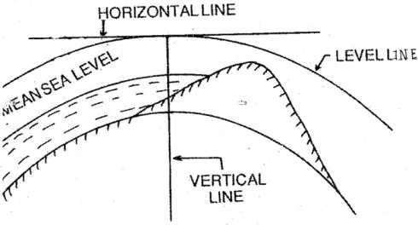

Figure1.2a
Bench Mark: These are fixed points or marks of known RL determined with reference to the datum line. These arevery important marks. Theyserveas reference points for finding the RL of new points or for conducting leveling operations in projects involving roads, Railways.
Bench mark are of four types.(a)GTS (Great Trigonometric Survey)Bench mark: This Bench mark s are established by Survey of India at large intervals all over the country(Mumbai). The values of Reduced levels, the relevant positions and the number of benchmarks are given in a catalogue published by this department(Ref.Fig:1.2b )
- Permanent Bench marks: These are fixed points or marks established by different Government Departments like PWD, Railway, Irrigation, etc..The R.L’s of these points are determinedwithreferencetotheGTSbenchmark.,andkeptonpermanentpointsliketheplinth of building, parapet of a bridge or culvert, and so on. Sometimes they are kept on underground pillars as in Fig:1.2c
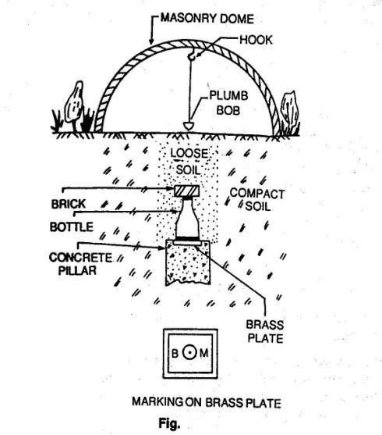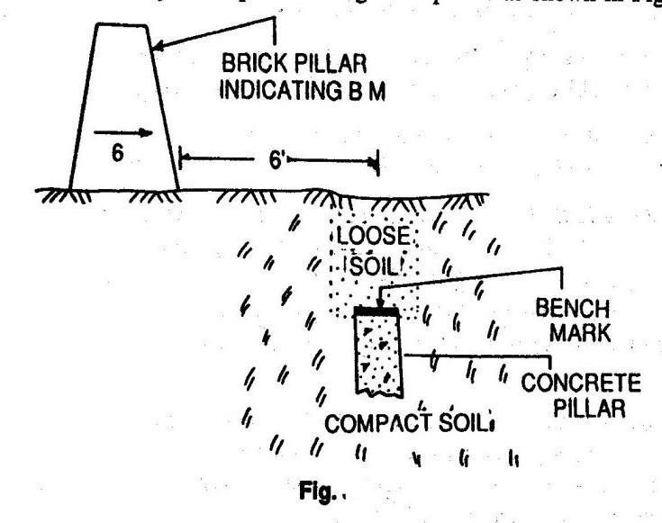
Figure1.2b Figure1.2c

- Arbitrary Bench marks: When the RL’s of some fixed points are assumed, they are termed arbitrarybench-mars.Theseareadoptedinsmallsurveyoperations,whenonlyundulationofthe ground surface is required to be determined.
(c)Temporary Bench marks: When the bench marks are established temporarily at the end of a day’s work, they are said to be temporary bench marks. They are generally made on the root of a tree, the parapet of a nearby culvert, a furlong post, or on a similar place.
:Descriptionof essentialfeaturesanduseofdifferenttypesof levelingInstruments:Referring to Fig.
1,2,3-Threetripodlegs,3a-triangularplatemaybefixedonthetopoftripodordetachablefromthe stand,(4),(5),(6)arethreefootscrewsthefootscrew(6)isnotvisibleinthepicture,(7)isamagnetic compass,(8) is a screw for holding a magnifying lens,(9)eye piece,(10)the object glass of the telescope covered by a detachable sun shade marked(11),(12)a milled headed screw is used for focusing known as focussing screw.(13) is one of the four capstan screws holding the cross hairs inthediaphragm,(14)mainspiritlevelorlongitudinalbubblewithmarkedgraduations,(15)across levelwhichissmallerinsizeandisnotgraduatedusually,(16)is,thetriangularbase,calledleveling head(trivet),(17) Tribrach
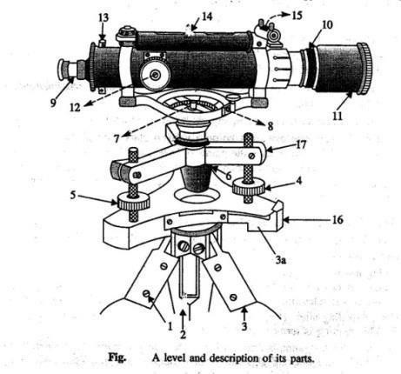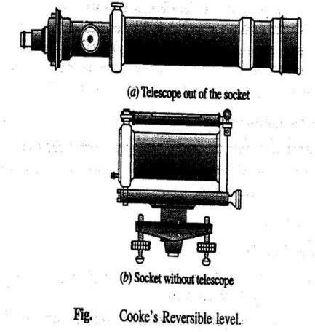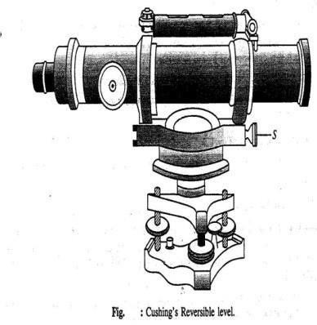

Figure1.3a Fig.1.3b Fig1.3c

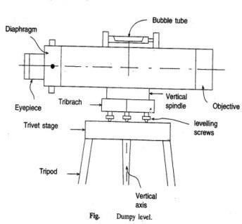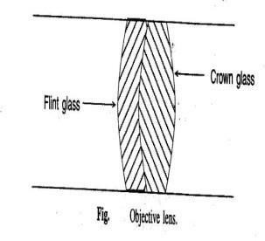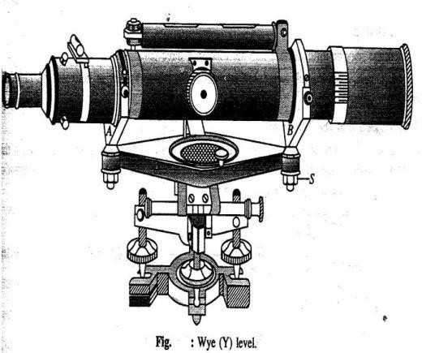

Fig. 1.3a Fig.1.3 Fig1.3d

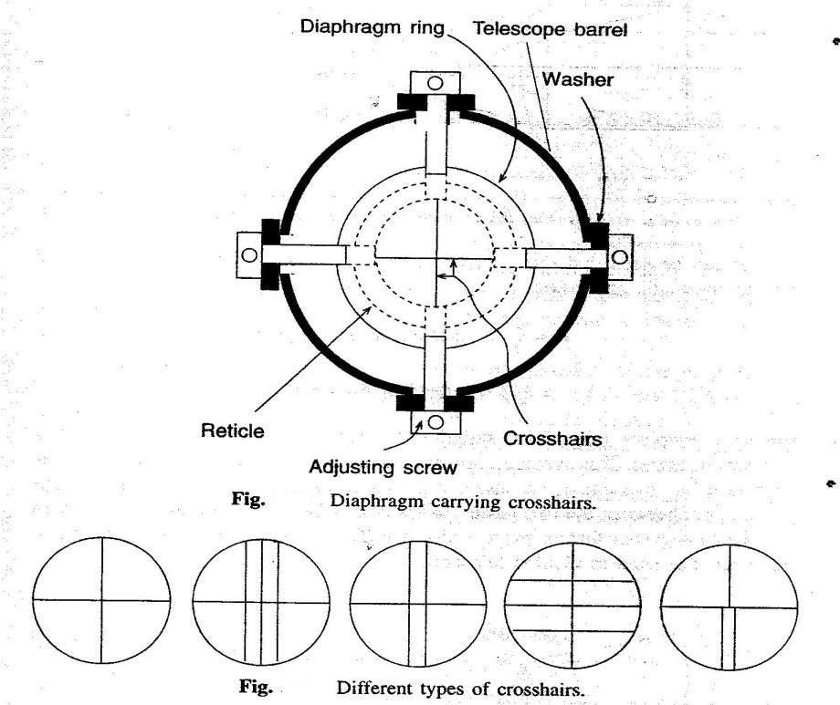
Fig.1.3a

Modificationsofdumpylevel:Twomodifiedforms ofDumpylevel are(1)Cooke’sReversiblelevel and Cushing’s reversible level.
Cooke’s reversible level:The telescope is placed within a socket as such the telescope can be rotatedaboutitslongitudinalaxisand(ii)canbetakenouttobereplacedwithitsendsinterchanged inposition,(iii)theaxisofthetelescopecanbetiltedalittleaboutitstransverse horizontalaxisby operating the nut marked “S”.

Cushing’s reversible level:(i) eye piece carrying the diaphragm and object glass are detachable and, thus, can be interchanged,(ii)Object glass and the eye piece can be rotated about the longitudinal axis of the telescope,(iii)The axis of the telescope can be tilted a little about the horizontal transverse axis of the telescope by operating the nut marked “S”.
Wye(Y) level:Here the telescope is placed on Y support,(i)the telescope can be taken out of the socket and can be replaced with its ends reversed,(ii)the telescope can be rotated about its longitudinal axis,(iii)the telescope can be a little about its transverse horizontal axis by operating the nut marked ”S”
Tiltinglevel:Thetelescopecanbetiltedaboutitstransversehorizontalaxisbyoperatingascrew called tilting screw.The line of collimation, thus can be made horizontal even when the vertical axisoftheinstrumentisnottrulyvertical.Thusitsavestimerequiredforadjustmentbeforetaking the reading.

ModernlevellingInstruments:
Automatic Levels: The manual adjustment is eliminated in the use of auto level.A compensator mechanism is used in the functioning of this level. Only the telescope is approximately level,the compensator is active and the readings can be takenon the staff at different points.
Electronicdigitallevels:Thelevelwhicheliminatestheneedtoreadthestaffandrecordreadings, modelDL100digital level,Sokkia’s SDL30,TopconDL500series level are available.
:Concept of line of collimation:It is an imaginary line passing through the intersection of the cross hairs at the diaphragm and the optical centre of the object glass and its continuation. It is also known as line of sight.
Axis of the telescope: This is an imaginary line passing through the optical centre of the object glass and the optical centre of the eye piece.
Axisofthebubbletube:Itisanimaginarylinetangentialtothelongitudinalcurveofthebubble tube at its middle point.
:LevellingStaff,typesfeaturesanduse:Alevelstaffisagraduatedrodofrectangular section. It is usuallymade of teak wood.It mayalso be fibre glass or metal.Two types of rod are:-

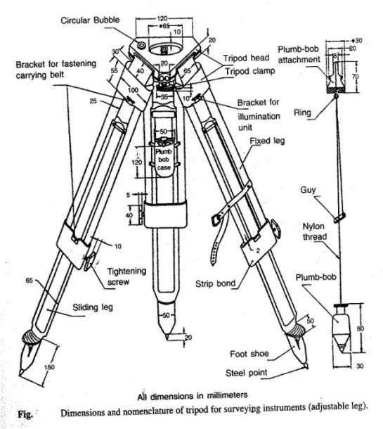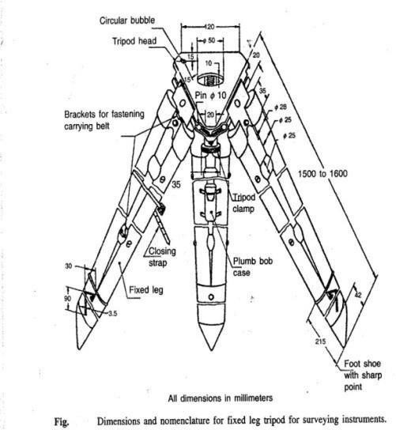

Fig.1.5a

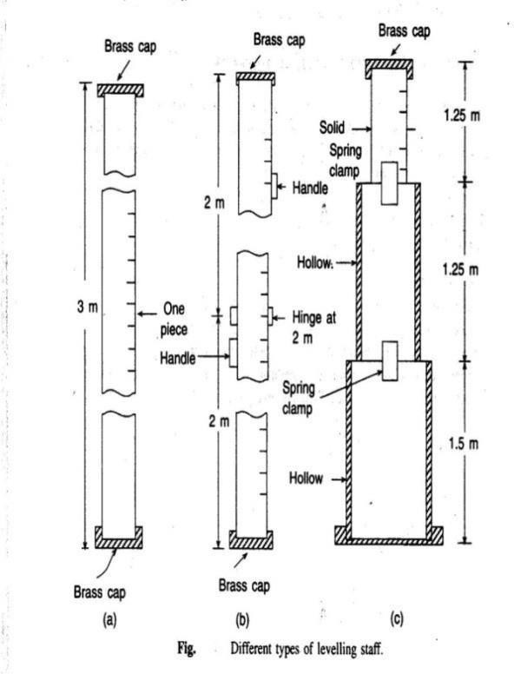
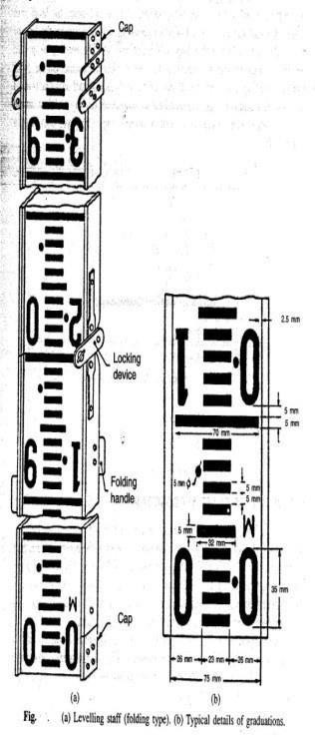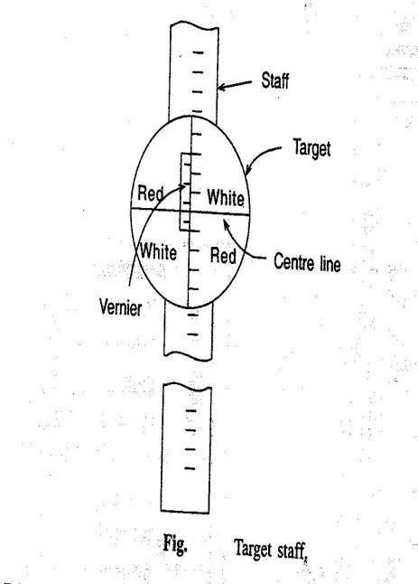
Fig.1.5b
1) Self-readingwhich can be read bythe instrument operator with sighting through the telescopeand noting theapparent intersection ofthe cross wires on the rod. This is the most

commontype.

:Temporaryadjustmentoflevel,takingreadingwithlevel:
- Setting up:Initially the tripod is set up at a convenient height and the instrument is approximately leveled.Some instruments are provided with a small circular bubble on the tribrach to check the approximatelevelling.At this stage the the leveling screw should be at the middle of its run.
- Levellingup:Theinstrument isthenaccuratelyleveledwiththehelp of levelingscrewsorfoot screws.For instruments with three foot screws the following steps are to be followed.
  - Turn the telescope so that the level tube is parallel to the line joining any two leveling screws as shown in Fig.
  - bringthebubbletothecentreofitsrunbyturningthetwolevelingscrewseitherbothinwards oroutwards.c)Turnthetelescopethrough90º,sothattheleveltubeisoverthethirdscreworon thelineperpendiculartothelinejoiningscrews1and2.Bringthebubbletothecentreofitsrun by the third foot screw only rotating either clockwise or anticlockwise.
- Repeattheprocesstillthebubbleisaccuratelycentredinboththeseconditions.
- Now turn the telescope through 180º so that it again parallel to leveling screws1 and 2.If the bubble still remains central,the adjustment is all right.If not,the level should be checked for permanent adjustments.

- Focussing:This is done in two steps.First step is focusing the eye piece.This is done by turning theeyepieceeitherinoroutuntilthecrosshairsaresharpanddistinct.Thiswillvaryfromperson toperson asitdependsonthevision oftheobserver.Thenext step isfocusingtheobjective.This is done by means of the focusing screw where by the image of the staff is brought to the plane of the cross hairs.This is checked by moving the eye up and down when reading the crosshair does not change with the movement of the eye as the image and the cross hair both move together.
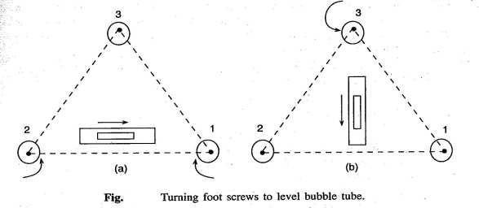
Fig.1.6

:ConceptofBenchMark,BS,IS,FS,CP,HI:
- Station:Thisisappointwherealevelingstaffisheldfortakingobservationswithalevel.
- Height of the Instrument(HI):It means elevation of the line of sight or line of collimation with respect to the datum.
- Back Sight(BS):It is the first reading taken at a station of known elevation after setting up of theinstrument.This reading gives the height of Instrument(elevation of line of collimation),
elevationoflineofcollimation=Knownelevation+backsight
- IntermediateSight(IS):Thesearereadingstakenbetweenthe1standlastreadingbeforeshifting the instrument to a new station.
- ForeSight(FS):Thisisthelastreadingtakenbeforeshiftinganinstrumenttoanewstation.
- TurnigPointorChangePoint:Forlevelingoveralongdistance,theinstrumenthastobeshifted a number of times.Turning point or change point connects one set of instrument readings with thenextsetofreadingswiththechangedpositionoftheInstrument.Astaffisheldontheturning point and a foresight is taken before shifting the instrument.From the next position of the instrument another reading is taken at the turning point keeping the staff undisturbed,which is known as back sight.
- ReducedLevel(RL):Reducedlevelofapointisitsheightrelativetothedatum.TheLevelis

calculatedorreducedwithrespecttodatum.

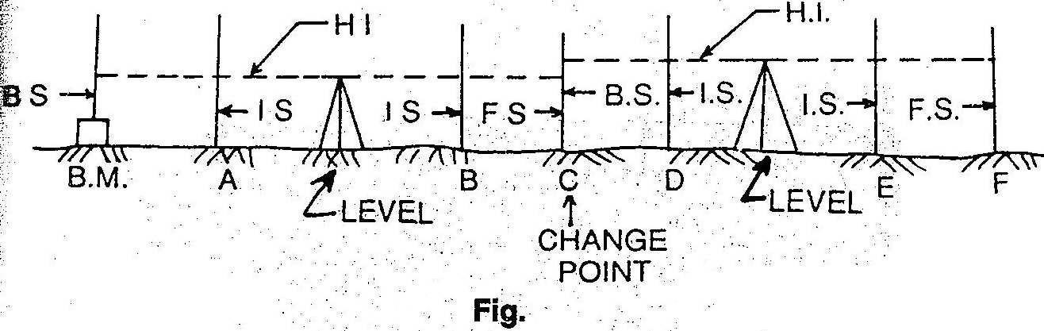
Fig.1.7

:Principlesoflevelling:
- Direct or simple levelling:In levelling it is desired to find out the difference in level between twopoints.Then iftheelevation of onepointis known,theelevation of otherpoint canbe easily found out.In fIg.the instrument is placed at C roughly midway between two points A and B.The staff readings are shown in figure.From the figure the R.L of B can be derived as 100.50+1.51- 0.57=101.44mm.From the reading it can also be observed that,if the second reading is smaller than the first reading, it means that the second point is at higher level than that the first.
- Trigonometrical levelling: In trigonometrical leveling the difference in elevation is determined indirectly from horizontal distance and the vertical angle.It is used mainly to determineelevationsofinaccessiblepointssuchasmountainpeaks,topoftowersetc.asshown in fig.
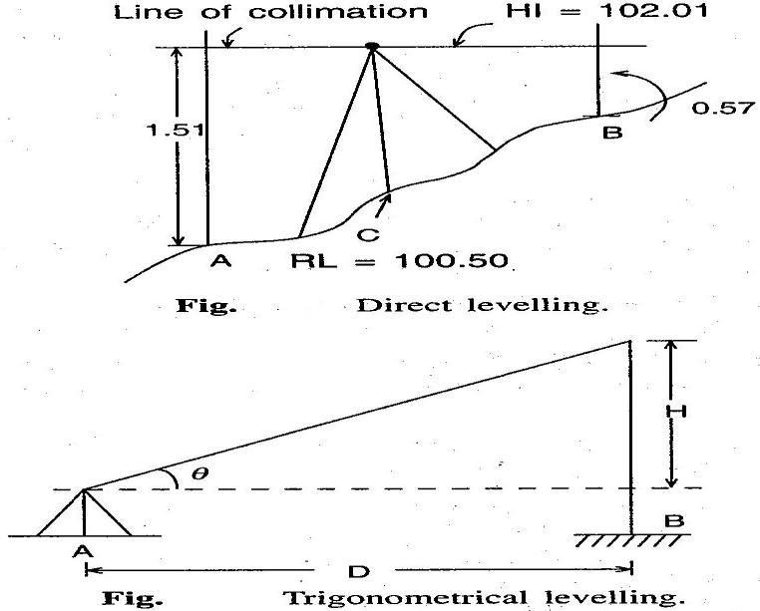
Fig.1.8

- Differential leveling:This type of leveling is adopted when(i)the points are at a great distance apart,(ii)the difference in elevation between the points is large,(iii)there are obstacles between thepoints.Thismethodisalso knownas compound levelling.Inthismethodthelevelissetup at several suitable positons and staff readings are taken at all of these.
:FieldDataentry:Levelbook
- HeightofcollimationorHeightofInstrumentmethod:
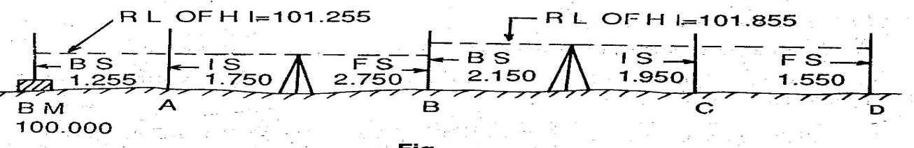
Fig:1.9

Thereducedlevelofthelineofcollimationissaidtobetheheightofinstrument.Inthissystem,the height of the line of collimation is found by adding the backsight reading to RL of the BM on which the BS is taken. Then the RL of the intermediate points and the change point are obtained by subtracting the respective staff readings from the height of Instrument(HI).The level is then shiftedforthenextsetup andagaintheheightofthelineofcollimationis obtainedbyaddingthe backsightreadingtotheRLofthechangepoint(whichiscalculatedinthefirstsetup).Sothe ht.of instrument is different in different set ups of the level.Two adjacent places of collimation.Two adjacentplanesofcollimationarecorrelatedatthechangepointbyanFSreadingfromonesetting and aBS reading from the next setting.The RLs of of unknown pointsare to be found out by deducting the staff readings from the RL of the height of instrument.Referring to Fig.
a)RL of HI in 1st setting=100.00+1.255=101.255,RL of A=101.255-1.750=99.505,RL of B=101.255-2.150=99.105,(b)RL of HI in 2nd setting=99.105+2.750=101.855,RL of C=101.855-
1.950=99.905,RLofD=101.855-1.550=100.305andsoon.,Arithmaticcheck:ΣBS−ΣFS
=LastRL-1stRL.Thedifferencebetweenthesumofbacksightsandthatofforesightsmustbe
equal to the difference between the last RL and the first RL.This check verifies the calculation of the RL of the HI and that of the change point.There is no check on the RLs of the intermediate points.
- The Rise and Fall method:In this method,the difference in level between two consecutive points is determined by comparing each forward staff reading with the staff reading at the immediately preceeding point.If the forward staff reading is smaller than the immediately preceeding staff reading,a rise is said to have occurred. The rise is added to the RL of the preceeding point to get the RL of the forward point.If the forward staff reading is greater than theimmediately preceeding staff reading, it means there has been a fall.The fall is subtracted from the RLof the preceeding point to get the RLof the forward point. Refer. to Fig.

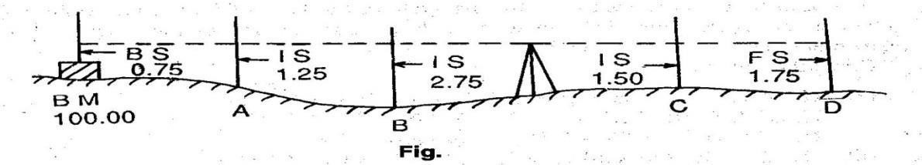
Fig.1.9
Point A(with respect to BM)=0.75-1.25=-0.50(Fall), Point B(with respect to A)=1.25-2.75=- 1.50(Fall),
Point C(with respect to B)=2.75-1.50=+1.25(Rise),Point D(with respect to C)=1.50-1.75=- 0.25(fall)
RL of BM=100.00,RL of A=100.00-0.50=99.50, RL of B=99.50-1.50=98.50, RL of C=98.00+1.25=99.25, RL of D=99.25-0.25=99.00
ArithmeticCheck:ΣBS−ΣFS=ΣRise−ΣFall=LastRL−1stRL
Inthismethod,thedifferencebetweenthesumofBS’sandthatofFS’s,the differencebetweenthe sum of rises and that of falls and the difference between the Last RL, and the first RL must be equal.
Note:The arithmetical check is ment only for the accuracy of calculation to be verified.It doesnot verify the accuracy of field work.There is a complete check on the RLs of the intermediate points in the rise and fall system.

Comparisonofthetwosystems:

Sl.No. | CollimationSystem | Riseandfallsystem
1. | It is rapid as it involves few calculation | Itislabourious,involvingseveralcalculations
2. | There is no check on the RL of intermediate points | There is a check on the RL of intermediate Points
3. | ErrorsinimmediateRLscannotbe detected | Errors in immediate RLs can be detected as all the points are correlated
4. | Thereare two checks on the accuracy of RL calculation | There are three checksonthe accuracy of RL Calculation
5. | This system is suitable for longitudinallevellingwherethereare a number of intermediate sights. | Thissystemissuitableforflylevellingwhere there are nointermediate sights.

PointstoberememberedwhileenteringthelevelBook:

  - ThefirstreadingofanysupportisenteredintheBScolumn,thelastreadingintheFScolumn

andtheotherreadings intheIScolumn.

  - ApagealwaysstartswithBS andfinisheswith anFS reading.
  - If a page finishes with an IS reading, the reading is entered in the IS and FS columns on thatpage and brought forward to the next page byentering it in the BS and IS columns.
  - TheFSandBSofanychangepointareenteredinthesamehorizontalline.
  - The RL of the line of collimation is entered in the same horizontal line in which thecorresponding are entered.
  - BenchMark(BM)andchangepoint(CP)shouldbeclearlydescribedintheremarkcolumn.
Example:The following consecutive readings were taken with a dumpy level along achain lineatacommonintervalof15m.Thefirstreadingwasatachainageof165m,whereRLis98.085.The instrument was shifted after the fourth and ninth readings:3.50,2.245,1.125,0.860,3.125,2.760,1.835,1.470,1.965,1.225,2.390 and 3.035
Markrulesonapageofyournotebookintheformofalevelbook pageandenteronittheabove readings and find the RL of all the points by:(1)The line of Collimation method,(2)The Rise and fall method&apply the usual checks.
(1)ThelineofCollimationmethod:

Station point | Chainage | BS | IS | FS | RL of Line of collimation(HI) | RL | Remarks
1 | 165 | 3.150 | xxxx | xxxx | 101.235 | 98.085
2 | 180 | xxxx | 2.245 | xxxx | xxxx | 98.990
3 | 195 | xxxx | 1.125 | xxxx | xxxx | 100.110
4 | 210 | 3.125 | xxxx | 0.860 | 103.500 | 100.375 | Change Point
5 | 225 | xxxx | 2.760 | xxxx | xxxx | 100.740
6 | 240 | xxxx | 1.835 | xxxx | xxxx | 101.665
7 | 255 | xxxx | 1.470 | xxxx | xxxx | 102.030
8 | 270 | 1.225 | xxxx | 1.965 | 102.760 | 101.535 | Change Point
9 | 285 | xxxx | 2.390 | xxxx | xxxx | 100.370
10 | 300 | xxxx | xxxx | 3.035 | xxxx | 99.725
TOTAL= |  | 7.500 | xxxx | 5.860 | xxxx | xxxx
ArithmeticCheck:ΣBS−ΣFS =LastRL-1stRL,(7.500-5.860)=+1.640,(99.725-99.085)=
+1.640
- TheRiseandfallmethod:

Station point | Chainage | BS | IS | FS | Rise(+) | Fall(-) | RL | Remarks
1 | 165 | 3.150 | xxxx | xxxx | xxxx | xxxx | 98.085

2 | 180 | xxxx | 2.245 | xxxx | 0.905 | xxxx | 98.990

3 | 195 | xxxx | 1.125 | xxxx | 1.120 | xxxx | 100.110
4 | 210 | 3.125 | xxxx | 0.860 | 0.265 | xxxx | 100.375 | ChangePoint
5 | 225 | xxxx | 2.760 | xxxx | 0.365 | xxxx | 100.740
6 | 240 | xxxx | 1.835 | xxxx | 0.925 | xxxx | 101.665
7 | 255 | xxxx | 1.470 | xxxx | 0.365 | xxxx | 102.030
8 | 270 | 1.225 | xxxx | 1.965 | xxxx | 0.495 | 101.535 | ChangePoint
9 | 285 | xxxx | 2.390 | xxxx | xxxx | 1.165 | 100.370
10 | 300 | xxxx | xxxx | 3.035 | xxxx | 0.645 | 99.725
TOTAL= |  | 7.500 | xxxx | 5.860 | 3.945 | 2.305 | xxxx
ΣBS−ΣFS=7.500-5.860=+1.640,Last RL-1st RL=(99.725-98.085=+1.640,
ΣRise−ΣFall=3.945-2.305=+1.640
Exercise No.1:The following figures are staff readings taken in order on a particular scheme,the backsights being
underlined.0.813,2.170,2.908,2.630,3.133,3.752,3.277,1.899,2.390,2.810,1.542,1.274,0.643,The
first reading was taken on abench mark39.563.Enter the readings in level book form,check theentries,and find the reduced level of the last point. Comment on your completed reduction.
Exercise No.2:A page of an old level book had been damaged by white ants and the readings marked X are missing.Find the missing readings with the help of available readings and apply arithmetical checks.

Distance in m | BS | IS | FS | RL of Line of collimation(HI) | RL | Remarks
 | X |  |  | X | 209.510 | B.M
0 |  | 1.675 |  |  | X
30 |  | X |  |  | 210.425
60 |  | 3.355 |  |  | 209.080
X | 0.840 |  | X | 209.520 | X | ChangePoint
120 |  | X |  |  | 208.275
150 |  | X |  |  | 210.635 | Underside  of bridge Girder
X | X |  | 2.630 | X | X | X
210 |  | X |  |  | 206.040
240 |  | 1.920 |  |  | 205.895
270 |  |  | X |  | 205.690

:Differenttypesoflevelling,usesandmethods:
- DifferentialorFlyLevelling:Itiscarriedoutwhenthedifferenceinelevationbetweentwo

points that are far apart is to be determined.Here there is no need to determine the RLs of the intermediate points.This method is adopted whenone wants to establish a bench mark near the

site of leveling work.Essentially,Backsights and foresights are taken to reach a point B startingfrom appoint AThis relates the R.Lof point B with the known RL of point A.(Ref:Fig.)
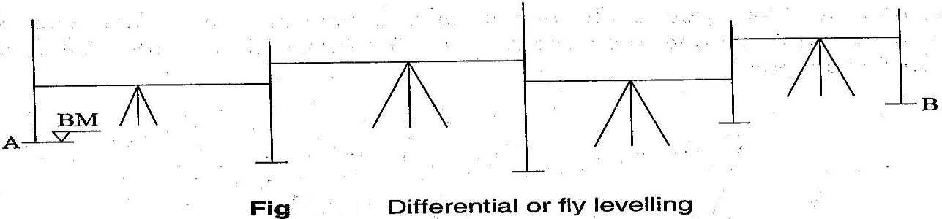
Fig.1.10

Example:

Stationpoint | BS | IS | FS | Rise(+) | Fall(-) | RL | Remarks
BM | 0.955 | xxxx |  | xxxx | xxxx | 250.550 | on BM  No.1
 | 1.250 | xxxx | 2.150 |  | 1.195 | 249.355
 | 0.785 | xxxx | 1.760 |  | 0.510 | 248.845
 | 1.535 | xxxx | 2.055 |  | 1.270 | 247.575 | ChangePoint
 | 1.260 | xxxx | 0.835 | 0.700 | xxxx | 248.275
 | 0.675 | xxxx | 0.955 | 0.305 | xxxx | 248.580
 | 1.275 | xxxx | 1.505 |  | 0.830 | 247.750
 | 1.675 | xxxx | 2.050 | xxxx | 0.775 | 246.975 | ChangePoint
 | 0.450 | xxxx | 2.160 | xxxx | 0.505 | 246.470
A | xxxx | xxxx | 1.005 | xxxx | 0.555 | 245.915 | Starting point of roadproject
TOTAL= | 9.840 | xxxx | 14.475 | 1.005 | 5.640 | xxxx
ΣBS−ΣFS=9.840-14.475=-4.635,LastRL-1stRL=(245.915-250.550=-4.635,
ΣRise−ΣFall=1.005-5.640=-4.635
- CheckLevelling:Itistheoperationdonetocheckthelevelingworkdone.Asimplemethodis to run runa seriesof levelsas in fly levelinguptothe startingpoint of the survey at the end ofthe day.This will check the accuracy of the leveling work.
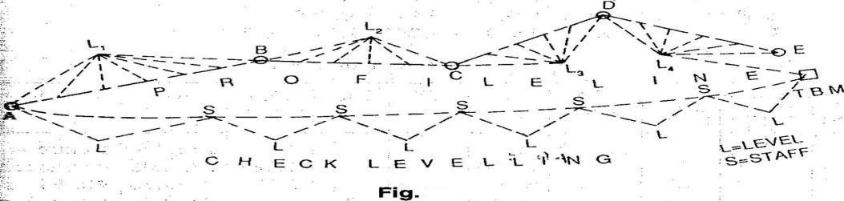
Fig:1.10

- ProfileLevelling:Profilelevelingorsectioningislevelingdoneacrossaline,e.g.,alongthecentre line of the road,to get a sketch of the profile.Essentially the staff stations have to be ranged to be along aline.Reading are taken on the staff held along this line.When the levels are plotted along the distances in aline,we get aprofile of the ground showing the elevations of the points.(Ref.Fig.)

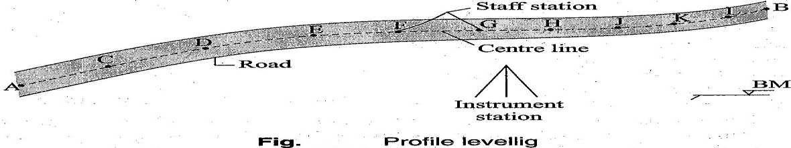

Fig:1.10
- Cross sectioning:It involves taking levels across alinee.g the centre line of a road,or a railway line.Depending upon the width of road,a number of staff stations are fixed across the centre line.Thisagaingivesaprofileperpendiculartothelongitudinallineandisusefulincalculatingthe volume,etc.
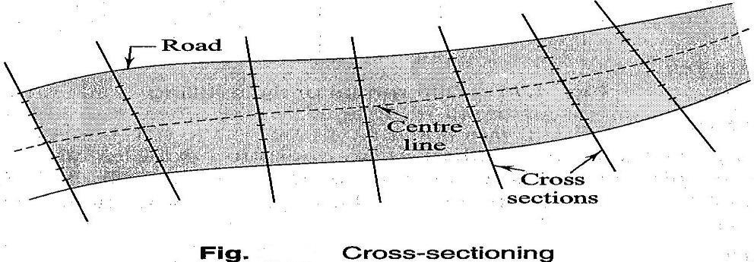

Fig:1.10
- Reciprocal Levelling:Reciprocal levelling is done when the distances are long and it is not possibletobalancethelengths of the lineof sights. Thishappens,e.g,inthe case of points laying oneithersideofariver,whenitisnotpossibletomaintainthelevelbetweenthetwopoints.This process eliminates many errors due to maladjustment of the instrument and those due to curvature and refraction.

:Plottingofprofiles:a)Longitudinalsections:
For plotting normally the Horzontal scale of 1:1000 or 1:2000 and vertical scale which is of either1:100 or 1:200 is followed.A horizontal line is drawn as the datum line.the chainages are markedalongthislineaccordingtothehorizontalscale.Thentheordinates(perpendicularlines)are drawnateachofthechainagepoints.TheRLofthedatumlineisassumedinsucha

waythatthegroundsurfacecanbeshownabovethedatum.Nowthevertical distances(RL ofGL- RL of datum)are plotted along the ordinates according to the vertical scale.The plotted pointsare joined to obtain the outline of the ground surface(as shown in fig.).The formation line are drawn in Red ink.
a)Cross sections:The cross sections are drawn/plotted in the same way as of longitudinal sections,but the Horizontal and vertical scales are slightly different(Horiz.1:400,Vert.1:100 are normallyfollowed)

Exampleofprofilelevelling:
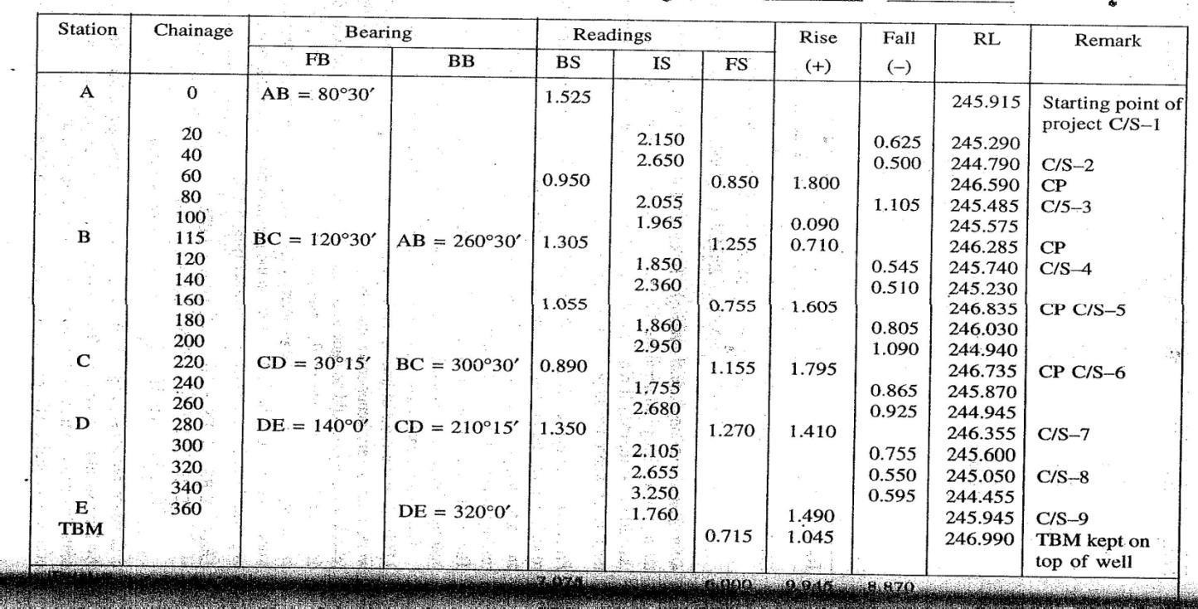

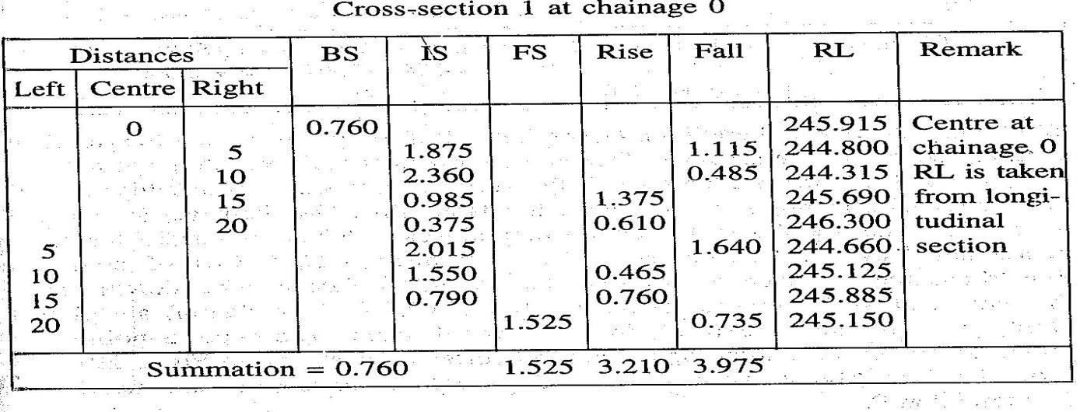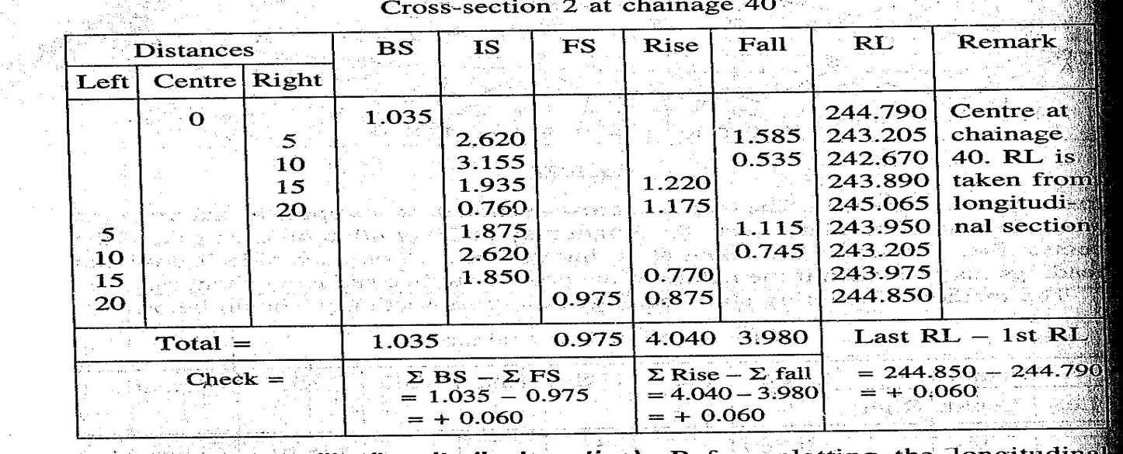
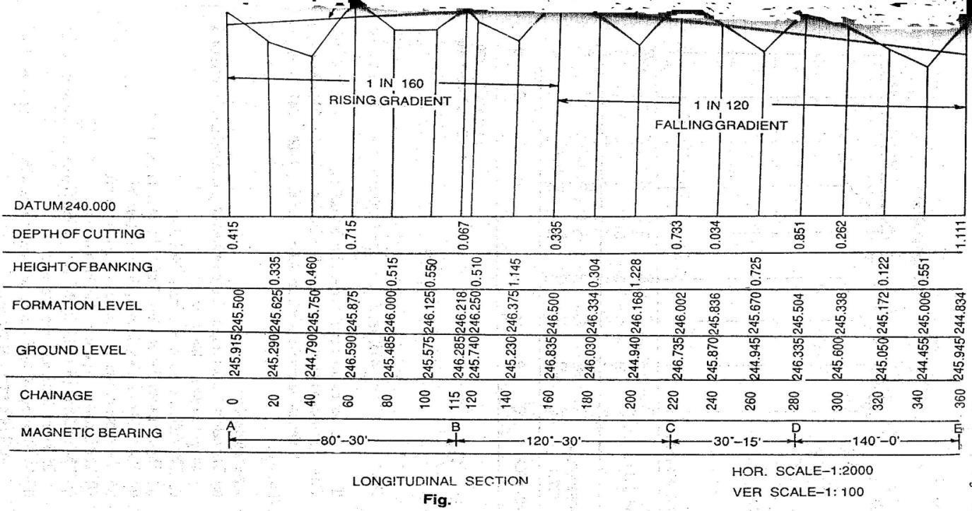
Fig.1.11

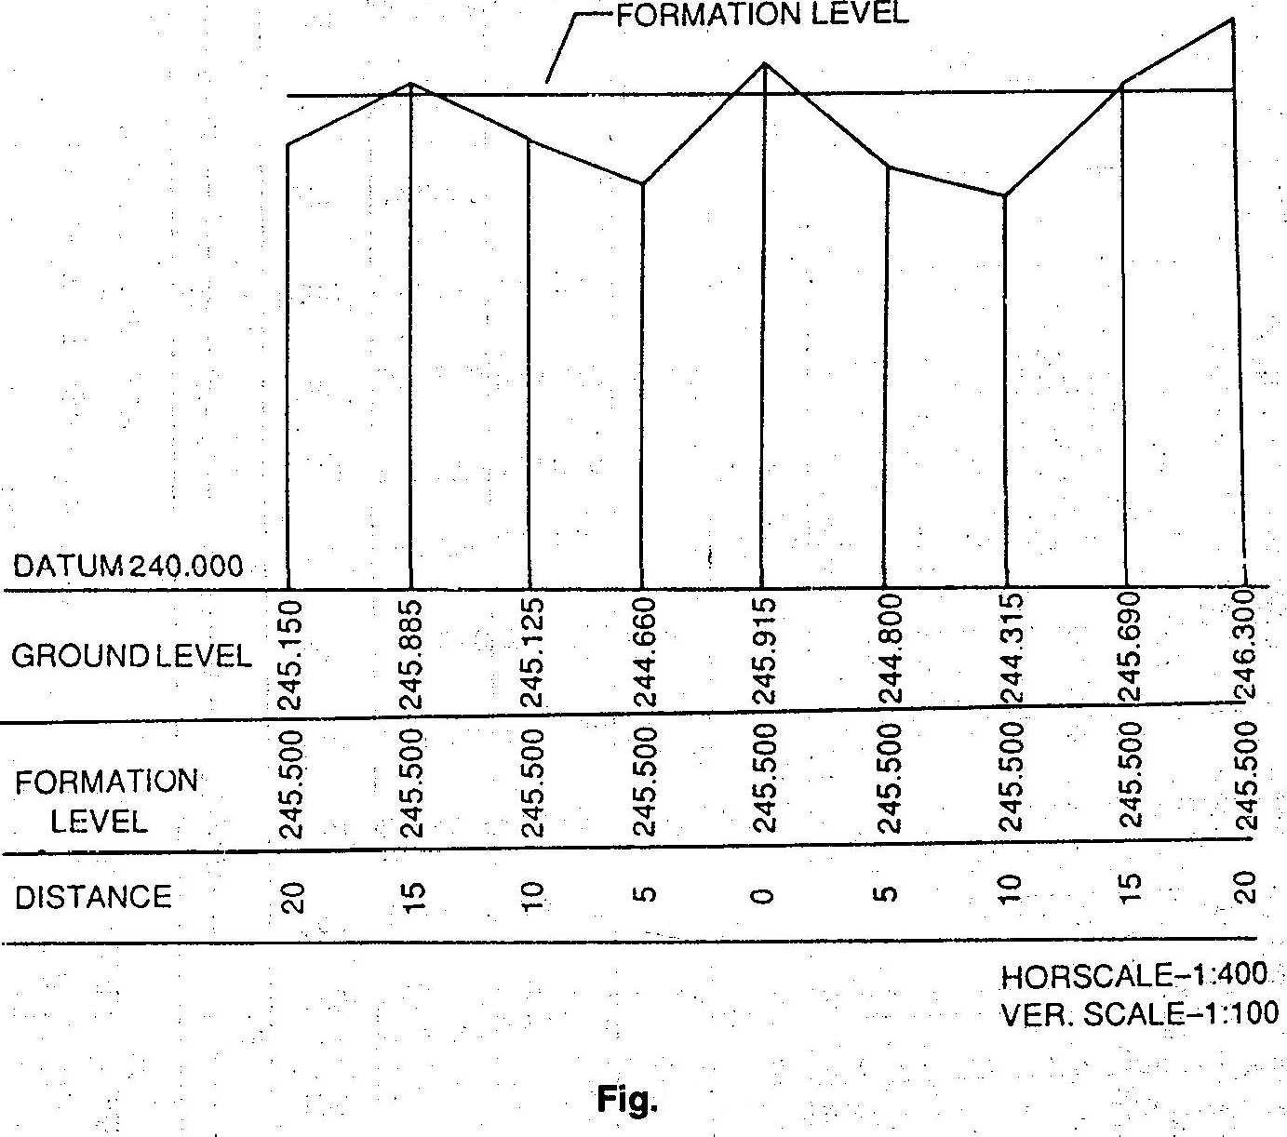

Fig:1.11

EfeectsofCurvatureandrefraction:
Leveling instruments provide horizontal line of sight and as a result curvature error occurs.In addition due to refraction in earth’s atmosphere the ray gets bent towards the earth introducing refraction errors.Fig. illustrates these errors.Neglecting small instrument HeightSA,OA can be taken as the radius of earth,From Geometry of a circle,AB(2R+AB)=d²,as AB is very small compared to diameter of the earthAB.2R= d²,AB= d²/2R,The dia. Of earth is taken as12734KM,Hence curvature correction:AB=d²/12734Km=0.078 d²m,d is expressed in Km.The radius of rayIC isbent due to refraction is taken as seven times the radius of earth.The refraction correctionistakenas1/7th ofthecurvaturecorrection.Refraction correctionreducesthecurvature

correctionandhencecombinedcorrectionis6/7thof0.078d²m,i,e0.067d²anddisexpressedinKm. The correction is subtractive from staff reading.
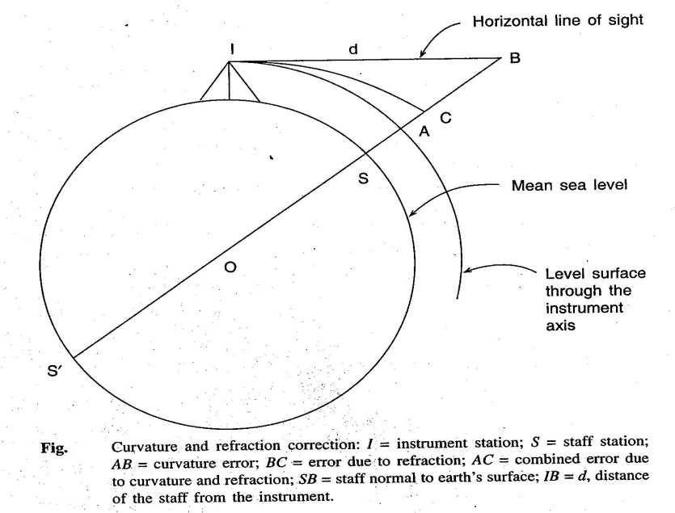
Fig.1.12
Example:Determinethedistanceforwhichthecombinedcorrectionis5mm.

Correction in m=0.067d^{2,}where d is in Km,d²=0.005/0.067,d=√0.005÷0.067)
=0.273Km=273m
Exercise: A sailor standing on the deck of a ship just seesthe top of alight house.The top of the light house is 30m above sea level and the height of sailors eye is 5m above sea level.Find the distance of the sailor from the light house.

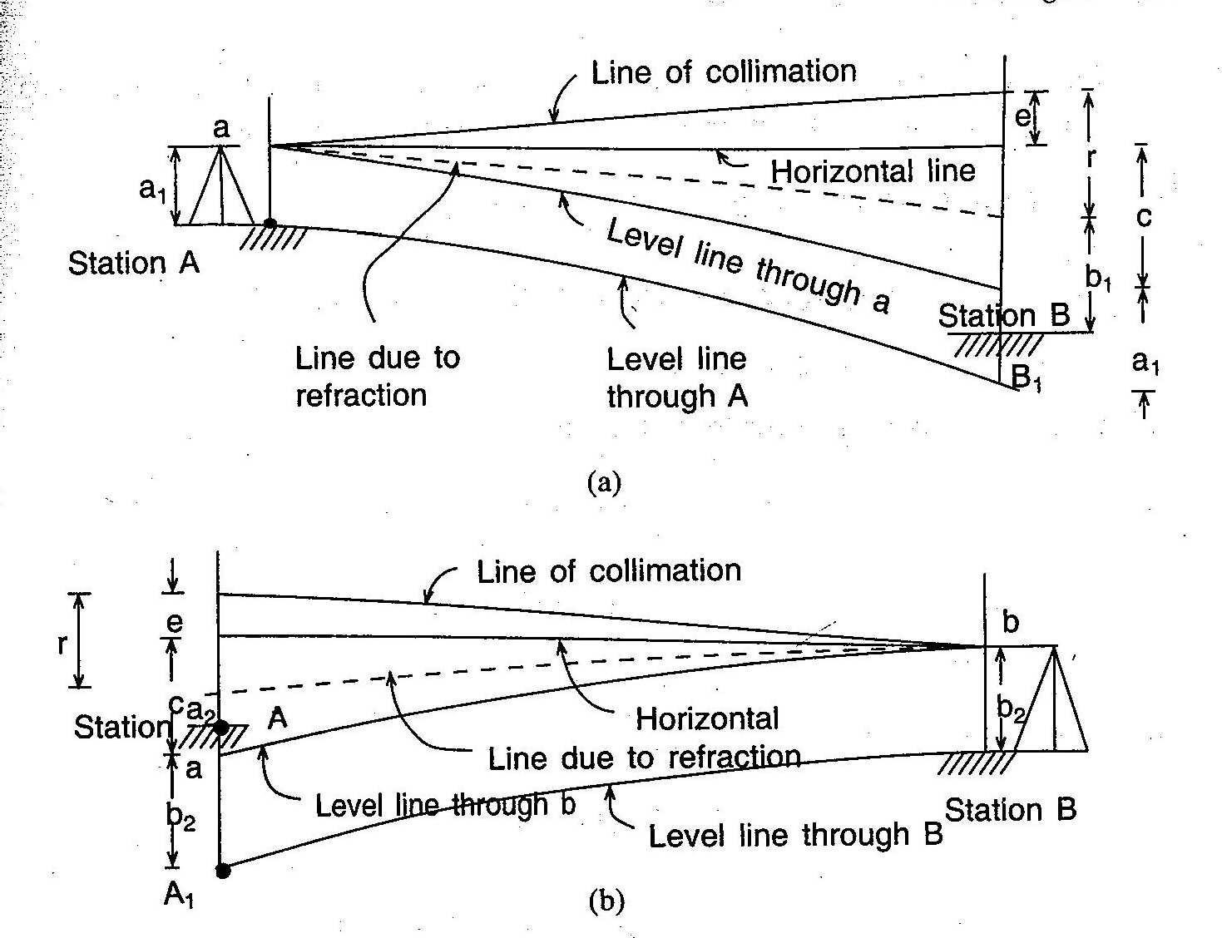
Fig:1.13

Reciprocallevelling:
Whilecrossingariverorravineitisnotpossibletoputthelevelmidwaysothatthebacksightand foresight are equal. Sight distance ,however, is long and errors due ti (i)collimation,(ii)curvature and refraction are likely to occur. To avoid these errors two observations are made.As shown in fig.instrumentisplacednearstationAandobservationsaremade.OnstaffsatAandB.Similarly instrument is placed near B and staff readings are taken on B and A.
Preciseleveling:PreciselevellingaimsatestablishingtheRLofapointwithhighestprecision.The objective of providing such high order of precision in the measurement is to establish network of Bench marks.Precise leveling employs precise level,precise leveling staff and all possible corrections in order to attain accuracy of highest orderin the Instrument.
FieldWork:1)Backsightsandforesightsaretakenwithinstrumentequidistantfromthestaffsfor eliminationof collimation errors,error due to curvature and refraction.(2)More than one setting at thesameinstrumentpositionwillhelpinthereductionoferror.(3)Readinginthestaffaretakenin three levels of stadia hairs.

Difficultiesinleveling:
- When the staff is too near the staff:if the staff is held very near the leveling instrument, the graduationsofthestaffarenotvisible.Insuchacseapieceofpaperismovedupanddownalong the staff until the edge of the paper is bisected by the line of collimation.Then the reading is noted from the staff with nacked eye.Sometimes the reading is taken by looking through the object glass.
- Levelling across a large pond or lake:As the water surface is level,all the points on it will have the same RL.Two pegs A and B are fixed on opposite banks of the lake or Pond.The tops ofthe pegs are just flush with the water surface.The level is set up at O1and the RL of A is determined bytakingtheFSonA.TheRLofBisassumedtobeequaltothatofA.Nowthelevelisshiftedand set up at O2.Then bytaking the BS on Peg B,leveling is continued (Ref:Fig.)

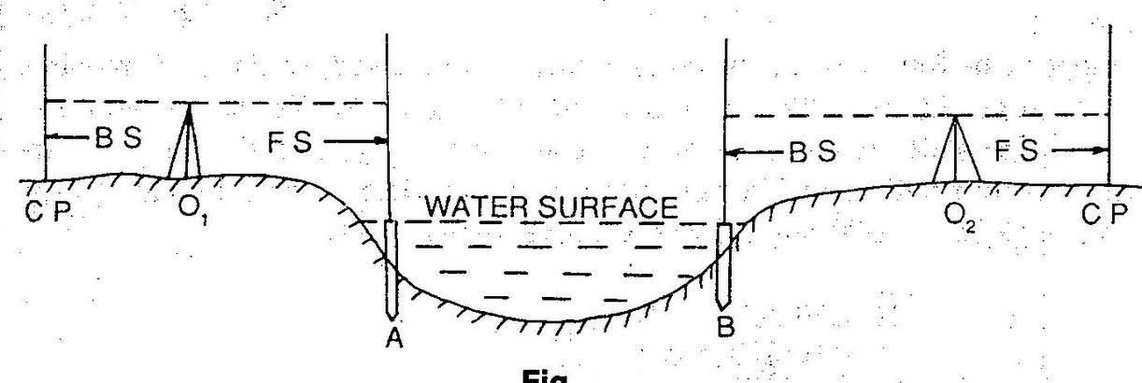
Fig:1.14
- Levelling across a River:In acse of a flowing water the surface cannot be considered to be level.The water levels on opposite edges will be different. In this case the method of Reciprocal leveling is followed.
- LevellingacrossaSolidwall: Whenlevelingiscarriedacrossabrickwall,twopegsAandBare drivenoneithersideofthewalljusttouchingit.ThelevelissetupatO1andastaffreadingistaken on A.Let this reading is Ac.Then the height of the wall is measured by staff.Let the ht.be AE.The HI is found out by taking aBS on any BM or CP,Then RL of A=HI-AC,RL of E=RL of A+AE=RL of F(Same level).The level is shifted to some point O2.The staff reading Bd is noted and the Ht. measured.ThusRLofB=RLofF-BF,HIatO2=RLofB+BD,Thelevelingisthencontinuedbyworking out the HI of the setting(Ref.Fig)
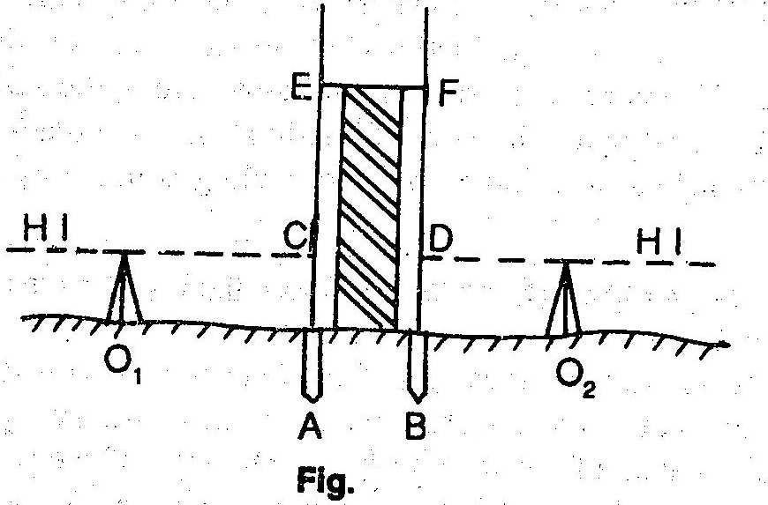
Fig:1.14

- When the BM is above the Line of collimation:This happens when the BM is at bottom of abridgegirderoronthebottomsurfaceofaculvert.SupposetheBMexistsonthebottomsurface ofaculvertandthatisrequiredtofindouttheRLofA.ThelevelisSetupatOandthestaffisheld inverted on the BM.The staff reading is taken and noted with a negative sign.The remark “staff held inverted” istobe entered in the appropriate coloumn.Letthe BS and FS readings be- 1.500 and 2.250 respectively. Now. HI=100.000-1.500=98.500,RL of A=98.500-2.250=95.250.
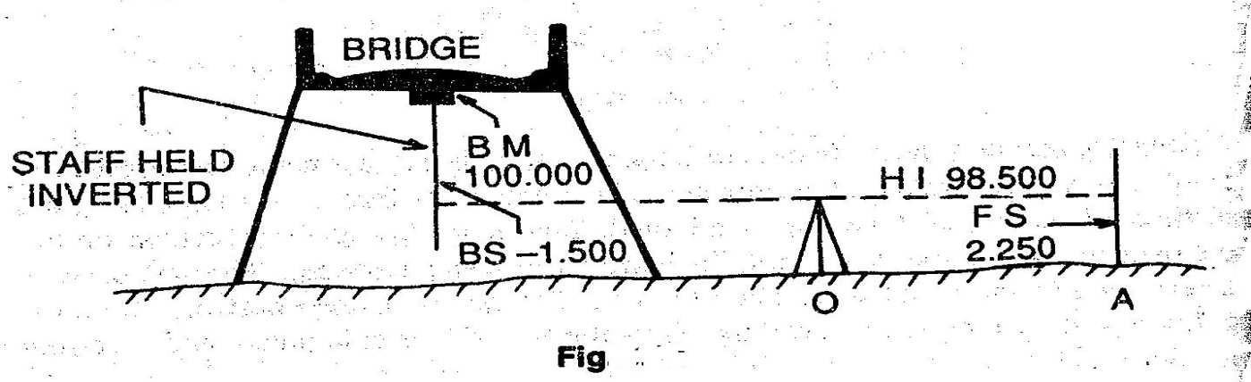
Fig.1.14
- Levellingalongasteepslope:Whilelevelingalongasteepslopeinahillyarea,itisverydifficult to have equal BS and FS distances.In such cases the level should be set up along a Zig- zag path so that the BS and FS distances may be kept equal.Let AB be the direction of leveling.I1,I2….are thepositionsofthelevelandS1,S2,S3…arethestaffposition(Ref.Fig.).levellingiscontinuedinthis manner and the RLs of the points are calculated.
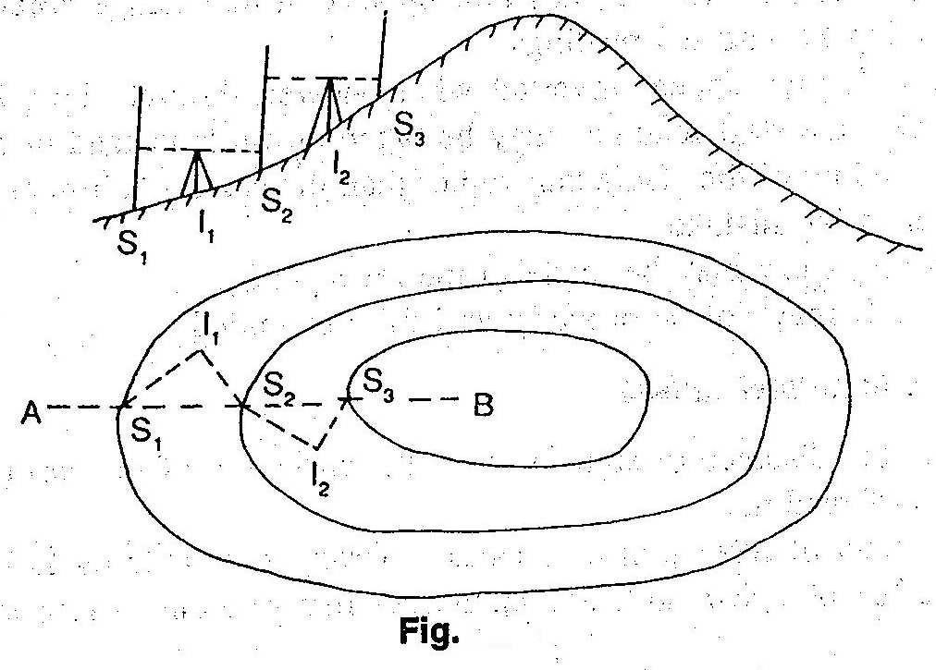
Fig:1.14

- Levelling across arising ground or depression:While levelling across high ground,the level should not be placed on top of this high ground,but on one side so that the line of collimation justpasses through the apex. While leveling across a depression, the level should be set up on one side and not at the bottom of the depression.(Ref:Fig.)
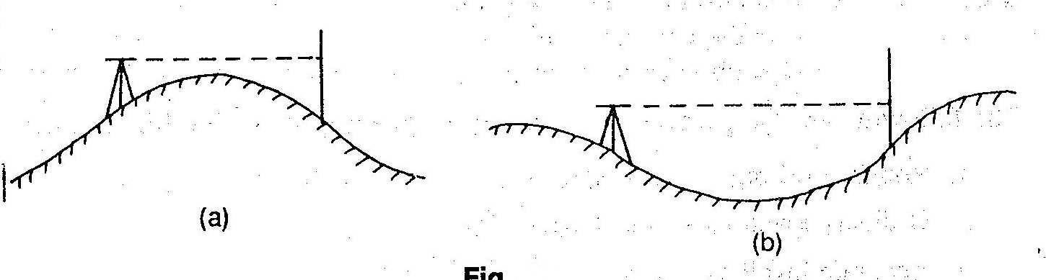
Fig:1.14

Errorsinlevellingandprecautions:
- Instrumentalerrors:(a)Thepermanentadjustmentoftheinstrumentmaynotbeperfect.That is the line of collimation may not be parallel to the axis of the bubble tube.(b)The internal arrangement of the focusing tube is not perfect.(c)The graduation of the leveling staff may not beperfect.
- Personal errors: (a)The instrument may not be leveled perfectly.(b)The focusing of eye piece and object glass may not be perfect and the parallax may not be eliminated entirely.(c)The position of the staff may be displaced at the change point at the time of taking FS and BS readings.(d)The staff may appear inverted when viewed through the telescope.By mistake,the staff readings may be taken upwards instead of downwards..(e)The reading of the stadia hair ratherthan the central collimation hair maybetaken bymistake.(f)Awrongentrymaybemade in the level book.(g)The staff may not be properly and fully extended.
- Errors due to natural Causes:(a)When the distance of sight is too long, the curvature of the earthmayeffectthe staff reading.(b)The effectofrefraction maycause awrongstaffreadingto be taken.(c)The effect of high winds and a shining Sun mayresult in a wrong staff reading.

Sensitivenessofbubbletube.
The sensitivity of the level tube depends on the Radius of curvature( R) and usually expressed as θ per unit division(d).This angle may vary from 1” to 2” in the case of precise level,up to 10” to 30” on engineer’s level..

Permanentadjustmentofdifferenttypesoflevels:
The establishment of desired relationship between fundamental lines of a levelling instrument is termed as permanent adjustment.So,permanent adjustment indicates the rectification of instrumental errors.
Thefundamentallinesareasfollows:
- The line of collimation,(2)The axis of the bubble tube,(3)The vertical axis,(4)The axis of telescope.
.

CONTOURING:
2.1Definationsofrelatedterms,conceptsofcontours,characteristicsofcontours:
- Contour line:The line of intersection of a level surface with the ground surface is known as the contourlineorsimply thecontour.It can also be defined as aline passing through points of equal reduced levels.
- Contourline:Thelineofintersectionofalevelsurfacewiththegroundsurfaceisknownasthe contour line or simplythe contour.It can also be defined as a line passing through points of equal reduced levels.
Forexample,acontourof100inindicatesthatallthepointsonthislinehaveanRLof100m. Similarly,inacontourof99min,allthepointshaveanRLof99in,andsoon(Fig.).Amap showing only the contour lines of anar e aiscalledacontourmap.

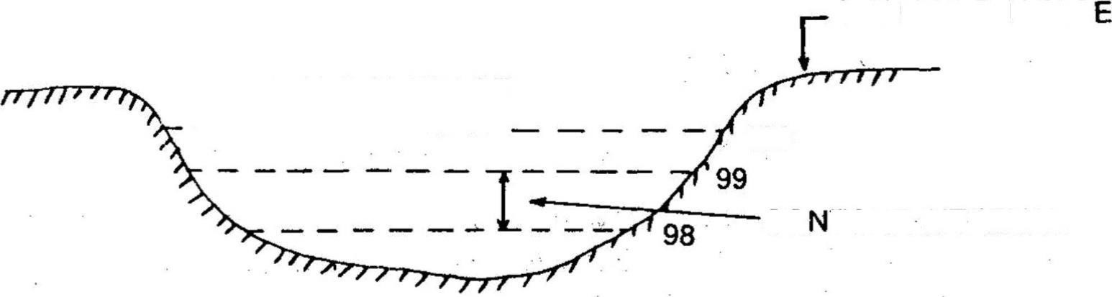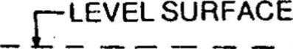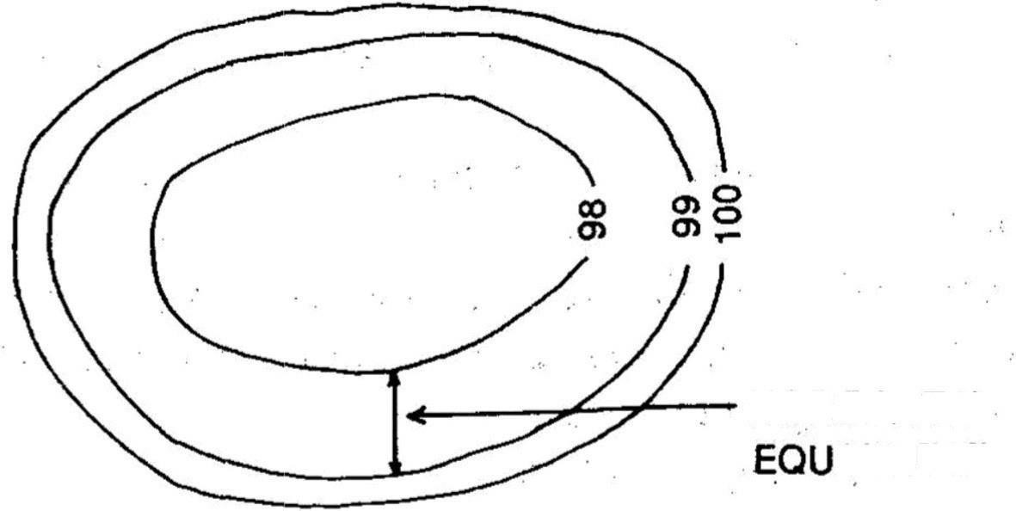
HORIZONTAL
IVALENT
Fig.2.1

  - Contour Interval: The verticaldistance between any two consecutivecontours isknownas acontourinterval.Supposeamapincludescontourlinesof100in,98in,96in,andso on. The contour interval here is 2 m. This interval depends upon: (i) the nature of the ground (i.e.whetherflatorsteep),(ii)thescaleofthemap,and(iii)thepurposeofthesurvey.
Contourintervalsforflatcountryaregenerallysmall,e.g.0.25 in, 0.50in,
0.75in,etc.Thecontourintervalforasteepslopeinahillyareaisgenerallygreater,e.g.5m,10m, 15m, etc.
Again for a small-scale map, the interval may be of 1 in, 2 in, 3 in, etc. and for L a r g es c a l e mapitmaybeof0.25m,0.50m0.75metc.Itshouldberememberedthatthe contourintervalforaparticularmapisconstant.Thehorizontaldistancebetweenany twoconsecutivecontoursisknown as horizontal equivalent. It isnot constant. It varies accordingtothe steepnessoftheground.Forsteepslopes,thecontourlinesrunclosertogether,andforflatterslopes they are widely spread.

2.1:Methodsofcontouring,plottingcontourmaps OBJECT0FPREPARING CONTOUR MAP:
Thegeneralmapofacountryincludesthelocationsofroads,railwaysriversVillages,towns,andso on. But the nature of the ground surface cannot be realised, from such a map. However, for all engineeringprojectsinvolvingroads.railways,andsoon,aknowledgeofthenatureoftheground surface is required for locat- ing suitable alignments and estimating the volume of earth work. Therefore,thecontourmapisessentialforallengineeringproject.Thisiswhycontourmapsare prepared.
USESOFCONTOURMAP:
Thefollowingarethespecificuses ofthecontourmap:
Thenatureoftheground surfaceof acountrycanbeunderstoodby studyingacontourmap.Hence,the possiblerouteofcommunicationbetweendifferentplacescan be demarcated.
A suitable site or an economical alignment can be selected for any engineering project. Thecapacityofareservoirortheareaofacatchmentcanbeapproximatelycomputed.
Theintervisibilityorotherwiseofdifferentpointscanbeestablished. Asuitableroute foragiven gradientcanbemarkedonthemap.
Asectionofthe groundsurfacecanbedrawninanydirectionfromthecontourmap.Quantitiesof earthworkcan be approximately computed.
Characteristics of Contours:1.(Ref Fig. ) the contour lines are closer near the top of a hill or high ground andwideapartnearthefoot. Thisindicatesaverysteepslopetowardsthepeak andaflatterslope towards thefoot.

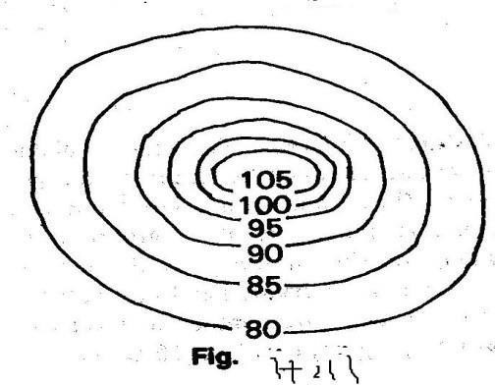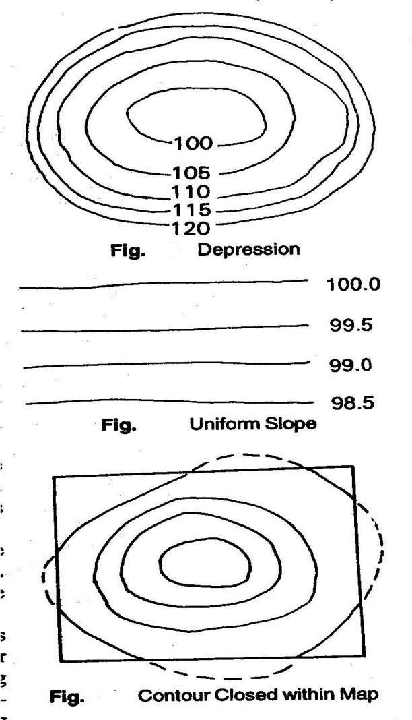

Fig:2.1

- InFig.thecontourlinesareclosernearthebankof apondordepressionand wideapart towardsthecentre.Thisindicatesasteepslope nearthe bankandaflatterslopeatthecentre.
3.Uniformlyspaced,contourlinesindicateauniformslope(Fig..‘-).
- Contourlinesalwaysforma closedcircuit.Buttheseinesmay bewithinor outsidethe limitsofthemap(Fig.)
- Contourlinescannotcrossoneanother,exceptinthecaseofan overhangingcliff.But theover-lapping portion mustbeshown bya dottedline(Fig.).
- Whenthehighervalueareinsidetheloop,it indicatesaridge line.Contour linescrossridge linesat right angles (Fig. ’).

- Whenthe lowervalues areinsidietheloop,it indicates avalleyline.Contourlinescrossthevalley line at rightangles(Fig. ).

- Aseriesofclosed contours always indicatesa depression or summit. The lower values being inside the loop indicates adepre- ssion andthe higher values being Insidetheloop indicatesa summit. (Fig.).
- Depressionsbetweensummitarecalledsaddles(Fig.)
- Contourlinesmeetingata pointindicateaverticalcliff.

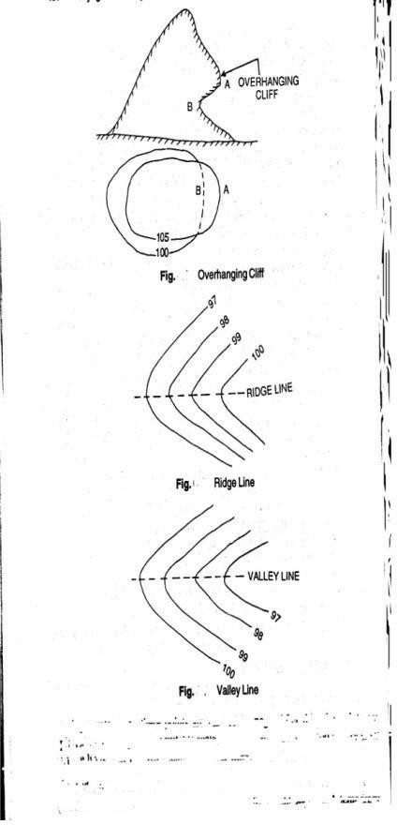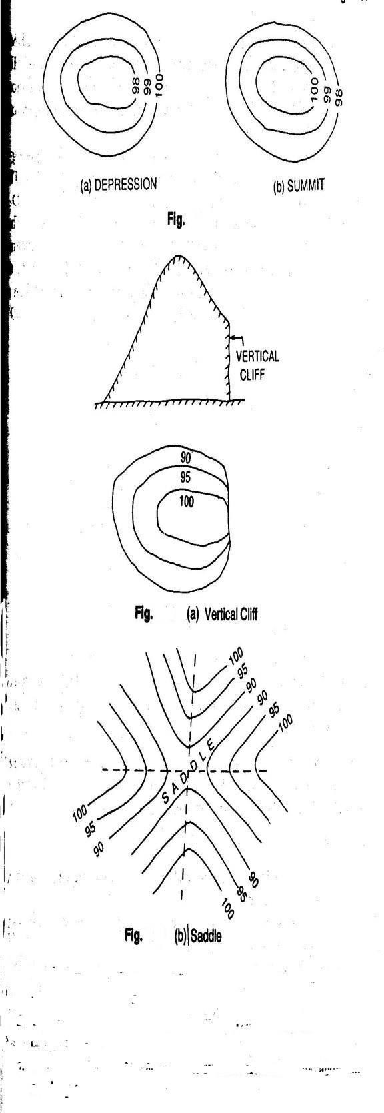

Fig:2.1

METHODSOFCONTOURING
Therearetwomethodsofcontouring----directand indirect.

A)DirectMethod:
Theremaybetwocases,asoutlinedbelow.
Case-I:Whentheareaisoblongandcannotbecontrolledfromasinglestation:Inthismethod,the variouspointsonanycontourarelocatedonthegroundbytakinglevels.Thenthesepointsare marked by pegs. After this,the points are plotted on the map to any suitable scale ,by plane table.Thismethodis veryslow. Andtedious.Butitgivesaccuratecontourlines.
Procedure:1)Supposeacontourmapistobepreparedforanoblongarea.AtemporaryBenchmark issetupnearthesitebytakingflylevelreadingsfromapermanentbenchmark.(2)Thelevelis thensetupatasuitablepositionLfromwheremaximum areacanbecovered.(3)ThePlane tableissetupatasuitablestationPfromwheretheaboveareacanbeplotted.(4)Abacksight reading is taken on the TBM. Suppose the RL of the TBM is249.500 m and that the BS readingis2.250m.thentheRLof HI251.750m.Ifscontourof250.000isrequired,thestaffreading shouldbe1.750m.Ifacontourof249.000misrequired,thestaffreadingshouldbe2.750m, and so on.(5)The staff man holds the staff at different points of the area by movingUp and down, or left and right, until the staff reading is exactly 1.750. Then,the points are marked by pegs.Suppose,these points are A, B, C, D,….

- AsuitablepointpisselectedonthesheettorepresentthestationP.Withthealidadetouchingp, raysaredrawntoA,B,CandD.TuedistancesPA,PB,PCandPDaremeasuredandplottedtoasuitable scale. In This manner, the points a, b, c and d of the contour line of RL 250.000m are obtained. These points arejoined toobtain thecontour of250.000m
- Similarly,thepointsoftheothercontoursarefixated.(8)Whenrequired,thelevellinginstrument and the plane table are shifted and set up in a new position in order to continue the operation along the oblongarea.

‘

Case-II:Whentheareaissmallandcanbecontrolledfromasinglestation:Inthiscase,themethodof radiallinesisadoptedtoobtaincontourmap.Thisisalsoveryslowandtedious, butgivestheactual contour lines.

DirectMethod:

- TheplanetableissetupatasuitablestationPfromwherethewholeareacanbecommanded.

- ApointpissuitablyselectedonthesheettorepresentthestationP.Radiallines arethen drawn in different directions.
- Atemporarybench-markisestablishednearthesite.ThelevelissetupatasuitablepositionLand aBSreadingistakenontheTBM.LettheHIinthissettingbe153.250m.So,toFindthecontour of RL, 152.000 in a staff reading of 1.250 in is required at a particular point, so that the RL of contourofthatpointcomesto152.000m.

RL=HI—Staffreading
=153.250—1.250=152.000in

- The staff man holds the staff along the rays drawn from the plane table station in such a waythat the staff reading on that point is exactly1.25In this manner, points A, B, C, D and E are located on the ground, where the staff readings are exactly 1.250.(5)The distances PA, PB, PC, PD and PE are measured and plotted to anysuitable scale. Thus the points a, b, c, d and e are obtained which are joined in order to obtain a contour of 152.000.(6)The other contours may be located in similar fashion(Fig. ).

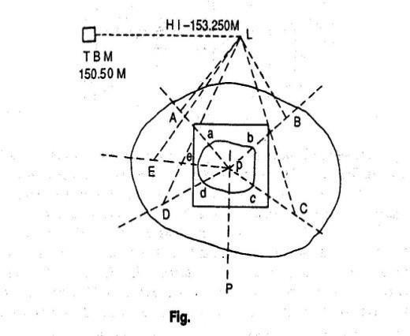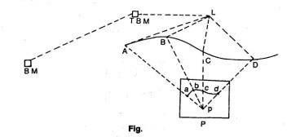

Fig:2.2
Indirect Method: In this method, the RLs of different points (spot levels) are taken at regularintervals along a series oflines set up on theground. Thepositions ofthesepoints are plotted on a sheet to any suitable scale. The spot levels are noted at the respective points. Then the pointsof contour lines are found out by interpolation, after which they arejoinedtogettherequiredcontourlines.Althoughveryquick,thismethodgivesonlythe approximatepositionsofthecontourlines.Thismethodcanbeadoptedintwoways,(i)cross- sections, and(ii) squares.

- Using Cross-sections: In this method, a base line, centre line or profile line is considered. Cross-sections are taken perpendicular to this line at regularintervals (say 50 m,100m etc.). After this, points are marked along the cross-sections at-regular intervals(say,5m,10m,etc).Atemporarybench-markissetupnearthesite.Staffreadings are taken along the base line and the cross-sections. The readings are entered in the levelbook;thebaselineandthecross-sectionsshouldalsobementioned.TheRLofeachof the points calculated. Then the base fine and cross-sections are plotted to a suitable scale. Subsequently the RLsoftherespectivepointsarenotedonthemap,after which the required contour line is drawn by interpolation . This method is suitable for route survey,when the cross sections are taken transverse to thelongitudinal section.

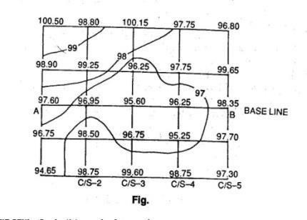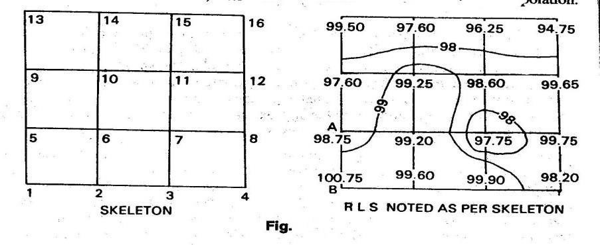
Fig:2.2

- UsingSquares:Inthismethod,theareaisdividedintoanumberofsquares.Thesizeof thesesquaresdependsuponthenatureandextentoftheground.Generallytheyhavea sidesvaryingfrom5to20m.Thecornersofthe squaresarenumberedserially, as1,2,3,…..A temporarybenchmarkissetupnearthesite,andthelevelissetupatasuitableposition. Thestaffreadingsonthecornersofthesquaresaretakenandnotedinthelevelbook maintainingthe sequenceofthe serial numbers of the corners. The RLs ofall the corners are calculated.Theskeletonsofthesquaresareplottedtoasuitablescale.TherespectiveRLs on the corners,after which the contour lines aredrawn byinterpolation.

2.3Interpretetionofcontourmaps,toposheets:
MethodofInterpolationofContours:Theprocess of locatingthecontoursproportionately betweentheplotted points istermed interpolation. Thiscan bedoneby:
- ArithmeticalCalculation:LetAand Bbetwocorners ofthesquares.TheRLofA is98.75m,and that of B 100.75m.The horizontal distance between A and B is 10m,Horizontal distance betweenAandB=10m,VerticaldistancebetweenAandB=100.75-98.75=2m,Letacontourof 99.00m be
required.Then,differenceoflevelbetweenAand99.00mcontour=99.00-98.75=0.25m,mDistance
10
of99.00mcontourlinefromA=x0.25=1.25m.Thiscalculateddistanceisplottedtothesamescale
2

inwhichthe skeletonwas plotted, toobtain apointofRL of99.00m,Similarly the other pointis located.

- Bygraphicalmethod:Onasheetoftracing paper,alineABisdrawnanddividedinto equalparts. AB is bisected at C, and a perpendicular is drawn at this point. A point O is selected on this perpendicular.ThenradiallinesaredrawnfromOtothedivisionsonAB.Theselinesserveasguide

lines.Theboundarylineandeveryfifthlineismarkedwithathickorredline.Supposewehaveto interpolatea2m contourintervalbetween two points a and b ofRLs92.5 and 100.75m.Let usconsider thelowestradiallineOBtorepresentanRLof90.00.Soeveryfifthline(whichisboldredorred)will represent95.100,105,etc.Thetracingpaperismovedovertheplanuntilaliesat92.5 andbat 100.25.Lineab should beparallelto AB.Nowthe points 94,96,98,100 arepickedthrough toobtain the positions of the required contour.
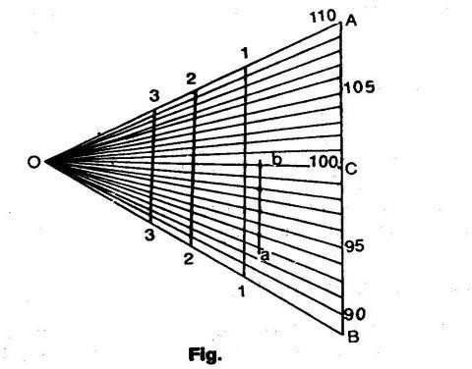

Fig:2.3

2.4Useofcontourmapsoncivilengineeringprojects-drawingcross-sectionsfromcontourmaps, locating:
Sinceacontourmapis a threedimensional representation oftheearth’s surface. it furnishes alot of information. Some of the uses that a contour map can be put to are as follows.
ded.

THEODOLITESURVEYINGANDTRAVERSING

INTRODUCTION
An instrument used for measuring horizontal and vertical angles accurately, is known as atheodolite.Theodoliteisalsouseforprolongationorsurveyline,findingdifferenceinelevation and setting out engineering work requiring higher precision I.e. ranging the highway and railway curves,aligning tunnels ,etc.

PARTSOFATRANSITTHEODOLITE:-
Atransittheodoliteconsistsofthefollowingessentialparts:
- Levelinghead:-Itconsistsoftwopartsi.e.uppertribarchandlowertribarch.
  - The upper tribarch: - It has three arms. Each arm carries a leveling screw.levellingr screw are provided for supporting leveling the instrument. The boss of the upper tribarch is pierced with a female axis in which lower male vertical axis operates.
  - Thelowertribarch: -ithasacircularholethroughwhichaplumbbobmaybe suspended for centering the instrument quickly and accurately.
Thethreedistinctfunctionsofalevelinghead are:
- Tosupportthemainpartoftheinstrument.
- Toattachthetheodolitetothetripod.
- Toprovideameansforlevelingthetheodolite.
- Lowerplates(orscaleplate).Thelowerplatewhichisattachedtotheouterspindlecarries ahorizontalgraduatedcircleatitsbevelededge.Itistheforesometimeknownasthescaleplate. It is divided into 360°. Each degree is further divided into ten minutes or twenty minutes arc intervals .Scale plate can be clamped at any position by clamping screw and a corresponding slow motion can be made with atangential screw or slow motion screw.When the lower clamp is tightened, the lower plate is fixed to the upper tribarch of the leveling head .The size of the theodolite is determined by the size of the diameter of the lower plate.
- Upper plate (or vernier plate): - The upper plate or vernier plate is attached to the inner spindleaxis.Twoverniersarescrewedtotheupperplatediametricallyopposite.Thisplateis so constructed that it overlaps and protests the lower plate containing the horizontal circle completely except at the parts exposed just below the verniers. The verniers are fitted with magnifiers.Theupperplate supportstheYsorAswhichprovidethebearingstothepivotsof the telescope. It carries an upper clamp screw and a corresponding tangent screw for accurately fixing to the lower plate on clamping the upper clamp and unclamping the lower clamp, the instrument may be rotate on this outer spindle without any relative motion betweentwoplates.Ontheotherhandifthelowerclampscrewistightenedandupperclamp

screwisunclamped,theinstrumentmayberotateabouttheinnerspindlewitharelative

motionbetweenthevernierandthegraduatedscaleofthelowerplate.Thispropertyisutilized for measuring the angle between two settings of the instrument. It may be ensured that the clamping screws are properly tightened before using the tangent screws for a finer setting.
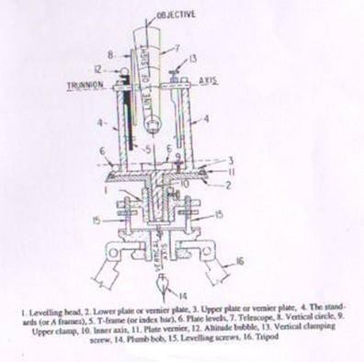
Fig.3.1 Showspartsoftransit theodolite

- The standards (or A frame): - Two standards resembling the English letter A are firmly attached to the upper p[late. The tops of these standards form the bearing of the pivots of thetelescope.Thestandardsaremadesufficientlyhightoallowtherotationofthetelescope on its horizontal axis in vertical plane. The T-frame and the arm of vertical circle clamp are also attached to the standards.
- T-frameorindexbar:-ItisT-shapedandiscenteredonthehorizontalaxisofthetelescopein theframeoftheverticalcircle.ThetwoverniersCandDareprovidedonitattheendsofthe horizontalarms,calledtheindexarm.Averticallegknownasclippingarmisprovidedwitha fork and two clipping screw at its lower extremity. The index and clipping arms together are known as T-frame. At the top of this frame, if attached a bubble tube which is called the altitude bubble tube.
- Plate levels: - The upper plate carries two plate levels placed at right angles to each other. Oneoftheplatebubblesiskeptparalleltothetrunnionaxis.Theplatelevelscanbecentered with the help of the foot screws. In some theodolites onlyone plate level is provided.
- Telescope:-Thetelescopesmaybeclassifiedas
  - Theexternalfocusingtelescope

  - Theinternalfocusingtelescope.

DEFINATIONSANDOTHERTECHNOICALTERMS
Followingtermsareusedwhilemakingobservationswithatheodolite.
- Verticalaxis:-Theaxisaboutwhichthetheodolite, mayberotatedinahorizontalplane, is called vertical axis. Both upper and lower plates maybe rotated about vertical axis.
- Horizontal axis:- The axis about which the telescope along with the vertical circle of a theodolite,mayberotated inverticalplane,iscalledhorizontalaxis.Itisalso sometimes called trunnion axis or traverse axis.
- Line of collimation: - The line which passes through the intersection of the cross hair of the eye piece and optical center of the objective and its continuation is called line of collimation. The angle between the line of collimation and the line perpendicular to the horizontal axis is called error of collimation.
The line passing through the eye piece and any point on the objective is called line of sight.
- Axis of telescope: - The axis about which the telescope may be rotated is called axis of telescope.
- Axisoftheleveltube:-Thestraightlinewhichthetangentialtolongitudinalcurveofthe level tube at its center is called the axis of the level tube. When the bubble 0f the level tube is central, the axis of the level tube becomes horizontal.

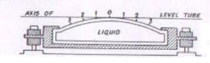

Fig.3.2Crosssection ofleveltube
- Centering:-The processof settingupatheodolite exactlyovertheground station mark, is known as centering. It is achieved when the vertical axis of the theodolite is made to pass through the ground station mark.
- Transiting:-Theprocessofturningthetelescopeinverticalplanethrough180˚aboutits horizontal axis is known as transiting. The process is also sometimes known as reversing or plunging.
- Swing: - A continuousmotion ofthetelescope aboutthe vertical axisinhorizontalplane iscalledswing.Theswingmaybeineitherdirectioni.e.leftorright.Whenthetelescope is rotate in the clockwise right direction, it is known as right swing. If it is rotated in the

anticlockwiseleftdirectionitisknownasleftswing.

- Face left observations: - When the vertical circle is on the left. of the telescope atthetime of observations, the observations of the angles are known as face left observations.
- Faceright observations: - When the vertical circle is on the right of thetelescope atthe time of observations, the observations of the angles are known as face right observations.
- Changingface:-Itistheoperation ofchangingthefaceofthetelescope fromleft tomright and vice-versa.
- Telescope normal: - Telescope is said to be normal when its vertical circle is to its left and the bubble of the telescope is up.
- Telescopeinverted:-Atelescopeissaidtobeinvertedorreversedwhenits verticalcircle is to its right and the bubble of the telescope is down.

FUNDAMENTALLINESOFATRANSITTHEODOLITE
Thefundamentallinesofatransittheodoliteare:
- Theverticalaxis
- Theaxisofplatebubble
- Thelineofcollimationwhichisalsosometimescalledlineofsight.
- Thehorizontalaxis,transverseaxisortrunnion axis.
- Thebubblelineoftelescopebubbleoraltitudebubble.

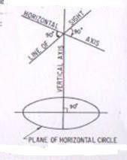
Fig.3.3Fundamentallinesoftransittheodolite

ADJUSTMENTSOFTHEODOLITE

Theadjustmentsoftheodolitesareoftwokinds.
- Temporaryadjustment
- Permanentadjustment
Temporary adjustments: The adjustments which are required to be made at every instrument station before making observations are known as temporary adjustments.
Thetemporaryadjustmentsofatheodoliteincludethefollowing:
- Settingupthetheodoliteoverthestation.
- Levelingofthetheodolite
- Eliminationoftheparallax.
  - Setting up: - The operation of setting up a theodolite includes the centering of the theodolite over the ground mark and also approximate leveling with the help of tripod legs.
  - Centering: - The operation with which vertical axis of the theodolite represented by a plumb line, is made to pass through the ground station mark is called centering.

Theoperationofcenteringiscarried outinfollowingsteps:
    - Suspend the plumb bob with a string attached to the hook fitted to the bottom ofthe instrument to define the vertical axis.
    - Place the theodolite over the station markbyspreadingthe legs well apart so thattelescope is at a convenient height.
    - The centering may be done by moving the legs radially and circumferentially till the plumb bob hangs within 1cm horizontally of the station mark.
    - By unclamping the center shifting arrangement, the finer centering may now bemade.

Approximatelevelingwith thehelpofthetripod:
Itisverynecessarytoensurethatthelevelofthetripodheadisapproximatelylevelbefore centeringisdone.Incasethereisaconsiderabledislevelment,thecenteringwillbedisturbedwhen leveling is done. The approximate levelling may be done either with reference to a small circular bubble provided on the tribarch or by eye judgment.

Levelling of a theodolite: The operation of the making the vertical axis of a theodolite truly vertical is known as leveling of the theodolite.
Afterhavingleveledapproximatelyandcenteredaccurately,accuratelevelingisdonewith the help of plate levels. Two methods of leveling are adopted to the theodolites, depending upon the number of leveling screws.
Levellingwiththreescrewhead:-Thefollowingstepsareinvolved

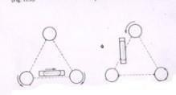
Fig.3.4Levelingofatheodolitewithathreescrewhead
- Turn the horizontal plate until the longitudinal axis of the plate level is approximately parallel to line joining any two leveling screws [fig (a)].
- Bring the bubble to the center of its run by turning both foot screws simultaneously in opposite directions either inwards or outwards. The movement of the left thumb indicatesthe direction of movement of the bubble.
- Turntheinstrumentthrough180˚inazimuth.
- Note the position of the bubble. If it occupies a different position, move it by means ofthe same foot screws to the approximate mean of the two positions.
- Turnthetheodolitethrough90˚inaazimuthsothattheplatelevelbecomes perpendicular to the previous position [fig. (b)].
- With the help of the third foot screw move the bubble to the approximate mean positionalready indicated.
- Repeattheprocessuntilthebubbleretainsthesamepositionforeverysettingof theinstrument in azimuth.
The mean position of the bubble is called the zero of the level tube. If the theodolite is provided with two plate levels placed perpendicular to each other, the instrument is not required to be turned through 90˚.in this case, the longer plate level is keptparalleltoanytwofootscrewsandthebubbleisbroughttocentralpositionbyturning both the foot screws simultaneously. Now with the help of the third foot screw, bring the bubble of second plate level central. Repeat the process till both the plate bubbles occupy the central position of their run for all the positions of the instrument.
ELEMATION OF PARALLAX: - An apparent change in the position of the object caused by change in position of the surveyor’s eye is known as parallax.
In atelescopeparallax is caused whentheimageformedbytheobjectiveisnot situated intheplaneofthecrosshairs.Unlessparallaxisremovedaccuratebisectionsandsightingof

objectsbecomedifficult.

Elimination of parallax may be done by focusing the eye piece for distinct vision of cross hairs and focusing the objective to bring the image of the object in the plane of the cross-hairs as discussed below.
Focusing the eye piece: To focus the eye-piece for distinct vision of cross hairs, either holds a whitepaperinfrontoftheobjectiveorsightthetelescopetowardsthesky. Movetheeyepiecein or out till the cross hairs are seen sharp and distinct.
Focusing the objective: After cross hairs have been properly focused, direct the telescope on a welldefineddistantobjectandintersectitwithverticalwire.Focustheobjectivetillasharpimage is seen. Removal of the parallax may be checked by moving the eye slowly to one side. If the object still appears intersected, there is no parallax.
If, on moving the eye laterally, the image of the object appears to move in the same direction as the eye, the observer’s eye and the image of the object are on the opposite sidesof the vertical wire. The image of the object andthe eye are brought nearer to eliminate theparallax. This parallax is called far parallax.
If,ontheotherhand,theimageappearstomoveinreversedirectiontothemovement oftheeye, theobserver’s eyeandtheimageoftheobjectareonthesamesideoftheverticalwire andtheparallaxisthencallednearparallax.Itmayberemovedbyincreasingthedistancebetween the image and the eye.

MISCELLANEOUSUSESOFTHEODOLITE:
Theodolitesarecommonlyusedforthefollowingoperations.
- Measurementsofhorizontalangles.
- Measurementsofverticalangles.
- Measurementsofmagneticbearingoflines.
- Measurementsofdirectangles.
- Measurementsofdeflectionangels.
- Prolongationofstraightlines.
- Runningastraightlinebetweentwopoints.
- Layingoffananglebyrepetition method.

Measurementofhorizontalangles
- Tomeasuretheanglebymethodofrepetition:-

LetABCbetherequiredanglebetweensidesBAandBCtobemeasuredbyrepetitio0n methodasshownin Fig 3.5.Whenthemeasureofan angleissmall,slighterrorinitssine value introduce a considerable error in the computed sides as the sine value of the angle changes rapidly. Therefore, for accurate and precise work, the method of repetition is generallyused. Inthismethod,Thevalueoftheangleisaddedseveraltimesmechanically and the accurate value of the angular measure is determined by dividing the accumulated reading by the number of repetition.
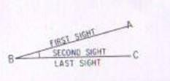
Fig.3.5 Methodofrepetition
- To measure the angle by reiteration method: When several angles having a commonvertex,aretobemeasuredthereiterationmethodisgenerallyadopted. Inthismethod angles aremeasured successivelystartingfroma referencestation and finally closing on the same station. The operation of making last observation on the starting station is known as closing horizon. Making observations on the starting station twice provides a check on the sum of all angles around a station. The sum should invariably be equal to 360˚, provided the instrument is not disturbedduringobservations.Astheanglesaremeasuredbysightingthestations in turn, this method is sometimes known as direction method of observation of thehorizontal angles.
  - Measurement of vertical angles: A vertical angle may be defined as the angle subtended bythe inclined lineof sightandthehorizontallineof sightat the station in vertical plane. If the point sighted is above the horizontal axis of the theodolite, the vertical angle is known as angle of elevation and if it is below, it is known as angle of depression.
Procedure: To measure a vertical angle subtended by the station B at the instrument station A, The following steps are involved:

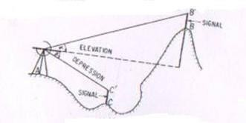

Fig.3.6.Measurementofverticalangle.
    - Set up the theodolite over the ground station mark A. Level it accurately by using the altitude bubble.
    - Set the zero of the vertical vernier exactly in coincidence with zero of the vertical scale using vertical clamp and vertical tangent screw. Check up whetherthebubbleofthealtitudeleveliscentralof itsrun.Ifnot,bringitto the centre of its run by means of the clip screw. In this position, the line of collimation of the telescope is horizontal and the verniers read to zero.
    - Loosen the vertical circle clamp and move the telescope in vertical plane until the station B is brought in field of view. Use verticalcircle tangent screw for accurate bisection.
    - Read both the verniers of the vertical circle. The mean of two vernier readings gives the value of the vertical angle.
    - Change the face of the instrument and make the observations exactly in similar way as on the face left.
    - The average of two values of the vertical angle is the required value of the vertical angle.
  - Measurement of magnetic bearing of a line: To measure the magnetic bearing of a line AB, the theodolite should be provided with either a circular or a trough compass. The following steps are involved:
- CentreandleveltheinstrumentaccuratelyonstationA.
- Settheverniertoreadzero.
- Loosenthelowerplateandalsoreleasethemagneticneedle.
- Swing the telescope about its vertical axis until the magnetic needle points S- N graduations of the compass box scale.
- Clampthelowerplate.Usingthelowertangentscrewbringtheneedleexactly against the zero graduation is exact coincidence with the north end of the needle.
- In this position, the line of collimation of the telescope lies in the magnetic meridianattheplacewhileverniersstillreadstozero.Thesettingofthe

instrumentisnowsaidtobeorientedonthemagneticmeridian.

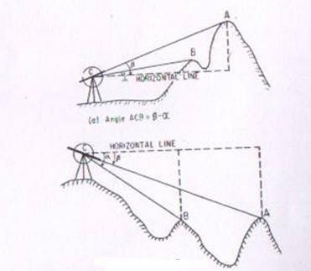
(b)AngleACB=α-β
Fig.3.7Measurementof verticalangle
- Loosen the upper plate, swing the instrument and bisect B accurately, usingthe upper tangent screw.
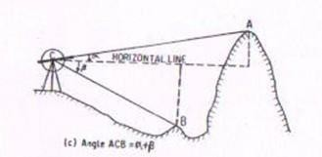
Fig.3.7Measurementof verticalangle
- Readboththevernier.Themeansofthetworeadingsistherequired magneticbearing of the line AB.
- Changethefaceoftheinstrumentandobservethemagneticbearingexactly ina similar way as on the left face.
- The mean of magnetic bearings observed on both faces is the accurate valueof the magnetic bearing of line AB.

  - Measurementofdirectangles:Theanglemeasuredclockwisefromtheprecedingline tothefollowinglineiscalledadirectangle.Theseanglesarealsosometimesknownas azimuths from the back line, or angles to the right and may vary from 0˚ to 360˚.

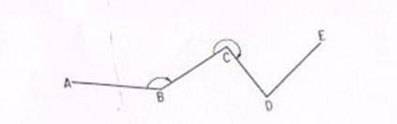
Fig.3.8Measurementof directangles

  - Measurement of deflection angles: The angle which any survey line makes with the prolongation of the preceding line is calleddeflection angle. Its value may vary from 0˚ to 180˚ and is designated as right deflection angle if it is measured in clockwise direction and as left deflection angle if it is measured in an anticlockwise direction. In fig. the deflection angles α and δ at stations B and E respectively are left deflection angles whereas angles βand γ at stations C and D are right deflection angles.
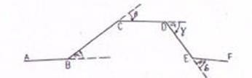

Fig.3.9Measurementofdeflectionangles
  - Prolongation of a straight line: Prolongation of any straight line AB to a point F may be done by any one of the following methods:

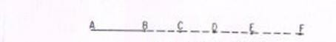
Firstmethod:-

Fig.3.10Prolongationofaline

Thefollowingstepsareinvolved:

    - SetupthetheodoliteatA,center andlevelitaccurately.

    - BisectanarrowcenteredoverthemarkatB.
    - EstablishapointCinthelineofsightataconvenientdistance.
    - Shifttheinstrumentto B.
    - Centered t5he theodolite over B, level it and sight C. Establish another pointD.
    - ProceedinasimilarmanneruntilthedesirepointFisestablished.

Secondmethod:-
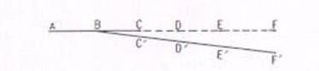
Fig.3.11Prolongationofaline The following steps are involved:
      - SetupthetheodoliteatBandcenteredit carefully.
      - BisectAaccuratelyandclampboththeplates.
      - PlungethetelescopeandestablishapointCinthelineofsight.
      - ShifttheinstrumenttoCandcenteritcarefully.
      - Bisect Band clampboththeplates.
      - PlungethetelescopeandestablishthepointDinthelineofsight.
      - ContinuetheprocesstillthelastpointFisestablished. NOTE: -
Thefollowingpoints maybenoted.
        - If the instrument is in perfect adjustment, the points B, C, D, E and F will lie in a straight line.
        - Ifthelineofcollimationisnotperpendiculartothehorizontalaxis, theestablished point C’, D’, E’ and F’ would lie on a curve.

Thirdmethod:-
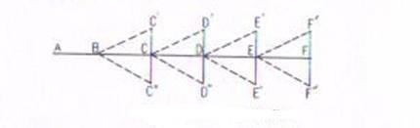
Fig.3.12Prolongationofaline Following steps are involved
- SetupthetheodoliteatBandcenterit carefully.
- BisectAonfaceleftandclampboththeplates.
- PlungethetelescopeandestablishapointC’.
- ChangethefaceandbisectAagain.
- PlungethetelescopeandestablishapointC’atthesamedistanceas
C’fromB.
- Iftheinstrumentisinadjustment,thepointC’andC’’willcoinside.
- IfnotestablishapointCmidwaybetweenC’andC”.
- ShifttheinstrumenttoCandrepeattheprocesstoestablishapoint D.
- RepeattheprocessuntiltherequiredpointFisestablished. NOTE: - The following points may be noted.
  - Thismethodofprolongationofalinerequirestwosightingsand assuch it is known as double sighting method.
  - This method is used only when greater precessionis required with apoorly adjusted instrument.
SOURCESOFERROR INTHEODOLITE WORK: Thesources of errorin theodoliteworkmaybe broadly divided into three categories, i.e.
- Instrumenterror.
- Personalerror
- Natural errors
Instrumental errors: - The theodolites are very delicate and sophisticated surveying instrument. In spite of best efforts during manufacturing perfect adjustment of fundamental axes of the theodolite, is not possible. The unadjusted errors of the instrument are called residualerrors.Weshallnowdiscusshowbesttoavoidtheeffectoftheseresidualerrorwhile makingfieldobservations.Instrumentalerrorsmayalsobedividedintodifferenttypesas

discussed below:

  - Error due to imperfect adjustment of plate level: - If the plate bubbles are not adjusted properly, the vertical axis of the instrument does not remain vertical evenif plate bubbles remain at the center of their run. Non verticality of the vertical axis introduced error in the measurements of both the horizontal and vertical angles. Due to non verticality of vertical axis the horizontal plate gets inclined and it does not remaining in horizontal plane. The error is especially important while measuring the horizontal angles between stations at considerable different elevations.
Elimination of the error: - this error can be eliminated only by leve3lling the instrument carefully, with the help of the altitude or telescope bubble, before starting the observations.

Errorduetolineofcollimationnotbeingperpendiculartothetrunnionaxis:
-Ifthelineofcollimationofthetelescopeisnottrulyperpendiculartothetrunnion axis, it generates a cone when it is rotated about the horizontal axis. The trace of theintersectionoftheconicalsurfacewiththeverticalplanecontainingthestation sighted the hyperbolic. This imperfect adjustment introduces errors in horizontal angels measured between stations at different elevations.

Personalerrors:
Personalerrorsaredueto mainlyfollowingcauses.
- inaccuratecentringoverastation
- slipofinstrumentwhennotputfirmlyonthetripod
- faultymanipulation ofinstrumentcontrolslikeclampingtheinstrumentand operating wrong tangent screw
- inaccurateleveling,inaccuratebisectionoftarget
- non-verticalityofrangingrod
- displacementoftargetstations,parallax
- errorsinsighting,readingandrecording

Naturalerrors
Errorsduetonaturalcausesincludethefollowings.
- settlementoftripodduetosoftsoil
- windcausingvibrationsandturning
- hightemperaturecausingfaultsinreadingduetorefraction,differential expansionof different parts
- directsunlightontheinstrumentmakingsightingandreadingdifficul

TRAVERSECOMPUTATIONS
After the field work is over, the positions of different points are plotted on a map with reference to lines XX1and YY1 as shown in fig. which are perpendicular and parallel to the meridian and are called “axes of coordinates”. The point of intersection of these lines, O, is called the “origin”.This origin may either be any traverse station orentirelyoutsidethesurveyarea.Thedistances ofvariouspointsfromYY1andXX1 are called the x-coordinates” and “y-coordinates” respectively. The coordinates of various traverse stations can be used for calculations of the area of the closed traverse and also for checking the field measurements
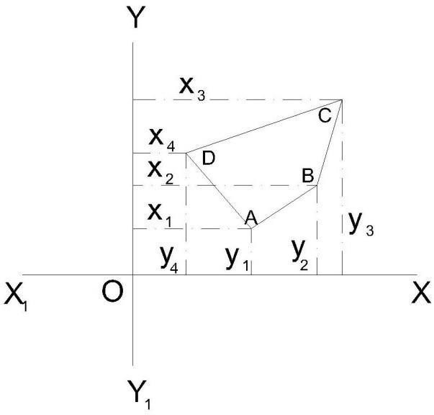
Traversecomputation
If the length and bearing of a line are known, the projection of such a traverse line may be obtained on the line parallel to the meridian YY1, and on the line perpendicular to the meridian XX1.

Latitude:

Theprojectionofthelineparalleltothe meridian(N-Sline)iscalledthe “latitude”of the line.

Departure:
The projection of the line perpendicular to meridian (N-S line) is called the “departure” of the line.
The latitude when measured upward or northward along the meridian, is positive and termed as “northing” and when it is measured downward or southward along the meridian it is negative and is called “southing”.
The departure when measured eastward or towards right, is positive and is known as “easting” and when it is measured westward or to the left, it is negative and is known as “westing”.

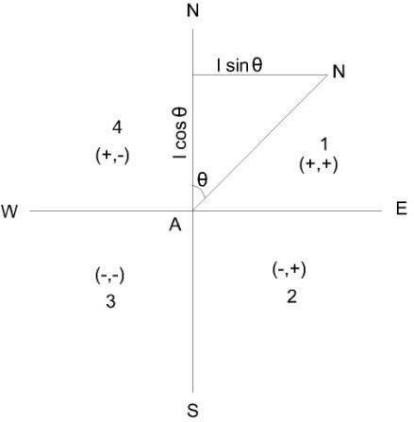
Traversecomputation
if the length of line AB is known and its reduced bearing from meridian (i,e,θ) is known, the latitude and the departure may be determined.
Latitudeofaline=Length oflinex Thecosine ofreduced bearingof line
=Lengthxcosθ
Departureofaline =Length oflinex Thesineofreduced bearingofline
=Lengthx sinθ
The letter N or S of the reduced bearing will givethe sign of the latitude as +ve or –ve respectively and the letter E or W will give the sign of the departure as +ve or – ve, respectively. If the bearings of various traverse lines have been measured as whole circle bearings, the same should be expressed in the form of reduced bearings and consequently can be utilized in determining the latitudes and the departures.
Thefollowingtablein suchacase, maybeused.
Signof
Wholecirclebearing  (WOB) | Quadrant | Latitude Departure
0°to 90° | (1)orNE | + +
90°to180° | (2)orSE | - +
180°to270° | (3)orSW | - -
270°to360° | (4) | + -

Consecutiveandindependentcoordinates
The latitude and departure of any point with referenceto the preceding point are known as“consecutivecoordinates”.Andthecoordinatesofanypointwithreferencetoacommonorigin are called the “independent coordinates” of the point. The independent coordinatesarealso known as “total latitude” and “total departure” of the points.
Theindependentcoordinatesofanypointmaybedeterminedbyadding(algebraically)the latitudes and departures of the lines between that point and the origin. Thus,
x-coordinate(ortotal = x-coordinateofthefirstpointofthedeparture)ofanypoint
traverse+Algebraicsumofthedeparturesofthelinesbetweenthefirstpoint and that point

y-coordinate(ortotal= y-coordinateofthefirstpoint ofthelatitude)ofanypoint
traverse + Algebraic sum of latitudes of the lines between the first pointand that point
Theaboverulefollowsthat
x-or y-coordinate of last = x.ory-coordinateofthefirstpoint point of the traverse + Algebraic sum of all departures or
Latitudes
Note
Thetheodolitetraverseshouldalwaysbeplotted withthehelp ofrectangular coordinates.

Adjustmentofclosingerrorsinaclosedtraverse:
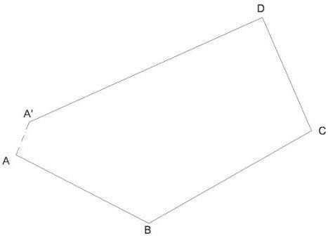
If the survey work is correct, in a closed traverse, the algebraic sum of latitudes (Ie, Σ L) should be equal to zero and also the algebraic sum of latitudes (Ie, ΣD) should be equal to zero. It follows that the sum of northings should be equal to sum of southings and the sum of eastings should be equal to sum of westings.
closingerrorsinaclosedtraverse
Therearealwayserrors inatheodolitetraversemainlydueto twosources,viz:
- theanglesbetweenthesides,and
- thelengthsofthesides.
Out these, the first is usually less important than the second. The traverse is plotted according to the field measurements, the same will not close on paper and the end point of the traverse will not coincide exactly with the starting point. The distance by which the last point of thetraversefallsshorttocoincidewiththestartingpointiscalledthe“errorofclosure”or“closing error”. As per the Fig shows plotting of traverse ABCD. The traverse is not closing at A but instead it ends at some other point A1 and thus AA1 is the closing error. The components of this error A1A2 and AA2 as in Fig parallel and perpendicular to the meridian may be obtained by finding thealgebraic sumof the latitudesΣL,andthe algebraic sumof departures
ΣD.
ΔAA1A2isright-angleatA2.
LinearerrorofclosureAA1 =√
WhereΦisthereducedbearing.
Thesigns ofΣLand ΣDwilldeterminetheposition ofclosinginaparticularquadrant.

The closing error is usually expressed as a fraction having the numerator as unity and is called the relative error of closure.

Note
Theerrorsinlengthsofsidesaremorelikelytooccuralongthelongestsidesofthe
traverse.

Angularerror
If the angles of a traverse do not add up correctly, ie, a difference exists between the sum of the measured angles and the theoretical sum of (2n±4) right angles, where n is the number of sides of closed traverse ; necessary correction to the angles nearestthe short sides (since thesearetheanglesmostlikelytobeslightlymoreinerror)istobeapplied.Iftheangularerrorissmall, thesamemaybearbitrarilydistributedtotwoorthreeangles.Ifthesurveyworkiscarriedoutwith ordinaryprecision,thecorrectionappliedtoanyangleisnotlessthantheleastcountofthevernier.

Adjustmentoferrorinbearings
Theclosingerrorinbearingmaybeobtainedbycomparingthetwobearingsofthelastline asobservedatthefirstandthelaststationsofthetraverseorifthetraverseendsonalineofknown bearing, the closing error can be obtained by finding the difference between its observed bearing and known bearing. This error ….. then, should be distributed among the sides of the traverse. If n is the number of sides, the corrections to the bearings of the sides will be as given below : Correction to the first bearing =
Correction to the second bearing = Correction to the third bearing = Correction to the last bearing =

BALANCINGTHETRAVERSE
When the closing error in latitude and in departure is determined, the latitudes, and departuresshouldbeadjustedsuchthatthealgebraicsumofthelatitudesshouldbeadjustedsuch thatthealgebraicsumofthelatitudesanddeparturesshouldeachbeequaltozero.Thisoperation of applying correction to the latitudes and the departuresis called the “balancing of the traverse”. Ifoneormoresidesofatraversehavenotbeenmeasuredwithequalcareduetosometypicalfield conditions, the whole or the largest part of the error may be adjusted to the sameside or sides. But,ifallthesideshavebeenmeasuredwithequalprecision andcare,the followingrulesmaybe applied to determine the corrections foe balancing the traverse.
  - Bowditch’srule
TheBowditch’sRuleorthe“compassrule”isgenerallyusedtobalancethetraversewhen theangularaswellaslinearmeasurementsaretakenwithequalprecision.Bythisrule,the totalerrorin latitude and in departureis distributed in proportion tothelength ofthesides.

Correctionto thelatitudeortothedeparture ofanyline
=Totalerrorinlatitudeordeparture X Length of the line
Perimeterofthetraverse
Thetraversecanalsobeadjustedasitisexplainedin“compasstraverseadjustment”.
  - Transitrule
Thetransitrulemaybeappliedtobalancethetraversewhentheangularmeasurements are taken with greater care and precision than the linear measurements as in the case of a theodolite and stadia traverse.According to this rule,
Correctiontolatitudeofanyline
=TotalerrorinlatitudeXLatitudeofthatline
Arithmeticalsumofallthelatitudes
Similarly,
Correctiontodepartureofanyline
=TotalerrorindepartureXDepartureofthat line
Arithmeticalsumofallthedeparture
  - Third rule
According to the third rule, Correctiontonorthingofanyside
=Total errorin latitudeX Northingofthat side
Sumofallnorthings Correction to southing of any line
=Total errorin latitudeXsouthingofthat side
Sumofall southings
Similarly,
Correctiontoeastingofanyside
=TotalerrorindepartureXEastingofthatside Sum of all easting
Correctiontowestingofanyside
=Total errorin departure XWestingofthat side
Sumofallwrstings
Whenthetraverseisthusbalanced,thelengthsandbearingsoflinesarechanged. Note
IncasethetraverseadjustmentsaremadebytheBowditch’sRule,anglesarechangedmore and the lengths are charged less than when the adjustment is made by the transit rule.

GalesTraverseTable:
Thefollowingstepsmayobserved.
    - Find out the sum of the observed included angles which should be equal to (2n±4) rightanglesaccordingastheinterioror exteriorangles are measured. Iftheyarenot

equal, apply the necessary corrections to the angles so that the sum of the correctedangles is exactly equal to (2n ± 4) right angles.
    - From the observed bearing of the first line AB and the corrected included angles, calculatetheWCBofalltheotherlinesBC,CD,etc.Asacheck,findoutthebearingof the first line which should be equal to its observed bearing.
    - Calculatethereducedbearingsoflinesfromthewholecirclebearingandfindoutthe respective quadrants.
    - Compute the latitudes and departures of lines, I e, the consecutive coordinates (coordinates with respect to preceding point, e g, in a closed traverse ABCD, the coordinates of A, with respect to D and coordinates of B with respect to station A, andsoon)fromtheirobservedlengthsandcorrectedreducedbearings.Forexample in the above traverse, to compute the coordinates of A, the length and reduced bearingof line DA should be taken, and similarly for point B, the length and reduced bearing of line AB should be considered.
    - Find out the algebraic sum of latitudes (ΣL) and that of departures (ΣD). Apply necessary corrections to the latitudes and departures so that their sum is equal to zero for closed traverse.
    - From the corrected consecutive coordinates, obtain the independent coordinates of thelinessuchthattheyareallpositiveandthewholetraverseliesinthefirstquadrant (NE).

Example
Thefollowingcorrectedlatitudesanddeparturescorrespondtothesidesofatraverse ABCDE. Compute the independent coordinates.
Latitude Departure

Lines  AB | Northing | Southing  325.16 | Easting  620.24 | Westing
BC | 449.35 |  | 946.24
CD | 980.25 |  |  | 742.60
DE |  | 536.89 |  | 797.80
EA |  | 567.55 |  | 26.08
The independent coordinates of an origin or the starting point A of the survey should be so chosen that the coordinates of all otherStation points are positive, i.e. all the points of the traverse lie in the first quadrant.
Alsothechosenindependentcoordinatesshould beinmultiplesof100and1000. Here, the coordinates of point A may be chosen as (400,0). Applying the rule, North coordinate of point A = 400.00
Deduct southing of point B =325.16 North coordinate of point B =78.84
Addnorthingofpoint C =449.35

NorthcoordinateofpointC Add northing of point D | =524.19  =980.25
NorthcoordinateofpointD | =1504.44
DeductsouthingofpointE | =536.89
NorthcoordinateofpointE | =967.55
DeductsouthingofpointA | =567.55
NorthcoordinateofpointA | =400.00(sameasassumed)
EastcoordinateofpointA | = 0.00
Addeastingofpoint B | =620.24
EastcoordinateofpointB | =620.24
AddeastingpointC | =946.24
EastcoordinateofpointC | =1 566.48
DeductwestingofpointD | = 742.60
EastcoordinateofpointD | =823.88
DeductwestingofpointE | =797.80
EastcoordinateofpointE | =26.08
DeductwestingofpointA | =26.08
EastcoordinateofpointA | =0.00 (sameas assuned)

Areaofclosedtraverses:
Thefollowingmethodsaregenerallyusedforcalculatingtheareaofclosedtraverses:
- Areafromcoordinates(yandx).
- Areafromlatitudesanddoublemeridian.
- Areafromdeparturesandtotallatitudes.

Areaofclosedtraversesfromcoordinates:

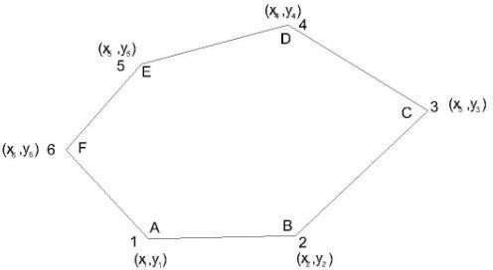

Ifthecoordinates(x1,y1),(x2,y2),etc.ofvariouspointsinaclosedtraverseareknown, the area can be easily calculated.
In Fig ABCDEF is a closed traverse of six sides and the coordinates are also indicated for each station.
To find the area, multiply (ordinate/abscissa) by the difference of (abscissae/ordinates) of the pointsbeforeandafterthepointconsidered,eg,whenpointAisconsidered,theordinateofpoint A is multiplied by the difference of abscissae of points B and F, i e, y1, (x2– x6).
Alwaystheprecedingabscissae/ordinatesaresubtractedfromthefollowingabscissae/ordinates. Find the sum of all such products which is equal to twice the area of the traverse.
Halfofthissumgivestherequiredareaofthetraverse. Thus, the area of closed traverse is given below:
Area=½[y1(x2,x6)+y2(x3,x1)+y3(x4–x2)+y4(x5,x3)+y5(x6,x4)+y6(x1,x5)] Area = ½[y1(x2– x6) + y2(x3– x1) + y3(x4 – x2) + … +yn(xn+1 –xn-1)]
Wherex1,x2,x3,etc.aretheabscissaeandy1, y2,y3 etc.aretheordinates. The abscissae or x-coordinates are along X-axis or east-west line.
Theordinatesory-coordinatesarealongY-axisornorth-southline.

Areaofclosedtraversefromlatitudesanddoublemeridiandistances(DMD):
The meridian distance (MD) of a line or “longitude” is the perpendicular distance of the middle point of the line from the reference meridian.
Thedouble meridian distance (DMD)or the doublelongitudeof a lineis equal to the sum of the meridian distance of the two ends of the lines. The MD of various lines can be calculated by the following principles:
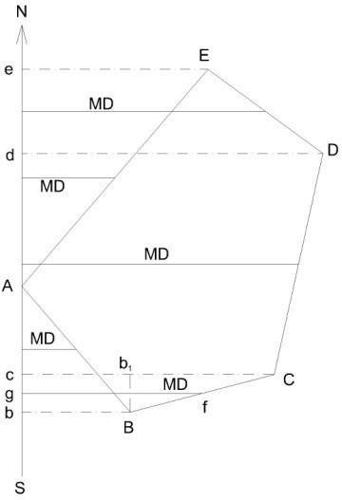
- TheDMDoffirstlineisequaltothedepartureofthat line.

- The DMD of each succeeding line is equal to DMD of the preceding line plus the departure of the line itself.
- TheDMDofthelastlineisnumericallyequaltothedepartureofthelastlinebut withopposite sign.
Rule
TofindouttheareaoftheclosedtraversebylatitudesandDMD,multiplyeachDMD bythe latitude of that line.
Findthealgebraicsumofalltheseproductswhichgivestwicetheareaofthetraverse. Half of this sum is equal to the required area of traverse.
Thefigureclearlyshowsthemeridiandistancefromthereferencemeridian.
Forexample,themeridiandistanceoflineBCwillbefgandtheDMDoflineBCis(Cc
+Bb).(Cc+Bb)=Cb1+b1c+Bb
=Cb1+Bb +Bb =(Bb +Bb + b1C)
DMDoflineBC=DMDoflineAB+DepartureoflineAB+DepartureoflineBC It proves the given principal.

Areaofclosedtraversedfromdeparturesandtotallatitudes:
Tofindouttheareaofclosedtraversebythisprincipalproceedas follows:
  - Findoutthetotallatitudeofeachstatinofthetraverse.
  - Findthealgebraicsumofdeparturesofthetwolinesmeetingatthat station.
  - Multiplythetotallatitudeofthatstationbythecorrespondingalgebraicsumof thedepartures.
  - Findthealgebraicsumoftheseproductswhichisequaltotwicetheareaofthe traverse.Example
Thelatitudesand departuresofthesurveylinesof atraverseABCDaregivenas follows:

Line |  | Latitude |  |  | Departure
 | N | S |  | E | W
AB | 204.6 |  |  | 113.9
BC |  |  | 234.9 | 205.8
CD |  |  | 150.7 | 86.0
DA | 181.0 |  | 233.7

Calculateitsareaifthesides aremeasuredin meters.

AreaoftraverseABCD bycoordinates(independent):
Theindependentcoordinatescanbecalculatedasalreadyexplained.Here,theindependent coordinatesofAcanbeassumedas(200,0)sothatallthe coordinatesarepositiveandthe traverse may lie in first quadrant only. The coordinates can be tabulated as given below.
Independentcoordinates

Line | Latitude | Departure | Station
 |  |  |  | North, | East,
 |  |  |  | Y | x
AB | +204.6 | +113.9 | A | 200.0 | 0.0
BC | -234.9 | +205.8 | B | 404.6 | 113.9
CD | -150.7 | -86.0 | C | 169.7 | 319.7
DA | +181.0 | -233.7 | D | 19.0 | 233.7
 |  | Cheek: | A | 200.0 | 0.0
Now,theareaofthetraverse
=½[y1(x2–x4)+y2(x3– x1)+y3(x4– x2)+y4(x1–x3)]
½[200(113.9– 233.7)+404.6(319.7– 0.0)
+169.7(233.7 – 113.9)+19(0.0– 319.7)]
=½[200X– 119.8+404.6 X319.7 +169.7 X119.8 +19 X–319.7]
=½[–23960.0 +129 350.62+20 330.06–6 074.30]
=½[149680.68 – 30 034.30]=½[119 646.38]=59 823.19
∴AreaofthetraverseABCD =59 823.19 m²
- AreaoftraverseABCDbylatitudesanddoublemeridiandistance: In this method, first of all the DMD of each line should be calculated. DMD of line AB = Departure of line AB = 113.9
MDoflineBC =DMDoflineAB +Departureof lineB+Departureof BC
=113.9113.9 +205.8=433.6
DMDoflineCD=DMDoflineBC +DepartureoflineBC +Departureofline Cd
=433.6+205.8 – 86.0 =639.4 – 86.0 =553.4
DMDoflineDA=DMDoflineCD+DepartureoflineCD+Departureofline DA
=553.4– 86.0 – 233.7 =553.4 –319.7
=233.7

Check
TheDMDoflastlineDAshouldbenumerically equaltoitsdeparturebut shouldbeofopposite sign.
Hence, the above calculations are correct. Now,theresultsmaybetabulatedasfollows:
Twicethearea (Column2XColumn 4)
Line | Latitude | Departure
 |  |  |  |  | + |  | –
1 | 2 | 3 | 4 | 5 |  | 6
AB | +204.6 | +113.9 | 113.9 | 23 303.94
BC | – 234.9 | +205.8 | 433.6 |  |  | 101 852.64
CD | – 150.7 | – 86.0 | 553.4 |  |  | 83 379.38
DA | +181.0 | – 233.7 | 233.7 | 42 299.70
Total |  |  |  | 65 603.64 | 185 250.02
Algebraicsum |  |  |  | 119 646.38
∴AreaoftraverseABCD=½ XAlgebraic sum
=½ X119 646.38 =59 823.19 m²
Note
Thenegativesignofthe hasnosignificance.

AreaoftraverseABCDfromdeparturesand totallatitudes:
Here,stationAcanbeassumedasthereferencestationandthetotallatitudesofother stations B, C and D are calculated.
Total latitude of station A = ΣL=00 TotallatitudeofstationB=ΣL=+204.6
TotallatitudeofstationC =ΣL=204.6 – 234.9 =–30.3
TotallatitudeofstationD=ΣL=204.6–234.9–105.7=–181.0 Check.
TotallatitudeofstationA=ΣL=204.6–234.9–105.7+181.0=0.0 The results may be tabulated as under:

Twicethearea LineLatitude Departure Total latitude Algebraic sum of adjoining departure
1 | 2 | 3 | 4 | 5 | 6 | 7 | 8
AB |  | +204.6 | +113.9 | B |  | +204.6 | +319.7 | 65 410.62
BC |  | – 234.9 | +205.8 | C |  | – 30.3 | +119.8 |  | 3 629.94
CD |  | – 150.7 | – 86.0 | D |  | – 181.0 | –319.7 | 57 865.70
DA |  | +181.0 | – 233.7 | A |  | 0.0 | –119.8 |  | 0.0

Total 123 276.32 3 629.94

Algebraicsum119646.38

∴Areaofthetraverse=½XAlgebraicsum
=½X119 646 38
=59 823.19 m²
Typesofproblemsintraversing
While solving the problems, the following trigonometrically relationship should be remember and employed according to need.
Thetrigonometricallyrelationshipofthecourseofalinetogetherwithitslatitudeand departure are employed are follows:
  - Latitude=LengthXcosineofreducedbearing
  - Departure=LengthXsineofreducedbearing
  - Tangentofreducebearing= Departure
Latitude
  - Length=√(Latitude)²+(Departure)²
Length = Latitude X secant of reduced bearing Length=DepartureXcosecantofreducedbearing Thevarious types ofproblemsmaybeas follows:
    - To find out the length and bearing of a line joining two-points whose independentcoordinates are given :
Insuchacaseproceedasgivenbelow:

- Findthedifferencebetweenthenorthcoordinates;

- Findthedifferencebetweentheeastcoordinates;
- Then,ifθbethereducedbearingofthelinejoiningthetwopoints,
Tanθ=Departureoftheline Latitude of the line
=Differencebetweentheeastcoordinates Difference between thenorth coordinates

ComputationofAreaand volume
Introduction:-

surface.
Itisthespaceofatractofland projecteduponthe horizontalplaneandnottothe actualareaofthe land

ItmaybeexpressedinSquaremetres(m²),Hectares(1hectare=10000m²),Squarefeet,Acre.

Methodsforcomputation ofarea:-
Therearetwo methods ofcomputation of the Area:-

Graphicalmethod
- Instrumentalmethod

Calculationofarea from Graphicalmethod:-
Theareamay becalculatedin two following ways:-
- FromfieldNotes
- FromPlottedplan
Computationoftheareafromfield notes

Inthismethodthecomputationof theareaisdoneintwo steps:-
  - InsurveyworksthewholeareaisdividedintonumberofsomegeometricalFig.suchastriangles, rectangles, square, trapeziums and then the area is calculated.
  - Thentheareaofthisgeometrical fig.addeduptogettherequiredarea.

Calculationoftheareafrom Plotted plan:-
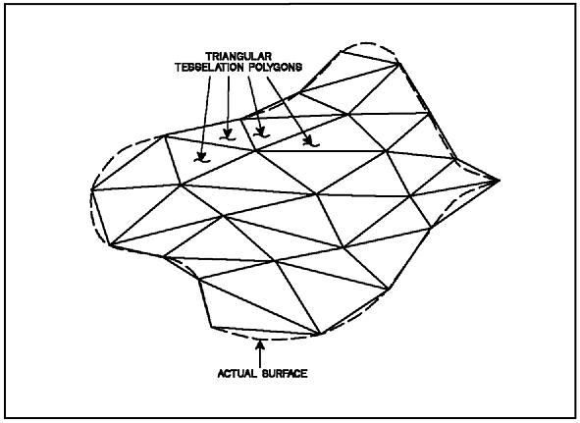
Theareamaybecalculatedintwofollowingways:- i.Considering the entire area
- ConsideringtheBoundaryarea
ConsideringtheEntirearea:-Theentireareaisdividedintoregionsof convenient shape and they are calculated by
  - Bydividingtheareaintotriangles:-Thetrianglesaresodrawnasto equalize the irregular boundary line. Then the bases and altitude of the
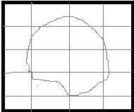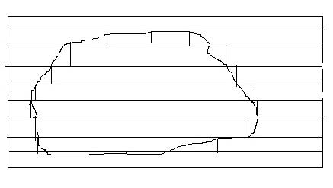trianglesaredetermined accordingtothescaleto towhichplanisdrawn.Afterthistheareasofthesetrianglesare calculated.(fig.1)
  - Bydividing the area into squares:- In this method squares of equal size are ruled out on a piece of tracing paper. Eachsquare represents a unit areawhich could be 1cm² or 1m².The tracing paper is placed over the plan and the full squres arecounted.Thetotalareaisthencalculatedbymultiplyingthenumberofsquresby the unit area of each square
  - Bydrawingparallellinesandconvertingthemintorectangles:-Inthis method , a series of equidistant parallel lines are drawn on a tracing paper. The constant distance represents a metre or cm. The tracing paper is placed over theplan in such away the areais enclosed between parallel lines at the top and bottom. Thus the area is number of strips. The curved ends of the strips are replaced by perpendicular lines and no. of rectangles are formed. The sum of the lengths of the rectangles is then calculated.
RequiredArea=∑lengthofrectangleXconstantdistant

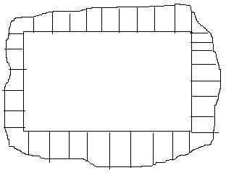
Considering the Boundary area:-In this method the large square or rectangleisformedwithintheareaintheplan.Theordinatesaredrawnat a regular interval from side of the square to the curved boundary. The middle area is calculated in the usual manner. The boundary area is calculated by
- MidOrdinate rule
- Averageordinaterule c.Trapezoidal rule d.Simpson’s rule
Mid Ordinaterule:-

Let 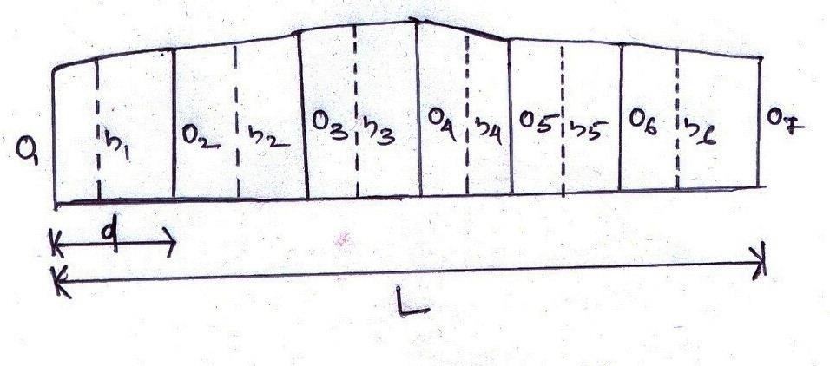O1,O2,O3,O4,O5,O6,O7 On= ordinates at equal intervals
L=lengthofthebaseline
d=Commondistancebetweenordinatesh1,h2,h3,h4,h5,h6,h7,… hn=midordinates
Areaof theplot=( h1Xd)+(h2Xd)+(h3Xd )+(h4Xd)+………………………………..+(hnXd)
=d(h1+h2+h3+h4+h5+h6+h7+ +hn)
Whereh1=(O1+O2)/2and soon
Thereforetherequiredarea= common distanceX sumofthemid ordinates.

Averageordinaterule:-

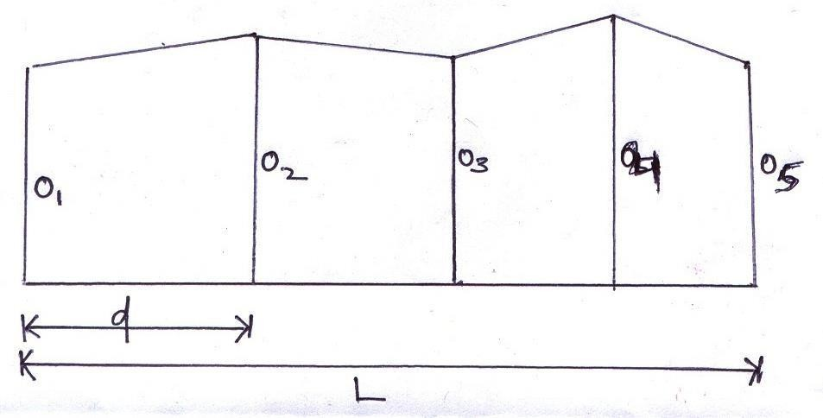
LetO1,O2,O3,O4,O5,O6, On=ordinatesoroffsets atregular intervals
L=lengthofthebaseline n= no. of divisions
n +1 =numberof ordinates
Area =(O1+O2+O3+O4+O5+O6+……………………….+On)XL
On+1

Trapezoidalrule:-
Whileapplyingthetrapezoidalruleboundariesbetweentheendsoftheordinatesareassumedtobestraight.So, thearea enclosed between the base line and the irregular boundary lines are to be considered as trapezoids.

Let,O1,O2,O3,O4,O5,O6,O7 On=ordinatesatequal intervals
d=Commondistancebetweenordinates L= length of the base line
Therefore,

1st area=O1+O2Xd
2
2nd area=O2+O3Xd
2
3rd area=O3+O4Xd
2
4th area=O4+O5Xd
2
… andsoon
Lastarea={(On–1+On)Xd}/ 2

Thereforethe requiredarea=1starea+2nd area +3rd area +4tharea + +Lastarea

)Xd)/2}]+
=[{(O1+O2)Xd}/2]+[{(O2+O3)Xd}/2]+[{(O3+O4)Xd}/2]+[{(O4+O5

…………………………..+{(On–1+On) Xd} / 2.

=d/2(O1+O2+O2+O3+O3+O4+O4+O5+O5+ On)

=d/2(O1+2O2+2O3+2O4+2 O5+ +On)

=commondistance{(1stordinate+lastordinate)+2(sumoftheotherordinates) 2
Thereforethe Trapezoidal rule states that thesum of thefirst and last ordinate, twicethe sum of theintermediate ordinatesisadded.Thistotalsum ismultipliedbythecommondistance.Halfofthis productistherequiredarea.

Limitation:-Thereis nolimitation. Thisrulecanbeapplied forany numberofordinates

Simpson’srule:-
Inthisruletheboundariesbetweenthe endsoftheordinatesareassumed toformanarcofparabola.Hence Simpson’s rule is also known as parabolic rule . This rule is also known as Prismodial rule.

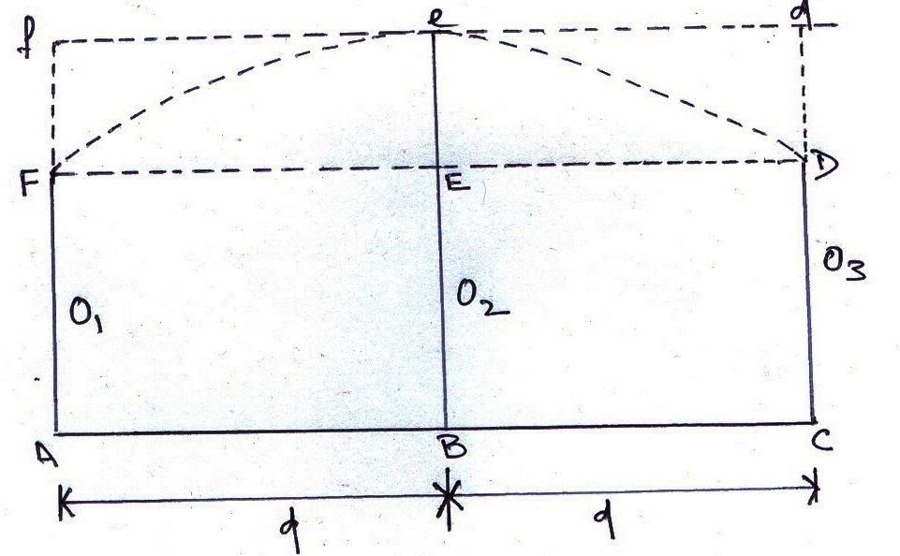

Let O1,O2,O3 = three consecutive ordinates d=Commondistancebetweenordinates
ThereforetherequiredareaAFeDC=AreaofthetrapeziumAFDC+Areaofthesegment FeDEF Area of thetrapezium AFDC = O1+ O3X 2d
2
AreaofthesegmentFeDEF=2 xareaoftheparallelogram
3
2/3(EeX2d) =2/3 X {O2– (O1+O3)} X2d
2
So,theareabetweenthefirsttwodivisionis

A1=[(O1+O3)X2d ]+[2/3 X{O2– (O1+O3)}X2d]
2 2
=d/3(O1+4O2+O3).
Similarily,theareabetweentwonextdivisioniscalculated…….. A2= d/3 (O3+ 4 O4 + O5) .

A3=d/3(O5+4O6+O7)andsoon

Requiredarea= A1+A2+A3 +An

={ d/3(O1+4O2+O3)}+{ d/3(O3+4 O4+O5)}+{d/3(O5+4O6+O7)} + +{d/3(On-2+4On-1+On)}

=d/3[{O1+On}+4(O2+O4+O6….................+4On-1)+2(O3+O5+O7+ +On-2)]

=commondistanceX{(1stordinate+lastordinate)+4X(sumoftheeven ordinates)+2X(sumoftheoddordinates) 3

ThereforeSimpson’sRulestatesthatthesumofthefirstandlastordinate, fourtimesthesumoftheremaining even ordinates and twice the sum of the remaining odd ordinates are added. This total sum is multiplied by the common distance. One third of this product gives the required area.

Limitation:-Thisruleisonlyapplicablewhenthe numberofdivisionsis evenand ordinatesare odd.

DifferencebetweentheTrapezoidalruleandSimpson’srule

Sl.no | Trapezoidalrule | Simpson’srule
1. | Theboundary betweentheordinatesis considered  tobestraight | Theboundarybetweentheordinatesisconsideredtobe  arcofaparabola
2. | There is no limitation. It can be applied forany number of ordinates | This rule is only applicable when the number of divisions is even and ordinates are odd.
3. | Itgives anapproximateresult. | Itgivesanaccurateresult.

……………………………………………************************………………………………………………
……….

AreasofCrossSections

Thecommoncrosssectiononecomesacrossinpracticeareshowninfigures.Thefollowing symbols will be used to indicate the various parameters of the area.

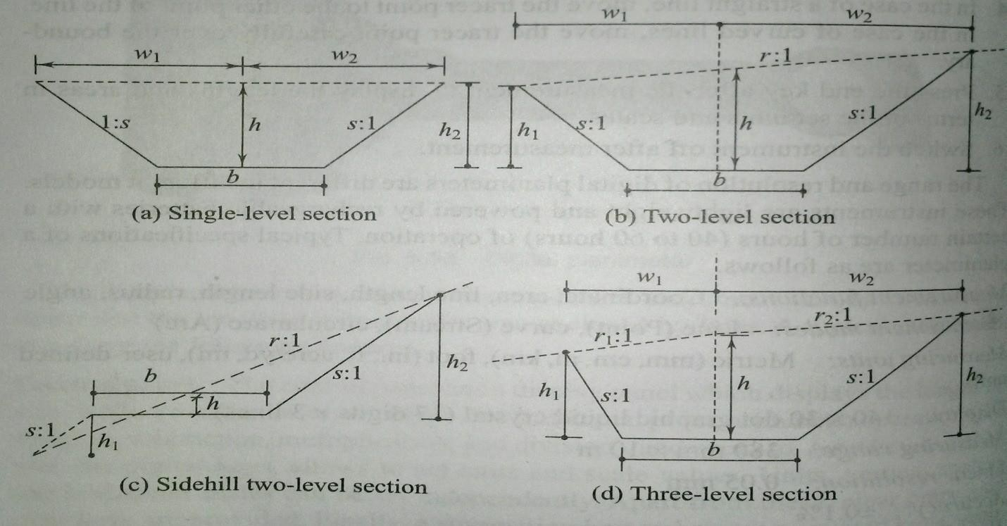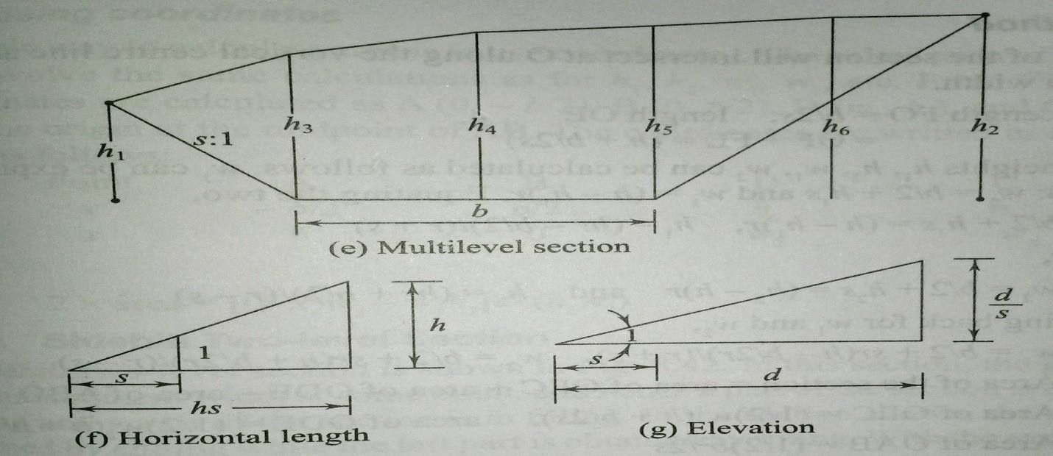

Fig
Formationwidth(widthatformationlevel):Itisthewidthofthesub-grade(b).

Depth:Itisthedepthofcuttingorfillingatthecentreline(h).
Cutbeingdenoted byaplus(+)signandfilbyaminus(-)sign.
Half-breadth: This is the horizontal distance from the centre to the intersection of the original ground
withthesideslopes(d1andd2).
Sideslope:sto1isthesideslope,shorizontaltovertical[i.e.,thegroundrises(or falls)by1m over a
horizontallengthlengthofsmeters].
Transverseslope:nto1isthetransverseslopeoftheground,nhorizontalto1vertical[i.e.,the ground
rises(orfalls)by1 m overahorizontal length ofn metres.
Sideheights:h1andh2aretheheightsfromtheformationleveltothesideslopewiththe ground.

Thefollowingpoints mustbeclearlyunderstoodindealing with slopes.
Ifs:1 istheslopegiven,thenforagivenheight h,thehorizontaldistance=hs.
Ifs:1istheslopegivenandthehorizontaldistanceisd,thentheverticaldistanceisgiven by d/s.

8.0MethodofComputationfordifferenttypesofcrosssections:
Theareaofeachofthesecrosssectionscanbecalculatedasfollows.
Single–levelSection

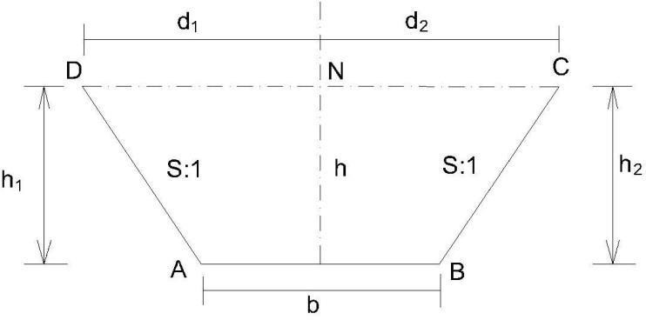
A single – level section may be formed by cutting or filling. In this type cross section the ground is assumed to be level transversely i.e the value of n approach to infinity. In this section, AB is the sub grade of width b, d1 and d2 are half-widths – equal in this section, and h1 and h2 are end heights – equal to h, the height at midsection. Therefore, d1=d2= b/2 + sh,h1= h2=h,

Areaofthesection=(1
)[2Xhalfbreadth+b]Xh=
2
b
[2(2+sh)+b] 2
=bh+sh²

Two-levelSection[

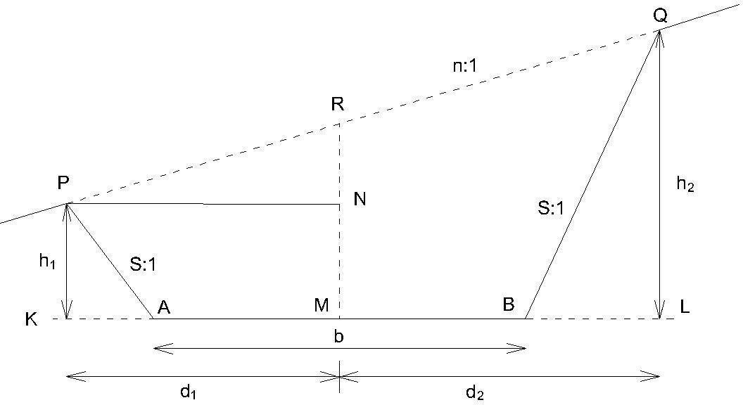

In two level section the top level is not horizontal and the original ground has a slope of n:1. The two end heights, h1and h2, are not equal.

Areaofthecross section=d1d2 b2
–
s 4s
b
Whered1=(h +
2s
ns
)( )
n+s

ThreeLevelsections:

d2=(h +
b ns
)( )
2s
n–s

Assumethat transverseslopeofthenatural ground is not uniform. Let it ben1 to 1and n2to 1on either side of the central line. ( as shownin Fig)
Areaofthesection=(d1+d2)–[ b2+h]-b2=
D[h+b]-b2
WhereDistotaltop width. 4s 2 4s 2 2s 4s

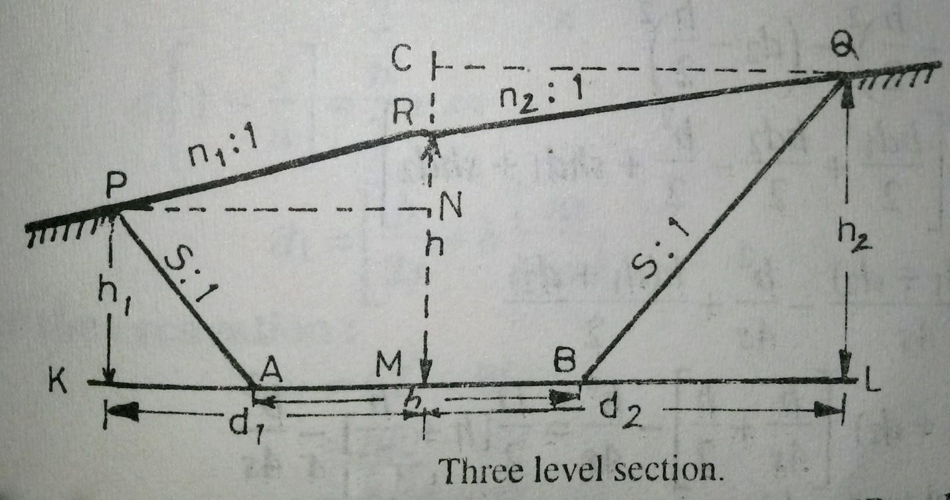

Sidehill twolevelsection.
In this cases, the ground slopes transversely and the slope of the ground surface cuts the formation level in such a way that one portion of the area is in cutting and the other portion is in embankment i.e. the section consists of two parts one in cutting and the other in filling.
Ingeneraltwocasesmayarise.
- Whenthecentrelineoftheformationisinexcavation.
- Whenthecentrelineoftheformationisinembankment.

(i)When centrelineoftheformation isin excavation:
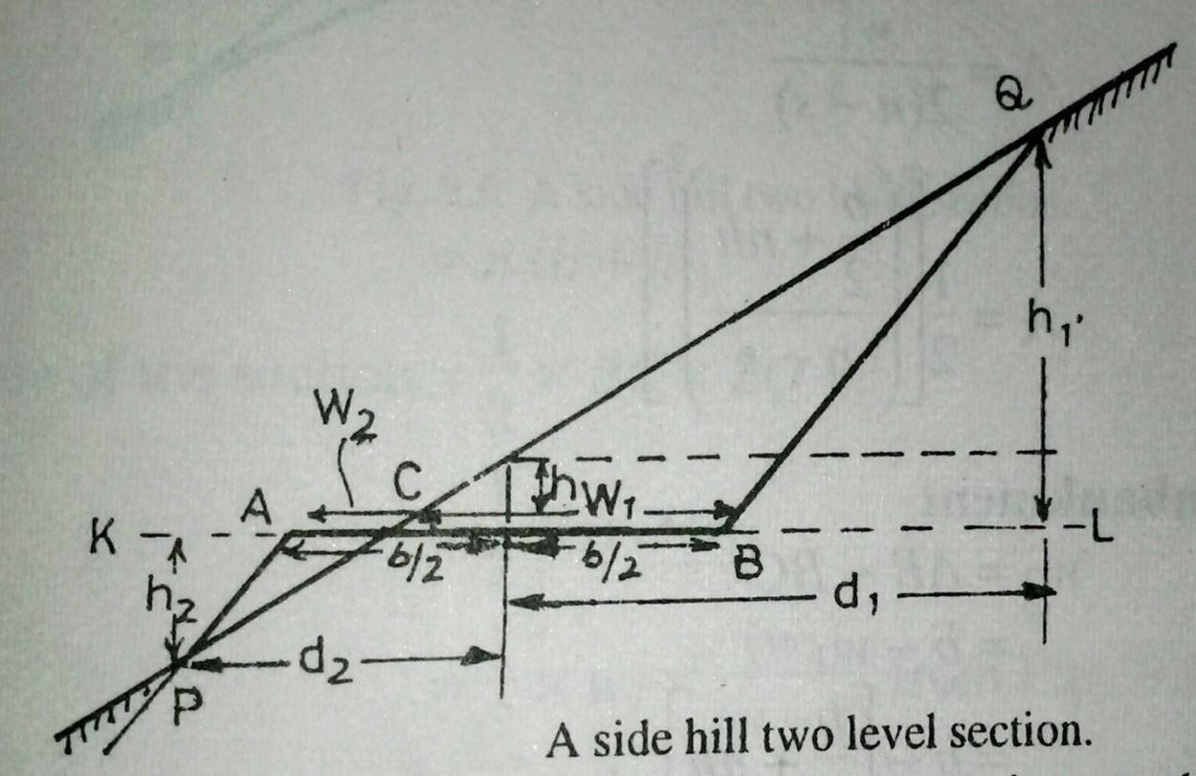
(a)Fortheexcavation:

w1=CL–BL=nh1–sh1=h1(n-s)
Or h1 =w1n–s

Areainexcavation=triangularareaBCQ
  - b+nh

1
A=xBCxQL=
2
1
Xw1Xh1=
2
[(2 )2]
  - n–s

Forthe
embank
ment b b-nh

W2=AB-BC =b-w1=b-[
2
+nh]=
2

b ns

Andd2=(–h)( )
2s n–s

Areainembankment=triangulararea ACP
=1/2Xw2Xh2
    - b–nh
=[(2 )²]
    - n–s

(ii)Whencentrelineoftheformationisin embankment.

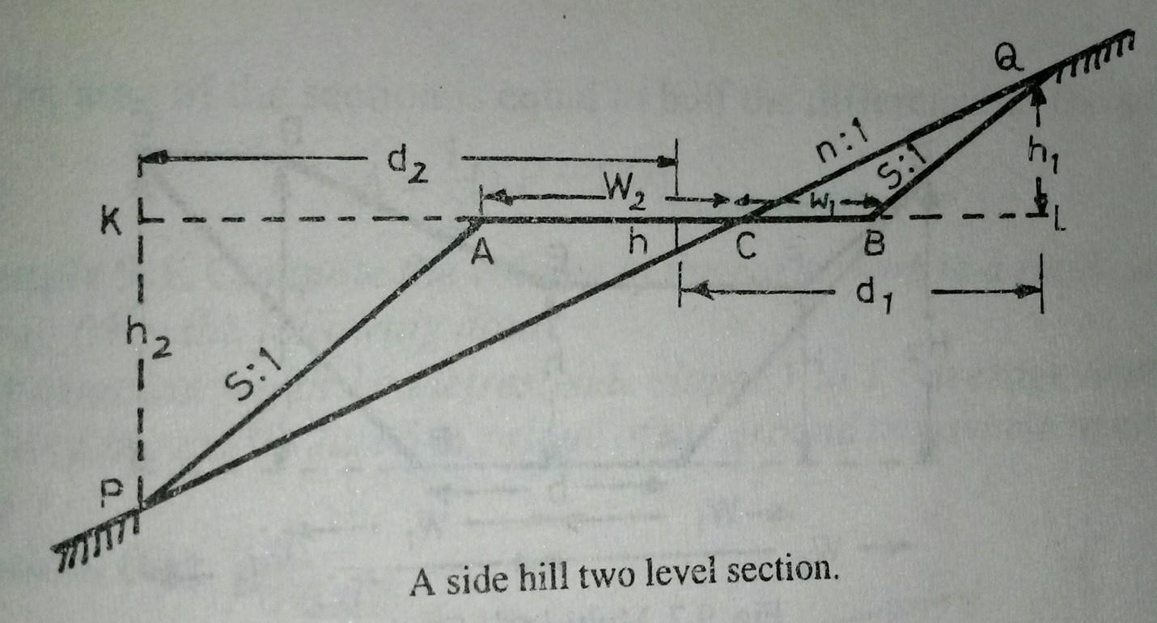
(i) Forexcavation
w1=nh1–sh1=(n-s)h1d1= nh1+ nh
=n (h +h1)
Areaofthesection=1/2xBCxLQ=1/2xw1x h1
(w1)2
=
2(n–s)
Forembankment
w2=b – w1
b
w2=+nh
2
b+sh2
d2=
2

Areaofthesection=½ xw2x h2
w2
Buth2=
n–s

(w2)2
A=
2(n–s)

- Multi-Level Section : In this case, spot levels andtheir distances from the central line, areusually recorded as shown in Table
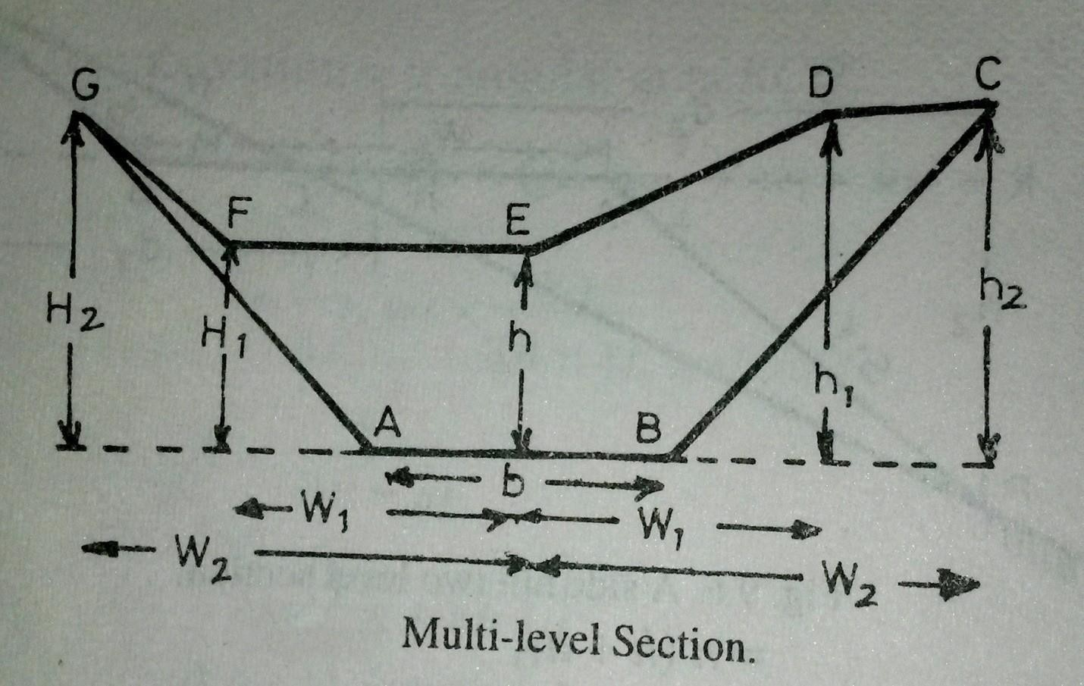
Table

Left |  | Centre | Right
±H2 | ±H1 | ±ℎ | ±ℎ1 | ±ℎ2
W2 | W1 | 0 | W1 | W2

InTablenumeratorsofthefractionsdenotetheamountofcutting(+ve) andfilling
(- ve) at the various points whereas the denominators denote their horizontal distances from the centre line of the section.
Assuming the formation level AB as x axis and OE, the perpendicular bisector of AB as theYaxis, thesenotesmaybeconsidered as xand ycoordinatesofeach point ofthesection. The area of the cross-section may then be computed by the method of coordinates. The points A,B.C,D,E,F,G may be written irrespective of their signs in the form of a determinant.

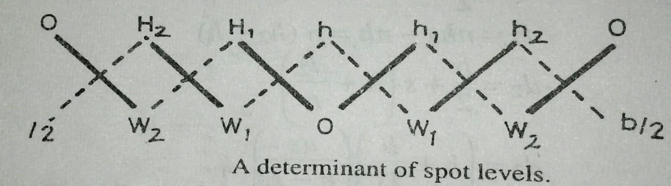

Forpreparationof thedeterminant,start fromthecentreandproceedto therightand to
theleft.
Forcalculationofthearea,proceedasunder:
- Findthesumof the productsof theco-ordinatesJoinedbyfulllinesanddenotedby∑F
i.e.∑F=OH1+W1H2+W2O+Oh1+w1h2+w2O
- FindthesumoftheproductsofthecoordinatesJoinedbydottedlinesanddenotedby∑D
i.e.∑D=hW1+H1W2+H2b b
2+hw1+h1w2+h2
2
- Theareaofthesectionisequaltohalfthedifferenceofthesums.i.e.
1
Area=[∑F-∑D]
2

Example 1.Compute the volume of the earthwork in a road cutting50 metreslong fromthe following date :
Theformationwidth 10metres; sideslopes1to 1; averagedepth ofthe cuttingalongthe centre line 5 m ; slope of the ground transverse to cross-section 10 to 1.
Solution.(Fig.9.9)

Thecross-sectionalareainterms ofd1,d2ands isgivenby

A=Areaofthecrosssection=d1d2
s–
(b)2

4s

b
Whered1=(h+
2s

b
d2=(h +
2s
ns
)( )
n+s ns
)( )
n–s

Hereh=5m,b=10m,s=1n=10
henced1=100mandd2= 100m

11 9

100
100
(10)2=76.01sq.m

A= x -
11 9
4x1

Therequired volumein cutting=AxL=76.01 X50=3800.05 cubicmetres

8.1Calculationofvolumes:
Thevolumeoftheearthworkbetween-crosssectionstakenalongaroute,maybe calculated by one of the following methods:

- Prismoidalformula 2.Trapezoidalformula(Endareaformula)

Prismoidalformula.
A Prismoid is a solid bounded by planes of which two, . Called end faces, are parallel. The end faces may be both polygons, not necessarily similar or with the same numberofsides,oneofthemmayevenbeapoint.Theotherfaces,calledthelongitudinal faces are planes extending between the end planes.
Statement of the formula : “The volume of a prismoid is equal to the sum of the areasofendparallelfacesplusfourtimestheareaofthecentralsection,andmultipliedby1/6the of the perpendicular distance between the end sections.
Let A1,A2, A3,…….An beareas of cross-sections and Dis thedistance between consecutive sections.

Volume(V)=
=
D
[ A1+ 4A2+ 2A3+4A4+……+An]
3
D
[A1+An+ 2∑odds + 4∑evens]
3

=[areaofthefirstsection+areaofthelast section
+2 times areaofremainingodd sections
+4timesareaofremainingevensections].

ItissometimesknownastheSimpson’srulefor volume.
Note:Thefollowingpoints maybenoted.

- In order to apply the prismoidal formula for volumes, number of cross-sections should always be odd.
- If there is even number of cross-sections, one of them (preferably the last one) may be treated separately and the volume of the remaining length of the route may be computed by the prismoidal formula.
- The volume of the last section may be calculated by the trapezoidal rule or prismoidal formula.

Trapezoidalformula(Endareaformula):
While calculating volumes by the end area formula , it is assumed that volume ofa prismoid, is equal to the product of the length of the prismoid by the average of the end areas.
i.e.V=LXA1+A2

2
where = V= Volume of the prismoid A1= Area of one end section A2=Areaofotherendsection
L=distancebetweenthesections. Foraseries of cross sections, theEqn.maybesimplified as
L
V=[A₁+2A₂+2A₃+…..2A_{n-1}+A_{n}]
2
A1+A2
V= L [ +A2+ A3+…..+An-1]
2

PrismoldalCorrection:
Thevolumeobtained by theend areaformula is not as accurateas obtained by the prismoidal formula. The accuracy of the result obtained by the end area formula may beincreasedbyapplyingacorrectioncalled,theprismoidalcorrection.Asthevolume of any prismoid calculated by the end area formula is somewhat larger than that obtained by the prismoidal formula, hence prismoidal correction is always negative.
PrismoidalCorrection(P.C.)
=volumebytheendareaformula– volumebytheprismoidal formula.
L L(A1+4Am+A2)=L

i.e. P.C. =(A1+A2)-
2 6
(A1+A2-2Am)
3

whereA1=(b+sh1)h1,A2==(b+sh2)h2,Am=[b+

substituting the values P.C.=Ls(h1−h2)2
6
s(h1+h2) 2
h1+h2
]( )
2

Curvaturecorrectionforvolumes:
Theformulaeobtainedfortheearthworkcalculationarebasedonthe

assumptions that the sections are parallel to each other and normal to the centre line. But,oncurvesthecross-sectionsareruninradiallinesandconsequentlytheearthsolids betweenthemdonothaveparallelfaces.Therefore,thevolumescomputed bytheusual methods, assuming the end faces parallel, require a correction for the curvature of the centralline.

Reference:
Surveying&LevellingBook By:N.N Basak
AtextBookofSurveyingandLevelling By: R.Agor
Surveying,vol-1&vol-2 By:Dr.B.C .Punmia Surveying and Levelling By:R.Subramanian

LECTURE NOTES

ON
STRUCTURAL DESIGN-II

Compiled by

Mrs. Nirali Das
Sr.Lecturer, Department of Civil Engineering,
GANDHI ACADEMY OF TECHNOLOGY AND ENGINEERING

CONTENT

S.No | Chapter Name | Page No
1 | Introduction | 3-16
2 | Structural steel Fasteners and connections | 17-75
3 | Design of steel Tension Member | 76-92
4 | Design of Steel Compression member | 92-96
5 | Design of Steel Beams | 96-97
6 | Design of Tubular Steel Structurs | 97-98
7 | Design of Masonry Structure | 98-102

Chapter-1
Introduction
- structural steel

Structural steels are commonly used in steel construction, namely, structural mild steel and high tensile structural steel.
All the structural steel used in general construction, coming under the purview of this standard shall before fabrication conform to IS 2062.
Structural steel other than those specified in 1.4.2 may also be used provided that the permissible stresses and other design provisions are suitably modified and the steel is also suitable for the type of fabrication adopted.
Steel that is not supported by mill test result may be used only in unimportant members and details, where their properties such as ductility and weldability would not affect the performance requirements of the members and the structure as a whole. However, such steels may be used in structural system after confirming their quality by carrying out appropriate tests in accordance with the method specified in IS 1608.

Properties
Physical properties of structural steel irrespective of its grade may be taken as:Unit mass of steel, p = 7850 kg/m~
Modulus of elasticity, E = 2.0 x 10s N/mm2 (MPa) Poisson ratio, p = 0.3
Modulus of rigidity, G = 0.769 x 10s N/mm2 (MPa) Co-efficient of thermal expansion cx.= 12 x 10’ /“c

Mechanical properties of structural steel
The principal mechanical properties of the structural steel important in design are the yield stress, fy; the tensile or ultimate stress, fu; the maximum percent elongation on a standard gauge length and notch toughness. Except for notch toughness, the other properties are determined by conducting tensile tests on samples cut from the plates, sections, etc, in accordance with IS 1608. Commonly used properties for the common steel products of different specifications are summarized in Table 1.4

Table 1.4 Tensile Properties of Structural Steel Products
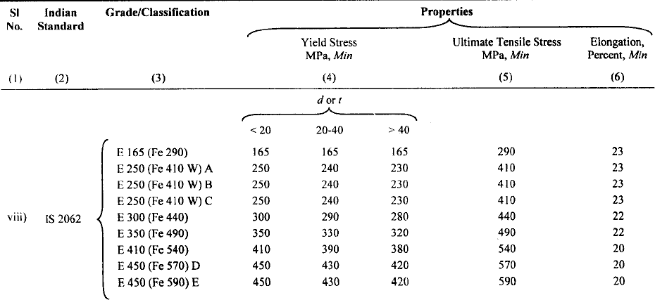

- Concept of Design of steel structures

Design problems are seldom amenable to solution by exact mathematical formulae. There is a considerable scope for exercising engineering judgement. Hence, there is no “correct solution” to a design problem, as there could be several so-called “correct solutions” to the same problem. This is because
- the designs are invariably subject to individual interpretation of Standards and Codes,
- the solutions are also subject to differing ideas about what is or what is NOT required from an engineering and environmental stand point, and
- the individual designers have ingrained ideas from their past experience, which may be valid to-day only to a limited extent, or may not be valid at all.

(Stress due to dead load + live load) < allowable stress (Stress due to dead load + wind load) < allowable stress
(Stress due to dead load + live load + wind) < 1.33 times allowable stress.

In practice there are severe limitations to this approach. These are the consequences of material non-linearity, non-linear behaviour of elements in the post-buckled state and the ability of the steel components to tolerate high theoretical elastic stresses by yielding locally and redistributing the loads. Moreover the elastic theory does not readily allow for redistribution of loads from one member to another in a statically indeterminate structures.

- Limit state design

An improved design philosophy to make allowances for the shortcomings in the “Allowable Stress Design” was developed in the late 1970’s and has been extensively incorporated in design standards and codes formulated in all the developed countries. Although there are many variations between practices adopted in different countries the basic concept is broadly similar. The probability of operating conditions not reaching failure conditions forms the basis of “Limit States Design” adopted in all countries.
“Limit States" are the various conditions in which a structure would be considered to

have failed to fulfil the purpose for which it was built. In general two limit states are considered at the design stage and these are listed in Table 3.1.

Table 3.1: Limit States

Limit State of Strength Serviceability Limit State

Strength (yield, buckling) Deflection Stability against overturning and sway Vibration
Fracture due to fatigue Fatigue checks (including reparable
Plastic collapse damage due to fatigue)
Brittle Fracture Corrosion
Fire

“Limit State of Strength” are: loss of equilibrium of the structure and loss of stability of the structure. “Serviceability Limit State" refers to the limits on acceptable performance of the structure.

Not all these limits can be covered by structural calculations. For example, corrosion is covered by specifying forms of protection (like painting) and brittle fracture is covered by material specifications, which ensure that steel is sufficiently ductile.

- Partial safety factor

The major innovation in the new codes is the introduction of the partial safety factor format. A typical format is described below:

In general calculations take the form of verifying that
S * < R*

where S* is the calculated factored load effect on the element (like bending moment, shear force etc) and R* is the calculated factored resistance of the element being checked, and is a function of the nominal value of the material yield strength. S* is a function of the combined effects of factored dead, live and wind loads. (Other loads – if applicable, are also considered)

In accordance with the above concepts, the safety format used in Limit State Codes is based on probable maximum load and probable minimum strengths, so that a consistent level of safety is achieved.

- Limit state of serviceability

As stated in IS: 800: 2007, Serviceability Limit State is related to the criteria, governing normal use. Serviceability limit state is limit state beyond which

service criteria, specified below, are no longer met:

- Deflection Limit
- Vibration Limit
- Durability Consideration

- Fire Resistance

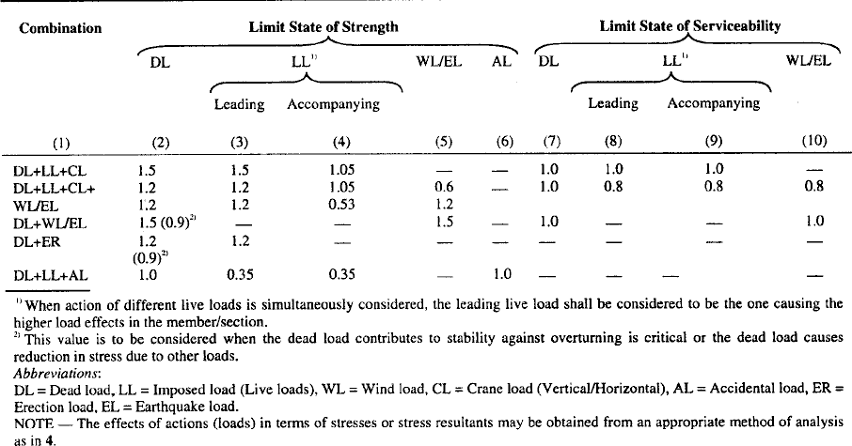

Table 3.3: Partial safety factors for materials γ m
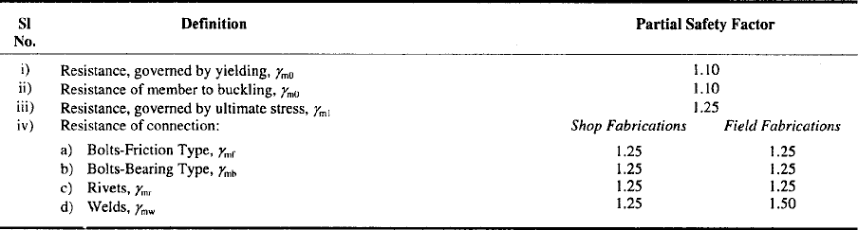

Table 3.4 Deflection Limits
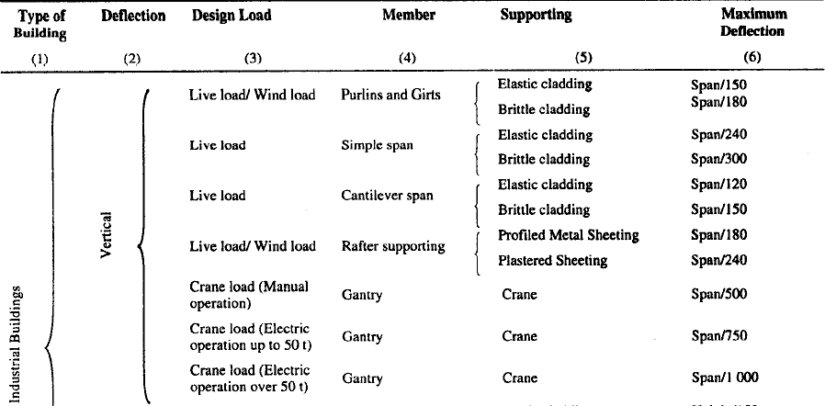

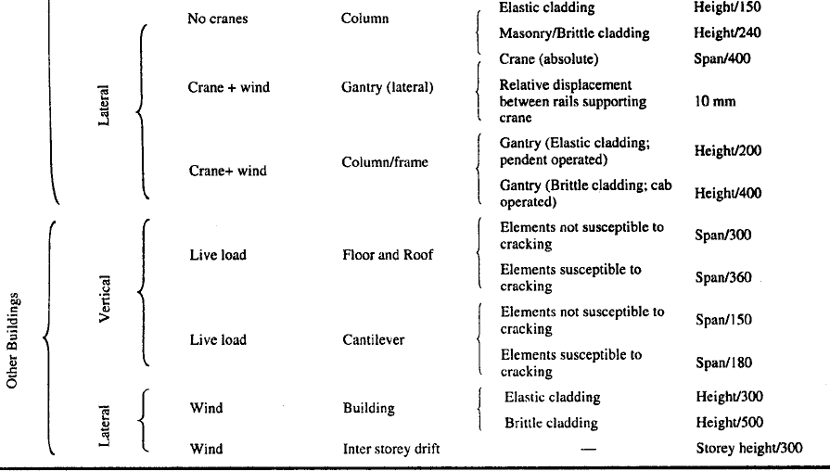

Table 3.5 Limiting Width to Thickness Ratio
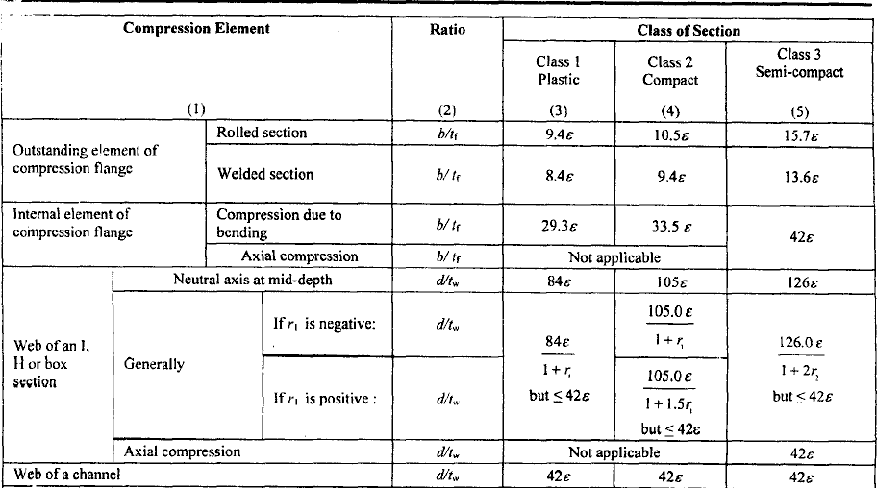

- Structural elements

A building structure consisting of a steel frame work skeleton is made up of the following structural elements or members
- Flexural members; beams or girders
- Tension members
- Compression members: columns, stanchions, struts
- Torsional members
- Elements of foundation structure

Some elements or members may be subjected to combined bending and axial loads. The members of steel frame are jointed together by riveted, bolted, pinned or welded connections or joints. No matter how complicated a structure may appear to be, it must consist of some combination of the basic members mentioned above. However, flexural members, (or beams) may, in some cases, appear as extremely heavy built-up girders and the compression members (or columns) and tension members (or ties) may be combined to form heavy trusses in an extensive frame work. The structural elements are made up of the following commonly used structural shapes and built-up sections as shown in Figure 4.1 below.
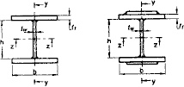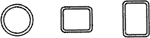

welded I-Section Hollow Section
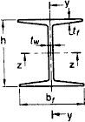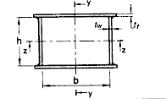
Rolled I-Sections Welded Box Section
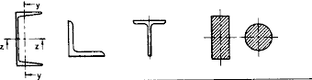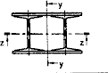

Channel, Angle, T and Solid Sections Built-upMember
Figure 4.1 Commonly used structural shapes

- Angle section
- T-section
- Channel section
- I-section
- Z-section
- Solid square section
- Square tube
- Circular section (solid)
- Hollow circular section
- Plate section
- Compound and built-up sections

- Structural steel sections

Structural steel is rolled into a variety of shapes and sizes. The shapes are designated by the shape and size of their cross-section. Following are various types of rolled structural steel sections commonly used:
- Rolled steel beam sections (I-section)
- Rolled steel channel sections
- Rolled steel angle sections
- Rolled steel T-sections
- Rolled steel bars
- Rolled steel plates
- Rolled steel sheets and strips
- Mild steel flats

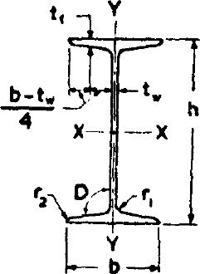
Figure 5.1 Rolled steel I beam

- Rolled steel beam section (Figure 5.1)
ISI Hand Book for Structural Engineers Vol 1: Structural steel sections gives five series of beam section
- Junior beams, designated as ISJB (Indian Standard Junior Beams)
- Light Beams designated as ISLB (Indian Standard Light Beams)
- Medium Beams, designated as ISMB (Indian Standard Medium Weight Beams)
- Wide Flange Beams, designated as ISWB (Indian Standard Wide-Flange Beams)
- H-Beams or column beams designated as ISHB (Indian Standard H-Beams)

Each beam section is designated by the series to which it belongs followed by the depth (in mm) of the section. For example, ISMB 400 means a beam section of medium weight and of depth equal to 400 mm. In some cases of wide flange beams and H-beams, more than one

section is available for the same depth. For example, more than one section is available for the same depth. For example, there are two sections of ISWB600; these two sections are differentiated by writing the mass of the beams per m run. Thus we have ISWB 600 @133.7 kg/m and ISWB 600@145.1 kg/m both of these being two different sections having different properties. Similarly we have ISHB 300@58.8 kg/m and ISHB 300@63.0 kg/m giving two different sections having different geometrical properties.

- Rolled Steel Channel Sections (Figure 5.2)
ISI hand book gives the following four series of channel sections:
- Junior channels designated by ISJC (Indian Standard Junior Channels)
- Light Channels designated by ISLC (Indian Standard Light Channels)
- Medium channels designated by ISMC (Indian Standard Medium Weight Channels)
- Special channels designated by ISSC (Indian Standard Special Channels)
Each rolled steel section is designated by the series to which it belongs, followed by its depth (in mm) and then its mass per metre length. Thus we have ISLC 400@45.7 Kg/m, meaning thereby that it is a light channel, having depth equal to 400 mm and mass equal to 45.7 kg/m. A channel section has only one axis of symmetry. Due to this, it is subjected to twisting or torsion, along with bending, when used as a beam.

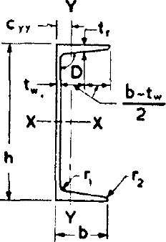

Figure 5.2 Rolled steel channel

- Rolled Steel Angle Sections (Figure 5.3) ISI hand book gives three series of angle sections:
- Equal angles section designated by ISA (Indian Standard Equal Angles)
- Unequal angles section designated by ISA (Indian Standard Unequal Angles)
- Bulb angle section designated by ISBA (Indian Standard Bulb angles) (Figure 5.4) Since the equal angle section and unequal angle section are designated by the same series, the width and height of the legs of the angle are also mentioned along with the series. Thus, ISA

4040 will mean an equal angle section, having width and depth equal to 40 mm. Similarly ISA 4025 will mean an unequal angle section having depth equal to 40 mm and width equal to 25 mm. A bulb angle has unequal legs and hence only its depth is mentioned along with the series designation. Thus we have ISBA 300 meaning there by that it is a bulb angle section having its depth equal to 300 mm. However, there may be two bulb sections of the same depth, and these are differentiated by mentioning their mass per metre length. Thus we have ISBA 300 @ 47.5 kg/m and ISBA 300 @52.6 kg/m giving two sections which have different properties. It should be noted that the angle sections mentioned above do not have any axis of symmetry and hence the principal axes u-u and v-v are inclined to x-x and y-y axes.
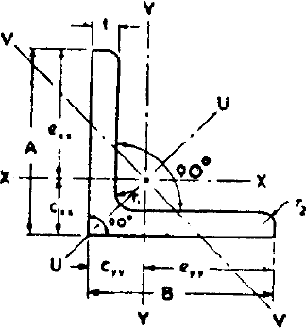
Figure 5.3 Rolled steel angle

- Rolled Steel T-sections (Figure 5.5)
- Normal Tee designated by ISNT, having width of flange, equal to the depth of section
- H-Tee or wide flange tee, designated by ISHT, having width of flange equal to twice the depth of the section.
- Short-Tee designated by ISST, having the width of flange shorter than the depth of the section
- Light-Tee, designated by ISLT, having light weight
- Junior Tee designated by ISJT

Each T-section is designated by the series to which it belongs followed by the depth in mm. Thus we have ISNT 100, meaning there by that it is a normal Tee section, having its depth equal to 100 mm. Similarly ISLT 100 will mean a light Tee section having depth of section equal to 100 mm. It is always preferable to mention the mass per metre length also such as ISNT 100 @ 15.0 kg/m or ISST 200 @ 28.4 kg/m etc.

- Rolled Steel Bar Sections (Figure 5.6)
ISI Hand book gives rolled steel bars of two types:
- Round bars designated by ISRO
- Square bars designated by ISSQ

Each bar section is designated by the series to which it belongs along with the diameter or the width in mm. Thus ISRO 100 will mean a round bar having 100 mm diameter. Similarly ISSQ 80 will mean a square bar of size 80 mm.

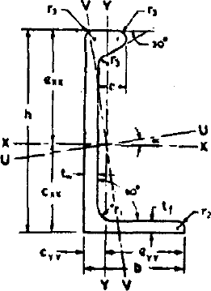
Figure 5.4 Rolled steel bulb angle
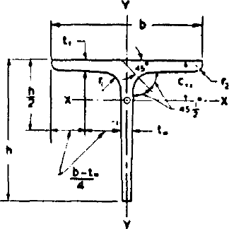
Figure 5.5 Rolled steel Tee bars

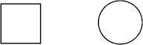
Figure 5.6 Square and round bars

Chapter-2
Structural steel fasteners and connections
A structure is an assembly of various elements or components which are fastened together through some type of connection. If connections are not designed properly and fabricated with care, there may be a source of weakness in the finished structure, not only in their structural action but also because they may be the focus of corrosion and aesthetically unpleasing. Where as the design of main members has reached an advanced stage, based upon theories which have been developed and refined, the behaviour of connections is often so complex that theoretical considerations are of little use in practical design. By their very nature, connections are a jumble of local effects. Most connections are highly inderminate, with the distribution of stress depending upon the deformation of fasteners and the detail material. Local restraints may prevent the deformation necessary for desirable stress redistribution.

Following are the requirements of a good connection in steelwork:
- It should be rigid, to avoid fluctuating stresses which may cause fatigue failure
- It should be such that there is the least possible weakening of the parts to be joined
- It should be such that it can be easily installed, inspected and maintained.

The following are the common types of connections used for structural steel work;

- Riveted connections
- Bolted connections
- Pinned connections
- Welded connections

Rivets, bolts and welds are used extensively, and frequently the economic advantage of one over the other two is so small to be uncertain. However, at one time, riveting prevailed but it has been superseded in importance by welding and high-strength bolting.

- Rivet and Riveting

Riveting is a method of joining together structural steel components by inserting ductile metal pins, called rivets, into holes of the components to be connected from coming apart. A rivet consists of (i) a shank of given length and diameter and (ii) a head known as manufactured head. The size of the rivet is defined by the diameter of the shank. Riveting is essentially a forging process during which a hot rivet is driven in its plastic state and a head isformed at the other end. The head so formed at the other end of the rivet with the help of a riveting hammer and a buckling bar is known as driven head.
Rivets driven in the field during the erection of a structure are known as field rivets. Rivets driven in the fabricating shop are known as shop rivets. Both these types are known as hot driven rivets since the rivets are heated to a temperature ranging between 1000º F to 1950ºF before driving. Field rivets are driven by a hand operated pneumatic riveting hammer, while the shop rivets are driven by “bull” riveter. Some rivets are driven at atmospheric temperature. They are known as cold driven rivets which are squeezed or driven to fill the holes and to form the heads by application of large pressure. However, they are smaller in diameter, ranging from 12 mm to 22 mm. Strength of cold driven rivet is more than hot driven rivets. Rivets driven by hand operated riveting hammer are known as hand driven rivets while those driven by power operated equipment are known as power driven rivets. Some times, even the field rivets may also be power driven.

- Types of Rivetd Joints

There are two types of riveted or bolted joints.
- Lap joint: The first is the lap joint in which the plates to be connected overlap each other. (Figure 6.1)
- Butt joint: The second is the butt joint in which the plates are to be connected butt against each other and the connection is made by providing a cover plate on one or both sides of the joint. (Figure 6.2)

Figure 6.1 Single Riveted lap joint
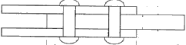
Figure 6.2 Double riveted butt joint

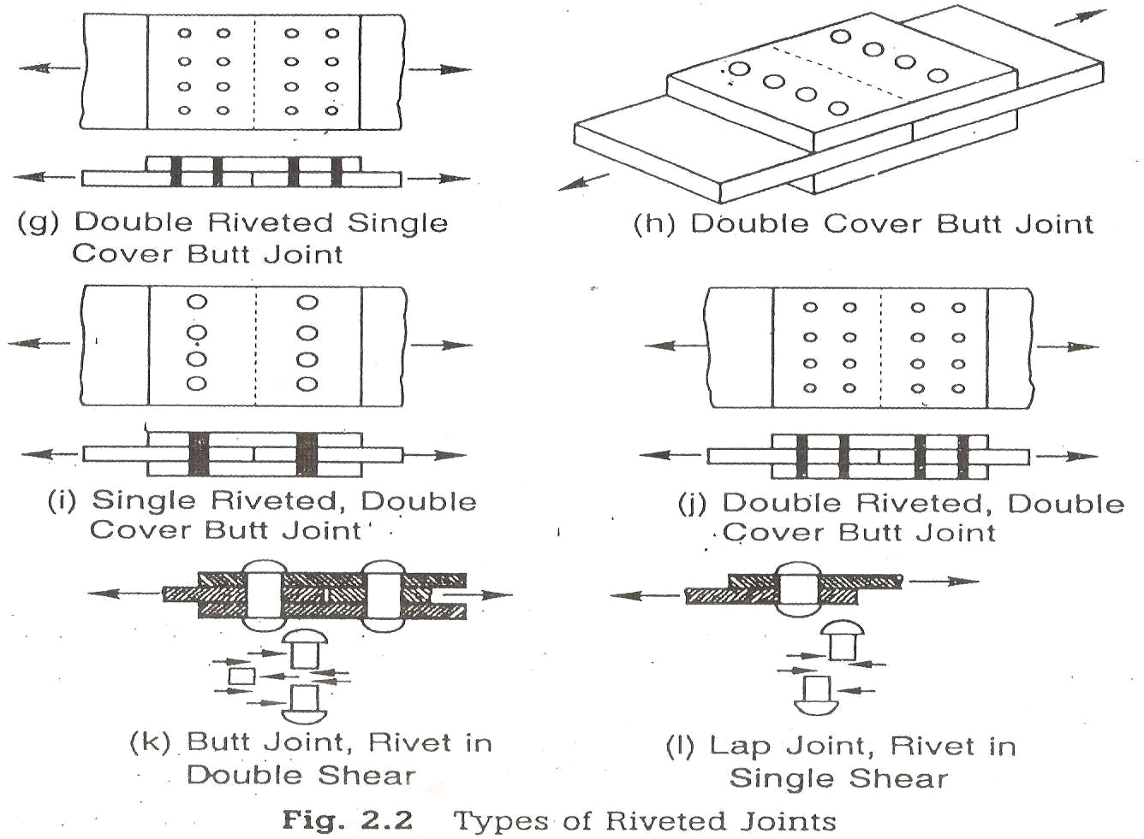

- Definitions

The following definitions are used for riveted or bolted joints
- Nominal diameter: The diameter of the shank of a rivet before riveting is called the nominal diameter.

- Effective diameter or gross diameter: The effective or gross diameter of a rivet is equal to the diameter of the hole it fills after riveting
- Gross area: The gross area of a rivet is given by its gross diameter.
- Pitch: The distance between centres of any two adjacent rivets is called the pitch.
- Gauge: A row of rivets parallel to the direction of force is called a gauge line. The normal distance between two adjacent gauge lines is called the gauge distance.
- Edge distance; It is the distance between the edge of a member or cover plate and the centre of the nearest rivet hole.
The joint may fail in any of the following manners.
- Tearing of the plate between rivet holes: The strength of the plate is reduced by rivet holes and the plate may tear off along the line of the rivet holes as shown in Figure b. This type of failure is for tension members only.
- Shearing of rivet: The rivets fail by shearing if the shearing stress exceeds their shearing strength. In lap joints and single cover butt joints, the rivets are sheared at one plane only. In a double cover butt joint, the rivets are sheared at two planes as shown in Figure c.
- Bearing of plate or rivet: The plate or rivet is crushed if the compressive stress exceeds the bearing strength of the plate or the rivet as shown in Figure d.
- Assumptions in the theory of riveted joints

Certain assumptions are made while deriving expressions for the strength of riveted joints as follows:
- The tensile stress is uniformly distributed on the portions of the plate between the rivets.
- The friction between the plates is neglected.
- The shearing stress is uniformly distributed on the cross-sections of the rivets.
- The rivets fills the holes completely.
- The rivets in a group share the direct load equally
- Bending stress in rivets is neglected
6.8 Efficiency of a joint

The original strength of a section is reduced by rivet holes. The efficiency of a joint is the ratio of the joint and the original strength of the member without rivet holes. At the weakest critical section, the number of rivet holes should be minimum for maximum efficiency.

6.9 Design of riveted joints for axially loaded members

The diameter of a rivet is generally calculated by the following formula;
d = 6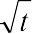 where d is the rivet diameter in mm and t is the thickness of plate in mm Number of rivets required for the joint = Load/Rivet value
The rivets are arranged bearing in mind the following points:
- The arrangement should satisfy the gauge, pitch and edge distance requirements
- The strength of joint should be increased gradually towards the joint for uniform distribution of stress in the rivets.

- The cg of each rivet group should coincide ith the centreline of the connected members. It is not possible practically to follow this condition in some cases e.g the angle connection with gusset plate. The small eccentricities are usually neglected.
- The centreline of all members meeting at a joint should coincide at one point only otherwise the joint will twist out of position,
- The strength of member reduces due to rivet holes. The reduction in area due to rivet holes is minimum if rivets are arranged in a zig-zag form.

Table 6.1 Rivet diameter pitch and edge distances
Nominal dia  of rivets (mm) | 12 | 14 | 16 | 18 | 20 | 22 | 24 | 27 | 30
Gross dia of  rivets | 13.5 | 15.5 | 17.5 | 19,5 | 21.5 | 23.5 | 25.5 | 29 | 32
Minimum edge distance for sheared or  rough edge | 19 | 25 | 29 | 32 | 32 | 38 | 44 | 51 | 57
Minimum edge distance for rolled or  planed edge | 17 | 22 | 25 | 29 | 29 | 32 | 38 | 44 | 51

Minimum pitch = 2.5 times the diameter of the rivet holeMaximum pitch = 32 t or 300 mm whichever is less

BOLTED CONNECTIONS
A bolt may be defined as a metal pin with a head at one end and a shank threaded at the other end to receive a nut as in Fig 1.0(a). Steel washers are usually provided under the bolt as well as under the nut to serve two purposes:

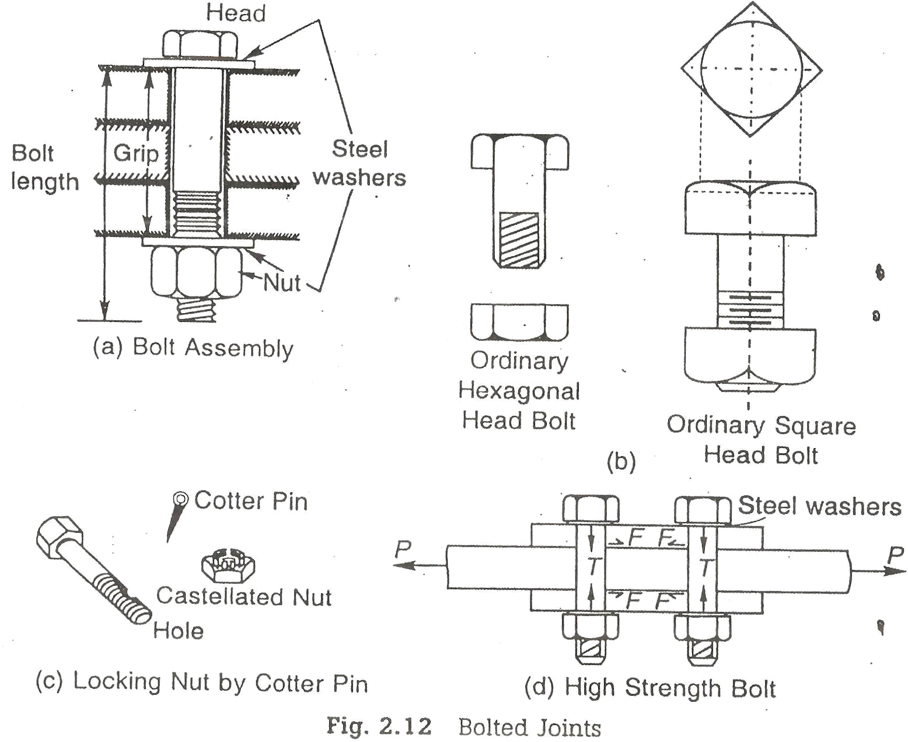

- To distribute the clamping pressure on the bolted member, and

- To prevent the threaded portion of the bolt from bearing on the connecting pieces.

In order to assure proper functioning of the connection, the parts to be connected must be tightly clamped between the bolt between the bolt head and nut. If the connection is subjected

vibrations, the nuts must be locked in position. Bolted connections are quit similar to riveted connections in behaviour but have some distinct advantages as follows:

- The erection of the structure can be speeded up, and

- Less skilled persons are required.

The general objections to the use of bolts are:

- Cost of material is high: about double that of rivets.

- The tensile strength of the bolt is reduced because of area reduction at the root of the thread and also due to stress concentration.
- Normally these are of a loose fit excepting turned bolts and hence their strength is reduced.
- When subjected to vibrations or shocks bolts may get loose.

Uses

- Bolts can be used for making end connections in tensions and compression member.

- Bolts can also be used to hold down column bases in position.

- They can be used as separators for purlins and beams in foundations, etc.

Types

There are several types of bolts used to connect the structural elements. Some of the bolts commonly used are:
- Unfinished bolts

- Turned bolts

- Ribbed bolts

- High strength bolts

- Interference bolts

UNFINISHED BOLTS
Unfinished bolts are also called ordinary, common, rough or black bolts. There are used for light structures (purlins, bracings, etc.) under static loads. They are not recommended for connections subjected to impact load, vibrations and fatigue. Bolts are forged from low carbon rolled steel circular rods, permitting large tolerances. Ordinary structural bolts are made from mild steel with square or hexagonal head, as shown in Fig 1.0(b). Square heads cost less but hexagonal heads give a better appearance, are easier to hold by wrenches and require less turning space. The bolt hole is punched about 1.6mm more than the bolt diameter. The nuts on bolts are tightened with spud wrenches, producing little tension. Therefore, no clamping force is induced on the sections jointed. Sometimes a hole is drilled in the bolt and a cotter pin with a castellated nut is used to prevent the nut from turning on the bolt, as shown in Fig 1.0(c). the connections with unfinished bolts are designed in a similar way as all the riveted connections except that the permissible stresses are reduced to account for tolerances provide on shank and threaded portion of the bolts. The requirements regarding pitch and edge distance are same as that for rivets. The permissible stresses are as given in Table 8.1 of I.S:800-1984.
TURNED BOLTS
These are similar to unfinished bolts, with the differences that the shank of these bolts is formed from a hexagonal rod. The surfaces of the bolts are prepared carefully and are machined to fit in the hole. Tolerances allowed are very small. These bolts have high shear and bearing resistance as compared to unfinished bolts. However, these bolts are obsolete nowadays. The specifications for turned bolts are given in I.S:2591-1969.
RIBBED BOLTS
These are also called fluted bolts. The head of the bolt is like a rivet head. The threaded and nut are provided on the other end of the shank. From the shank core longitudinal ribs project making the diameter of the shank more than the diameter of the hole. These ribs cut grooves into the connected members while tightening and ensure a tight fit. These bolts have more resistance to

vibrations as compared to ordinary bolts. The permissible stresses for ribbed are same as that for rivets.
Table 10.1 Tensile Properties of Fasteners
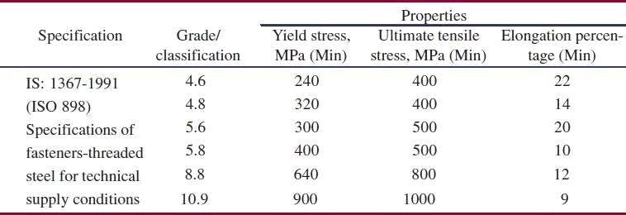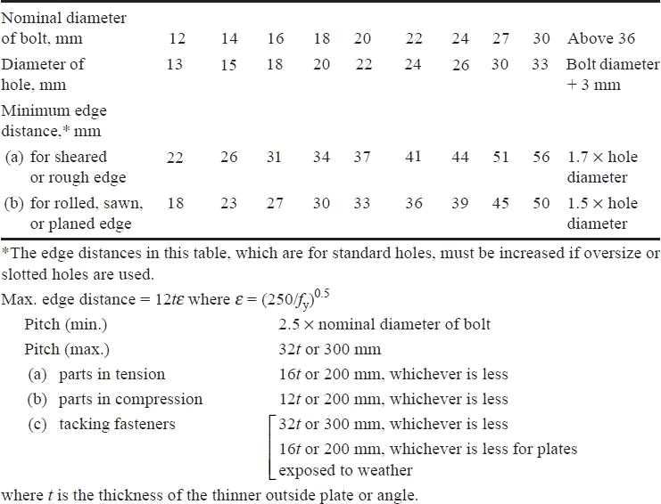

For grade 4.6 bolts, nuts of grade 4 are used and for grade 8.8, nuts of grade 8 or 10 are used

In these bearing type of connections, the plates are in firm contact but may slip under loading until the hole surface bears against the bolt .The load transmitted from plate to bolt is therefore by bearing and the bolt is in shear. Under dynamic loads, the nuts are liable to become loose and so these bolts are not allowed for use under such loading. In situations where small slips can cause significant effects as in beam splices, black bolts are not preferred. However, due to the lower cost of the bolt and its installation, black bolts are quite popular in simple structures subjected to static loading.

Though square heads cost less, hexagonal heads give better appearance, are easier to hold by wrenches, require less turning space. Most of the connections with black bolts are made by inserting them in clearance holes of about 1.5mm to 2 mm more than the bolt diameter and by tightening them with nuts. They are produced in metric sizes ranging from 5-36 mm and designed as M5 to M36. In Structural steel work M16, M20, M24 and M30 bolts are often used. The bolts used in steel work have a course pitch of thread, that is, 2, 2.5, 3 and 3.5 mm for 16, 20, 24 and 30 mm diameter bolts respectively. The ratio of net tensile area at threadsto nominal plain shank area of the bolt is 0.78 as per IS 1367 (Part I). The other dimensions are given in Table 10.2

Table 10.2 Dimensions of Grade 4.6- Hexagon Head Bolts (IS 1364)
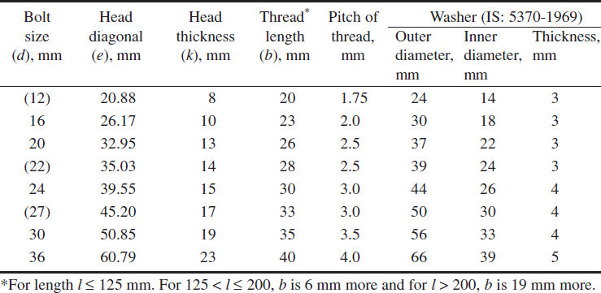

Turned and fitted bolts are available from grade 4.6 to grade 8.8. For the higher grades thereis no definite yield point and so 0.2% proof stress is used..
Advantages of Bolted Connections

Black Bolted connections offer the following advantages over riveted or welded connections:
- Use of unskilled labour and simple tools
- Noiseless and quick fabrication
- No special equipment/process needed for installation
- Fast progress of work
- Accommodates minor discrepancies in dimensions
- The connection supports loads as soon as the bolts are tightened (in welds and rivets,cooling period is involved).

HIGH STRENGTH BOLT
These bolts are called friction grip bolts. These are made from bars of medium carbon steel. Their high strength is achieved through quenching and tempering processes or by alloying steel. Steel washers of hard steel or carburized steel are provided as shown in Fig1.0 (d), to evenly distribute

the clamping pressure on the bolted member and to prevent the threaded portion of the bolt from bearing on the connecting pieces. If the bolts are tightened by the turn of nut method, the nut is made snug and is tightened a half turn more by hand wrenches, then the washers are not required. The vibrations and impact resistance of the joint is also improved. The nut and headof the bolts are kept sufficiently large to provide an adequate bearing area. The specifications for high strength bolts are laid in I.S:3757-1972 and I.S: 4000-1967. These bolts have a tensile strength several times that of the ordinary bolts. High strength bolts have replaced rivets and are being used in structures, such as high rise buildings, bridges, machines etc. Due to their distinct advantages and vital use, high strength bolts are discussed below in some detail.

Advantages of high strength bolts
High strength friction grip (HSFG) bolts have replaced the rivets because of their distinct advantages as discussed below. However, the material cost is about 50% greater than that of ordinary bolts and special workmanship is required in installing and tightening these bolts.
- These provide a rigid joint. There is no slip between the elements connected

- Large tensile stresses are developed in bolts, which in turn provide large clamping force to the elements connected. High frictional resistances is developed providing a high static strength the joint.
- Because of the clamping action, load is transmitted by friction only and the bolts are not subjected to shear and bearing.

- The frictional resistance is effective outside the hole and therefore lesser load is transmitted through the net section. Thus, the possibility of failure at the net section is minimized.
- There are no stress concentrations in the holes; therefore, the fatigue strength is more.

- The tension in bolts is uniform. Also the bolts are tensioned up to proof load hence; the nuts are prevented from loosening
- Few persons are require to make the connections, thus cost is reduced.

- Noise nuisance is not there as these bolts are tightened with wrenches.

- The hazard of fire is not there and there is no danger of tossing of the bolt.

- Alterations can be done easily.

- For some strength, lesser number of bolts are required as compared to rivets which brings overall economy.
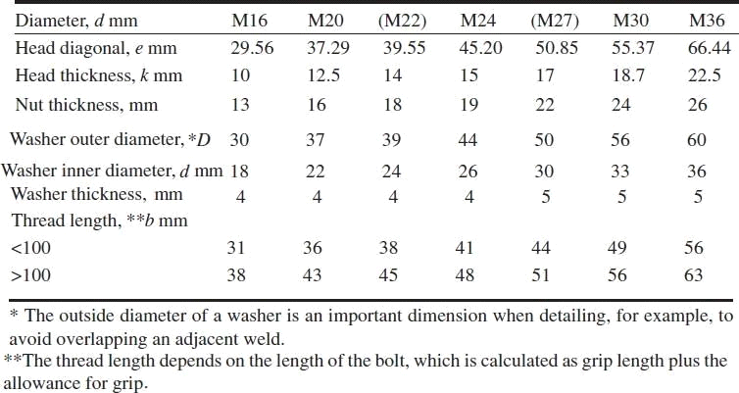
Design Strength of Ordinary Black Bolts

The nominal capacity, Vnsb, of a bolt in shear is given in the code as
V_{nsb} = (fu / 3)(nn Anb + n_{s} A_{sb} )β ljβ lgβ pk

where nn = number of shear planes with threads intercepting the shear plane, ns = number of shear planes without threads intercepting the shear plane,

βlj = reduction factor which allows for the overloading of end bolts that occur in long connections
βlg = reduction factor that allows for the effect of large grip length, βpk = reduction factor to account for packing plates in excess of 6mm.

The factored shear force Vsb should satisfy Vsb ≤ Vnsb / γmb (γmb = 1.25)

Design Strength of Black Bolts (cont.)

Asb = Nominal shank area
Anb = Net tensile stress area through the threads Anb = / 4 (d - 0.9382p)2 ≈ 0.78 Asb
p= pitch of thread, mm Reduction Factor for Long Joints:
βlj = 1.075 – lj (200 d) with 0.75 ≤ βlj ≤ 1.0 Reduction Factor for Large Grip Length:
βlg = 8d / (3d + lg); lg ≤ 8d; βlg ≤ βlj Reduction Factor for Packing plate:
βpk = (1-0.0125 tpk ); tpk is the thickness of the thicker packing plate in mm

Bolts in Tension

The nominal capacity of a bolt in tension is:
Tnb = 0.90 fub Anb < fyb Asb (γm1 / γm0 ) where Asb = Shank area of bolt
Anb = Net Tensile Stress area of bolt fyb = Yield stress of the bolt
γm1 = 1.25; γm0 = 1.10

The factored tension force Tb shall satisfy Tb ≤ Tnb / γmb ; γmb = 1.25

If any of the connecting plates is flexible, the additional prying forces must be considered Bolts in Bearing

Bolts in Bearing

The nominal bearing strength of the bolt is :
Vnpb = 2.5 kbd t fu
fu = Ultimate tensile stress of the plate in MPa d = nominal diameter of the bolt in mm
t = summation of the thicknesses of the connected plates experiencing bearing stress in the same direction (If the bolts are countersunk, the thickness of the plate minus one half of the depth of counter sinking)
kb is smaller of e/(3do), p/(3do)-0.25, fub/ fu and 1.0,
where fub is the ultimate tensile stress of the bolt, e is the edge distance, p is the pitch of the fastener along bearing direction, and do is the diameter of the bolt hole.
Vnpb should be multiplied by a factor 0.7 for over size or short slotted holes and by 0.5 for long slotted holes.

The factor kb takes into account inadequate edge distance or pitch and also prevents bearing failure of bolts.
If we adopt a minimum edge distance of 1.5 x bolt hole diameter and a minimum pitch of 2.5 x diameter of bolt, kb may be approximately taken as 0.50.
The bolt bearing on any plate subjected to a factored shear force Vsb, shall satisfy Vsb ≤ Vnpb / γmb ; γmb = 1.25

Tables 10.6, 10.7 and 10.8 will aid the designer while designing joints using ordinary bolts.

Table 10.6 Strength of Bolts in Clearance Holes

 |  | Bolt  N/mm² | grade | 4.6 | Bolt  N/mm² | grade | 8.8 | Other grades  N/mm² | of bolts
Shear streng th, vnsb |  | 185 |  |  | 370 |  |  | fu / /( 3 ×1.25)
Bearing  Vnpb | strength, | 400 |  |  | 800 |  |  | 2.5kb fu /1.25(kb = 0.5)
Tension strength, tnb |  | 272 |  |  | 576 |  |  | 0.9 fbu / /(1.25) greater  f yb / (1.25 /1.1) | not than

Table 10.7 Bearing strength vnpp of connected parts for ordinary bolts in clearance holes in N/mm²

Grade 410 | Grade 540 | Grade 570 | Other grades
820 | 540 | 570 | 2.5kb fu /1.25

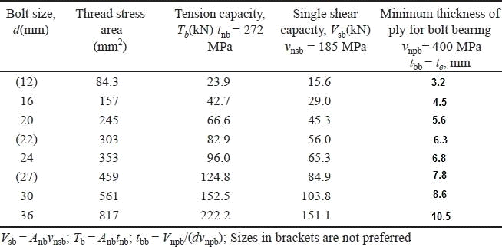

Principles of high strength bolts
The shank of the high strength bolts does not fully fill the hole. So shear and bearing are not the criteria for load transmission as is in the case of rivets, which fill the hole completely. The nut is tightened to develop a clamping force on the plates which is indicated as the tensile force T in the Bolt. This tension should be about 90% of proof load. When a shear load is applied to the joint no slip will occur until the shear load exceeds the frictional resistance between the elementsjointed.

When shear load exceeds the frictional resistance a slip occurs. On further increase ofthis load, the gradual slipping brings the bolt in contact with the plate edges.
The horizontal frictional forces F, is induced in the joints which is equal to the tensile force T, as in Fig.1.0(d), in the bolts multiplied by the coefficient of friction.
F = µT

This frictional force F should exceed the applied force P on the member.
µ= Coefficient of friction or slip factor, is defined as ratio of the load per effective interface required to produce slip in a pure shear joint to the proof load induced in bolt. When the element surfaces are free from paint, dust, etc. its value is 0.45.
PIN CONNECTIONS
When two structural members are connected by means of a cylindrical shaped pin, the connection is called a pin connection. Pins are manufactured from mild steel bars with diameters ranging from
9 to 330 mm. Pin connections are provided when hinged joints are required, i.e.,for the connection where zero moment of free rotation is desired. Introduction of a hingesimplifies the analysis by reducing indeterminacy. These also reduce the secondary stresses. These connections cannot resist longitudinal tension. For satisfactory working it is necessary to minimize the friction between the and members connected. High grade machining is done to make the pin and pin hole surface smooth and frictionless. Pins are provided in the following cases:
FAILURE OF BOLTED JOINTS
The bolted joint may fail in any of the following six ways, out of which some failures can be checked by adherence to the specifications of edge distance. Therefore, they are not of much importance, whereas the others require due consideration.

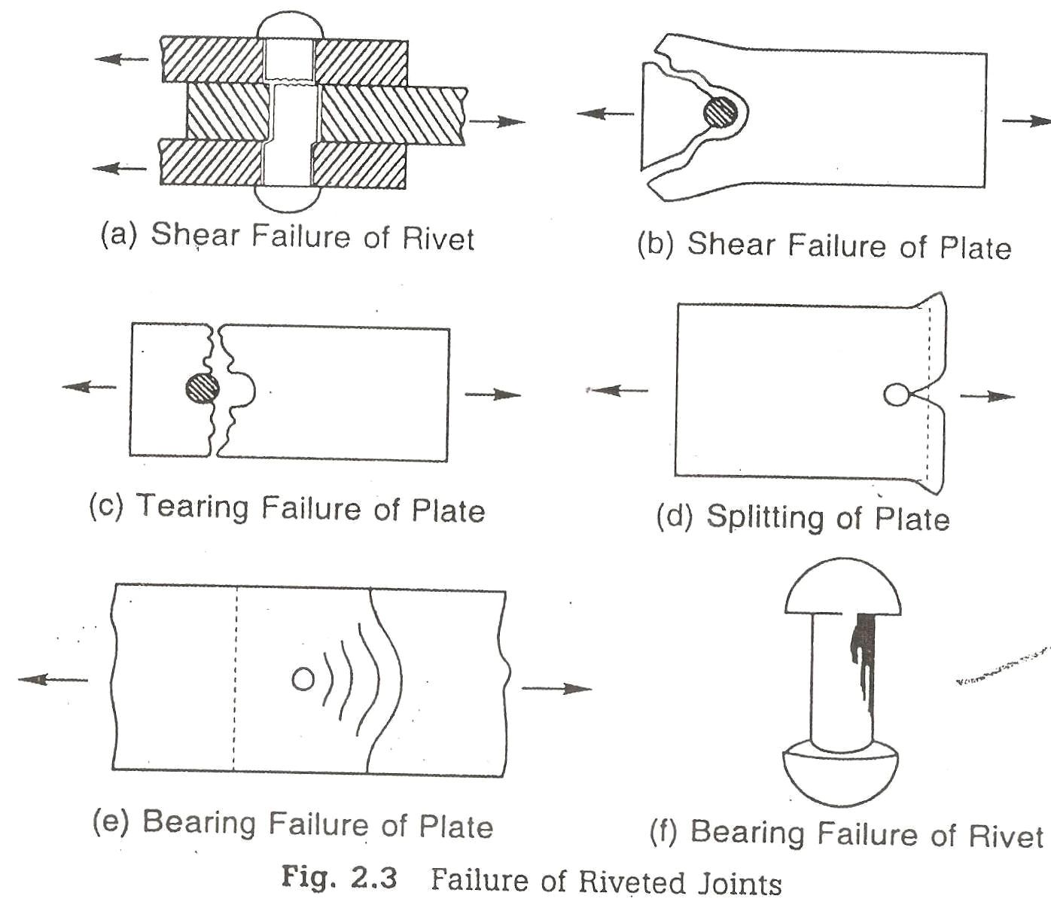

Shear failure of bolts (Fig. 2.3 (a))
The shear stress in the bolt may exceed the working shear stress in the bolt. Shear stresses are generated because the plates slip due to applied forces.

Shear failure of plates (Fig. 2.3(b))
The internal pressure of overdriven (shank length more than the grip) bolts placed at a lesser edge distance than specified causes this failure. This can be checked by providing proper edge distance between the center of the hole and the end of the plate as specified by I.S.800.
Tension or tearing failure of plates (Fig. 2.3(c))
The tensile stress in the plate at the net cross-section may exceed the working tensile stress. Tearing failure occurs when bolts are stronger than the plates.
Splitting of plates (Fig. 2.3(d))

Bolts may have been placed at a lesser edge distance than required causing the plates to split or shear out.
Bearing failure of plates (Fig. 2.3(e))
The plate may be crushed when the bearing stress in the plate exceeds the working bearing stress.
Bearing failure of bolts (Fig. 2.3(f))
The bolt is crushed around the half circumference. The plate may be strong in bearing and the heaviest stressed plate may press the bolt.

CAPACITY OF HSFG SHEAR BOLTS

As stated in Fig, these are the bolts made of high tensile steel which are pretensioned and then provided with nuts. The nuts are clamped also. Hence resistance to shear force is mainly by friction.
There are two types of HSFG bolts. They are parallel shank and waisted shank type. Parallel shank type HSFG bolts are designed for no-slip at serviceability loads. Hence they slip at higher loads and slip into bearing at ultimate loads. Hence such bolts are checked for their bearing strength at ultimate load. Waisted shank HSFG bolts are designed for no slip even at ultimate load and hence there is no need to check for their bearing strength.
Vnsf = µf ne Kh F0

Where,

µf = Co-efficient of friction (Called slip factor) as specified in Table 3.1. ne = number of effective interfaces offering frictional resistance to this slip. [Note: ne = 1 for lap joints and 2 for double cover butt joints]
Kh = 1.0 for fasteners in clearance holes

= 0.85 for fasteners in oversized and short slotted holes and for long slotted holes located perpendicular to the slot.
=0.70 for fasteners in long slotted holes loaded parallel to the slot.

F0 = Minimum bolt tension at installation and may be taken as Anb f0
π

Anb

= net area of the bolt at threads

= 0.78 d ²
4

f0 = Proof stress = 0.70 fub

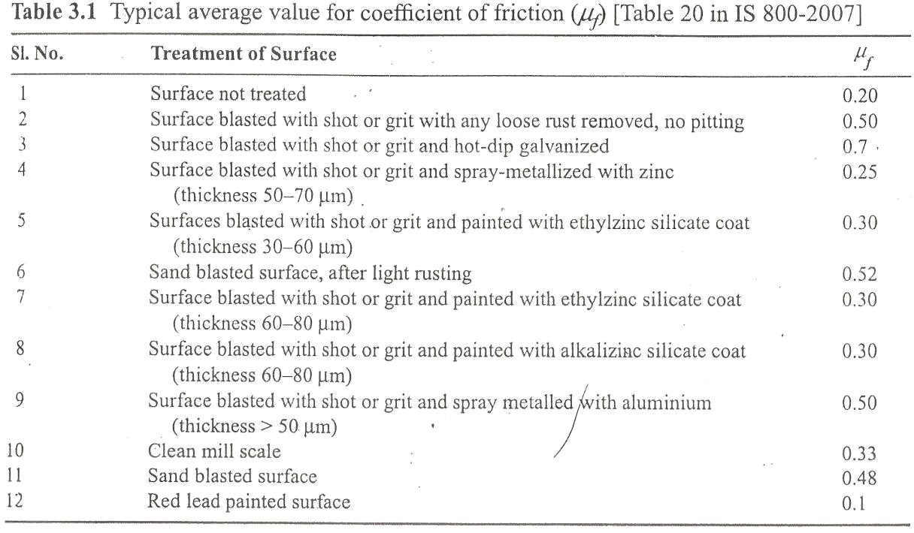

The slip resistance should be taken as Vsf = Vnsf /1.10
Where,

=1.10, if the slip resistance is designed at service load (Parallel shank HSFG)

=1.25, if the slip resistance is designed at ultimate load (Waisted shank HSFG).

It may be noted that the reduction factors specified (Fig. 3.11) for bearing bolts hold good for HSFG bolts also.
For commonly used HSFG bolts (Grade 8.8), yield stress fyb =640 Mpa and ultimate stress fub
=800 N/mm²

Example 3.12

Determine the shear capacity of bolts used in connecting two plates as shown in Fig.3.30

- Slip resistance is designated at service load

- Slip resistance is designated at ultimate load

Given:
HSFG bolts of grade 8.8 are used. Fasteners are in clearance holes
Coefficient of friction = 0.3

Solution:
For HSFG bolts of grade 8.8,
For fasteners in clearance holes Kh = 1.0 Coefficient of friction µf =0.3
.’. Nominal shear capacity of a bolt

Vnsf = µf nc Kh F0

Where F0 = 0.7 fub Anb
=0.7 X 800 X 0.78 X π X 202
4

ne=2, since it is double cover butt joint

- Design capacity of one bolt, if slip resistance is designated at service load

Vnsf = 0.3 x 2 x1.0 x137225

= 82335 N

= 82335/1.1 =74850 N

Therefore design capacity of joint = 6 x 74850, since 6 bolts are used

= 449099 N

= 449.099 kN

- Design capacity of one bolt, if the slip resistance is designated at ultimate load

= 82335/1.25 =65868 N

Therefore design capacity of joint = 6 x 65868, since 6 bolts are used

= 395208 N

= 395.208 kN

In case (i), bearing strength at ultimate load should be checked. If it is low that will be the governing factor.

TENSION RESISTANCE OF HSFG BOLTS
The expression for nominal tension strength of HSFG bolts is also as that for bearing bolts. i.e,

T_{nf} = 0.9 Xfub XAn ≤ f _{yb} A_{sb}

γ mb
γ

Tdf

= 0.9 fub An ≤
mb

m

f yb Asb
γ

m

Where

An = net tensile area as specified in various parts of IS 1367, it may be taken as the area at the
π
root of the thread = 0.78 d 2
4

Asb = shanke area. γmb = 1.25, γm = 1.1
fub for bolts of grade 8.8 is 800 MPa and fyb = 640 MPa.

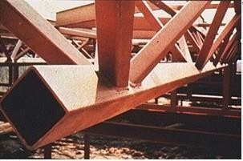
Welded Connections

- Introduction

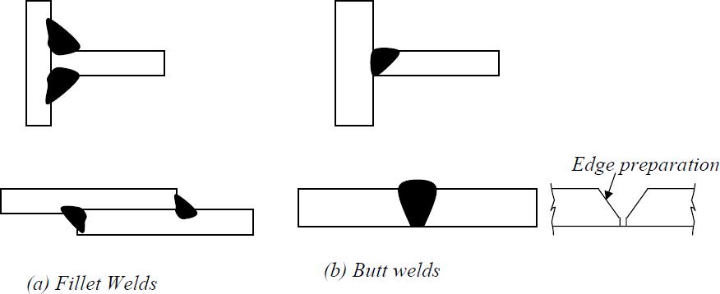Steel sections are manufactured and shipped to some standard lengths, as governed byrolling, transportation and handling restrictions. However, most of the steel structural members used in structures have to span great lengths and enclose large three dimensional spaces. Hence connections are necessary to synthesize such spatial structures from one- and two-dimensional elements and also to bring about stability of structures under different loads.Thus, connections are essential to create an integral steel structure using discrete linear and two-dimensional (plate) elements.

Figure 7.1 Typical welded connections The merits of butt welds are:
- easily designed and fabricated to be as strong as the member,
- better fatigue characteristics, compared to fillet welds,
- better appearance, compared to fillet welds, and
- easy to detail and the length of the connection is considerably reduced. The demerits of the butt welds are:
- more expensive than fillet welds because of the edge preparation required, and
- require more skilled manpower, than that required for filled welds.

It has been pointed out that steel sections are linear elements produced in certain convenient lengths due to constraints on manufacturing and transportation. Therefore connections are necessary to provide continuity, where required, as well as to create three-dimensional steel

structures
Advantages of welding

Welding offers many advantages over bolting and riveting. Some of the advantages are listed in the following.

- Welding enables direct transfer of stress between members. Hence, the weight of the joint is minimum. Besides efficiency, design details are very simple. Less fabrication cost compared to other methods due to handling of fewer parts and elimination of operations like drilling, punching etc. The most striking advantage of welded structures is in the area of economy. Welded structures allow the elimination of a large percentage of the gusset and splice plates necessary for riveted or bolted structures. Time is saved in detailing, fabrication and field erection. In some bridge trusses it may be possible to save up to 15% of the steel weight by resorting to welding. Welding also requires considerably less labour for executing the work.

- Welding offers air tight and water tight joining of plates and hence ideal for oil storage tanks, ships etc.

- Welded structures usually have a neat appearance as against the cluttered surface of bolted or riveted connections. Fig. 7.2 shows a comparison of riveted plate girder and a welded plate girder. Further, welded connections offer the designer more freedom for innovation in his design concept. It enables him to use any cross section and the best configuration to transmit forces from one member to another.

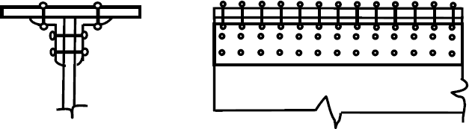

- Riveted plate girder
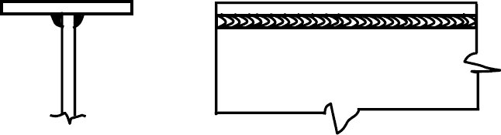

b). Welded plate girder Figure 7.2

The range of application of welding is very wide. For example, connection of a steel pipe column to other members can be made very easily by welding whereas it is virtually impossible by bolting or riveting. Welding is practicable even for complicated shapes of joints.

- There is no need for holes in members connected by welding except possibly for erection purposes. This has direct influence in the case of tension members as the problem of determining the minimum net section is eliminated. This also results in a member with a smaller cross section.

- Welded structures are more rigid compared to structures with riveted and bolted connections. The rigidity of welded structures is due to the direct connection of members by welding. In bolted or riveted structures, the connection is established through angles or plates,which deflect under loads, making the structure flexible.

- It is easier to make design changes and to correct mistakes during erection, if welding is used. It is also a simple procedure to strengthen the existing structures with welding.

*. A truly continuous structure is formed by the process of fusing the members together. This gives the appearance of a one-piece construction. Generally welded joints are as strong or stronger than the base metal, thereby placing no restriction on the joints.

Due to this continuity advantage, a very large number of steel frames have been constructed all over the world.
- Stress concentration effect is considerably less in a welded connection. Some of the lesser important advantages of the welding processes are: relative silence of the process of welding and fewer safety precautions.
Some of the disadvantages of welding are:
- Welding process requires highly skilled manpower
- Experienced manpower is needed for inspection of welded connections. Also, non- destructive evaluation may have to be carried out to detect defects in welds

- Welded joints are highly prone to cracking under fatigue loading
- Costly equipment is essential to make welded connections
- Proper welding can not be done in the field environment
- Large residual stresses and distortion are developed in welded connections


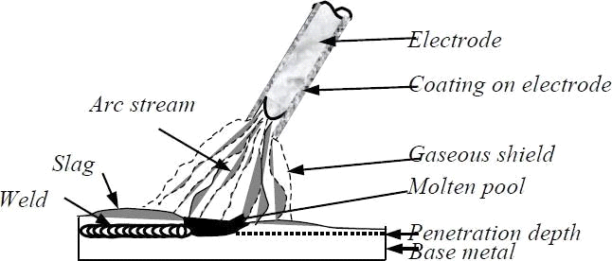
Figure 7.3 Shielded Metal Arc Welding (SMAW) process
Types of joints and welds

By means of welding, it is possible to make continuous, load bearing joints between the members of a structure. A variety of joints is used in structural steel work and they can be classified into four basic configurations as shown in Figure 7.7.
They are:
- Lap joint
- Tee joint
- Butt joint, and
- Corner joint

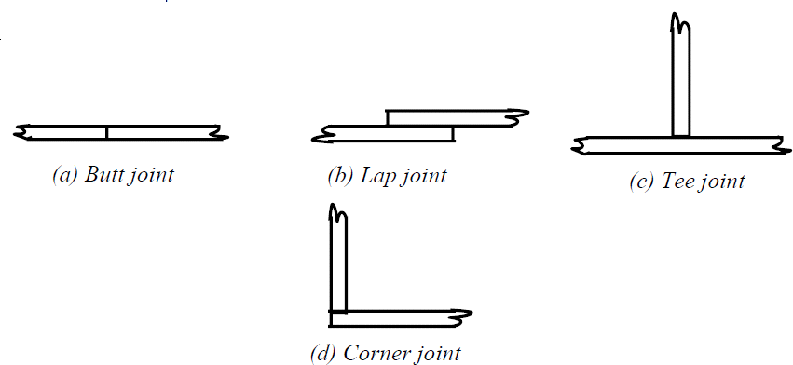
Figure 7.7 Types of joints

For lap joints the ends of two members are overlapped, and for butt joints the two members are placed end to end. The T- joints form a Tee and in Corner joints, the ends are joined like the letter L. The common types of welds are shown in Fig.7. 8. Most common joints are madeup of fillet weld and the groove weld. Plug and slot welds are not generally used in structural steel work. Fillet welds are suitable for lap joints and Tee joints and groove welds for buttand corner joints. Groove welds can be of complete penetration or incomplete penetration depending upon whether the penetration is complete through the thickness or partial.

Generally a description of welded joints requires an indication of the type of both the joint and the weld.

fillet welds are weaker than groove welds, about 80% of the connections are made with fillet welds. The reason for the wider use of fillet welds is that in the case of fillet welds, when members are lapped over each other, large tolerances are allowed in erection. For groove welds, the members to be connected have to fit perfectly when they are lined up for welding. Further groove welding requires the shaping of the surfaces to be joined as shown in Fig. 7.9. To ensure full penetration and a sound weld, a backup plate is temporarily provided as shownin Fig. 7.9.

Welds are also classified according to their position into flat, horizontal, vertical and overhead (Fig. 7.10). Flat welds are the most economical to make while overhead welds are the most difficult and expensive.
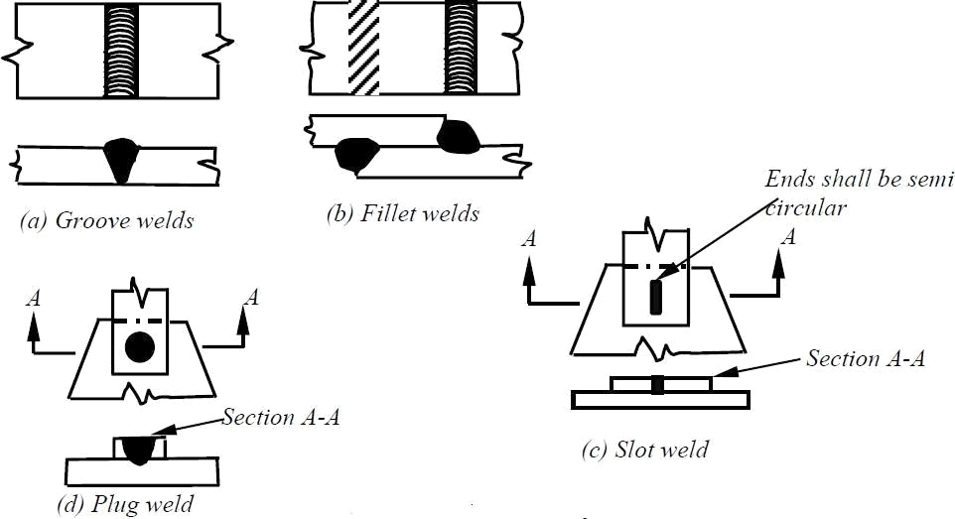
Figure 7.8 Common types of welds

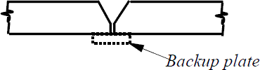
Figure 7.9 Shaping of surface and backup plate

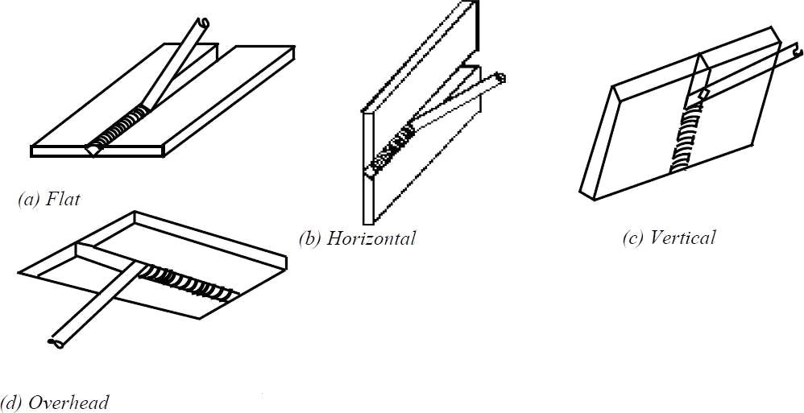
Figure 7.10 Classification based on position

Groove welds

The main use of groove welds is to connect structural members, which are in the same plane. A few of the many different groove welds are shown in Fig. 7.11. There are many variations of groove welds and each is classified according to its particular shape. Each type of groove weld requires a specific edge preparation and is named accordingly. The proper selection of a particular type depends upon
- Size of the plate to be joined.
- Welding is by hand or automatic.
- Type of welding equipment.
- Whether both sides are accessible.
- Position of the weld.
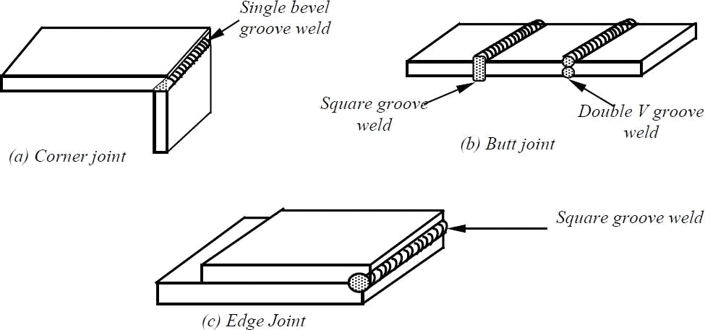
Figure 7.11 Typical connections with groove weld

The aim is to achieve the most economical weld of the requisite efficiency and strength. The butt weld whether of full penetration or partial penetration should attain the required strength of the joined parts. The size of the butt weld is defined by the thickness i.e. the thickness of the connected plate for complete penetration welds or the total depth of penetration for partial penetration welds.

Groove welds have high strength, high resistance to impact and cyclic stress. They are most direct joints and introduce least eccentricity in the joint. But their major disadvantages are: high residual stresses, necessity of edge preparation and proper aligning of the members in the field. Therefore, field butt joints are rarely used.

To minimise weld distortions and residual stresses, the heat input is minimised and hence the welding volume is minimised. This reduction in the volume of weld also reduces cost. Hence for thicker plates, double groove welds and U welds are generally used.

Edge Preparation for Butt Weld

Typical edge preparations are shown in Fig. 7.12
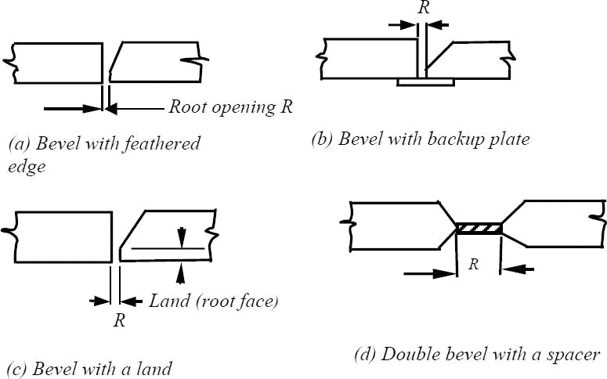
Figure 7.12 Typical edge preparation for butt weld

For a butt weld, the root opening, R, is the separation of the pieces being joined and is provided for the electrode to access the base of a joint. The smaller the root opening the greater the angle of the bevel. The depth by which the arc melts into the plate is called the depth of penetration [Fig. 7.13 (a)]. Roughly, the penetration is about 1 mm per 100A and in manual welding the current is usually 150 – 200 A.

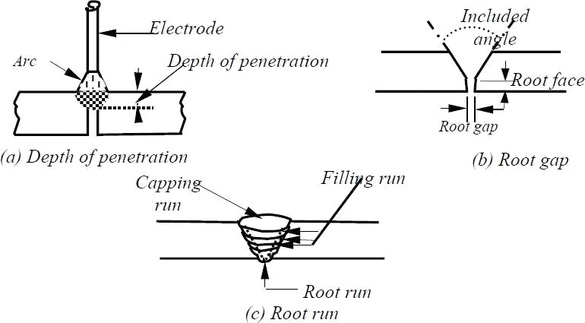
Figure 7.13 Groove weld details
Fillet welds

A typical fillet weld is shown in Fig. 7.14 (a).

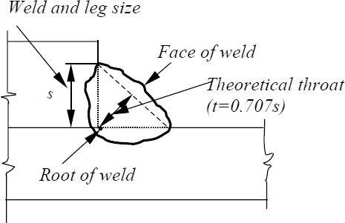
Figure 7.14 Typical fillet weld

The root of the weld is the point where the faces of the metallic members meet. Thetheoretical throat of a weld is the shortest distance from the root to the hypotenuse of the triangle. The throat area equals the theoretical throat distance times the length of the weld. Though a fillet weld is specified by defining the two sides of the inscribed triangle, its actual cross section will be quite complex. A fillet weld must penetrate the base metal and the interface of the weld is either concave or convex [Fig .7.17(a)&(b)].
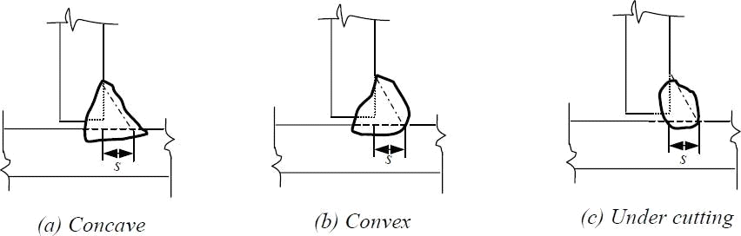
Figure 7.17 Cross section of fillet weld
The concave shape of free surface provides a smoother transition between the connected parts and hence causes less stress concentration than a convex surface. But it is more vulnerable to shrinkage and cracking than the convex surface and has a much reduced throat area to transfer stresses. On the other hand, convex shapes provide extra weld metal or reinforcementfor the throat. But while making a convex surface there is always the possibility of causing undercut at the edges, which undermines the strength of the joint [Fig. 7.17(c)]. The stress concentration is higher in convex welds than in concave welds. It is generally recommended that for statically loaded structures, a slightly convex shape is preferable, while for fatigue – prone structures, concave surface is desirable. Large welds are invariably made up of a number of layers or passes. For reasons of economy, it is desirable to choose weld sizes that can be made in a single pass. Large welds scan be made in a single pass by an automatic machine, though manually, 8 mm fillet is the largest single-pass layer.

Table 7.1 Elementary Symbols

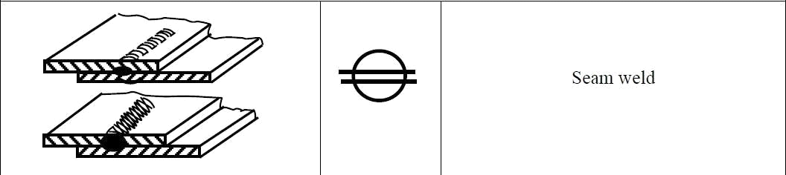Table 7. 2 Supplementary Symbols

Table 7. 3 Combination of Elementary and Supplementary Symbols
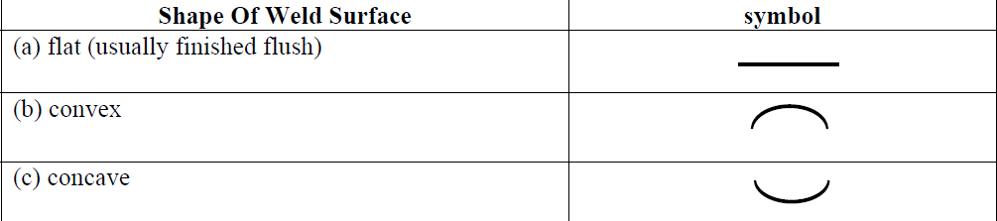

Butt welds

Full penetration butt welds are formed when the parts are connected together within the thickness of the parent metal. For thin parts, it is possible to achieve full penetration of the weld. For thicker parts, edge preparation may have to be done to achieve the welding, which has been discussed in the previous lecture.

There are nine different types of butt joints: square, single V, double V, single U, double U, single J, double J, single bevel and double bevel. They are shown in Fig. 8.1. In order to

qualify for a full penetration weld, there are certain conditions to be satisfied while making the welds. The more important ones are given below:
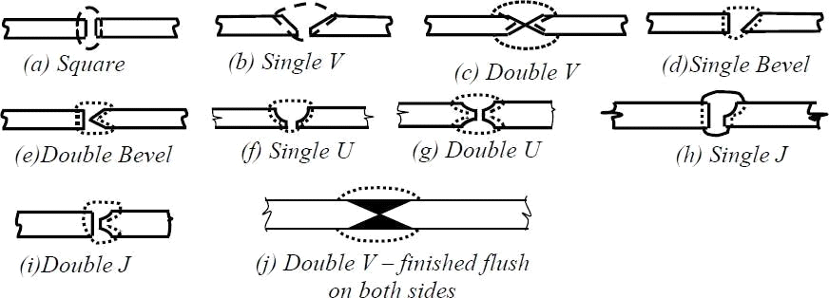
Figure 8.1 Different types of butt joints Static behaviour of butt welds

Permissible stresses for butt welds are assumed same as for the parent metal with a thickness equal to the throat thickness. For field welds, the permissible stresses in shear and tension may be reduced to 80% of the above value.

Effective length of Groove welds

The effective length of groove welds in butt joints is taken as the length of continuous full size weld, but it should not be less than four times the size of the weld.

Effective area of groove weld (Figure 8.5)

The effective area of groove weld is the product of the effective throat dimension te multiplied by the effective length of the weld. The effective throat dimension of a groove weld depends on the minimum width of expected failure plane

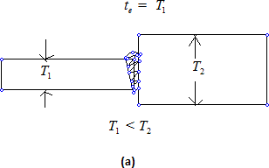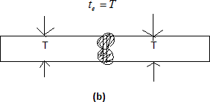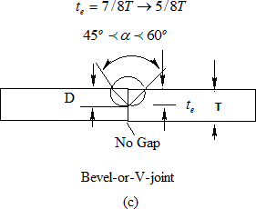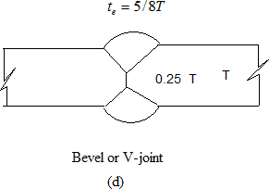

Figure 8.5 Effective throat dimensions for groove welds

The effective throat thickness of a complete penetration groove weld is taken as the thickness of the thinner part joined. The effective throat thickness of T or L joints are taken as the thickness of the abutting part. Reinforcement which is provided to ensure full cross-sectional area is not considered as part of the effective throat thickness.
The effective throat thickness of partial penetration joint weld is taken as the minimum thickness of the weld metal common to the parts joined, excluding reinforcement. In unsealed single groove welds of V, U, J and bevel types and groove welds welded from one side only, the throat thickness should be at least 7/8th of the thickness of the thinner part joined. However, for the purpose of stress calculation, the effective throat thickness of 5/8th thicknessof the thinner member only should be used (IS816:1969). The unwelded portion in

incomplete penetration welds welded from both sides should not be greater than 0.25 times the thickness of the thinner part joined and should be central in the depth of the weld. In this case also, a reduced effective throat thickness of 5/8th of the thickness of the thinner part should only be used in the calculations. Groove welds used in butt joints, where the penetration is less than those specified above, due to non-accessibility, should be considered as non-load carrying for the purposes of design calculations.

Design of Butt Welds as per IS 800: 2007

The following assumptions are usually made in the analysis of welded joints

- The welds connecting the various parts are homogeneous, isotropic and elastic
- The parts connected by the welds are rigid and their deformation is therefore neglected
- Only stresses due to external forces are considered. The effects of residual stresses, stress concentrations and shape of the weld are neglected.

As per IS 800: 2007 the grooved welds in butt joints will be treated as parent metal with a thickness equal to the throat thickness and the stresses shall not exceed those permitted in the parent metal.

- For tension or compression normal to effective area and tension and compression parallel to the axis of the weld,
f y Lwte
Tdw = γ
mw
Where T_{dw} is the design strength of the weld in tension, f y is the smaller of yield

stress of the weld and the parent metal in MPa, tw is the effective throat thickness of
the weld in mm, Lw is the effective length of the weld in mm, and γ mw is the partial safety factor taken as 1.25 for shop welding and as 1.5 for site welding.
- For shear on effective area
Lwte f yw
dw

Where Vdw is the design strength of the weld in shear.

As discussed previously, in the case of complete penetration groove weld in butt joints, design calculations are not required as the weld strength of the joint is equal to or even greater than the strength of the member connected. In the case of incomplete penetration groove weld in butt joints, the effective throat thickness is computed and the requiredeffective length is determined and checked whether the strength of the weld is equal to or greater than the strength

of the member connected to the applied external force.

Problem 1: Two plates of thickness 14 mm and 12 mm are to be jointed by a groove weld as shown in Figure 8.6 below.

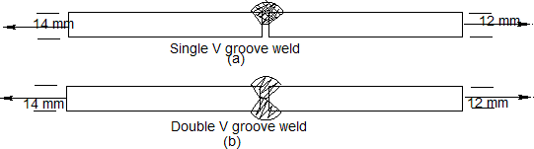
Figure 8.6

The joints are subjected to a factored tensile force of 350 KN. Assuming an effective length of 150 mm, check the safety of the joint for i) single V-groove weld joint ii) double V-groove weld joint
Assume that Fe410 grade steel plates are used and that the welds are shop welded. Solution
Case (i)
Single V-groove weld: In this case, incomplete penetration results due to single-V groove weld
Hence throat thickness,
te = 5t / 8 = 5×12 / 8 = 7.5mm Effective length of weld Le = 150mm
Strength of weld = Lete f y / γ mw = 7.5×150 × 250 /(1.25×1000) = 225KN p 350KN Hence the joint is not safe
Case (ii)
In the case of double-V groove weld, complete penetration takes place Throat thickness = thickness of thinner plate = 12 mm
Strength of weld = 12 ×150 × 250 /(1.25×1000)= 360KN f350KN hence the joint is safe.

Case (i)
Sample Matlab Program is provided for calculating strength of butt weld (incomplete penetration)

% Calculation of the strength of the weld
% t = thickness of the plate
% te=5/8t (for incomplete penetration)
%te=t (for complete penetration)
% Le= effective length of the weld
% fy=yield strength of the plate

% vmw= partial safety factor for weld material

t=12;
te=5*t/8; Le=150; fy=250;
vmw=1.25;
P=Le*te*fy/vmw
% P in KN P=P/1000

Case (ii)
Sample Matlab Program is provided for calculating strength of butt weld (complete penetration)
% Calculation of the strength of the weld
% t = thickness of the plate
% te=5/8t (for incomplete penetration)
%te=t (for complete penetration)
% Le= effective length of the weld
% fy=yield strength of the plate
% vmw= partial safety factor for weld material

t=12;
te=1*t/1; Le=150; fy=250;
vmw=1.25;
P=Le*te*fy/vmw
% P in KN P=P/1000

Problem 2 : The tie member of a truss is made of ISA 65 x 65 x 6 mm is subjected to a factored tension load of 90 KN. The length of the angle is not enough to go from end to end and hence a splice has to be provided. Design a groove welded joint.
Solution:
Provide a single V groove weld
The effective throat thickness = te = 5t / 8 = 5× 6 / 8 = 3.75mm Perimeter length of angle available for welding = 65 + 65 = 130 mm
Strength of weld = Lete f y / γ mw = 3.75×130 × 250 /(1.25×1000) = 97.5KN f 90KN

Area of angle = 744 mm²
Design strength of the member = Af y / γ mo = 744 × 250 /(1.1×1000) = 169KN f 90KN

Fillet welds

These are generally used for making lap joint splices and other connections where the connecting parts lap over each other. Though a fillet weld may be subjected to direct stresses, it is weaker in shear and therefore the latter is the main design consideration.

Fillet welds are broadly classified into side fillets and end fillets (Fig. 8.7). When a connection

with end fillet is loaded in tension, the weld develops high strength and the stress

developed in the weld is equal to the value of the weld metal. But the ductility is minimal. On the other hand, when a specimen with side weld is loaded, the load axis is parallel to the weld axis. The weld is subjected to shear and the weld shear strength is limited to just about half the weld metal tensile strength. But ductility is considerably improved. For intermediate weld positions, the value of strength and ductility show intermediate values.

Actual distribution of stresses in a fillet weld is very complex. A rigorous analysis of weld behaviour has not been possible so far. Multiaxial stress state, variation in yield stress, residual stresses and strain hardening effects are some of the factors, which complicate the analysis.
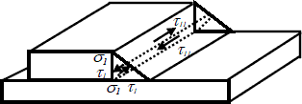
Figure 8.8 Average stress in the weld throat

In many cases, it is possible to use the simplified approach of average stresses in the weld throat (Fig. 8.8). In order to apply this method, it is important to establish equilibrium withthe applied load. Studies conducted on fillet welds have shown that the fillet weld shape is very important for end fillet welds. For equal leg lengths, making the direction of applied tension nearly parallel to the throat leads to a large reduction in strength. The optimum weld shape recommended is to provide shear leg equal to 3 times the tension leg. A small variationin the side fillet connections has negligible effect on strength. In general, fillet welds are stronger in compression than in tension.
Table 8.1 Minimum size of first run or of a single run fillet weld

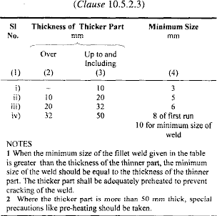

For stress calculations, the effective throat thickness should be taken as K times fillet size, where K is a constant. Values of K for different angles between tension fusion faces are given in Table 8.2. Fillet welds are normally used for connecting parts whose fusion faces form angles between 60° and 120°. The actual length is taken as the length having the effective length plus twice the weld size. Minimum effective length should not be less than four times the weld size. When a fillet weld is provided to square edge of a part, the weld size should be at least 1.5 mm less than the edge thickness [Fig. 8.11(a)]. For the rounded toe of a rolled section, the weld size should not exceed 3/4 thickness of the section at the toe [Fig. 8.11(b)].

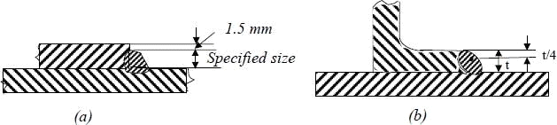
Figure 8.11 (a) fillet welds on square edge of plate, (b) fillet welds on round toe of rolled section

Table 8.2 Value of K for different angles between fusion faces
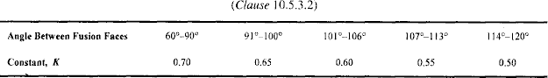

Intermittent fillet welds may be provided where the strength required is less than that can be developed by a continuous fillet weld of the smallest allowable size for the parts joined. The length of intermediate welds should not be less than 4 times the weld size with a minimum of 40 mm. The clear spacing between the effective lengths of the intermittent welds should be less than or equal to 12 times the thickness of the thinner member in compression and 16 times in tension; in no case the length should exceed 20 cm. Chain intermittent welding is better than staggered intermittent welding. Intermittent fillet welds are not used in main members exposed to weather. For lap joints, the overlap should not be less than five times thethickness of the thinner part. For fillet welds to be used in slots and holes, the dimension of the slot or hole should comply with the following limits:

- The width or diameter should not be less than three times the thickness or 25 mmwhichever is greater
- Corners at the enclosed ends or slots should be rounded with a radius not less than 1.5 times the thickness or 12 mm whichever is greater, and
- The distance between the edge of the part and the edge of the slot or hole, or between adjacent slots or holes, should be not less than twice the thickness and not less than 25 mm for the holes.

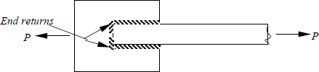

Figure 8.12 End returns

The effective area of a plug weld is assumed as the nominal area of the whole in the plane of the faying surface. Plug welds are not designed to carry stresses. If two or more of the general types of weld (butt, fillet, plug or slots) are combined in a single joint, the effective capacity of each has to be calculated separately with reference to the axis of the group to determine the capacity of the welds.

The high stress concentration at ends of welds is minimised by providing welds around the ends as shown in Fig. 8.12. These are called end returns. Most designers neglect end returns in the effective length calculation of the weld. End returns are invariably provided for welded joints that are subject to eccentricity, impact or stress reversals. The end returns are provided for a distance not less than twice the size of the weld.

Slot Welds

In certain instances, the lengths available for the normal longitudinal fillet welds may not be sufficient to resist the loads. In such a situation, the required strength may be built up by welding along the back of the channel at the edge of the plate if sufficient space is available. This is shown in Fig. 8.13(a). Another way of developing the required strength is by providing slot or plug welds. Slot and plug welds [Fig. 8.13(b)] are generally used along with fillet welds in lap joints. On certain occasions, plug welds are used to fill the holes that are temporarily made for erection bolts for beam and column connections. However, their strength may not be considered in the overall strength of the joint.

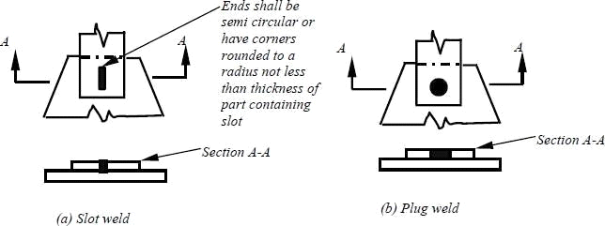
Figure 8.13 Slot and Plug welds

The limitations given in specifications for the maximum sizes of plug and slot welds are necessary to avoid large shrinkage, which might be caused around these welds when they exceed the specified sizes. The strength of a plug or slot weld is calculated by considering the allowable stress and its nominal area in the shearing plane. This area is usually referred to as the faying surface and is equal to the area of contact at the base of the slot or plug. The length of the slot weld can be obtained from the following relationship:

L = Load/ (width) allowable stress

Example 4: Design a joint according to the instructions given in Example 3. If the welding is done on three sides of the angle as shown below.
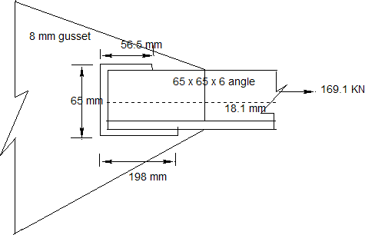

Solution:

Strength of 4 mm weld = 2.8 x 410 / (sqrt(3) x 1.25 ) = 530 N/mm P2 =530 x 65/1000 = 34.45 KN
P1 = Ty/d – P2/2 = 169.1 x 18.1 / 65 – 34.45 /2
= 29.86 KN
P3 = T-P1 - P2 = 169.1 -34.45 – 29.86 = 104.79 KN

Lw1 = 29.86 x 1000/ 530 = 56.3 mm say 56.5 mm Lw3 = 104.79 x 1000/530 = 197.7 mm, say 198 mm
Total length of weld = 65 + 56.5 + 198 = 319.5 mm Check for block shear failure
Since the member is welded to the gusset plate, no net areas are involved and hence Avn and Atn in the equation for Tdb should be taken to be the corresponding gross areas. Using the weldment with L1 = 198 mm L2 = 56.5 mm and 65 mm at the end of the angle yields

Tdb1 = [ 8 x (198 x 2) x 250 /(sqrt(3)x1.1)+0.9 x 410 x 8x 65/1.25]/1000 = 569.2 KN

Tdb2 = [0.9 x 410 x (198 x 2/(sqrt(3) x 1.25) + 250 x 8x 65/1.1)/ 1000 = 658.1 KN

Hence

Tdb = 569.2 KN > 169.1 KN

Hence, the thickness of gusset plate is adequate.

Note: L2 does not enter into this calculation because a shear rupture of the gusset plate along the toe of the angle runs for the full length of the contact with the toe, 198 mm in stead of only the length L

Chapter-3

Design of Tension Members

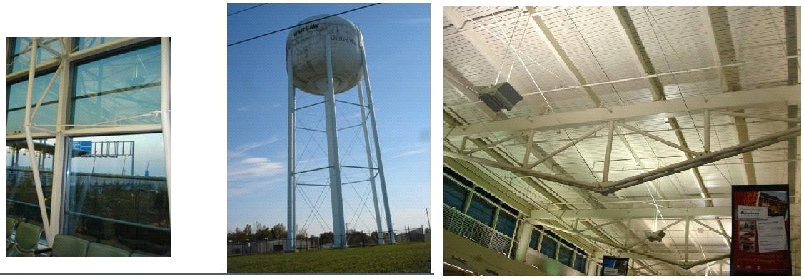

Introduction

Tension members are linear members in which axial forces act so as to elongate (stretch) the member. A rope, for example, is a tension member. Tension members carry loads most efficiently, since the entire cross section is subjected to uniform stress. Unlike compression members, they do not fail by buckling (see chapter on compression members). Ties of trusses [Fig 9.1(a)], suspenders of cable stayed and suspension bridges [Fig. 9.1 (b)], suspenders of buildings systems hung from a central core [Fig. 9.1(c)] (such buildings are used in earthquake prone zones as a way of minimising inertia forces on the structure), and sag rods of roof purlins [Fig 9.1(d)] are other examples of tension members.

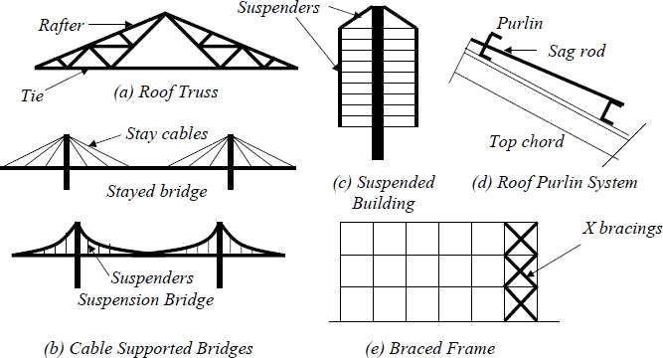
Figure 9.1 Tension Members in Structures

Tension members are also encountered as bracings used for the lateral load resistance. In X type bracings [Fig.1 (e)] the member which is under tension, due to lateral load acting in one direction, undergoes compressive force, when the direction of the lateral load is changed and vice versa. Hence, such members may have to be designed to resist tensile and compressive forces.

The tension members can have a variety of cross sections. The single angle and double angle sections [Fig 9.2(a)] are used in light roof trusses as in industrial buildings. The tension members in bridge trusses are made of channels or I sections, acting individually or built-up [Figs. 9.2(c) and 9.2(d)]. The circular rods [Fig. 9.2 (d)] are used in bracings designed to resist loads in tension only. They buckle at very low compression and are not considered effective. Steel wire ropes [Fig. 9.2 (e)] are used as suspenders in the cable suspended bridgesand as main stays in the cable-stayed bridges.
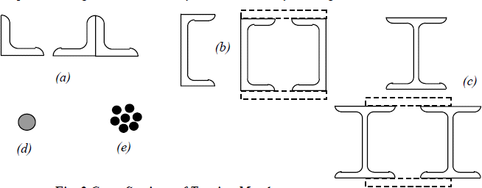
Figure 9.2 Cross section of tension members
Slenderness Ratio (Table 9.1)
Although stiffness is not required for the strength of a tension member, a minimum stiffness is stipulated by limiting the maximum slenderness ratio of the tension member.
Table 9.1 Slenderness ratio for tension members

Behaviour of tension members

Since axially loaded tension members are subjected to uniform tensile stress, their load deformation behaviour (Fig. 9.3) is similar to the corresponding basic material stress strain behaviour. Mild steel members (IS: 2062) exhibit an elastic range (a-b) ending at yielding (b). This is followed by yield plateau (b-c). In the Yield Plateau the load remains constant as the elongation increases to nearly ten times the yield strain. Under further stretching the material shows a smaller increase in tension with elongation (c-d), compared to the elastic range. This range is referred to as the strain hardening range. After reaching the ultimate load (d), the loading decreases as the elongation increases (de) until rupture (e). High strength steeltension members do not exhibit a well-defined yield point and a yield plateau (Fig.9.3). The 0.2% offset load, T, as shown in Fig. 9.3 is usually taken as the yield point in such cases.

- Design Of Tension Members

Tension members are linear members in which axial forces act to cause elongation (stretch). Such members can sustain loads up to the ultimate load, at which stage they mayfail by rupture at a critical section. However, if the gross area of the member yields over a major portion of its length before the rupture load is reached, the member may become non- functional due to excessive elongation. Plates and other rolled sections in tension may alsofail by block shear of end bolted regions

The factored design tension T, in the members shall satisfy the following requirement.

T p Td (9.1)

Where Td = design strength of the member under axial tension, Td is the lowest of the design strength due to the yielding of cross-section, Tdg, rupture of critical section Tdn and block shear failure, Tdb.

- Design Strength Due To Yielding Of Gross-Section
Tension yielding of the members at the gross cross-section is given by
Tdg = f y Ag / γ mo (9.2a)

Where f y is the yield stress of material in MPa, and Ag is the gross area of cross-section
γ mo is the partial safety factor for failure in tension by yielding

- Design Strength Due To Rupture Of Critical Section

- Plates
Tension rupture of the plate at the net cross-section is given by
Tdn = 0.9 fu An / γ m1 (9.2b)

Where fu is the ultimate stress of the material in MPa and An is the net effective area of the

member given (as shown in the Figure 9.4 for the definition of variables). γ m1 is the partial safety factor for failure at ultimate stress
⎡ p ² ⎤
An = ⎢b − ndh + ∑ 4gsi ⎥t

⎣
Where

i i ⎦

b,t= width and thickness of the plate, respectively.
dh = diameter of the bolt hole (2 mm in addition to the diameter of the hole, in case the directly punched holes),
g=. gauge length between the bolt holes, as shown in Fig. 9.4,

ps=. staggered-pitch length between line of bolt holes, as shown in Fig. 9.4, n=. number of bolt holes in the critical section, and
i= subscript for summation of all the inclined legs

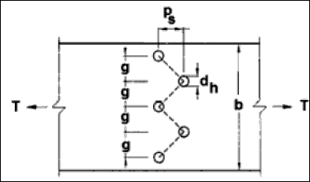
Figure 9.4 plate with the staggered holes in tension

- The design strength of threaded rods in tension, Tdn , as governed by rupture is given by
Tdn = 0.9 An fu / γ m1
Where
An is the net root area at the threaded section

- Single Angles

For angle members connected through one leg, the design rupture strength Tdn , is calculated as:
Tdn = 0.9 Anc fu / γ m1 + βAgo f y / γ mo
Where
β = 1.4 − 0.076(w / t )( f y / fu )(bs / Lc ) ≤ ( fuγ mo / f yγ m1 )≥ 0.7

w=outstand leg width
bs = shear lag width, as shown in Fig. 9.5, and
Lc = length of the end connection, that is the distance between the outermost bolts in the end joint measured along the load direction or length of the weld along the load direction.

For preliminary sizing, the rupture strength of net section may be approximately taken as:

Tdn = αAn fu / γ m1

Where
α = 0.6 for one or two bolts, 0.7 for three bolts and 0.8 for four or more bolts along the length in the end connection or equivalent weld length;
An = net area of the total cross-section;

Anc = net area of the connected leg;
Ago = gross area of the outstanding leg; and t= thickness of the leg.

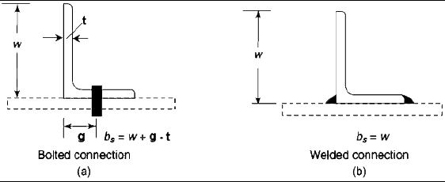

Figure 9.5 Angles with single leg connections
- Other Sections

The rupture strength, Tdn,of the double angles, channels, I-sections and other rolled steel sections, connected by one or more elements to an end gusset is also governed by shear lag effects. The design tensile strength of such sections as governed by tearing of net section may also be calculated using equation in 9.4.3, where β is calculated based on the shear lag distance, b,, taken from the farthest edge of the outstanding leg to the nearest bolt/weld line in the connected leg of the cross-section.

- Design Strength Due to Block Shear

Block shear failure was recognized as a failure mode first in 1978, when Birkemoe and Gilmor conducted tests on coped beams with bolted web connections, and incorporated in AISC specifications in 1978. Block shear failure in angles were investigated after the failure of Hartford Civic Center roof, Connecticut in 1978. Block shear failure in bolted / welded connections is characterized by a condition, where a "block" of material, in a pattern surrounding the bolted region, reaches its capacity through a combination of tension and shear. If the connection is loaded further, the block is eventually displaced from the connection region (see Fig. 9.6). Block shear is usually initiated with tension fracture. The block shear strength, Tdb of the connection shall be smaller of

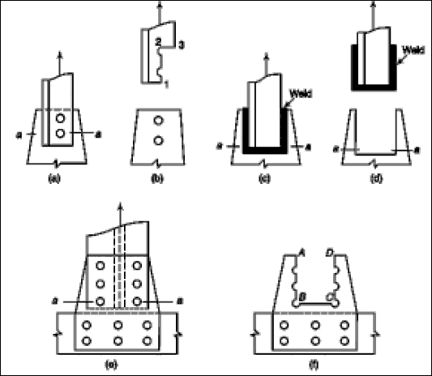

Figure 9.6 Examples Of Block Shear Failures
Tdb = [Avg f y /( 3γ mo )+ 0.9 Atn fu / γ m1 ]
Or
Tdb = [0.9 Avn fu /( 3γ m1 )+ Atg f y / γ mo ]

Avg and Avn = minimum gross and net area in shear along a line of transmitted force, respectively (along 1-2 in Fig.9. 6a or along A-B and D-C in Fig 9.6f), Atg and Atn = minimum gross and net area in tension from the hole to the toe of the angle, or next last row of bolts in plates perpendicular to the line of force, respectively (along 2-3 in Fig. 9.6a or along B-C in Fig. 9.6f).

It may be of interest to note that the American code has adopted the following block shear formula for angles, with a resistance factor of ϕ = 0.75
ϕTn = ϕ[0.6 f y Avg + 0.5 f n Atn ]
with
0.6 fu Avg = 0.6 fu A_{v}

10.2 Design of a tension Member

The following example is given to explain the application of tension member design provisions of the code.

A tie member in a bracing system consists of two angles 75 x 75 x 6 bolted to 10 mm gusset, one on each side using single row of bolts (Fig. 10.17a) and tack bolted. Determine the tensile capacity of the member and the number of bolts required to develop full capacity ofthe member. What will be the capacity if the angles are connected on the same side of the gusset plate and tack bolted (Fig. 10.17 b)? What is the effect on tensile strength if the members are not tack bolted?

Solution
- . Two angles connected to opposite side of the gusset as in Fig. 10.17a

- Design strength due to yielding of gross section Tdg = fy(Ag/γm0)
Ag = 866 mm2 (for a single angle)
Tdg = 250 x 2 x (866/1.10) x 10-3 Tdg = 393.64 kN

- The design strength governed by tearing at net section Tdn = αAn(fu/γm1)
Assume single line of four numbers of 20mm diameter

bolts (α=0.8)
An = [(75 - 6/2 - 22) 6 + (75 - 6/2) 6]2
An = (300 + 432)2 = 1464 mm2
Tdn =( 0.8 x 1464 x 410/1.25)/1000 = 384.15 kN
Therefore Tensile capacity = 384.15 kN

Design of bolts:
Choose edge distance = 35 mm
Capacity of bolt in double shear (Table 10.8)
= 2 x 45.3 = 90.6 kN
Bearing capacity of the bolt does not govern as per Table 10.7

Hence strength of a single bolt = 90.6 kN Provide 5 bolts
Total strength of the bolt = 5 x 90.6= 453 kN > 384.15 kN Hence safe.
Minimum spacing = 2.5 t = 2.5 x 20 = 50 mm Provide a spacing of 50 mm
The arrangements of bolts are shown in Fig. 10.17c

Check for block shear strength: (clause 6.4)
Block shear strength Tdb of connection shall be taken as the smaller of,
Tdb1 = [Avgfy / (v3m0) + 0.9Atn fu / λm1] Tdb2 = [0.9fu Avn /(v3γm1) + fy Atg / γm0] Avg =(4 x 50 + 35) 6 = 1410 mm2
Avn = (4 x 50 + 35 − 4.5 x 22) 6 = 816 mm2 Atn = (35.0 −22/2)6 = 144 mm2
Atg = (35 x 6) = 210 mm2
Tdb1 = [1410 x 250 / (v3 x 1.10) + 0.9 x 144 x 410 /1.25] x 10-3 = 227.5 kN
Tdb2 = [0.9 x 410 x 816/ (v3 x 1.25)] + 250 x 210 /1.10] x 10-3 = 186.8 kN

For double angle block shear strength = 2 x186.8= 373.6 kN
Therefore Tensile capacity = 373.6 kN (smallest of 393.64 kN, 384.15 kN and 373.6 kN)

- Two angles connected to the same side of the gusset plate (Fig. 10.17b)
- Design strength due to yielding of Gross section= 393.64 kN
- Design strength governed by tearing at net section= 384.15 kN Assuming 10 bolts of 20 mm diameter, five bolts in each connected leg Capacity of M20 bolt in single shear = 45.3 kN
Total strength of bolts = 10 x 45.3 = 453 kN> 393.64 kN

Hence the connection is safe.
The arrangement of bolts is shown in Fig. 10.12d. Since it is similar to the arrangement in Fig. 10.17c, the block shear strength well be same, i.e. 373.6 kN.
Hence the tensile capacity = 373.6 kN

The tensile capacities of both the arrangements (angles connected on the same side and connected to the opposite side of gusset) are same as per the code though the load application is eccentric in this case. Moreover, the number of bolts is 10 whereas in case (a) we used only 5 bolts since the bolts were in double shear.

- If the angles are not tack bolted, they behave as single angles connected to gusset plate.
In this case also the tensile capacity will be the same and we have to use 10 numbers of M20 bolts. This fact is confirmed by the test and FEM results, which states that "the net section strength of double angles on opposite sides of the gusset and tack connected adequately over the length is nearly the same as that of two single angles acting individually. Current design provisions indicating greater efficiency of such double angles are not supported by test and FEM results".

Figure 10.17 Example problem

Sample Questions in Steel Structures

Q1. A builtup steel beam comprises of two flange plates 250 mm wide x 10 mm thick and web plate 330 mm deep x 6 mm thick. The moment of inertia of the section is 162.5 x 10⁶ mm⁴. The allowable normal stress in the extreme fibres of flange plates is 140 N/mm². And the average allowable shear stress in the web plate is 100 N/mm². Compute the flexural and shear capacities of beam. The flange plates are welded to web plate by 6 mm intermittentfillet welds. The allowable shear stress in weld material is 100 N/mm². Determine thepercentage of weld length for intermittent welding at the section of maximum shear. At a section of maximum bending moment, the flange plates are to be spliced using 12 mm thick plates. The maximum allowable normal stress in splice plate is 150 N/mm². Determine the minimum width B of flange splice plate. The total length of flange splice plate is L and it is welded all around using 6 mm fillet weld. Determine length L.

Q2. a) Details of a double angle web member of a steel roof truss are given below. Check to see if the member has the capacity to carry tensile force of 240 KN and compressive force of 165 KN at service load. The member consists of 2-ISA 90x90x6 connected to opposite sides of 8 mm gussets using 20 mm bolts.
Effective length for buckling about xx axis = 1.7 m Effective length for buckling about yy axis = 4.0 m Yield strength of steel used = 250 MPa
Properties of single ISA 90x90x6 are
Area = 1047 mm², y = 24.2mm , I _{x'x'} = 801000mm⁴
0.60 f y fcc

Allowable compressive stress = (f 1.5 + f 1.5 )1/1.5
Where fcc = Euler buckling stress
b) Calculate the number of bolts required at the end connections of the angle to the gussets using 20 mm bolts given the allowable shear stress in the bolt = 80 MPa and allowable bearing stress = 250 MPa

Q3. Two plates are proposed to be jointed by welding. Determine the size and length of the weld required to develop the full strength of the smallest plate which is 8 cm x 1.2 cm. Assume permissible tension in plate is 1500 Kg/cm² and permissible shear in fillet weld is 1025 Kg/cm.

Q4. Design a compression member when effective length is 1.5 m and which carries a load of 12000 Kg. Use angle sections and data given below
Angle | Sectional area cm² | Radious of  gyration rmin (cm) | l/r | Allowable stress in axial  compression  kg/cm²
ISA 65x65x10 | 12.0 | 1.25 | 70 | 1075

ISA 70x70x10 | 13.02 | 1.35 | 80 | 1007
ISA 75x75x10 | 14.02 | 1.45 | 90 | 928
ISA 80x80x10 | 17.81 | 1.64 | 100 | 840
ISA 90x90x10 | 20.12 | 1.64 | 110 | 753

Q5. Check the adequacy of the rafter member of a roof truss made of 2-ISA 90x90x6 double angles back to back made of the rafter member of a roof truss made of 2-ISA 90x90x6 double angles back to back made of mild steel for tension and compression given below. The length of the rafter member between nodes of the truss is 1.5 m. The effective length factor for buckling of the member in the plane of the truss is 0.85 and that for out of plane of the truss is 1.0. The member is connected to the end gussets 6 mm thick using 20 mm diameter bolts Area of ISA 90x90x6 = 1047mm² , I _{x'x} ' = 801000mm⁴ , distance of centre of gravity from the back = 24.2mm , The compression in the member due to dead + live loads = 300 KN
The tension in the member due to dead load + wind uplift = 250 KN The allowable stress in compression are as follows:
(kl/r) | 30 | 40 | 50 | 60
σ ac in MPa | 145 | 145 | 139 | 122
Chapter-4 Compression member
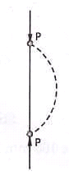DESIGN OF STEEL COMPRESSION MEMBERS A structural member loaded axially in compression is generally called a compression member. Vertical compression members in buildings are called columns, posts or stanchions. A compression member in roof
trusses is called struts and in a crane is called a boom. Columns which are short are subjected to crushing and behave like members under pure compression. Columns which are long tend to buckle out of the plane of the load axis.
various end conditions

 | Type | Effective length of member l
1 | Effectively held in position and restrained in direction at both ends. | 0.67 L
2 | Effectively held in position at both ends restrained in direction at one end. | 0.85 L

3 | Effectively held in position at both ends but not restrained in direction. | L
4 | Effectively held in position and restrained in direction at one end and at the other end effectively restrained in direction but not held in position. | L
5 | Effectively held in position and restrained in direction at one end and the other end partially restrained in direction but not held in position. | 1.5 L
6 | Effectively held in position and restrained in direction at one end but not held in position or restrained in direction at the other end. | 2.0 L

MAXIMUM SLENDERNESS RATIO:
According to Indian Standard IS 800, the slenderness ratio should not exceed the values given in the table below:
No. | Type of Member | Slenderness ratio 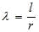
1 | A member carrying compressive loads resulting from dead and superimposed loads. | 180
2 | A member subjected to compressive loads resulting from wind/earthquake forces provided the deformation of such members does not adversely affect the stress in any part of the structure. | 250
3 | A member normally carrying tension but subjected to reversal of stress due to wind or earthquake forces. | 350
4 | Tension member (other than pre-tensioned member) | 400

Example 11.1 A single angle discontinuous strut ISA 150 mm x
150 mm x 12 mm (ISA 150 150,@0.272 kN/m) with single riveted connection is 3.5 m long. Calculate safe load carrying capacity of the section.
Solution:
Step 1: Properties of angle section
ISA 150 mm x 150 mm x 12 mm (ISA 150 150,@0.272 kN/m) is used as discontinuous strut. From the steel tables, the geometrical properties of the section are as follows:
Sectional area A = 3459 mm² Radius of gyration r_{xx}= r_{yy}=149.3 mm
Radius of gyration r_{uu}= 58.3 mm, r_{vv}=29.3 mm Step 2: Slenderness ratio,
Minimum radius of gyration r_{min}= 29.3 mm Effective length of strut l= 3.5 m Slenderness ratio of the strut
Step 3: Safe load
From IS:800-1984 for l/r=119.5 and the steel having yield stress, f_{y}=260 N/mm², allowable working stress in compression σ_{ac} =64.45 N/mm² (MPa)
For single angle discontinuous strut with single riveted connection, allowable working stress
0.80 σ_{ac} = (0.80 x 64.45) = 51.56 N/mm².

The safe load carrying capacity

Example 11.2 In case in Example 11.1, a discontinuous strut 150 x 150 x 15 angle section is used, calculate the safe load carrying capacity of the section.
Solution:
Step 1: Properties of angle section
Angle section 150 mm x 150 mm x 15 mm is used as discontinuous strut. From the steel tables, the geometrical properties of the section are as follows:
Sectional area A = 4300 mm² Radius of gyration r_{xx}= r_{yy}=45.7 mm
Radius of gyration r_{uu}= 57.6 mm, r_{vv}=29.3 mm
Step 2: Slenderness ratio,
Minimum radius of gyration r_{min}= 29.3 mm Effective length of strut l= 3.5 m
Slenderness ratio of the strut
Step 3: Safe load
From IS:800-1984 for l/r=119.5 and the steel having yield stress, f_{y}=260 N/mm², allowable working stress in compression σ_{ac} =64.45 N/mm² (MPa)
For single angle discontinuous strut with single riveted connection, allowable working stress
0.80 σ_{ac} = (0.80 x 64.45) = 51.56 N/mm².

Chapter-5
Design of Steel Beams
LATERALLY SUPPORTED BEAM
- When the lateral support to the compression flange is adequate, the lateral buckling of the beam is prevented and the section flexural strength of the beam can be developed.
- The strength of I-sections depends upon the width to thickness ratio of the compression flange.
- When the width to thickness ratio is sufficiently small, the beam can be fully plastified and reach the plastic moment, such sections are classified as compact sections.
- However provided the section can also sustain the moment during the additional plastic hinge rotation till the failure mechanism is formed.Such sections are referred to as plastic sections.
- When the compression flange width to thickness ratio is larger, the compression flange may buckle locally before the complete plastification of the section occurs and the plastic moment is reached.
- Such sections are referred to as non-compact sections.
- When the width to thickness ratio of the compression
flange is sufficiently large, local buckling of compression flange may occur even before extreme fibre yields.
- Such sections are referred to as slender sections.
LATERALLY UNSUPPORTED BEAMS
- Under increasing transverse loads, a beam should attain its full plastic moment capacity.
Two important assumptions have been made therein to achieve the ideal beam behaviour. They are:
- The compression flange of the beam is restrained from moving laterally; and
- Any form of local buckling is prevented.

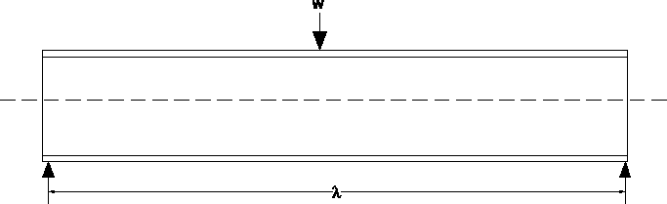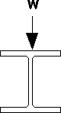
1.Design a continuous beam of spans 4.9 m, 6 m, and 4.9 carrying a uniformly distributed load of 32.5 kN/m and the beam is laterally supported.
Factored load calculation
Factored uniformly distributed load = 1.5 x 32.5 = 48.75 kN/m The bending moment and shear force distribution are shown below
Maximum bending moment = 146.25 kNm Maximum shear force = 146.25 + 146.25 = 292.5 kN Plastic section modulus required
zp= = = 643.5x103mm3𝑀 𝑥 𝛾 𝑚 𝑜 𝑓𝑦 146.25𝑥106𝑥
1.10 250
Selection of suitable section
Choose a trial section of ISLB 350 @0.495 kN/m. Overall depth (h) = 350 mm
Width of flange (b)= 165 mm
Thickness of flange (tf) = 11.4 mm
Depth of web (d) = h -2(tf+ R) = 350 -2(11.4 + 16) = 295.2 mm
Thickness of web (tw) = 7.4 mm
Moment of inertia about major axis I, = 13158.3 x lo4 mm4
Elastic section modulus (Ze) = 75 1.9 x 103mm3 Plastic section modulus (Zp) = 851.11 x 103mm3 Section classification
=𝑏/ 𝑡𝑓+=82.5/ 11.4
𝑏/ 𝑡𝑓 =295.2/7.4=39.9<84
Hence the section is plastic.
Check for shear capacity of section
=
Vd = 𝑓𝑦 mo x √3 x h x 𝑡𝑤
250 1.1 x √3 x 350 x 7.4 =340kN
0.6 vd= 204 kN< 292.5 kN
This shows a high shear condition.
Check for moment capacity of the section [Eqn6.8(a)]
Mdv=Md-β(Md-Mfd) ≤ 1.09 x Zex fy
where Mfdis the plastic design strength of the area of cross section excluding the shear area.
β = [2 𝑥 ( 𝑣 vd ) x 1 ]2

= [2 𝑥 (292.5 340 ) x 1 ]2
Calculation of section modulus of flange
𝑍𝑓𝑑 = 𝑍𝑝 - 𝐴𝑤 𝑦𝑤
= 851.11 x 103-(350 x 7.4 x ) 350/4
= 624.485 x 103mm3

Chapter-6
Design of Tubular steel structures
Hollow Section is a type of metal profile with a hollow tubular cross section. HSS is only composed of structural steel per code. During the manufacturing process flat steel plate is gradually changed in shape to become round where the edges are presented ready to weld.

hollow structural section (HSS) is a type of metal profile with a
hollow cross HYPERLINK "https://en.wikipedia.org/wiki/Cross_section_(geometry)" HYPERLINK "https://en.wikipedia.org/wiki/Cross_section_(geometry)"section. The term is used predominantly in the United States, or other countries which follow US construction or engineering terminology.
HSS members can be circular, square, or rectangular sections, although other shapes such as elliptical are also available. HSS is only composed of structural steel per code.
HSS is sometimes mistakenly referenced as hollow structural steel. Rectangular and square HSS are also commonly called tube steel or box section. Circular HSS are sometimes mistakenly called steel pipe, although true steel pipe is actually dimensioned and classed differently from HSS. (HSS dimensions are based on exterior dimensions of the profile; pipes are also manufactured to an exterior tolerance, albeit to a different standard.) The corners of HSS are heavily rounded, having a radius which is approximately twice the wall thickness. The wall thickness is uniform around the section.
In the UK, or other countries which follow British construction or engineering terminology, the term HSS is not used. Rather, the three basic shapes are referenced as CHS, SHS, and RHS, being circular, square, and rectangular hollow sections. Typically, these designations will also relate to metric sizes, thus the dimensions and tolerances differ slightly from HSS.

98

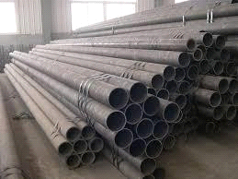
Chapter-7
Design of Masonry Structures
Masonry structures must have system of walls with cross walls at regular interval( about 3.0m to 3.5m c/c). In case cross walls are not available, need for provision of RCC columns to laterally support the long wall arises. Opening in masonry structures must be properly planned in consultation with Architect.
Zones of stress /load concentrations must be identified. Introduction of RCC columns may be resorted where stress is exceeding.
All beams must rest on PCC bed blocks/or extended bearing length on masonry to keep the stress on brickwork within limit.

Mortars for brick work:
This shall be provided as per design requirements. Very approximately:

CM 1:6 - single storeyed (can be 3rd class brick in exceptional cases if design permit)
CM 1:5 - Ground storey of Two storied( with min 2nd class brick) CM 1:4 - Ground storey of Three storied( with First class brick) CM 1:3 - Ground storey of Four storied( with First class brick)
Curing of brick work - This is very neglected area and 10 to 14 days curing must be emphasized.
Provision of plasters also help in strengthening the walls Free standing Boundary walls must be in CM 1:5 minimum.

SP20 of Indian Standard (IS) Code provides all the guidelines for design and construction of brick masonry.
ADVANTAGES AND DEVELOPMENT OF LOADBEARING MASONRY
The basic advantage of masonry construction is that it is possible to use the same element to perform a variety of functions, which in a steelframed building, for example, have to be provided for separately, with consequent complication in detailed construction. Thus masonry may, simultaneously, provide structure, subdivision of space, thermal and acoustic insulation as well as fire and weather protection. As a material, it is relatively cheap but durable and produces external wall finishes of very acceptable appearance. Masonry construction is flexible in terms of building layout and can be constructed without very large capital expenditure on the part of the builder.
In the first half of the present century brick construction for multistorey buildings was very largely displaced by steel- and
reinforcedconcrete-framed structures, although these were very often clad in brick. One of the main reasons for this was that until around 1950 loadbearing walls were proportioned by purely empirical rules, which led to excessively thick walls that were wasteful of space and material and took a great deal of time to build. The situation changed in a number of countries after 1950 with the introduction of structural codes of practice which made it possible to calculate the necessary wall thickness and masonry strengths on a more rational basis. These codes of practice were based on research programmes and building experience, and, although initially limited in scope, provided a sufficient basis for the design of buildings of up to thirty storeys. A considerable amount of research and practical experience over the past 20 years has led to the improvement and refinement of the various structural codes. As a result, the structural design of masonry buildings is approaching a level similar to that applying to steel and concrete.
- BASIC DESIGN CONSIDERATIONS
Loadbearing construction is most appropriately used for buildings in which the floor area is subdivided into a relatively large number of rooms of small to medium size and in which the floor plan is repeated on each storey throughout the height of the building. These considerations

give ample opportunity for disposing loadbearing walls, which are continuous from foundation to roof level and, because of the moderate floor spans, are not called upon to carry unduly heavy concentrations of vertical load. The types of buildings which are compatible with these requirements include flats, hostels, hotels and other residential buildings.
The form and wall layout for a particular building will evolve from functional requirements and site conditions and will call for collaboration between engineer and architect. The arrangement chosen will not usually be critical from the structural point of view provided that a reasonable balance is allowed between walls oriented in the principal directions of the building so as to permit the development of adequate resistance to lateral forces in both of these directions. Very unsymmetrical arrangements should be avoided as these will give rise to torsional effects under lateral loading which will be difficult to calculate and which may produce undesirable stress distributions.
Stair wells, lift shafts and service ducts play an important part in deciding layout and are often of primary importance in providing lateral rigidity.
The great variety of possible wall arrangements in a masonry building makes it rather difficult to define distinct types of structure, but a rough classification might be made as follows:
Types HYPERLINK "https://civiltoday.com/civil-engineering-materials/mortar/65-types-of-mortar" HYPERLINK "https://civiltoday.com/civil-engineering-materials/mortar/65-types-of-mortar"of HYPERLINK "https://civiltoday.com/civil-engineering-materials/mortar/65-types-of-mortar" HYPERLINK "https://civiltoday.com/civil-engineering-materials/mortar/65-types-of-mortar"Mortar
Mortar is produced by mixing a binding material (cement or lime) with fine aggregate (sand, surki, etc) with water. For construction purpose, different types of mortar are used. Depending upon the materials used for mortar mixture preparation, the mortar could be classified as follows.
- Cement Mortar
- Lime Mortar
- Surki Mortar
- Gauged Mortar
- Mud Mortar
Cement Mortar
Cement mortar is a type of mortar where cement is used as binding material and sand is used as fine aggregate. Depending upon the desired strength, the cement to the sand proportion of cement mortar varies from 1:2 to 1:6.

Lime Mortar
Lime mortar is a type of mortar where lime (fat lime or hydraulic lime) is used as binding material and sand is used as fine aggregate. The lime to the sand proportion of cement mortar is kept 1:2. The pyramids at Giza are plastered with lime mortar.
Gauged Mortar
Gauged mortar is a type of mortar where cement and lime both are used as binding material and sand is used as fine aggregate. Basically, it is a lime mortar where cement is added to gain higher strength. The process is known as gauging. The cement to the lime proportion varies from 1:6 to 1:9. Gauged mortar is economical than cement concrete and also possess higher strength than lime mortar.
Surki Mortar
Surki mortar is a type of mortar where lime is used as binding material and surki is used as fine aggregate. Surki mortar is economic.
Mud Mortar
Mud mortar is a type of mortar where mud is used as binding material and sawdust, rice husk or cow-dung is used as fine aggregate. Mud mortar is useful where lime or cement is not available.

Reference:
Limit state design of steel structures
By: S.K .Duggal

Limit state design of steel structures
By: S.S.Bhavikatti Element of steel,timber & masonry Design
By: Samal & Panigrahi
Steel Tables
By: Samal & Panigrahi

