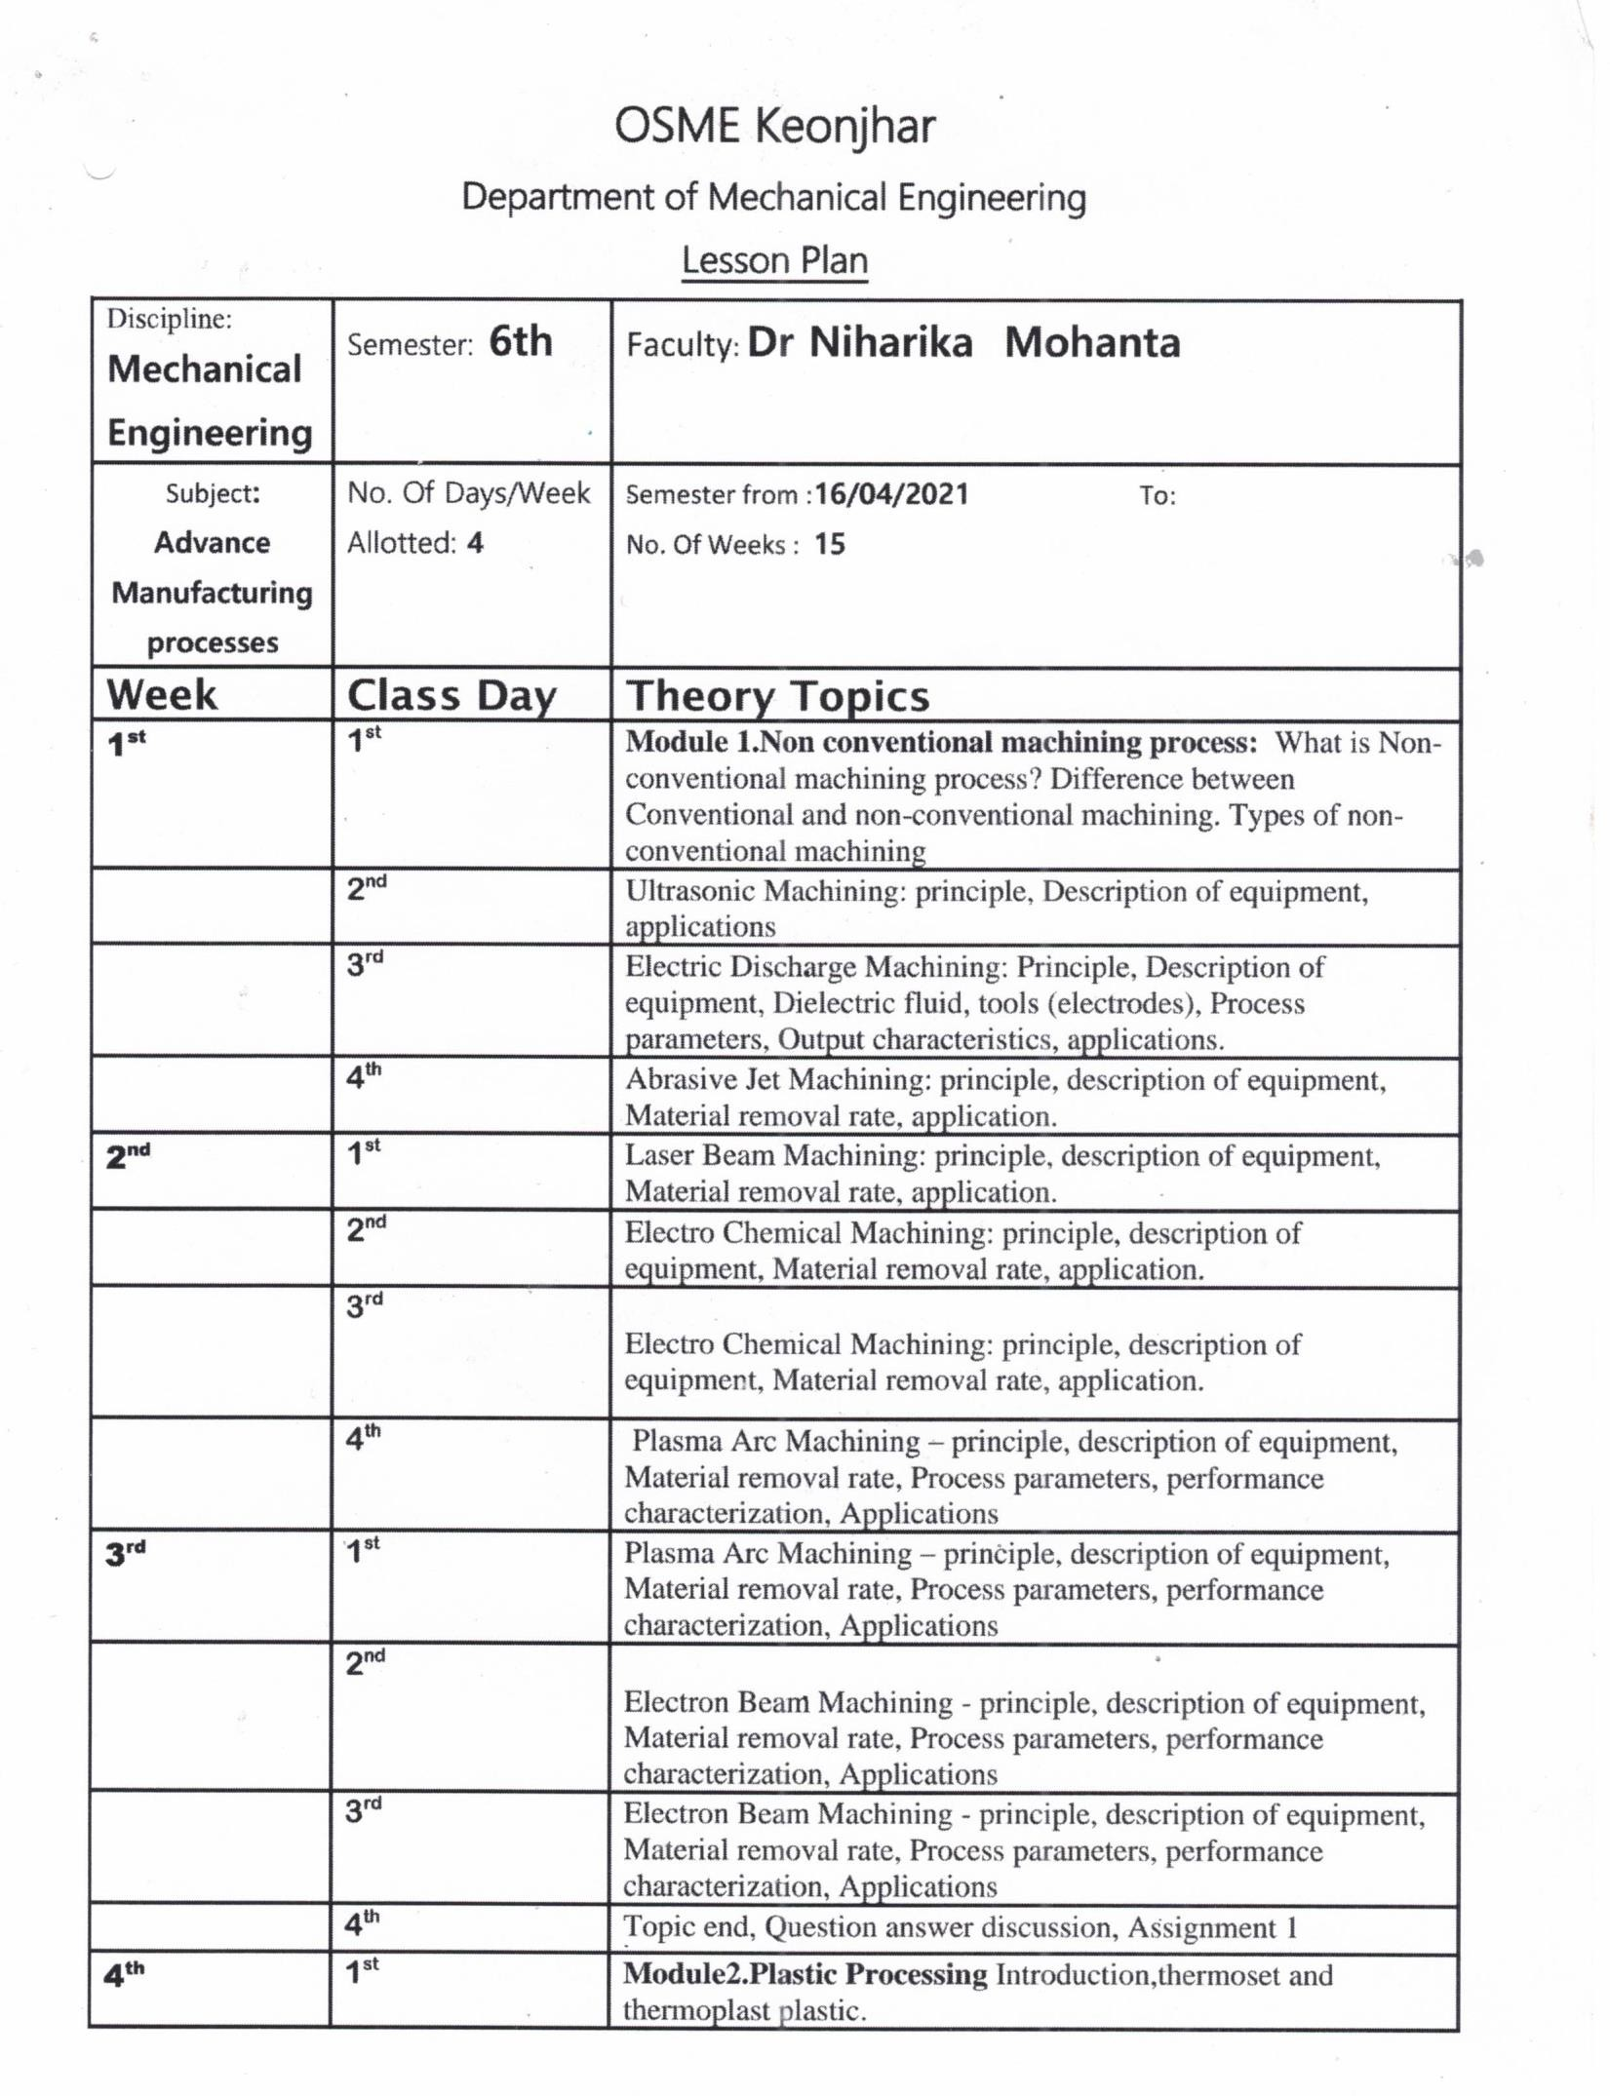
GANDHI ACADEMY OF TECHNOLOGY AND ENGINEERING

FACULTY: Mr. Abinash Samantaray

SESSION- 2023-24
E-MAIL ID- simanchal.panda.1@gmail.com
10.03.2022
Subject
Adv.
Manufacturing Process- Th 4b

